Phase Change Materials for Sustainable Thermal Energy Storage: From Characterization to Applications in Buildings, Photovoltaics, Electronics, Textiles and Cold Chain Systems
  - TESI DI LAUREA MAGISTRALE IN
  - ENERGY ENGINEERING
  - INGEGNERIA ENERGETICA
Author: Matteo Comaschi
Student ID: 10625420
Advisor: Domenico Mazzeo
Co-advisor: Emanuele Giovanni Carlo Ogliari
Academic Year: 2025-26

Abstract
The thesis presents an organic review of phase change materials (PCM) for latent-heat thermal storage, including classification (solid–liquid, solid–solid, eutectics), thermo-physical/chemical properties, and stabilization strategies (micro/macro-encapsulation, nano-conductive additives, flame retardants, compatibility, and container corrosion). The main characterization methods (DSC, T-history, and other more recent techniques to derive conductivity, specific heat, and latent heat) are compared, highlighting advantages, experimental limitations, and criteria for use to obtain reliable data for design purposes. The analysis of the leading companies in the global PCM market is also reported.
An application analysis based on the relevant scientific literature illustrates the integration of PCMs in electronics, with a focus on applications in batteries, data centers, and distribution networks, in photovoltaic modules, in buildings, in cold-chain logistics (with a biomedical focus), and in cooling garments, discussing for each application field the benefits, critical issues, and safety aspects, as well as economic and environmental impacts. A dedicated section analyses a selection of recent patents on PCMs in the energy sector, in order to highlight the most relevant technological innovations and application fields.
The modeling section analyzes the Stefan problem, solved through the Neumann method. The solution through the enthalpy model, the effective specific heat, and the apparent specific heat is also examined.
Overall, the work provides an operational framework linking characterization, modeling, and application requirements to support a reliable, safe, and sustainable deployment of PCMs in the energy sector.
Key-words: Phase Change Materials; Latent Heat Thermal Energy Storage; DSC; T-history; Transient characterization; Encapsulation; Thermal conductivity; Electronics cooling (batteries, data centers, grids); Photovoltaics; Buildings; Cold chain; Cooling garments; Analysis of economic and environmental impact; Patents; Stefan problem; Neumann method; Enthalpy method.

Abstract in italiano
La tesi presenta una rassegna organica dei phase change materials (PCM) per l’accumulo di energia termica latente, includendo classificazione (solid–liquid, solid–solid, eutettici), proprietà termo-fisiche/chimiche e strategie di stabilizzazione (micro/macro-incapsulamento, additivi nano-conduttivi, ritardanti di fiamma, compatibilità e corrosione dei contenitori).
Vengono confrontati i principali metodi di caratterizzazione (DSC, T-history e altre più recenti per ricavare conducibilità, calore specifico e calore latente) evidenziando vantaggi, limiti sperimentali e criteri d’impiego per dati affidabili ai fini di progetto. Viene riportata l'analisi delle aziende leader del mercato globale dei PCM.
Un’analisi applicativa sulla letteratura scientifica di riferimento illustra l’integrazione dei PCM in elettronica, con focus sull'applicazione nelle batterie, nei data center e nelle reti di distribuzione, in moduli fotovoltaici, negli edifici, nella logistica del freddo (con focus biomedico) e negli indumenti refrigeranti, discutendo per ciascun campo applicativo benefici, criticità, sicurezza oltre all'analisi dell'impatto economico e ambientale. Una sezione dedicata analizza una selezione di brevetti recenti sui PCM nel settore energetico, al fine di evidenziare le innovazioni tecnologiche più rilevanti e i relativi campi di applicazione.
La sezione dei modelli analizza il problema di Stefan, risolto tramite metodo di Neumann. Viene anche analizzata la risoluzione attraverso l'applicazione del modello entalpico, del calore specifico effettivo e del calore specifico apparente.
Nel complesso, il lavoro fornisce un percorso operativo che collega caratterizzazione, modellazione e requisiti applicativi per favorire un impiego affidabile, sicuro e sostenibile dei PCM nel settore energetico.

Parole chiave: Materiali a cambiamento di fase; Accumulo termico a calore latente; DSC; T-history; Caratterizzazione transitoria; Incapsulamento; Conduttività termica; Raffreddamento dell’elettronica (batterie, data center, reti elettriche); Fotovoltaico; Edifici; Catena del freddo; Indumenti refrigeranti; Analisi dell'impatto economico e ambientale; Brevetti; Problema di Stefan; Metodo di Neumann; Metodo entalpico.

Contents
Abstract i
Abstract in italiano iii
Contents v
Introduction 1
1 PCMs: Classification, Properties, Characterization Methods, and Commercial Products 4
1.1. Classification of PCMs 4
1.1.1. Solid-Liquid PCMs 5
1.1.2. Solid-Solid PCMs 10
1.2. Thermal, Chemical and Stability Properties of PCMs 14
1.2.1. Thermal conductivity 15
1.2.2. Heat storage capacity and latent heat of fusion 17
1.2.3. Specific heat capacity 17
1.2.4. Chemical properties 17
1.2.5. Supercooling 22
1.2.6. Hysteresis 25
1.3. Methods for the determination of thermophysical properties. 27
1.3.1. DSC 28
1.3.2. T-History method 30
1.3.3. New procedure 33
1.4. Commercial PCMs 35
2 Literature review and patents in different energy applications 51
2.1. Introduction 51
2.2. Electronic devices 51
2.2.1. PCMs for thermal management of electronic components 58
2.2.2. Application of PCMs in the cooling of data centers 65
2.2.3. Application of PCMs in Electric Distribution Networks 65
2.3. PCMs in PV systems 67
2.3.1. PCMs for thermal regulation in PV systems 74
2.3.2. The effect of temperature on a PV module 74
2.3.3. PV-PCM models 75
2.3.4. PV-PCM systems 77
2.3.5. Economic and environmental considerations of PV-PCM and PV/T-PCM systems 79
2.4. PCMs in buildings 81
2.4.1. Incorporation of PCMs into buildings for thermal comfort and energy optimization 86
2.4.2. Application of PCMs in building materials 87
2.4.3. Application of PCMs in building envelopes 92
2.4.4. Energy saving, economic, and environmental analysis impact 96
2.4.5. Future research directions 98
2.5. PCMs in cold chain application 99
2.5.1. Cold Chain Logistics and the Use of PCMs for Passive Cooling 105
2.5.2. Analysis of Cold Chain Logistics and the Application of PCMs 107
2.5.3. Phase change properties of commercial PCMs for cold chain logistics 109
2.5.4. Focus on the application of PCMs in the biomedical field 111
2.5.5. Environmental analysis impact 112
2.5.6. Future reasearch directions on PCMs in biomedical applications and cold chain logistics 113
2.6. PCMs in textile and cooling garments applications 114
2.6.1. Clothing comfort using PCMs 119
2.6.2. Working Principle of PCMs in Textiles 120
2.6.3. Performance evaluation of PCMs cooling garments 122
2.6.4. Application of PCMs integrated in clothing 123
2.6.5. Environmental impact and safety of PCMs 125
2.6.6. Future reasearch directions 126
2.7. Patents review 127
3 PCM Models 137
3.1. Introduction to the Stefan problem 137
3.2. Stefan problem 138
3.3. Neumann solution 142
3.4. Numerical models 143
3.4.1. Enthalpy model 144
3.4.2. Equivalent specific heat capacity model 146
3.4.3. Apparent specific heat capacity model 148
3.5. COMSOL Multiphysics 150
Bibliography 155
List of Figures 177
List of Tables 181

Introduction
Historically, energy demand has been met primarily through non-renewable sources, particularly fossil fuels and nuclear power. However, these resources are limited and do not regenerate on a time scale compatible with human needs. The intensive use of fossil fuels has two major consequences. The first concerns the environment: the combustion of coal, oil, and natural gas releases large amounts of greenhouse gases into the atmosphere, such as CO₂, CH₄, and N₂O, which intensify the natural greenhouse effect and contribute to global warming. Data clearly show an increase in CO₂ concentrations and anomalies in global average temperature. The effects are already tangible: melting glaciers, rising sea levels, more frequent extreme events (floods, heat waves, wildfires), with economic costs estimated in the trillions of dollars by mid-century [1]. The second consequence concerns energy security. Since fossil fuels and uranium are limited resources, their availability is subject to sharp price fluctuations and geopolitical risks. Moreover, the concentration of production in a few countries and the dependence on imports make energy systems vulnerable to political and economic crises. A third aspect concerns access to energy. Even today, in many parts of the world, a portion of the population does not have reliable access to electricity or to clean cooking fuels. Renewable technologies, being decentralized and scalable, can provide off-grid solutions and improve living conditions in remote regions. Naturally available resources regenerate on a human time scale and, if properly integrated with storage systems and smart grids, can ensure clean, safe, and sustainable energy for the future.
However, their integration still presents some significant challenges, particularly related to their intermittency and variability. Production is not constant, but depends on external conditions that can change rapidly and unpredictably. This variability makes it difficult to ensure a continuous match between energy supply and demand, creating issues for grid integration. For this reason, it is essential to develop reliable and economically sustainable energy storage solutions capable of balancing production fluctuations and ensuring system stability. Thermal energy storage can overcome the disadvantages of renewable energy systems by storing the energy generated during off-peak hours of consumption and returning this energy during the period of high peak consumption [2]. Thermal energy storage can occur in three ways, represented in Figure 1. The first consists of sensible heat storage, where the added energy is used to increase the temperature of the medium without any phase change [3]. The second one consists of Thermochemical storage that works through reversible chemical reactions, where energy is stored when molecular bonds are broken and can be recovered when the reaction runs in reverse [4]. In this work, our focus will be particularly on latent heat storage, which allows the accumulation or release of heat as the medium undergoes a phase change. Materials used for latent heat storage are called Phase Change Materials (PCM), and in recent decades, they have been the subject of scientific research due to their properties and the significant contributions they can make to thermal storage. When the temperature increases, the material undergoes a phase change (for example, from solid to liquid) and absorbs energy during this process. Conversely, when the temperature decreases, the PCM releases energy. The use of these materials is preferred over other storage systems because PCMs allow large amounts of energy to be stored at high density with limited temperature variations, ensuring greater efficiency and operational stability [5].
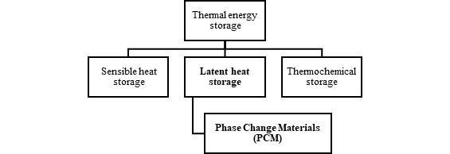
Figure 0.1. Classification of thermal energy storage (TES) systems: sensible heat storage, latent heat storage, and thermochemical storage; PCMs are a subclass of latent heat storage.

PCMs: Classification, Properties, Characterization Methods, and Commercial Products

Classification of PCMs
In this paragraph, the classification of phase PCMs encountered in engineering applications will be discussed. First of all, it can be stated that PCMs can be classified into solid–solid, solid–liquid, solid–gas, and liquid–gas materials. Figure 1.1 shows the classification of PCMs. However, it should be emphasized that their selection depends on many criteria and on thermophysical, kinetic, and chemical properties, in addition to economic considerations. Table 1.1 shows selection criteria for physical properties and economic aspects, while a specific section will be dedicated to them later in this work [6].
Selection criteria
Thermophysical properties | Ideal melting point range  High value of the latent heat of phase change  Excellent thermal conductivity  Significant specific heat  Good density  Minimal volume fluctuations and low vapor pressure  Consistent melting
Kinetic properties | Fast nucleation rate to avoid supercooling  No sub-cooling  Rapid crystallization rate, which leads to optimal heat release  Fast melting rate, which leads to optimal heat storage capacity
Chemical properties | Full reversibility of solidification and melting  Chemical stability and resilience  Integrity maintained through numerous solidification/melting cycles  Non-corrosive  Non-toxic, Non-flammable, and Non-explosive
Economics | Reasonable cost  Immediately accessible and widely available
Table 1.1. Selection criteria for PCMs grouped by thermophysical, kinetic, chemical, and economic properties.
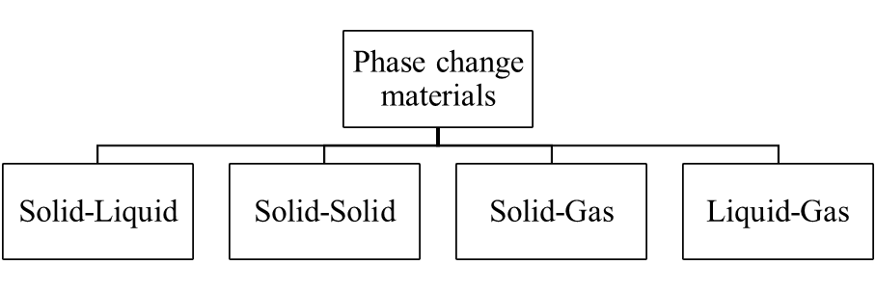
Figure 1.1. Phase-change pathways in PCM: solid–liquid, solid–solid, solid–gas, and liquid–gas.

Solid-Liquid PCMs
Figure 1.2 shows the subdivision of solid–liquid PCMs. Solid–liquid PCMs are divided into organic, inorganic, and eutectic types, and are the most suitable for latent heat storage applications because they offer high energy storage density, operate at nearly constant temperatures, and provide a wide variety of materials available for different temperature ranges.
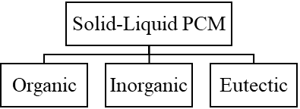
Figure 1.2. Classification of solid–liquid PCMs into organic, inorganic, and eutectic families.

Organic PCMs
Organic PCMs mainly include paraffins (open-chain saturated alkanes), fatty acids, and vegetable oils. They exhibit a high latent heat storage capacity and are characterized by good chemical stability, being non-reactive. Furthermore, they do not show phase segregation or supercooling during melting and solidification cycles, while also presenting favorable nucleation properties. Despite these advantages, their main drawbacks are related to their inherently low thermal conductivity and their flammable nature, which limit their use in certain applications [7].
Paraffin is the final product of petroleum refining, obtained after asphalt extraction and subsequently treated with chemical agents for its conversion into wax [8]. From a chemical perspective, it belongs to the alkane family, saturated compounds of carbon and hydrogen with linear, cyclic, or branched structures. It is the most widely used commercial PCM due to its stability over approximately 1500 cycles and the possibility of adjusting melting and solidification points according to molar mass and chain length. Good cycling stability and the absence of supercooling are further advantages, while its inherently low thermal conductivity represents the main limitation, which can be partially mitigated through the use of high-conductivity additives or finned structures. From a safety standpoint, paraffins are non-corrosive and chemically stable, though they may undergo oxidation and, in industrial grades, can contain volatile compounds that are toxic or carcinogenic (e.g., formaldehyde, benzene, toluene, and naphthalene). Therefore, in building applications, the use of certified and safe products is essential.
Vegetable oil-based PCMs represent an attractive option for various applications, due to their higher safety compared to paraffin-based materials. They exhibit a latent heat capacity ranging from 150 to 220 J/g and melting temperatures within the 90–150 °C range. Unlike paraffins, which are toxic if ingested, vegetable oils are edible and pose no health risks. However, they are characterized by lower flash points and longer flame propagation times. From an environmental perspective, vegetable feedstocks are natural and renewable resources with an almost negligible carbon content. Moreover, their chemical inertness ensures compatibility with most construction materials.
Fatty acids are carboxylic acids with long hydrocarbon chains and a terminal carboxyl group. They are mainly derived from glycerides or phospholipids. From an application perspective, fatty acids present significant drawbacks: they are corrosive, flammable, and often characterized by an unpleasant odor, which limits their use in building applications. Moreover, their cost is considerably higher than paraffin wax (two to three times greater).

Inorganic PCMs
Inorganic PCMs can consist of metals or salt hydrates. In contrast to the previously described organic materials, inorganic compounds offer the advantages of very high latent heat storage capacity, non-flammability, and sharper phase transitions [7]. However, they are inherently corrosive and may undergo phase segregation and supercooling, which represent significant challenges for their practical application.
Salt hydrates are inorganic compounds integrally associated with water molecules, and they are attractive as PCMs due to their low cost, high specific heat capacity, high latent heat storage, and good thermal conductivity. However, they exhibit supercooling caused by poor nucleation and phase segregation due to incongruent melting. In addition, with an increasing number of cycles, the hydrated mass decreases, and the material degrades after several uses.
Salt hydrates are available within a limited temperature range that is suitable for most applications. Their main drawback is the phenomenon of incongruent melting, which reduces the reversibility of the phase change process and, consequently, their heat storage capacity. For this reason, the potential use of salt hydrates as PCMs requires a fundamental study of their thermal properties, such as phase change temperature, supercooling behavior, nucleation rate, and enthalpy. Ideally, these properties should be evaluated before and after repeated heating and cooling cycles. Proper encapsulation is therefore required before their use in building applications. Moreover, their tendency to cause corrosion in metal containers makes compatibility with containment materials another significant challenge. Salt hydrates are mostly considered non-toxic, but some compounds can cause skin, eye, or breathing irritation, especially when in powder form or in direct contact. In certain cases, the health risks can be more serious. Most salts are not carcinogenic, but some are not biodegradable. For this reason, proper safety measures are needed, and data sheets should be consulted when frequent exposure is expected.

Eutectics
Eutectics are mixtures of two or more compounds that melt and solidify together at a specific composition, known as the eutectic composition, and at a defined eutectic temperature. Their main advantage is the sharp and well-defined phase change temperature. They undergo melting and freezing without segregation, which makes them stable. Most eutectics reported in the literature for air-conditioning applications are organic in nature. However, some of them have unpleasant odors, which limit their use in buildings. In addition, their synthesis, characterization, and testing can be costly and time-consuming, which may explain the limited research available on their thermophysical properties. Their level of toxicity depends on the nature of the constituent materials, whether organic or inorganic.
Table 1.2 summarizes the advantages and disadvantages of PCMs, in accordance with the discussion above and with the scientific literature [9].
Classification | Advantages | Disadvantages
Organic PCMs | Versatility over a wide temperature range  High latent heat of phase change  Absence of subcooling  Physical/chemical stability and recyclability  High compatibility with various materials | Low thermal conductivity  Significant volume change  Low volumetric heat storage density  Susceptibility to flammability
Inorganic PCMs | High melting point  Excellent thermal conductivity  Low volume change  High volumetric heat storage density (compared to organic PCMs)  Low-cost access | Supercooling  Corrosion
Eutectic PCMs | Distinct phase change temperature  High volumetric heat storage capacity | Insufficient data available on thermophysical properties
Table 1.2. Advantages and disadvantages of different categories of PCMs.
To provide a comparative overview, Table 1.3 presents the characteristic values of the most commonly studied PCMs reported in the literature [7], including melting point, latent heat, sensible heat capacity, thermal conductivity, and density.
Material/  References | Melting point [°C] | Latent heat storage [kJ/kg] | Sensible heat storage [kJ/(kg °C)] | Thermal conductivity [W/(mK)] | Density [kg/m³]
Organic PCM
Stearic acid | 64.5 | 196 | 2.27[l], 1.76[s] | 1.60[s] | 940
Palmitic acid | 61-63 | 212 | 2.20 [40 °C] | 0.162 [68.4 °C] | 942
Polyurethane | 29.8 | 189 | - | 0.17[s] | 860
Paraffin wax | 54 | 184 | - | - | -
Malic acid | 51.5-53.6 | 200-204.5 | - | - | 878[l], 904[s]
Capric acid | 31.5-31.6 | 153 | - | 0.16[s] | 862
Lauric acid | 41-44 | 183-212 | 1.76 [25°C] | 0.16[s] | 862
Erythritol | 118 | 339 | 2.61[l], 2.25[s] | 0.326[l], 0.733[s] | 1480[s], 1300[l]
Hydroquinone | 169-173 | - | - | - | -
Acetamide | 82 | - | - | - | 1159
Acetanilide | 116 | - | - | - | -
Dimethyl Sulphoxide | 189 | - | - | - | 1009[l]
Hexadecane | 18 | 237 | 2.22 [l] | 0.189 [38.6 °C] | 770 [20 °C]
Inorganic PCM
Na₂CO₃·10H₂O | 33-36 | 247 | - | - | 1485
CaCl₂·6H₂O | 30 | 190-192 | 1.4[s], 2.1[l] | 1.08[s], 0.56[l] | 1710
Na₂SO₄·10H₂O | 32 | 254 | 2.01[l], 2.25[s] | 0.15[l], 0.3[s] | 1450
MgCl₂·6H₂O | 117 | 167 | 2.61[l], 2.25[s] | 0.57[l], 0.69[s] | 1560
Na₂HPO₄·12H₂O | 35-45 | 279.6 | - | - | 1520
Mn(NO₃)₂·6H₂O | 89.3-89.9 | 167-175 | - | 0.57 [120 °C] | -
K·4H₂O | 18.5 | - | 1.84[s], 2.39 [l] | - | 870
Eutectic PCM
Palmitic acid+stearic acid | 53 | - | - | - | -
Lauric acid | 35 | - | - | - | -
Capric lauric acid | 18-39 | - | - | - | -
Paraffins | 22.5 | 173 | 2.0[s], 2.3[l] | 0.14 | 870[s], 790[l]
Capric acid-Palmitic acid | 22.5 | - | - | - | -
Table 1.3. Key thermophysical properties of common PCMs, grouped into organic, inorganic, and eutectic.

Solid-Solid PCMs
Recent progress has highlighted a growing interest in solid–solid PCMs (SS-PCMs), which offer specific advantages such as low supercooling, limited volume expansion during the solid–solid transition, high thermal stability, and significant values of both latent heat and thermal conductivity. Solid–solid phase change materials (SS-PCMs) exhibit a phase transition from a crystalline structure to a semi-solid polycrystalline structure, and further to an amorphous phase transition with full reversibility, which helps reduce thermal degradation. The thermal stability of SS-PCMs is comparatively higher than that of solid–liquid PCMs (SL-PCMs). In recent years, research on PCMs has increased significantly, but it has been mainly focused on SL-PCMs [10]. Despite the fundamental advantages offered by SS-PCMs over the previously discussed materials, only a limited number of reviews are available. Figure 1.3 shows that SS-PCMs can be classified into organic, organometallic, and polymeric categories.
Figure 1.3. Classification of solid–solid PCMs: organic, organometallic, and polymeric.

Organic Solid-Solid PCMs
Some polyalcohols are commonly used either individually or in binary, ternary, or quaternary mixtures as SS-PCMs [11]. Studies in the literature [12] [13] [14] report that polyols exhibit a low-symmetry, layered crystal structure at low temperatures, which transforms into a high-symmetry, face-centered cubic structure when the temperature rises above the phase change point. Figure 1.4 shows this behavior. Table 1.4 shows representative thermophysical properties of selected organic solid–solid PCMs, including phase transition and melting temperatures, latent heat, specific heat, and density.
ORGANICS | Phase transition temperature [°C] | Melting temperature [°C] | Latent heat of transition | Specific heat [J K⁻¹ mol⁻¹] | Density [kg/m³]
Neopentane | -133 | -16.54 | 35.9 J/g | 121.07–120.57 | 3.255 (Vapor)
NPA | -31 | 51–55 | 50.6–53.3 J/g | 2.79 | 36
AMPD | 23.4–78 | 71.4–107 | 77.05 J/g | - | 3.63 (Vapor)
NPG | 40–48 | 129.13 | 110.4–131 J/g | 287 | 1060
PEG 4000 | 41–44.5 | - | 60.4 J/g | - | 1200
PE | 187 | - | 36.8 kJ/mol | - | 1400
Table 1.4. Representative thermophysical properties of organic solid–solid PCMs: phase transition and melting temperatures, latent heat, specific heat, and density.
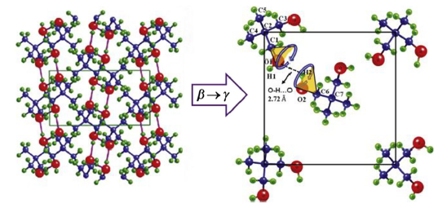
Figure 1.4. Phase transition behavior of organic polyol SS-PCM [10].

Polymeric Solid-Solid PCMs
Polymeric PCMs consist of a solid–liquid macromolecule that is chemically linked to a polymer. The soft part undergoes melting and is stabilized by the hard part, resulting in a solid–solid phase transition, as shown in Figure 1.5. Organic compounds such as fatty acids are SL-PCMs with high latent heats. Another high-enthalpy PCM is polyethylene glycol (PEG), which exhibits good phase change properties at molecular weights above 4000. The enthalpy of polymeric PCMs depends on the active component used. Composite solid PCMs have lower enthalpy compared to the original phase-changing polymer, since the supporting structure does not take part in the phase transition. PEG is the most commonly used substance, and some studies [15] have shown that the molecular weight of PEG directly influences its phase transition temperature and enthalpy. Table 5 presents thermophysical data for polymeric solid–solid PCMs as phase transition temperature, latent heat of transition, and, when reported, melting temperature.
POLYMERICS | Phase transition temperature (°C) | Latent heat of transition (J/g) | Melting temperature (°C)
Poly(2-myristoxyethyl acrylate-co-methylacrylate) | -5.8 – 1.4 | 48.5–110.8 | -
Cellulose-g-Polyethylene glycol | 12.2–19.4 | 70.3–192.1 | 40.2–41.6
Polystyrene-co-stearoxyethyl acrylate | 23.3–27.5 | 54.8–84.3 | -
Polyethylene glycol | 36–59.9 | 91–107.5 | -
Polyethylene glycol 100,000 | 38.6 | 166.3 | 83.62
Polyethylene glycol  8000/4,4’-diphenylmethane diisocyanate/Glucose | 45.5–46.3 | 183.72 | 56.7–61.4
Table 1.5. Thermophysical properties of polymeric solid–solid PCMs: phase transition temperature, latent heat of transition, and melting temperature.
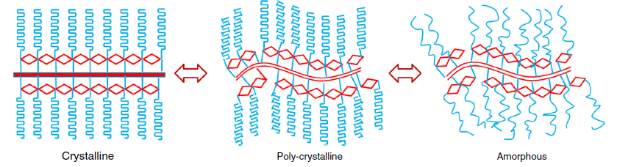
Figure 1.5. Phase transition behavior of polymeric SS-PCM [10].

Organometallic Solid-Solid PCMs
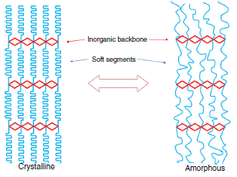
Organometallic SS-PCMs of the type (1-CₙH₂ₙ₊₁NH₃)₂·MX₄, where n is the number of carbon atoms in the hydrocarbon chain, M is a divalent metal, and X is a halogen, are classified as layered perovskites. These structures are formed by MX₄ layers consisting of halide octahedra connected in a plane, while –NH₃ groups bond to the halogens through hydrogen bonding and to the hydrocarbon chain through covalent bonding. Several layers are held together by van der Waals forces. Figure 1.6 shows that the structural framework of layered perovskites is formed by MX₄ layers, which consist of halide octahedra sharing corners within a plane. During phase transition, these materials move from an ordered to a disordered state, similar to paraffin melting, but the transition is solid–solid and the inorganic metallic substrate remains unchanged. The properties of these PCMs depend on the chain length (n), the metal, and the halogen. The transition temperature and enthalpy increase with the length of the alkyl chain in the amine. The metallic salt part does not contribute to the enthalpy but instead reduces it compared to normal paraffins. However, the thermal behavior can vary significantly depending on the coordination geometry of the metal atoms. Table 1.6 presents thermophysical data for organometallic solid–solid PCMs as phase transition temperature, latent heat of transition, and, when available, melting temperature.
Figure 1.6. Phase transition behavior of organometallic SS-PCM [10].
ORGANOMETALLICS | Phase transition temperature (°C) | Latent heat of transition (J/g) | Melting temperature (°C)
C10Mn | 32.8 | 70.34 | -
C11Cu | 40 | 70.4 | 513.5–515.5
C12Fe | 46 | 77.2 | 202
C12Mn | 58.7 | 87.5, 12.6 | 202
C14Mn | 65.7 | 66.8, 17.2 | -
C15Cu | 67.8 | 95.9, 15.8 | -
C16Cu | 72.91 | 87.8, 16.6 | 160
C16Mn | 73.6 | 90.1, 14.1, 20.3 | 197
C16Co | 105 | 113.8 | 171
Table 1.6. Thermophysical properties of organometallic solid–solid PCMs: phase transition temperature, latent heat of transition, and melting temperature.

Thermal, Chemical and Stability Properties of PCMs
In PCMs, a large amount of energy can be stored or released in the form of latent heat during the transition of the material from one phase to another. Despite these significant benefits, most PCMs present certain limitations, such as low phase change enthalpy, low specific heat capacity and thermal conductivity, supercooling, volume change, and phase segregation. The efficiency of a phase change thermal energy storage device is directly related to its thermophysical properties. In this paragraph, the thermophysical and chemical properties will be defined and explained, together with methods proposed for their improvement. We will see that, to improve the properties of PCMs, particularly their thermal conductivity, nanoparticles are added to the base material. The resulting material is called nano-enhanced PCM [16].

Thermal conductivity
The thermal conductivity of a PCM represents the amount of heat that flows per unit of time through a unit surface of the material, according to Fourier’s law Eq. (1). For PCMs, higher values of k allow a faster absorption and release of latent heat during the melting/solidification cycle. This property is particularly important because it affects the rate at which the material can absorb or release heat during the phase change process.
$$q=-kA\frac{dT}{dx} (1)$$
The low thermal conductivity of PCMs is a major drawback. The development of composite materials with high thermal conductivity matrices can help to overcome this issue; therefore, enhancing the thermal conductivity of PCMs through composites remains an important research topic [17]. Many factors influence the thermal conductivity of PCMs, but phonon scattering is considered one of the most significant factors limiting the conductivity of composite PCMs. A phonon is the most fundamental description of heat transfer at the microscopic level, acting as a carrier that transports heat from one point to another. The main factors governing phonon transmission are heat power, phonon velocity, and mean free path. However, heat transport in PCMs and interfacial phonons is not restricted only to these parameters, as they are also directly or indirectly affected by other factors such as atomic weight, temperature, mass, and bonding energy.

Methods to increase thermal conductivity
The thermal conductivity of PCMs can be improved by analyzing and modifying their microscopic and morphological structure. This includes chemical modification and addition of structures. Figure 1.7 shows that the improvement can be achieved either through chemical strategies or by integrating external conductive structures [17].

Figure 1.7. Methods to improve the thermal conductivity of PCMs: chemical modification and addition of conductive structures at different length scales.

The impact of macroscopic doping on the micromorphology of the composite is mainly reflected in the amount and size of the pores within the matrix.
Doping produces significant changes in the composition and structure of the thermal conductive matrix at the surface phase. It reduces phonon scattering and increases the number of thermal conduction pathways. Porous materials obtained with a doped element can enhance the cyclic stability of the PCM and its thermal conductivity, while also improving microstructure and surface compatibility. Several studies have demonstrated that nitrogen-doped porous carbons can significantly improve the performance of composite PCMs. Atinafu et al. [18] reported high thermal storage capacity and efficiency up to 117% using N-doped mesoporous carbons. Mehri et al. [19] showed that the incorporation of NDG into palmitic acid enhanced thermal conductivity by up to 50% and ensured stability for up to 1000 cycles. Chen et al. [20] highlighted that PCMs confined in nanoscale NDG structures exhibit higher heat transfer rates and high crystallinity. Finally, Atinafu et al. [21] synthesized a PEG/NPC-Al composite with thermal conductivity increased by 52%, storage capacity up to 100%, and excellent cycling stability.
Grafting, also known as post-synthesis, is a chemical process in which organic groups are introduced onto the surface of mesoporous channels. This can generate new active centers without altering the mesoporous structure of the matrix. However, it may reduce pore volume by blocking the channels due to the irregular distribution of organic groups. The main characteristics of grafting in composite materials are:
(i) progressive reduction of pore size with the increase of organic groups, (ii) preservation of the mesoporous structure of the matrix, (iii) possibility to modify the shape of the organic groups to control the thermal conductivity of the material.
With regard to the addition of structures of different dimensions, there are two main strategies to improve the thermal conductivity of PCMs by adding conductive materials. The first consists of creating a form-stable composite, where the PCM is absorbed into the pores of a supporting material. This prevents leakage during phase change and enhances heat transfer by introducing 2D or 3D conductive networks. Such systems are usually referred to as passive composite PCMs. The second strategy involves adding a smaller amount of highly conductive materials directly to the PCM. Since leakage cannot be avoided in this case, the mixture is called an initiated composite PCM. When conductive structures of 1D or 0D are added, they provide an efficient heat conduction pathway.

Heat storage capacity and latent heat of fusion
The heat storage capacity of a PCM is the total amount of thermal energy that the material can absorb and release during heating and cooling processes. It includes both the sensible heat and the latent heat. Several studies have shown that the heat storage capacity of base PCMs can be improved by adding carbon-based materials such as carbon nanotubes, carbon nanofibers, single- and multi-wall carbon nanotubes, as well as graphene. Other additives like silica (SiO₂), alumina (Al₂O₃), titanium dioxide (TiO₂), and silica-alumina mixtures (SiO₂–Al₂O₃) have also been used to enhance their performance.
Latent heat of fusion is the amount of heat required to change a substance from the solid state to the liquid state at its melting temperature, without changing its temperature. In the case of PCMs, it represents the energy stored or released during the melting and solidification processes. Due to the low thermal conductivity of PCMs, thermally conductive nanoparticles are often proposed to be incorporated into them. However, any addition of “foreign substances” should not compromise the latent heat of the PCM. The majority of experiments have shown that the additives have little effect, or sometimes decrease, the absolute phase change enthalpy of composite PCMs because they displace part of the actual PCM mass [22] [23]. Some researchers attribute the change in latent heat of nano-enhanced PCMs to two main factors: (i) the alteration of the interaction between PCM molecules and nanoparticles, which can improve the latent heat, and (ii) the use of heavy nanoparticle loadings, where excessive replacement of PCM with nanoparticles leads to a degradation of latent heat.

Specific heat capacity
The addition of nanoparticles can significantly improve the specific heat capacity of PCMs. For example, the use of nitrogen-doped graphene (NDG) increased the specific heat capacity of PA/NDG composites, with higher values observed for increasing NDG concentrations. Similarly, the dispersion of lithium silicate (LiCl) or other nanoparticles (SiO₂, Al₂O₃, TiO₂, SiO₂-Al₂O₃) showed improvements of up to 15% with only 1% of nanoparticles. This effect is mainly due to mechanisms such as higher intrinsic heat capacity, interfacial thermal resistance, and the semi-solid behavior of molecules adsorbed on the surface.

Chemical properties

Thermal and chemical stability
The thermal and chemical stability of a PCM plays a crucial role in determining its long-term reliability and suitability for TES applications [10]. In TES systems such as solar energy storage, PCMs undergo multiple charging and discharging cycles throughout their lifetime. This repeated cycling often leads to a gradual degradation of their thermophysical properties. Thermal stability is commonly assessed through accelerated thermal cycling tests in the laboratory, where the PCM is repeatedly cycled across its phase transition temperature. A PCM is considered thermally stable when, after numerous cycles, it retains its thermal, chemical, and physical characteristics. Changes in thermal properties are usually evaluated using a Differential Scanning Calorimeter (DSC), which compares variations in phase change temperature and enthalpy before and after cycling. In contrast, chemical stability is typically examined using FTIR analysis, which can detect alterations in chemical structure induced by thermal cycling. A slight degree of degradation is considered inevitable; however, it is generally accepted as long as it remains within permissible limits.
Several studies have investigated the long-term stability of PCMs through accelerated thermal cycling. For instance, Fu et al. synthesized polyurethane-based PCMs with PEG and surfactants, reporting enthalpy losses of 8–14% after 100 cycles. Zhou et al. tested crosslinking polyurethane with graphene oxide, finding negligible enthalpy variation and excellent reliability. The incorporation of Halloysite nanotubes (HNT) further improved cycling stability and increased decomposition temperature. Other works focused on organics and polymeric PCMs. Huang et al. examined polyacrylonitrile-based copolymers and observed enthalpy losses of around 3–4% after 100 cycles. Similarly, PEG/expanded graphite composites showed minimal changes in phase transition temperature and enthalpy, confirming their reliability. Raj et al. studied manganese-based organometallic SS-PCMs, stable up to 1000 cycles, while Sari et al. tested copolymers such as poly(styrene-co-maleic anhydride)-graft-PEG, reporting stability up to 5000 cycles with negligible degradation. Overall, results suggest that most organic and polymeric PCMs maintain good stability for long-term applications, while organometallic PCMs require further research to address their relatively low enthalpies despite high stability.

Toxicity
Toxicity is the degree to which a chemical substance, or a mixture of elements, can harm living organisms. For TES applications, a careful risk assessment and material selection are essential, guided by the toxicological and environmental profile of the complete system. As shown in paragraph 1.2.1, we can say that for solid–liquid PCMs, organics (paraffins, fatty acids, vegetable oils) are generally low-toxicity: paraffins and many oils can be food-grade, but they are flammable, and some industrial grades may release VOCs when overheated; fatty acids are typically non-toxic/biodegradable but can be irritant or mildly corrosive. Inorganics (salt hydrates) show variable toxicity: many have low acute toxicity but may cause skin/eye irritation and respiratory issues as dust; several are corrosive to containers and poorly biodegradable. Studies on PCMs show heterogeneous behavior: some organometallic PCMs and some organic solid PCMs are non-toxic for specific applications. In general, organic SS-PCMs have low toxicity, while polymeric SS-PCMs are considered minimally toxic, although attention is needed because of reactive chains and the isocyanates used in synthesis. Among layered perovskites, mercury-based systems are disadvantaged because they are toxic and also have lower enthalpies; manganese-based perovskites offer high enthalpy, but their toxicity remains a limitation; cobalt-based perovskites combine high enthalpy and high transition temperatures, yet toxicity is still a major drawback [24].

Flammability and fire retardation
Flammability is one of the main factors limiting the application of PCMs, especially in the building sector. Flame retardants must be carefully selected so as not to significantly affect the latent heat capacity and must remain chemically compatible with the PCM material. Their action mechanisms include:
- Endothermic decomposition, preventing PCM combustion
- Dilution of the gas phase below the minimum oxygen concentration (MOC) by forming inert gases
- Release of radicals (e.g., Cl and Br) that interrupt combustion chain reactions
- Separation of the flame from the surface through charring
Volatile phosphorus-based compounds are among the most effective flame inhibitors, being about five times more effective than bromine and ten times more effective than chlorine in stopping chain reactions. However, external charring agents are required if the chain lacks oxygen and nitrogen atoms. Fire resistance of PCMs is usually assessed by ignition time, mass loss, thermal stability, and smoke generation. An important parameter is the Peak Heat Release Rate (PHRR), while the cone calorimeter is commonly used to evaluate PCM combustibility [25].
Common Flame Retardants | Working principle | Material tested
Ammonium Polyphosphate | Results in char formation, which separates the flame from the material; Releases vapors of water, which acts as a diluting agent; Sometimes used with PER | Paraffin/HDPE
Montmorillonite | As the temperature rises, a rigid layer of ceramic forms on the surface, acting as char | n-octadecane/HDPE-polyethylene co-vinyl acetate
Melamine | Interferes with combustion due to the formation of ammonia vapors | Paraffin/HDPE
Metallic hydroxides | Break endothermically; Releases water at high temperature; Dilutes combustible vapors; Lowers the PCM temperature | RT21/HDPE
Red Phosphorous | Mechanism is not very clear; Researchers suggest it is due to char formation or formation of PO radicals, which deactivate the reaction | -
Halogenated compounds | Forms inactive halogen radicals, which terminate the chain reactions; Antimony oxides act as synergists for them | Chlorinated paraffin+10% Antimony oxide
Expandable graphite | When exposed to heat, it expands several times, acting as a charring and insulating agent due to the minute air spaces in them | -
Table 1.7. Common flame retardants for PCMs.

Corrosion and container requirements
PCM | Suitable container materials
Paraffin’s | All materials are suitable; Care has to be taken with plastics
CaCl₂·6H₂O | Aluminum is not to be used; Stainless steel is a good choice
Na₂SO₄·10H₂O | Stainless steel
Na₂S₂O₃·5H₂O | Carbon steel
MgSO₄·7H₂O | Aluminum; Iron
Table 1.8. Suitable container materials for important PCMs.
Table 1.8 summarizes suitable container materials for representative PCMs. The selection of appropriate materials for the containment of PCMs is important, as they can cause different types of metal corrosion. The most common forms of corrosion include pitting, crevice corrosion, erosion, wear, and oxidation. Pitting corrosion is particularly dangerous when the PCM is in direct contact with metals such as aluminum, and its rate increases when copper is present due to the galvanic effect, which may lead to structural failure. Possible prevention methods include coating the container with a more reactive metal that decomposes first, thereby protecting the container material. Another solution is galvanizing the container with zinc, although care must be taken to avoid cracks or crevices that could promote pitting corrosion. Paraffins are generally considered non-corrosive, but they can still cause swelling of plastic containers. In contrast, fatty acids and salt hydrates are corrosive and therefore require more resistant containers. Stainless steel and carbon steel are corrosion-resistant for most of the materials tested. However, no studies in the literature have specifically examined the suitability of iron as a container, even though it is one of the most commonly used metals.

Encapsulation technique
Encapsulation is a technique that provides a supporting structure to the PCM in order to prevent its interaction with the external environment, increase the surface area available for heat transfer, eliminate leakage, and ensure compatibility between the PCM and its surroundings. PCMs can be encapsulated in either macro or micro form. Macro-encapsulation consists of containing the PCM in pouches, shells, tubes, thin plates, or spheres. This method allows for an easy integration of PCMs into buildings, offering volume control and protection against environmental degradation. However, this form of containment is often limited by problems such as leakage, poor heat transfer performance, and thermal stratification. For these reasons, micro-encapsulation is generally considered the preferred technique. Micro-encapsulation is the technique of forming micrometer-sized capsules by coating PCM materials with a very thin layer of a substance, often a polymer. This method is designed to overcome several issues, such as leakage, volumetric changes during melting–solidification cycles, reactivity with the environment, and to improve both strength and compatibility with building materials. In addition, micro-encapsulation increases the surface area available for heat transfer, thereby enhancing thermal performance. Table 1.9 summarizes the advantages and disadvantages of both encapsulation approaches.

Category | Micro-encapsulation | Macro-encapsulation
Advantages | • Good control of volume change when phase change occurs.  • Easily incorporable into conventional building materials.  • Thermal reliability is considerably improved.  • Enhancing conductive heat transfer between PCM and the surrounding material.  • Prevent PCM leakage by acting as a barrier.  • Chemical stability is improved. | • Improved material compatible with the surrounding material.  • External volume changes effects are mitigated.  • Improves PCM handling during production.  • Preventing changes in its composition through contact with the environment.  • Can serve directly as heat exchangers.
Disadvantages | • Can affect the strength of the material.  • Lead to super-cooling effects.  • Natural convection is interrupted, affecting solidification phenomena.  • Costly process. | • Poor thermal conductivity/heat transfer characteristics.  • Solidification at the edges.
Table 1.9. Advantages and disadvantages of various encapsulation techniques.
The encapsulating material should be compatible with the PCM, should not melt together with it, and must remain stable under pressure changes caused by melt–freeze cycles. It should also maintain thermal stability and provide sufficient mechanical strength. An effective stabilizing agent is required to properly bind the PCM with the shell material. In addition, the encapsulating material should be thermally conductive; otherwise, it may degrade over time, reducing the overall performance of the system. This is one of the main reasons why many PCMs show a decrease in heat capacity after encapsulation. Several factors play a crucial role in determining the effectiveness and properties of fabricated microcapsules. For example, the proper choice of co-agent can improve the size distribution of the microcapsules, although it does not affect the core size itself. Microcapsules synthesized with urea–formaldehyde and formaldehyde resins have shown promising results, while gelatin-based microcapsules displayed higher mechanical strength compared to MF and UF resins. Urea and melamine–formaldehyde also provide good mechanical resistance, thermal stability, and low water absorption, but they release formaldehyde vapors when burned, which pose significant health hazards. Polyurea, on the other hand, appears to be an optimal material because of its good physical and chemical properties and the absence of environmental or health risks. It is important to highlight that no studies in the literature have reported on the microencapsulation of salt hydrates, even though these materials would benefit from this technique more than organic PCMs. Likewise, no studies have established clear criteria for selecting the most suitable encapsulating material for a given PCM. Structural similarity between the PCM and the shell material is expected to provide the best results.

Supercooling
Supercooling is a natural phenomenon that keeps a PCM in its liquid state at a temperature lower than its solidification temperature [26]. During supercooling, the material is in a metastable state, and several factors can trigger solidification. The onset of solidification leads to the release of latent heat, which causes an increase in temperature within the material. If the energy stored in the liquid is sufficient, the temperature of the liquid will rise until it reaches its melting temperature, as shown in Figure 1.8b [27]. Figure 1.8a shows the representation of the supercooling degree. The degree of supercooling is defined as the difference between the theoretical melting temperature and the lowest temperature reached by the liquid phase, known as the nucleation temperature, indicated as T_{n}. Supercooling in PCMs is influenced by factors related to the container, the material, the cooling conditions, and external stimuli. These elements are summarized in Table 1.8.
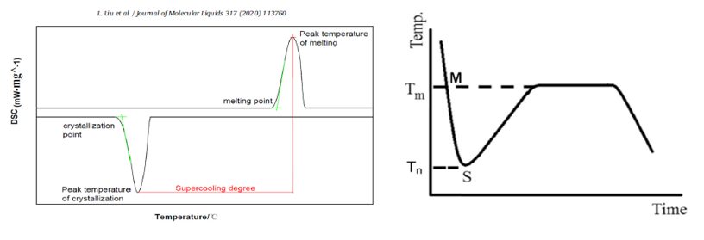
Figure 1.8. (a) The changing curve of latent heat value in the practical phase change transition [26]. (b) Plot of liquid undergoing supercooling upon cooling [27].

Category | Factors
Container | Surface Roughness  Volume  Thermal history
PCM | Thermal conductivity  Composition  Type
Cooling | Area of heat transfer  Rate  Temperature
Others | Mechanical shocks  Electric field  Applied voltage  Magnetic field
Table 1.10. Factors influencing the phase-change behavior of PCMs, grouped by container, PCM, cooling, and other.
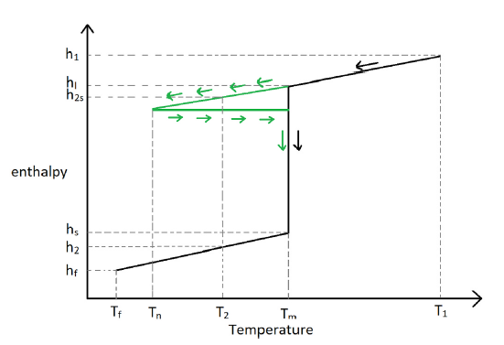
Figure 1.9 shows the variation of enthalpy as a function of temperature. It can differ depending on the presence of supercooling. The case of no supercooling is represented in black, the case of supercooling is represented in green [17]. As highlighted in green, when supercooling occurs, solidification is delayed and the temperature of the liquid PCM continues to decrease until it reaches the nucleation temperature Tₙ, where the phase change finally begins. If a PCM with melting temperature Tₘ is expected to operate between T₁ and T₂, instead of undergoing a phase transition during cooling, it will remain in a supercooled state. In this condition, the release of latent heat does not occur at the expected melting temperature but only once nucleation starts. For this reason, supercooling is considered an unwanted effect in most thermal energy storage systems, as it alters the normal solidification–melting cycle. Consequently, specific approaches are studied and applied to minimize this phenomenon and ensure stable and reliable PCM performance.
Figure 1.9. Enthalpy–temperature diagram without supercooling (black) and with supercooling (green) [17].
- The container volume and surface roughness significantly affect supercooling in PCMs. Rough surfaces and larger volumes promote nucleation, as shown in Figure 1.10, thereby reducing the degree of supercooling. Studies [28] [29] have shown that increasing the PCM volume from very small values (0.025 cm³) to larger ones (16 cm³) decreases supercooling considerably. However, storing PCM in reduced volumes, as in encapsulation, is also beneficial because it increases the heat transfer surface, improving thermal exchange. On the other hand, the solidification of large volumes of supercooled PCM can release a significant amount of energy in a short time. The cooling method strongly influences PCM supercooling.
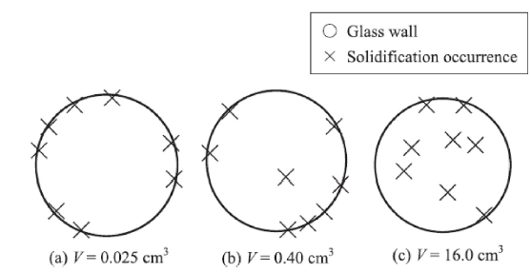
Figure 1.10. The position of solidification initiation for three different volumes having a measured degree of supercooling for the same PCM of a) 88 °C, b) 58 °C, and c) 48 °C [28].

- A higher cooling rate, achieved by lowering the cooling fluid temperature, increases the degree of supercooling but shortens the time spent in the supercooled state. Conversely, a lower cooling rate reduces the degree of supercooling but extends the duration of the supercooled state.
- Two main methods are used to induce crystallization in supercooled PCMs. Manual seeding adds seed particles to the liquid, triggering immediate crystallization and latent heat release. Dynamic stimulation involves external actions such as mechanical shocks, ultrasonic vibrations, friction, agitation, or magnetic fields, which can also initiate solidification [30] [31].
- The composition of PCM and the use of additives strongly influence supercooling. Heterogeneous nucleation starts from rough surfaces, impurities, or additives, while homogeneous nucleation occurs spontaneously in the liquid. Additives can reduce supercooling to very low values, but beyond a certain concentration, they may increase it again due to molecular clustering. Even small amounts (e.g., 1%) are often enough to almost eliminate supercooling, though the exact loading is difficult to define since additives also modify the PCM’s chemical composition [32].

Hysteresis
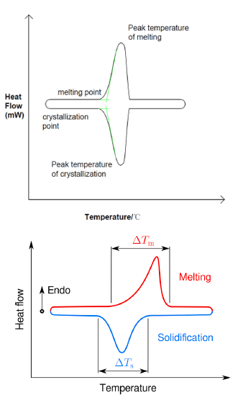
Phase change hysteresis is the temperature delay between the melting and the solidification process [33]. PCMs can undergo both solid–solid (S–S) and solid–liquid (S–L) phase transitions, but most of them experience the melting process (from solid to liquid) and the solidification process (from liquid to solid). As shown in Figure 1.11 (Top), the solid–liquid phase transition is often considered an isothermal process. However, this condition is valid only for most pure materials, but the actual solidification temperature of most PCMs is lower than the melting temperature. The phase change hysteresis can be defined by the difference between the actual melting temperature and the solidification temperature. This difference can be used to measure the energy loss of a system. Simply speaking, we can say that the phase change hysteresis causes the melting and the solidification not to follow the same c(T) or h(T) [34]. The curves are rather shifted with respect to the temperature, which also causes a difference in the phase change temperature range of the process, as shown in Figure 1.11 (Bottom).
Figure 1.11. Top: DSC curve of ideal phase change transition [33]. Bottom: Difference in phase change temperature range of the PCM during solidification and melting [34].

Let us consider the figure below. Figure 1.12a shows a typical h(T) curve of a PCM. When the solid PCM starts from the initial state 1, it follows the h(T) curve until it reaches state m. At this point, corresponding to the melting temperature (T_{m}), melting begins, and the phase change takes place over the temperature interval ΔT. The process is completed at states, where the latent heat of fusion is fully absorbed. Beyond points, heat is stored in the material as sensible heat. The reverse process, cooling, follows the same h(T) curve as heating. This means that solidification begins at point s, with the solidification temperature (T_{s}), and proceeds over the same ΔT interval until it is completed at state m. Since melting and solidification are considered exactly opposite processes, they are described as symmetric and follow an identical h(T) curve.
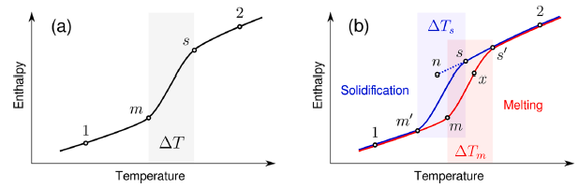
Figure 1.12. Enthalpy-temperature curve for (a) symmetric model with no phase change hysteresis, and for (b) asymmetric model considering phase change hysteresis [34].
On the other hand, phase hysteresis introduces a significant change in the behavior of h(T) curves, as shown in Figure 1.12b. When the liquid PCM in state 2 is cooled, solidification does not begin at point s′, which corresponds to the melting curve, but instead starts at point t on the solidification curve, where Tt < T_{s}. As a result, the melting and solidification curves are shifted relative to each other. A similar temperature shift, but in the opposite direction, occurs during the heating of solid PCM when T₂ > Tm. Consequently, the melting range ΔT_{m} does not coincide with the solidification range ΔT_{s}. A model that accounts for it is considered asymmetric, since solidification is not an exact reverse process of melting.
Several studies have shown that hysteresis is strongly dependent on temperature and operating conditions.
- Zhou et al. [35] investigated a cryogenic organic microencapsulated PCM and observed that, as the core-to-shell ratio increases, the energy storage capacity progressively improves, while the crystallization temperature decreases. This highlights a direct link between geometry and the PCH phenomenon.
- Noel et al. [36] found that hysteresis varies with the heat transfer rate: as the rate of heat exchange increases, the degree of PCH also tends to rise.
- Further experimental investigations, such as those conducted by Delcroix et al. [37], confirmed that heating and cooling rates have a significant effect on the enthalpy curve of PCMs, shifting the transition temperature to lower values.
- Hus et al. [38], analyzing microencapsulated PCMs (based on TiO₂, Al₂O₃, and SiO₂), also demonstrated that the degree of PCH increases with shell thickness and solidification temperature, emphasizing the important role of both chemical and morphological properties. An important aspect concerns the methods used to study hysteresis.
- Mehdaoui et al. [39] applied a one-dimensional heat conduction model and enthalpy–temperature curves to demonstrate that PCH enhances the overall performance of PCMs, particularly in terms of latent heat storage and release. Other researchers have employed techniques such as Differential Scanning Calorimetry (DSC) or enthalpy-based models combined with numerical simulations and duration.
In general, the main factors influencing hysteresis include latent enthalpy, density, thermal conductivity, geometry, and shell thickness of PCMs (especially in microencapsulated systems), as well as the presence of nucleating additives. These same factors, in addition to affecting hysteresis, also play a key role in related phenomena such as supercooling.

Methods for the determination of thermophysical properties.
When selecting a PCM for a thermal energy storage system, it is essential to consider suitable thermophysical, kinetic, and chemical properties, while also taking into account economic and safety aspects.
The focus here is on thermophysical properties, as they are the most relevant for choosing the appropriate PCM for the design and simulation of storage equipment. To be effective, a PCM should meet the following conditions [40] [41] [42]:
1) Have a melting temperature within the desired operating temperature range.
2) Possess a high latent heat of fusion per unit volume, allowing smaller container sizes for a given amount of stored energy.
3) Exhibit a high specific heat to provide additional sensible heat storage.
4) Have high thermal conductivity in both solid and liquid phases to facilitate charging and discharging processes.
5) Undergo minimal volume change during phase transition and maintain low vapor pressure at the operating temperature to avoid containment problems.
6) Display congruent melting behavior to ensure a constant storage capacity over repeated melting and solidification cycles.
Both thermal analysis (TA) and calorimetric techniques provide data that can be further analyzed to determine the key thermophysical properties of PCMs, such as phase change temperature (T_{m}), enthalpy (H_{m}), and the specific heats of solid and liquid phases (c_{p}).

DSC
Conventionally, the thermal characterization of materials is carried out using thermal analysis techniques, among which DSC is the most widely used. This technique allows for the analysis of the thermal behavior of a PCM by determining its melting and solidification enthalpies, melting and solidification temperatures, and the specific heat of the material as a function of temperature. However, DSC presents some limitations: the small sample mass (typically less than 90 mg) can influence the thermal response; repeatability may not be achieved when analyzing heterogeneous samples; and, in the case of composite materials, the main component can interfere with the DSC curve. Calorimetry is a method universally used to measure the heat inflow and outflow of a sample. It investigates the generation or consumption of heat resulting from chemical reactions involving endothermic and exothermic processes. This technique measures the heat flow associated with transitions occurring within the same phase of a material or during a phase change, as a function of both time and temperature. The main purpose of DSC is to measure the amount of heat that can be attributed to thermal exchange [43]. According to Höhne et al. [44], DSC is defined as “the measurement of the change in the difference of heat flow between a sample and a reference sample while both are subjected to a controlled temperature program.” DSC records only the variation in the sample’s temperature; when no temperature change occurs, there is no variation in the heat flow difference. There are two main categories of DSC: the heat flux DSC and the power compensation DSC.

Heat flux DSC
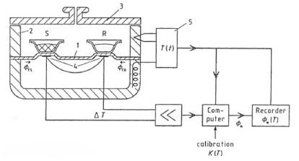
- Disk
- Furnace
- Lid
- Differential thermocouple
- Programmer and controller
S- crucible with sample material
R- crucible with reference material
Figure 1.13. Typical heat flux DSC system [43].
Figure 1.13 shows a typical heat flux DSC system. The disk is made of metals, quartz, or ceramics and is equipped with integrated temperature sensors. During heating, the heat flow passes through the sample disks, which initially have a temperature difference (ΔT) equal to zero under steady-state conditions. If the state of the disk is disturbed, a temperature difference is generated, producing an electrical voltage that is expressed as power (in μW or mW) in accordance with Eq. (2).
$$ϕ_{m}=-k^{'}ΔT (2)$$
Where, $ϕ_{m}$ is the measured heat flow rate, and k is the calibration factor. The relation established in Eq. (3) is valid.
$$ϕ_{FS}-ϕ_{FR}\sim ΔT (3)$$
Where $ϕ_{FS}$ is the heat flow rate from the furnace to the sample crucible, $ϕ_{FR}$ is the heat flow rate from furnace to reference crucible and $ΔT=T_{S}-T_{R}$

Power compensation DSC
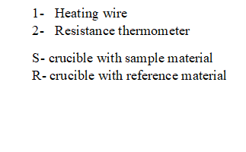
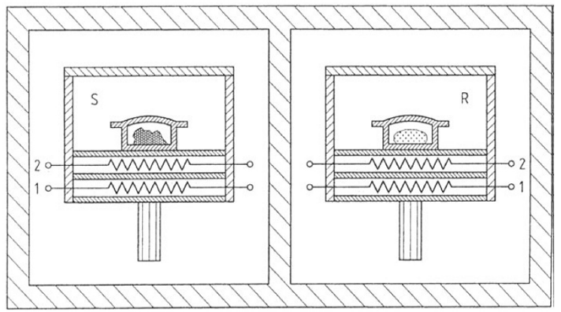
Figure 1.14. Power compensation DSC system [45].
Another type of DSC is the power compensation DSC, which belongs to the category of heat-compensating calorimeters, where electrical energy is used to balance the Joule heating power. The operation of this DSC type is illustrated in Figure 1.14, representing an isoperibolic system. This system consists of two identical microfurnaces mounted inside a thermostatic aluminum block [45]. Platinum–iridium is commonly used to manufacture these furnaces, each equipped with its own temperature sensor and heating resistor. The microfurnaces are approximately 9 mm in diameter, 6 mm in height, and have a mass of about 2 grams. This DSC operates with an isothermal noise of around 0.2 μW and a time constant of 1.5 seconds. The microfurnaces can reach heating powers of up to 15 W, with a maximum heating rate of 500 K/min. During heating, an equal amount of power is supplied to both microfurnaces through a control circuit that regulates the average temperature according to the preset heating rate Eq. (4).
$$ΔP=-k_{1}ΔT (4)$$
Where $k_{1}$ is a constant fixed by the manufacturer.

T-History method
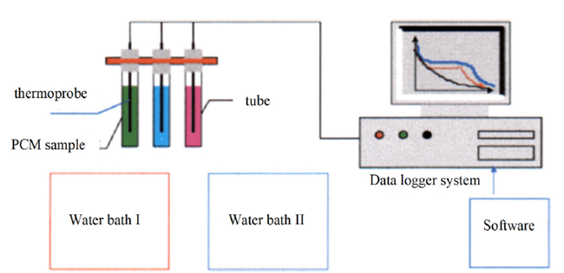
Figure 1.15. Setup for T-hystory method [47].
This method was first developed by Yinping et al. in 1999 [46] and is capable of simultaneously measuring the thermal conductivity, melting temperature, latent heat of fusion, specific heat, and degree of supercooling of several PCM samples. Figure 1.15 illustrates the first setup of this method [47]. In this configuration, glass test tubes are filled with the PCMs to be tested, together with a reference tube, which is generally filled with water due to its well-known thermal properties. Both the sample and reference tubes are preheated in a water bath to a temperature higher than the melting point of the PCM. Then, all the tubes are simultaneously subjected to an instantaneous temperature change by exposing them to the ambient temperature (T∞). During the cooling process, temperature history curves (temperature versus time) are plotted for both the reference material and the PCM samples. Figures 1.16a illustrate the T-history cooling curves with supercooling, Figure 1.16b illustrates the T-history cooling curves of PCM without supercooling, and Figure 1.17 illustrates the T-history cooling curves compared to the reference material.
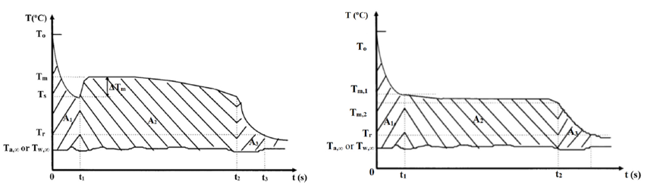
b)
a)
Figure 1.16. a) Cooling temperature recorded versus time when PCM shows subcooling in the T-history method. b) Cooling temperature recorded versus time when PCM shows no subcooling in the T-history method [47].
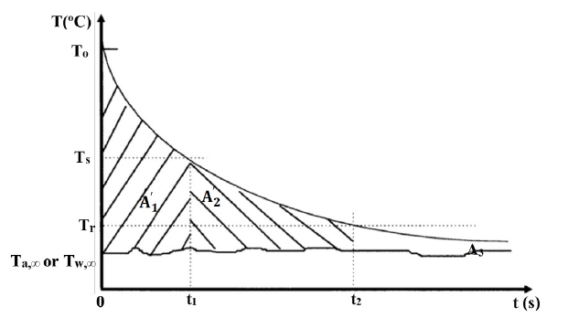
Figure 1.17. Cooling temperature recorded versus time of the reference substance (water) in the T-history method [47].
The thermal properties of PCMs are determined by comparing their curves with those of the reference material. The heat transfer coefficient h is calculated using the following equation Eq. (5), taking into account the recorded temperature–time curve.
$$h=\frac{m_{W}C_{p,W}+m_{t}C_{p,t}}{{A'}_{1}A_{C}}(T_{i}-T_{s}) (5)$$
where $m_{W}$ is the mass of the reference substance, $C_{p,W}$ is the specific heat of the reference substance, $m_{t}$ is the mass test tube, $C_{p,t}$ is the specific heat of the test tube, $A_{1}^{'}$ is the integral of the difference in temperature between the reference and ambient temperature, and $A_{C}$ is the surface area of the test tube. This equation is obtained from Eq. (6)
$$hA_{1}A_{C}=\left(T_{i}-T_{s}\right)\left(m_{P}C_{p,l}+m_{t}C_{p,t}\right) (6)$$
where $T_{i}$ is the initial temperature of PCM, $T_{s}$ in the temperature of the PCM in the solid state, $m_{P}$ is the mass of PCM and $C_{p,l}$ is the specific heat of PCM in the liquid state. When a PCM undergoes supercooling, its phase change temperature lies between Tm and Ts. This temperature difference is also referred to as the degree of supercooling (ΔTm). On the other hand, for a PCM without supercooling, the phase change occurs within the temperature range between Tm₁ and Tm₂. This allows the determination of the phase change enthalpy. Table 1.11 [48] compares the DSC method and the T-History method, two widely used techniques for the thermal characterization of PCMs. It highlights the main aspects of each approach, including testing conditions, measured parameters, and their respective advantages and limitations, providing a clear overview of their applicability in thermal energy storage studies.
Test methods | DSC method | T-History method
Specification of test | 1–10 mg / liquid state / solid particle | Water bath device of constant temperature integrated with a data acquisition system
Temperature range of the test | −170 °C – 730 °C | −20 °C – 180 °C
Instrument for test | Heat flux, DSC Diamond, the power compensation DSC | Water bath device of constant temperature integrated with a data acquisition system
Results of the test | Specific heat, freezing/melting temperatures, latent heat, and degree of supercooling | Thermal diffusivity, thermal conductivity, specific heat, freezing/melting temperatures, latent heat & supercooling effect
Advantages and disadvantages | Advantages: high maturity, high accuracy in results, and wider temperature test range.  Disadvantages: quantity of sample is tiny and may cause supercooling; unable to evaluate thermal diffusivity & thermal conductivity of the sample. | Advantages: simple construction and principle of the apparatus, able to test several thermal properties.  Disadvantages: errors in results may occur if the performer does not properly operate or damage the component.
Table 1.11. Comparison of DSC and T-history methods for PCM characterization: test specification, temperature range, instrumentation, measured outputs and key advantages/limitations.

New procedure
Let us analyze a new procedure [49] to determine thermophysical properties. This experimental method was developed to determine the thermal conductivity and specific heat capacity of a material in both its solid and liquid phases. The test involves subjecting the sample to a thermal transient without allowing any phase change to occur. During this process, the temperature and heat flux are measured on both surfaces of the sample: the data from the transient regime are used to calculate the specific heat, while the data from the final steady-state regime are used to determine the thermal conductivity. The thermal conductivity (k) is calculated in Eq. (7) and it is based on the temperature difference between the two faces and the measured heat flux, following a relation proportional to the thermal gradient.
$$k=\frac{F_{f}}{\left(T_{top,f}-T_{bot,f}\right)}L (7)$$
Where $F_{f}$ is the heat flux, $T_{top,f}$ is the final temperature at the top and $T_{bot,f}$ is the final temperature at the bottom. The stored energy during the thermal transient is obtained through an energy balance shown in Eq. (8)
$$E_{S}= A \int_{t_{0}}^{t_{f}}{\left[F_{top}(t)- F_{bot}(t)\right]dt}= A ρc \int_{0}^{L}{\left[T_{f}(x)- T_{0}(x)\right]}dx (8)$$
from which the specific heat capacity is derived in Eq. (9), considering the average temperature variation and the exchanged heat between the two surfaces.
$$c=\frac{ A \int_{t_{0}}^{t_{f}}{\left[F_{top}(t)- F_{bot}(t)\right]dt}}{m\left[\frac{T_{top,0}+T_{bot,0}}{2}-\frac{T_{top,f}+T_{bot,f}}{2}\right]} (9)$$
Figure 1.18 shows the trends of temperature and heat flux on the two surfaces of the sample during the thermal transient between an initial and a final steady state, also highlighting the stored sensible energy (E_{s}) used to determine the thermal conductivity and specific heat capacity in the two phases.
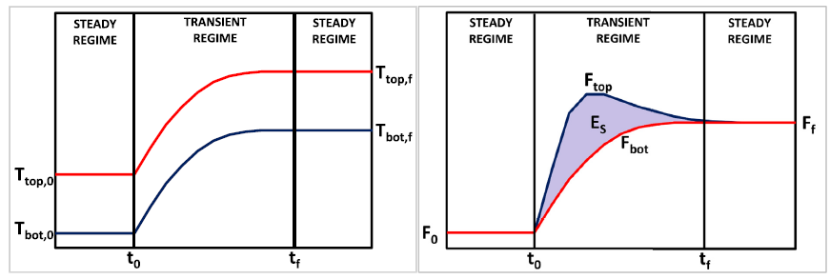
Figure 1.18. Schematization of surface temperature trends Ttop and Tbot, on the left, and of surface heat flux trends F_{top} and F_{bot}, and of the stored sensible energy ES, on the right, during the thermal transient between an initial steady state and a final one [49].
The experimental device was also used to determine the latent heat and the melting temperature. The experiment consists of a thermal transient involving the entire sample, which is initially in the solid state and finally completely liquid. At both the beginning and the end of the process, the system is in steady and uniform conditions. Since melting does not occur simultaneously at all heights of the sample, the overall energy balance was obtained as the sum of the energy contributions of the subvolumes monitored by the individual thermocouples. The calculation of the energy stored in a generic subvolume (with thickness Δxⱼ) is based on the integral of the difference between the incoming and outgoing heat fluxes over time. This energy includes two main components:
- the sensible energy, accumulated during the periods when the subvolume is entirely in the solid or liquid phase, and calculated from the temperature variations
- the latent energy, accumulated during the time interval in which the phase change occurs, is proportional to the mass of the subvolume.
For the entire sample, the total stored energy is written in Eq. (10) and is obtained by summing the contributions of the n subvolumes. Developing the calculation, we obtain that the total stored energy is written as
$$E_{T}= A \int_{t_{0}}^{t_{f}}{\left[F_{top}(t)- F_{bot}(t)\right]dt} (10)$$
and solving the calculation, it is possible to obtain the formulation Eq. (11) of the latent heat H_{F}
$$H_{F}=\frac{E_{T}-E_{S,s}-E_{S,l}}{m} (11)$$
To determine the phase change temperature, for each subvolume, the time interval in which the transition occurs (between t₁ and t₂) is considered, and the average temperature during this interval is analyzed. Figure 1.19 shows a schematic representation of the temperature evolution in a j-th node and of the surface heat fluxes and total stored energy (Eₜ) during the thermal transient, used to determine the latent heat and phase change temperature.
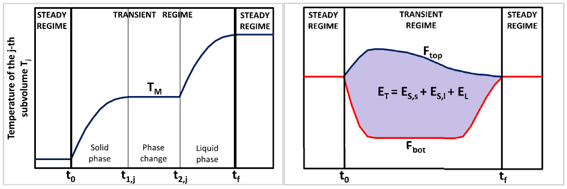
Figure 1.19. Schematization of the temperature trend in a j-th node, on the left, and of the surface heat flux trends F_{top} and F_{bot}, and of the total stored energy ET, on the right, during the thermal transient between an initial steady state and a final one. [49].

Commercial PCMs
The global market for PCMs includes a wide range of companies engaged in developing and commercializing materials used for thermal energy storage and temperature regulation. These materials are applied across sectors such as building energy efficiency, electronics, textiles, logistics, and renewable energy systems. In general, pure PCMs are single substances or well-defined materials that store and release latent heat during their phase transition between solid and liquid states. In contrast, PCM-based products are engineered systems or formulations in which these materials are encapsulated, stabilized, or integrated into a support matrix or finished component, making them suitable for practical and large-scale applications. Table 1.12 presents a selection of major international PCM manufacturers, outlining their main commercial products and application areas. For some of these companies, a detailed classification will then be provided, distinguishing between pure PCMs and PCM-based products.
PCM Manufacturer | Commercial Products & Applications
Honeywell International Inc. (US) | Reported as one of the main players in the advanced PCM market
Teappcm | PCM (T series Latent®) for telecom enclosures, back-up air conditioning, and free cooling. PCM in the form of panels, balls, etc. available for retrofitting applications.
Croda International Plc (UK) | Produces bio-based PCMs and offers the “CrodaTherm PCM Wax” range for various temperature intervals.
Rubitherm (Germany) | Paraffin-based PCMs; manufacture organic, inorganic, and dry PCMs, micro-encapsulated PCMs, freezer, heat packs, and warming elements (RT, SP, PX, etc.).
PlusS (India) | Include GSM latent, multipurpose PCMs and greenhouse applications. PCM under registered trademark name savE and in LS as savENRG; available in a temperature range from −33 to 89 °C. Developed solar PCM-evaporator for 24 h drying with no temperature fluctuations.
DuPont (US) | Thermal mass panel (Energain); able to absorb heat from the temperature around 22 °C; saves up to 30% air conditioning cost; 15% heating cost, and reduces peak temperature by 7 °C.
RGES LLC | DuPont™ Tyvek® Air Cargo Covers are used for shipping pharmaceuticals, vegetables, and fruits. Organic, bio-based & hydrated salt-based PCM materials under trade name PCM-HS, PCM-OS, etc. SaveENGC: cool warm, incubation, freezer PCMs for storage & shipping; maintaining body temperature and for cold chains (medical applications).
Entropy Solutions | PureTemp, a bio-based PCM technology, 100% renewable PCM. Acquired by Sonoco ThermoSafe in its Greenbox for temperature-sensitive pharmaceuticals; able to maintain payloads up to 5 days without requiring external power. Envoy, Certis, and Pallet Shipper are other packaging solutions using this technology. PepsiCo is using its PureTemp technology in its Cold Box to serve perishable meals to school children. Used in the Embrace infant warmer, costing less than 1% of the $20,000 incubators found in top hospitals. Cool Vest, developed by Glacier Tek, uses this technology, which prevents overheating in human and canine troops in Afghanistan.
Phase Change Energy Solutions (US) | Bio-PCM® based products (BioPCM® and Thermastick). Successfully used in residential and commercial buildings.
BASF | Micronal PCM boards are stable for more than 10,000 cycles made out of PMMA and absorb heat in the range 21–26 °C. Micronal PCM smart boards were used in LIWA/COOL low-energy house buildings, schools, etc.
PCM Products Ltd (US) | PCM materials with trade names PlusICE, FlatICE, BallICE, etc. Used in the National Theatre (London, UK), China Shipping Office Building, Flexistore, UKE EIDOS Italy, a heat pump application, Qatar FIFA 2022 World Cup Stadium, and many others.
Table 1.12. Overview of major PCM manufacturers and their commercial products/applications, distinguishing pure PCMs from PCM-based solutions.

Honeywell International Inc. The PCMs developed by Honeywell represent one of the most advanced solutions for thermal management in the electronic and industrial sectors. Thanks to their high thermal conductivity and operational stability, Honeywell PCMs enable effective temperature control, reducing thermal contact resistance and improving the efficiency of high-performance systems. Table 1.13 presents Honeywell’s phase-change thermal interface materials (pads and pastes), summarizing their thermal conductivity, thermal impedance, and density.
https://advancedmaterials.honeywell.com/us/en/products/advanced-semiconductor-materials/thermal-management/phase-change-materials

PCM product | Thermal conductivity [W/(mK)] | Thermal impedance  [°C cm²/W] | Density [g/cm³]
Phase Change Pad  PTM XXXX | 4.4-8.5 | 0.04-0.08 | 2.3-2.8 | 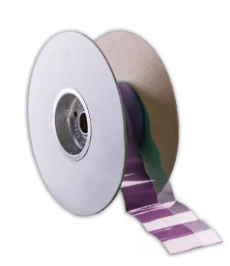
Phase Change Paste  PTM XXXX-SP | 4.4-8 | 0.04-0.10 | 2-2.6 | 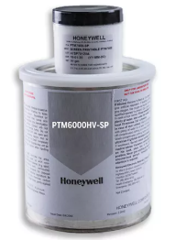
Phase Change Paste  PCM 45 F | 2.0 | 0.09-0.12 | 2.2 | 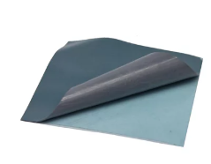
Phase Change Paste  LTM 6300-SP | 2.0 | 0.04 | 1.8 | 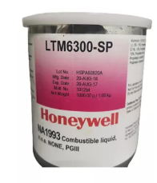
Table 1.13. Honeywell PCM thermal-interface materials (pads and pastes): reported thermal conductivity, thermal impedance, and density.
Croda International Plc. Croda International Plc develops CrodaTherm™, a range of bio-based PCMs designed for thermal regulation and energy storage applications. These materials are made from renewable and biodegradable sources, offer high latent heat capacity, and cover a wide range of melting temperatures. Croda’s PCMs are also characterized by excellent long-term stability, verified through extensive laboratory testing.
https://www.crodaindustrialspecialties.com/en-gb/functions/phase-change-materials
CrodaTherm PCM Wax. Croda International Plc offers a comprehensive portfolio of bio-based PCMs designed to operate across a wide range of temperatures. For effective use in real applications, these PCM waxes are macroencapsulated, meaning they are enclosed within durable or flexible containers to ensure stability, safety, and reliable thermal performance. Table 1.14 presents CrodaTherm PCM Wax products, reporting melting/crystallization temperatures, heat capacities, flash point, and density, with range summaries across the lineup.
Product | Melting Temperature (°C) | Crystallization Temperature (°C) | Heat Capacity (Melting) (J/g) | Heat Capacity (Crystallization) (J/g) | Flash Point (°C) | Density (Kg/liter)
CrodaTherm 5 | 5 | 4 | 217 | 219 | 191 | 0.857
CrodaTherm 6.5 | 7 | 5 | 219 | 226 | 200 | 0.857
CrodaTherm 9.5 | 9 | 9 | 220 | 216 | 200 | 0.858
CrodaTherm 15 | 13 | 12 | 207 | 212 | 206 | 0.896
CrodaTherm 19 | 18 | 18 | 205 | 208 | 202 | 0.850
CrodaTherm 21 | 20 | 20 | 215 | 210 | 208 | 0.850
CrodaTherm 24W | 23 | 23 | 207 | 213 | 226 | 0.843
CrodaTherm 29 | 28 | 27 | 223 | 222 | 215 | 0.851
CrodaTherm 32 | 31 | 31 | 211 | 213 | - | 0.836
CrodaTherm 37 | 36 | 36 | 216 | 217 | 232 | 0.812
CrodaTherm 53 | 52 | 52 | 220 | 221 | 250 | 0.829
CrodaTherm 60 | 60 | 60 | 215 | 219 | 272 | 0.824
CrodaTherm 74 | 75 | 71 | 226 | 224 | 288 | 0.858
RANGE | 5-57 | 4-71 | 205-226 | 208-224 | 191-288 | 0.812-0.896
Table 1.14. CrodaTherm PCM Wax product line: melting and crystallization temperatures, heat capacities (melting/crystallization), flash point, and density, with range summaries.
CrodaTherm Microencapsulated PCM. CrodaTherm™ Microencapsulated PCM consists of PCM wax enclosed within a thin polymer shell, which enables its use in applications where traditional macroencapsulation is not feasible, such as in textiles or coatings. This technology allows the final material to remain solid, even when the PCM inside the microcapsules becomes liquid during the phase transition. Crodasupplies these microencapsulated PCMs in both powder and dispersion forms, offering flexibility for integration into various products and manufacturing processes. Table 1.15 presents CrodaTherm™ microencapsulated PCMs, summarizing form (powder/dispersion), shell type, particle size (d90), melting/crystallization temperatures, and latent heat.
Product | Form | Shell | Particle Size  [d90, µm] | Melting Temperature [°C] | Crystallization Temperature [°C] | Latent Heat (Melting) [J/g]
CrodaTherm ME 24XD | Dispersion* | Thicker | 10 | 24 | 19 | 160
CrodaTherm ME 29D | Dispersion* | Standard | 10 | 29 | 24 | 183
CrodaTherm ME 29P | Powder | Standard | 250 | 29 | 24 | 183
CrodaTherm ME 29XD | Dispersion* | Thicker | 10 | 29 | 22 | 165
CrodaTherm ME 29DS | Dispersion* | Standard | 3 | 29 | 21 | 175
CrodaTherm ME 32DS | Dispersion* | Standard | 3 | 32 | 26 | 175
RANGE |  |  | 3-250 | 24-32 | 19-26 | 160-183
Table 1.15. CrodaTherm™ microencapsulated PCMs: product form (powder/dispersion), shell type, particle size (d90), melting and crystallization temperatures, and latent heat of melting.
Rubitherm Technologies GmbH. Rubitherm® Technologies GmbH is a German company specializing in PCM technology, active since 1993. It develops customized thermal solutions for applications such as sustainable heating and cooling, pharmaceutical logistics, HVAC systems, batteries, functional textiles, and medical or therapeutic uses. The company produces organic and inorganic PCMs, available in various quantities and supplied in both micro- and macro-encapsulated forms, ensuring high cycling stability and excellent thermal storage capacity. Rubitherm also offers innovative products such as non-flammable PCMs, viscosity-adjustable formulations, and bound PCM systems (based on powders or granulates) that simplify integration into industrial systems. All Rubitherm products are distinguished by their high quality, reliability, and long operational lifetime. Table 1.16 briefly summarizes commercial PCM solutions, pure PCMs (RT-Line, SP-Line), PX powder, and encapsulated formats (macro packs, microencapsulated CSM), with melting ranges and heat-storage capacity.
https://www.rubitherm.eu/en/productCategories.html
Pure PCM | Melting Temperature range [°C] | Heat storage capacity [kJ/kg]
PCM RT-Line | -9 <> +128 | 150 <> 260 | 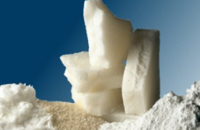
PCM SP-Line | -52 <> 90 | 150 <> 320 | 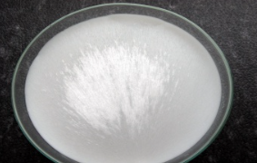
Product PCM | Melting Temperature range [°C] | Heat storage capacity [kJ/kg]
Bound PCM-PX.  The PX material can be applied by filling it into heat pouches for therapeutic use. They can be further used for transport or other applications | 10 <> 82 | 95 <> 145 | 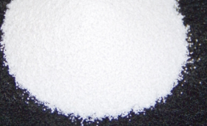
Product PCM | Description
Macroencapsulation Thermal packs | Cool packs filled with PCM are often used in cold chain logistics. They enable passive temperature control of insulated transport boxes. These PCM-filled cold packs aim to keep the temperature constant at a defined level. Depending on the melting point of the PCM used, the temperature to be stabilized can be freely selected |  | 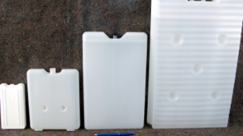
Microencapsulation-CSM | SM (compact storage modules) are widely established aluminum cases that are filled with PCMs. This packaging, which is also called macroencapsulation, enables a variety of applications. The advantage lies in the fact that phase change (from solid to liquid and vice versa) is established within the case |  | 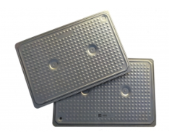
Table 1.16. Overview of representative PCM products: pure PCMs with melting-temperature ranges and heat-storage capacity; bound PX powders; and encapsulated solutions with brief application notes.
Phase Change Solutions. Phase Change Solutions is a global leader in thermal control and energy-efficient technologies, using PCMs to maintain stable temperatures across a wide range of applications. Its BioPCM® products are used in food and pharmaceutical logistics, building systems, telecommunications, and data centers, helping to save energy and support the achievement of the Sustainable Development Goals (SDGs).https://phasechange.com/products-biopcm/
BioPCM. It is a tunable, non-toxic, non-corrosive, non-flammable, recyclable, and eco-friendly material, available in different forms (liquid, gel, or solid). Thanks to this versatility, it can be used in various types of packaging and is also available in dual-temperature formulations. Table 1.17 presents BioPCM® grades Q20, Q23, and Q25, summarizing their key properties and typical operating range.

Product   | Q20  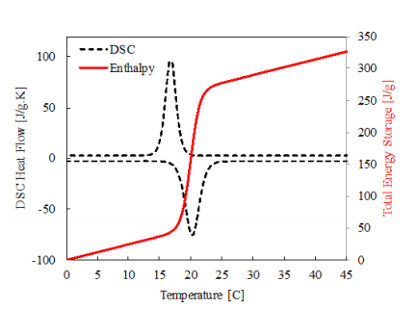
Type of material | Derived from natural agricultural sources (such as vegetable oils and their derivatives)
Melting temperature [°C] | 20
Density [g/mL] | 0.85 - 1.4
Latent heat [J/g] | 210 – 250
Specific heat [J/g] | 2.2 - 4.5
Thermal conductivity [W/mK] | 0.15 - 2.5
Heat storage capacity [J/m²] | 400 – 1250
Product   | Q23
Type of material | Derived from natural agricultural sources (such as vegetable oils and their derivatives)
Melting temperature [°C] | 23
Density [g/mL] | 0.85 - 1.4
Latent heat [J/g] | 210 – 250
Specific heat [J/gK] | 2.2 - 4.5
Thermal conductivity [W/mK] | 0.15 - 2.5
Heat storage capacity [J/m²] | 400 – 1250
Product   | Q25
Type of material | Derived from natural agricultural sources (such as vegetable oils and their derivatives)
Melting temperature [°C] | 25
Density [g/mL] | 0.85 - 1.4
Latent heat [J/g] | 210 – 250
Specific heat [J/gK] | 2.2 - 4.5
Thermal conductivity [W/mK] | 0.15 - 2.5
Heat storage capacity [kJ/m²] | 400 – 1250
BioPCM | Temperature range [°C]: -25 <> +25  Energy density [J/g]: 200 <> 210
Table 1.17. Key properties of BioPCM® Q20/Q23/Q25 (plant-based): melting point, density, latent heat, specific heat, thermal conductivity, and heat-storage capacity; typical range.
Table 1.18 introduces two BioPCM® commercial solutions, ENRG Blanket and Apollo™ Panel, summarizing their key operating features and typical applications (building envelope and refrigeration).
Product | Description
ENRG Blanket | The ENRG Blanket encloses the natural BioPCM—a non-toxic and non-corrosive PCM—between two durable aluminum layers. Its design simplifies both handling and installation. The BioPCM used in ENRG Blanket can be formulated with a melting temperature ranging from 20°C to 25°C. The ENRG Blanket can be installed in various positions and across all parts of the building envelope, including the roof. ENRG Blanket products are shipped as prefabricated sheets measuring 24 × 48 cm or 16 × 48 cm, with custom dimensions available upon customer request. | 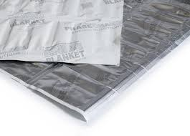
Apollo Panel | The Apollo™ Panel by Phase Change Solutions is a BioPCM®-based panel designed to maintain consistent temperatures inside refrigerators, freezers, and storage facilities. Operating at around 7°C with an energy density of 210 J/g, the panel improves energy efficiency by up to 30%, reducing waste of temperature-sensitive products such as pharmaceuticals and perishable foods. It is easy to install (mounted under shelves in less than 45 minutes) and requires no maintenance or external power, providing up to 7 hours of thermal stability during power outages. | 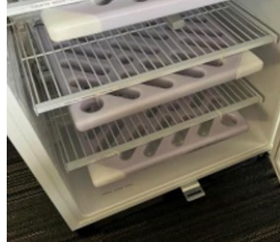
Table 1.18. PCM® commercial solutions: ENRG Blanket and Apollo™ Panel.
PCM Products Ltd. PCM Products Ltd is a UK-based company specializing in the development and supply of PCMs for applications in energy efficiency, thermal management, and heat storage. The company provides both pure PCMs, such as hydrated salts, paraffins, and eutectic mixtures, and engineered solutions based on these materials, designed for different temperature ranges and application fields. The following table presents the main categories of solid/liquid PCMs offered by PCM Products, classified according to their chemical nature and operating temperature range. Table 1.19 presents PCM Products Ltd’s offering and illustrative encapsulated products https://www.pcmproducts.net/Phase-Change-Material-Solutions.htm
Type | Phase change Temperature [°C] | Density [kg/m³] | Latent Heat capacity [kJ/kg] | Specific Heat capacity [kJ/kgK] | Thermal conductivity [W/mK]
S | 8 <> 77 | 1.45 <>2.1 | 100<> 215 | 1.9<>2.61 | 0.43<> 0.7
A | 2 <> 155 | 765 <> 910 | 120<>280 | 2.16<>2.85 | 0.18<>0.23
E | -74<> 0 | 1000<>1510 | 200<>395 | 3.15<>4.19 | 0.53<>0.64
X - solid solid PCMs | 25 <> 180 | 1046<>1330 | 110<>315 | 1.4<>1.67 | 0.34<>0.37
H | 104 <>885 | 1553<>2530 | 100<>602 | 1.5<>1.6 | 0.5 <> 0.59

Encapsulated PCM products | Description
Flat Ice Containers | These containers are constructed of blow-molded HDPE and can be filled with positive or negative temperature PCMs, although high temperature PCMs may be unsuitable due to softening of the plastic. | 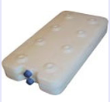
Tube Ice PCM | These containers operate on a similar principle to the FlatICE containers, and are supplied as fully sealed PCM-filled HDPE tubes. | 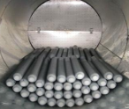
Thin Ice PCM | ThinICE PCM modules have been carefully sized to fit above a standard suspended ceiling grid. These can be fitted above perforated metallic suspended ceilings for the best performance. | 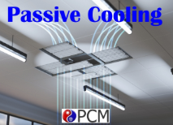
Eutectic Plates PCM | The methods of encapsulation available for our sub-zero eutectic PCMs, and their typical modes of application and uses. | 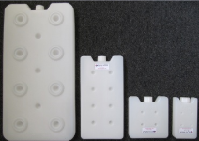
PCM Pouches | The bulk of the range of PCMs can be supplied prefilled in a wide variety of flexible metallic or non-metallic pouches. | 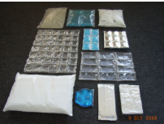
Board Ice PCM | This new technology utilizes a natural fibre board as the encapsulation material, which is then infused with a range of organic PCM solutions. | 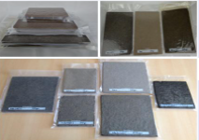
PCM for Cold Storage | Static PCM storage provides a stand-by capability against any power or refrigeration failures and therefore peace of mind for the operators. | 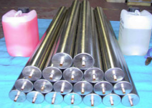
Table 1.19. PCM Products Ltd: properties of PCM types (S, A, E, X, H) and examples of encapsulated products.
Axiotherm. Axiotherm is a company specializing in thermal energy storage solutions based on PCMs. With extensive experience in development and application planning, it provides efficient and cost-effective systems using approved macroencapsulation technologies, working in partnership with leading industrial companies. Table 1.20 presents Axiotherm’s ATS and ATP PCM series, with phase-transition ranges and heat-storage capacities. https://www.axiotherm.de/en/produkte/axiotherm-pcm/
PCM Type | Phase Transition Temperature Range (°C) | Heat Storage Capacity Range (kJ/kg)
ATS Series | –63 <> –10 | 180 <> 60 | 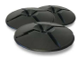
ATP Series | 4 <> 115 | 145 <> 275 | 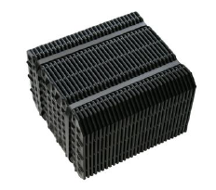
Table 1.20. Axiotherm products: ATS and ATP: phase transition ranges and heat-storage capacity.
Table 1.21 presents three Axiotherm products, like BlackIce, HeatSel, and HeatStaxx Air, briefly summarizing their functions and typical thermal energy storage applications.
Product | Description
BlackIce | BlackIce® is a polymer-based PCM compound designed to provide thermal stabilization for electronic components and systems, preventing temperature peaks and extending their lifespan. It is lightweight, leak-proof, easy to process, and can be customized with additives to enhance thermal performance, making it suitable for automotive, aviation, and logistics applications. | 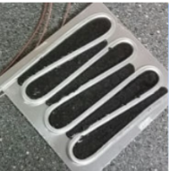
HeatSel | HeatSel®, developed by Axiotherm, is a high-performance thermal energy storage system designed for water-based applications. It uses a hybrid macro-encapsulation structure optimized for efficient heat transfer and maintaining stable temperatures during heat storage and release. Suitable for cooling and heating systems, it is applied in HVAC and industrial thermal storage. Recognized by the European Commission as one of the most innovative energy solutions, HeatSel® combines efficiency, modularity, and reliability. | 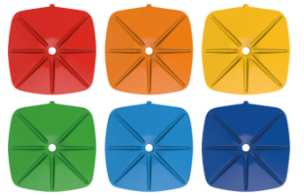
HeatStaxx | HeatStaxx® Air is a high-performance thermal storage system designed for air-based applications. Made from a specially tailored synthetic material with advanced macro-encapsulation, it ensures efficient heat transfer even with small temperature variations and minimal pressure loss. It is ideal for air conditioning, night cooling, solar heating, and heat recovery ventilation systems. | 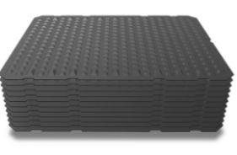
Table 1.21. Axiotherm products: BlackIce, HeatSel, and HeatStaxx Air: brief descriptions and typical TES applications.
PureTemp. PureTemp is a biobased specialty chemical company headquartered in Minneapolis, Minnesota. PureTemp LLC, originally known as Entropy Solutions, began producing the world’s first 100% renewable PCM in 2007. These patented PCMs, developed through three years of research sponsored by the U.S. Department of Agriculture, are used in a wide variety of temperature-control applications — from cooling vests and warming blankets to refrigeration systems and thermal energy storage tanks. Derived entirely from sustainable sources such as animal fats and plant oils, PureTemp’s PCMs are nontoxic and biodegradable. They are engineered to maintain more than 200 distinct transition temperatures with consistent and repeatable performance. Table 1.22 summarizes key properties of PureTemp bio-based PCMs, including melting temperature, solid/liquid density, latent heat, thermal conductivity, and heat-storage capacity https://puretemp.com/
Product | PureTemp 20
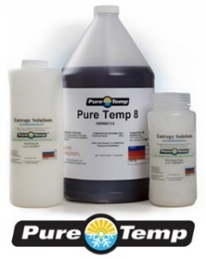 | 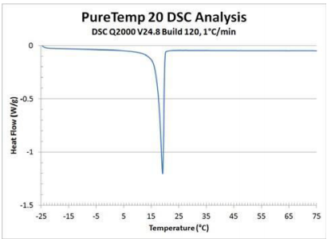
Melting temperature (°C) | 20
Liquid- density (g/ml) | 0.86
Solid-density (g/ml) | 0.95
Latent Heat (kJ/kg) | 180
Liquid-thermal conductivity (W/m°C) | 0.14
Solid-thermal conductivity (W/m°C) | 0.23
Heat storage capacity (J/g) | 171
Product | PureTemp 23
Melting temperature (°C) | 23
Liquid- density (g/ml) | 0.83
Solid-density (g/ml) | 0.91
Latent Heat (kJ/kg) | 203
Liquid-thermal conductivity (W/m°C) | 0.15
Solid-thermal conductivity (W/m°C) | 0.25
Heat storage capacity (J/g) | 201
Product | PureTemp 25
Melting temperature (°C) | 25
Liquid- density (g/ml) | 0.86
Solid-density (g/ml) | 0.95
Latent Heat (kJ/kg) | 187
Liquid-thermal conductivity (W/m°C) | 0.15
Solid-thermal conductivity (W/m°C) | 0.25
Heat storage capacity (J/g) | 187
Table 1.22. PureTemp bio-based PCMs: melting point, solid/liquid density, latent heat, thermal conductivity, and heat-storage capacity.
Table 1.23 presents two PCM products, like BlockVesl tiles and MatVesl film pouches, highlighting form factor and melting-temperature range.
Product | Description
BlockVesl | BlockVesl is a plastic plate measuring 30 × 255 × 39 mm, specifically designed to contain a natural, biodegradable, and non-toxic PCM. The plates can be assembled to form wall coverings. The PCM contained inside BlockVesl can be manufactured with a melting temperature ranging from -15 °C to 29 °C. | 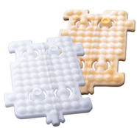
MatVesl | MatVesl are hermetically sealed multilayer film pouches filled with naturally derived PCM. These prefabricated sheets, measuring 27 × 106 cm and weighing 1.1 kg, are designed for a wide range of applications. The PCM inside has a melting temperature range between -15°C and 29°C. | 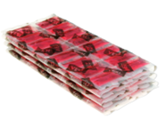
Table 1.23. BlockVesl and MatVesl: brief product overview.

Literature review and patents in different energy applications

Introduction
In the following, the applications of PCMs will be examined systematically across five areas: electronic devices, with a focus on data centers and distribution networks, photovoltaics (PVs), buildings, the cold chain, with particular attention to the biomedical sector and vaccine logistics, and the textile sector. For each application, articles will be retrieved from Scopus using a dedicated query, then classified according to the platform’s relevance indicator and subjected to a selection based on year of publication, prioritizing the most recent contributions, the prestige of the source, and the number of citations. An analysis of publication trends over time and the geographical distribution by country is reported, together with summary tables compiling the most relevant research articles and reviews. The application-focused sections will then examine the energy benefits of using PCMs and the related environmental and economic impacts, and each subsection will conclude with a discussion of future challenges.

Electronic devices
This paragraph presents a synthesis of the scientific literature concerning the application of PCMs in electronic devices and systems. The content was developed following a systematic search conducted on the Scopus database, using targeted queries to identify recent and relevant studies addressing the thermal management of electronic systems through PCM integration. The reviewed literature highlights how PCMs are increasingly employed to mitigate overheating, enhance energy efficiency, and stabilize the operating temperature of electronic components. Particular attention has been devoted to the coupling of PCMs with battery systems, data centers, and electrical and distribution networks, where thermal regulation plays a critical role in ensuring reliability, safety, and long-term performance. To explore the scientific literature on the use of PCMs in electronic systems, a bibliometric search was carried out on the Scopus database using the following query:
("phase change materials" OR PCM) AND (electronics OR "electronic devices" OR "power electronics" OR batteries) AND (cooling OR "temperature control" OR "thermal management" OR "thermal regulation")
which returned 2,541 results. The analysis of these results highlights the growing interest of the scientific community in the integration of PCMs for thermal management in electronic applications. These include power electronics, batteries, and temperature control systems, where effective heat dissipation is crucial for improving performance, efficiency, and reliability.
b)
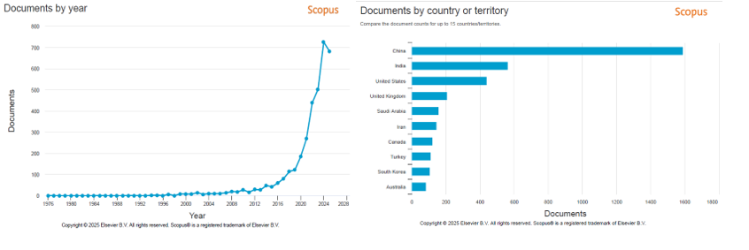
a)
Figure 2.1. Scopus trends for PCM applications in electronic devices: (a) publications rising exponentially since the early 2010s; (b) country share led by China, then India, and the United States.
Figure 2.1a illustrates the evolution of publications over time, showing a significant increase starting from the early 2010s, followed by an exponential growth in the past decade. This trend confirms the rapid development of PCM-based thermal management technologies driven by the miniaturization of electronic components and the rise of energy storage systems. Figure 2.1b shows the distribution of publications by country. The data indicate that China leads the field, followed by India and the United States, reflecting these countries’ strong industrial and academic commitment to energy efficiency and electronic innovation. Other countries, such as the United Kingdom, Saudi Arabia, and Iran, also contribute substantially, confirming the global relevance of PCM-based solutions for electronic thermal control. To ensure the scientific reliability of the analysis, both research articles and review papers retrieved from the Scopus database were examined according to the relevance ranking suggested by Scopus. Among these, the selected papers were chosen following the criteria below:
- Priority was given to publications from well-established and high-impact journals in the fields of energy engineering and applied sciences, as these sources are recognized for their methodological rigor and relevance to the topic of PCM applications in electronic systems.
- Articles with the highest number of citations, relative to their year of publication, were also analyzed, as citation frequency is generally considered an indicator of scientific impact and recognition within the research community.
It is worth noting that most of the papers meeting these selection criteria were focused on the application of PCMs in Battery Thermal Management (BTM) systems, which currently represents the most extensively studied field within electronic PCM applications. Conversely, to identify works addressing the integration of PCMs in data centers and power distribution systems, a more in-depth search was required, employing additional and more restrictive queries to capture the relevant literature. Table 2.1 presents a selection of the most relevant contributions from the literature concerning the use of PCMs for the thermal management of electronic devices. For each study, the main bibliographic information, including title, authors, source, year of publication, number of citations, and the most significant results extracted from the abstracts, is summarized.
Title | Authors | Source | Year | Citations | Abstract summary
Phase-change materials for thermal management of electronic devices | Bianco, V., De Rosa, M., Vafai, K. | Applied Thermal Engineering, 214, 118839 | 2022 | 137 | Integrating PCMs into electronic heat sinks increases thermal inertia and reduces hotspots by 6–10%, but low conductivity and long-term validation remain issues.
Cooling high-power electronics using dynamic phase change material | Kim, S., Stavins, R.A., Garimella, V.S., ... Miljkovic, N., King, W.P. | International Journal of Heat and Mass Transfer, 237, 126433 | 2025 | 14 | Pressure-assisted close-contact melting removes more heat, cutting junction temperature by >50% vs. air and static PCM; guidelines for spreader/PCM design provided.
Phase change material integrated cooling for transient thermal management of electronic devices | Kim, S., Yang, T., Miljkovic, N., King, W.P. | International Journal of Heat and Mass Transfer, 213, 124263 | 2023 | 35 | Copper foam + Field’s metal dampens thermal swings up to 21% but works best near PCM melting; a reduced-order model enables fast temperature prediction.
Performance evaluation and heat transfer mechanism for battery thermal management of autonomous underwater vehicles based on phase change material cooling | Li, B., Mao, Z., Song, B., ... Lu, C., Li, M. | Applied Thermal Engineering, 219, 119655 | 2023 | 28 | Natural-convection PCM around the battery, with optimized eccentricity (≈10 mm), speeds up melting and improves temperature-control and storage rates (+29% and +5.7%).
Research on thermal management systems of lithium-ion battery with a new type of spider web liquid cooling channel and phase change materials | Yao, F., Guan, X., Chen, Q., Lin, L. | Journal of Energy Storage, 81, 110447 | 2024 | 25 | PCM combined with a spider-web liquid channel keeps Tmax < 40°C even at 5C and controls PCM melt fraction while limiting coolant pressure drop.
Enhanced thermal management system for Li-ion batteries using phase change material and liquid cooling under realistic driving cycles | Saxena, V., Sahu, S.K., Kundalwal, S.I., Tsai, P.A. | Energy, 318, 134759 | 2025 | 8 | Zig-zag cold plate + PCM under intermittent cooling reduces pumping power by up to 83.9% while maintaining adequate battery temperatures.
Thermal management of electronic devices and concentrator photovoltaic systems using phase change material heat sinks: Experimental investigations | Emam, M., Ookawara, S., Ahmed, M. | Renewable Energy, 141, pp. 322–339 | 2019 | 92 | RT25–RT44 PCMs lower component wall temperatures by up to ~80°C; solidification slows with higher ambient T, but air cavities have little effect.
Thermal performance enhancement of phase change material heat sinks for thermal management of electronic devices under constant and intermittent power loads | Yang, H., Li, Y., Zhang, L., Zhu, Y. | International Journal of Heat and Mass Transfer, 181, 121899 | 2021 | 53 | Proper PCM filling and power-off intervals lengthen operating time and reduce peaks; under strong forced convection, a sink without PCM can outperform.
Effect Analysis on Thermal Management of Power Batteries Utilizing a Form-Stable Silicone Grease/Composite Phase Change Material | Wu, T., Hu, Y., Liu, X., Wang, C. | ACS Applied Energy Materials, 4(6), pp. 6233–6244 | 2021 | 21 | SCPCM shows low contact thermal resistance and good performance at 1–2C; at 3C+ it saturates, so water + PCM (W-PCM) is best.
Effect of Phase Change Material on Dynamic Thermal Management Performance for Power Electronics Packages | Hollis, J., Sharar, D.J., Bandhauer, T. | Journal of Electronic Packaging, 143(4), 041111 | 2021 | 7 | Adding PCM to single- or dual-sided packages stabilizes transients and can cut SiC die count or package volume by up to 50%.
Hybrid battery thermal management by coupling fin-intensified phase change material with air cooling | Ahmad, S., Liu, Y., Khan, S.A., Hao, M., Huang, X. | Journal of Energy Storage, 64, 107167 | 2023 | 77 | PCM with embedded fins and air cooling reduces battery temperature by 18.6% vs. fin-only, and prevents PCM latent-heat run-out at 2 m/s air.
An equivalent circuit model for a battery thermal management system using phase change material and liquid cooling coupling. | Hou, G., Liu, X., He, W., ... Li, Z., Shao, D. | Journal of Energy Storage, 55, 105834 | 2022 | 35 | An equivalent-circuit model plus EKF estimates battery temperature with <5% error and shows 7.35°C lower battery T at 3C than free cooling.
Thermal management and heat transfer enhancement of electronic devices using integrative phase change material (PCM) and triply periodic minimal surface (TPMS) heat sinks | Gado, M.G. | Applied Thermal Engineering, 258, 124504 | 2025 | 34 | TPMS structures accelerate PCM melting and lower base temperatures; the gyroid is most effective under both passive and active cooling.
Phase Change Material Applications in Thermal Management of Electronics and Electrical Systems | Ambreen, T., Saleem, A., Ruiz-Hincapie, P., ... Ali, H.M., Park, C.W. | Phase Change Materials for Thermal Energy Management and Storage Fundamentals and Applications, pp. 207–230 | 2024 | 0 | Shows PCM-based passive and hybrid cooling (heat sinks, pipes, TIMs) as promising to handle high power densities and prevent overheating.
A fuzzy-based hybrid multi-criteria decision-making methodology for phase change material selection in electronics cooling system | Loganathan, A., Mani, I. | Ain Shams Engineering Journal, 9(4), pp. 2943–2950 | 2018 | 53 | A FAHP–TOPSIS/VIKOR/PROMETHEE model ranks 10 PCMs; RT-80 is the best for power-electronics thermal management.
An energy-saving battery thermal management strategy coupling tubular phase-change-material with dynamic liquid cooling under different ambient temperatures | Weng, J., Xiao, C., Yang, X., ... Kit Yuen, R.K., Wang, J. | Renewable Energy, 195, pp. 918–930 | 2022 | 67 | PCM–CP module keeps good cooling even with 65°C coolant; intermittent (DLC-2) operation gives higher energy efficiency.
Optimization of thermal management system with water and phase change material cooling for Li-ion battery pack | Li, Q., Cho, J.-R., Zhai, J. | Energies, 14(17), 5312 | 2021 | 16 | Optimizing terminal layout, coolant flow, and PCM placement near the outlet reduces Tmax and brings ΔT down to ~5 K with low energy use.
Battery thermal management based on multiscale encapsulated inorganic phase change material of high stability | Ling, Z., Li, S., Cai, C., ... Fang, X., Zhang, Z. | Applied Thermal Engineering, 193, 117002 | 2021 | 125 | Micro-EG + macro silicone encapsulation lifts k to 4.96 W/mK, removes leakage, and offers safer, cooler operation than organic PCM.
Table 2.1. Selected studies on PCM-based thermal management for electronic devices: bibliographic details (title, authors, source, year, citations) and key findings from abstracts.
Table 2.2 summarizes a selection of the most influential review papers from the literature addressing the application of PCM in the thermal management of electronic devices. These reviews provide comprehensive analyses of PCM properties, configurations, and integration strategies, highlighting key advancements, challenges, and future research directions in the field. For each paper, the main bibliographic information, including title, authors, source, year of publication, number of citations, and the principal insights outlined in the abstracts, is reported.
Title | Authors | Source | Year | Citations | Abstract summary
High latent heat phase change materials (PCMs) with low melting temperature for thermal management and storage of electronic devices and power batteries: Critical review | Liu, Y., Zheng, R., Li, J. | Renewable and Sustainable Energy Reviews, 168, 112783 | 2022 | 197 | Reviews >200 PCMs (0–100 °C) and selection criteria; methods to boost thermal conductivity and latent heat; survey of PCM use in electronics/battery cooling; research needs.
Review on thermal management systems using phase change materials for electronic components, Li-ion batteries, and photovoltaic modules | Ling, Z., Zhang, Z., Shi, G., ... Wang, S., Liu, X. | Renewable and Sustainable Energy Reviews, 31, pp. 427–438 | 2014 | 485 | Summarizes PCM systems and key properties (Tm, latent heat, k); conductivity‑enhancement methods and advanced heat‑sink designs; PCM keeps devices safe and efficient.
Battery thermal management systems (BTMs) based on phase change material (PCM): A comprehensive review | Luo, J., Zou, D., Wang, Y., Wang, S., Huang, L. | Chemical Engineering Journal, 430, 132741 | 2022 | 576 | Covers CPCM + heat‑transfer enhancement, phase‑change fluids, flexible PCMs, hybrids, and PCM‑based preheating in cold climates; future work: improve k, flame‑retardancy, stability, PCF/FPCM, coupled BTMS.
A Review on Transient Thermal Management of Electronic Devices | Mathew, J., Krishnan, S. | Journal of Electronic Packaging, 144(1), 010801 | 2022 | 162 | Compares fast‑response solutions—active two‑phase microchannels, PCMs, heat pipes/vapor chambers, combined PCM–heat pipes, flash boiling—and gives package‑level design guidance.
Effects of different phase change material thermal management strategies on the cooling performance of the power lithium-ion batteries: A review | Chen, J., Kang, S., E, J., ... Zhang, F., Liao, G. | Journal of Power Sources, 442, 227228 | 2019 | 315 | Pure vs composite vs hybrid PCM BTMS; pure PCMs suffer low k; carbon/metal fillers and hybrids reduce peaks and improve uniformity—best for high‑power packs; goals: higher efficiency, lower energy/size/mass.
A state-of-the-art review on modeling and simulation of battery thermal management system using phase change material and liquid cooling: Enhancing performance, sustainability, and future research needs | Kumar, A., Dewangan, A.K., Yadav, A.K. | Journal of Energy Storage, 133, 117978 | 2025 | 0 | Modeling/experiment review: coupling liquid cooling with PCM improves control and uniformity under dynamic loads; discusses material/channel integration and simulation; challenges: k, leakage, complexity/energy; future: better encapsulation, intelligent control, CFD optimization.
A comprehensive review of a composite phase change material-based thermal management system for lithium-ion batteries | Zhao, Y., Zou, B., Zhang, T., ... Ding, J., Ding, Y. | Renewable and Sustainable Energy Reviews, 167, 112667 | 2022 | 133 | Boost performance via porous hosts + conductive nanofillers; analyze structure/size/surface effects and polymer blending/copolymerization for stability/mechanics; recommend flame‑retardant/inorganic CPCMs; reduce interfacial resistance and improve manufacturability.
Table 2.2. Influential review papers on PCM applications for electronic devices and batteries: bibliographic details (title, authors, source, year, citations) and key insights from abstracts.

PCMs for thermal management of electronic components
The increase in power density of electronic devices, driven by higher performance requirements and miniaturization, has led researchers to explore new and alternative thermal management techniques. Since most electronic devices often undergo high-frequency thermal cycles, cooling systems must also be capable of handling transient thermal profiles in order to delay temperature response and reduce temperature gradients within the device. Such gradients can generate thermal stresses and, in the long term, lead to the failure of electronic components. The integration of PCMs into heat sinks for electronic devices represents an interesting approach to enhance the thermal inertia of the cooling system while ensuring more stable temperatures within the electronic components. However, several technical challenges still limit their practical applicability in real electronic systems. Bianco et al [50] in their review said that the interest in using PCMs for the thermal management of electronic devices lies in their ability to exploit the isothermal phase change to reduce internal temperature peaks and control transient temperature rise. In general, the thermal charging and discharging processes between the initial and final temperatures (T_{i} and T_{f}) in a PCM can be described as shown in the following equation, Eq. (12).
$$Q_{PCM}=\int_{T_{i}}^{T_{m}}{mc_{P}dT}+m∙a_{m}Δh_{m}+\int_{T_{m}}^{T_{f}}{mc_{P}dT} (12)$$
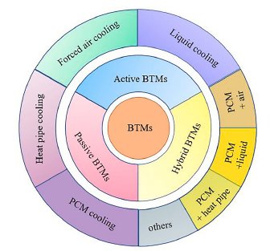
where $Q_{PCM}$ is the total thermal energy stored, $m$ is the mass of the storage medium, $a_{m}$ is the fraction melted, $c_{P}$ is the specific heat, $Δh_{m}$ is the heat of fusion per unit of mass and $T_{m}$is the melting temperature. In general, Figure 2.2 shows the classification of the thermal management of electronic components that can be classified into (i) active and (ii) passive systems [51]. Active systems, such as fan-assisted cooling, spray cooling, and microchannel systems [52], offer high heat removal capacity and effective temperature control, but they often involve higher maintenance, noise, and vibration. Passive systems, on the other hand, remove heat without external assistance, using technologies such as heat pipes [53] or heat sinks [54]. Although their heat removal capacity is lower than that of active systems, passive techniques are attractive for electronic applications because they are silent, require no additional power, and have low operational costs. The integration of PCMs into heat sinks has gained increasing attention due to their high latent heat of fusion, low flammability, and safety. During operation, PCMs absorb heat at nearly constant temperature while changing phase from solid to liquid, and when the device is turned off, they release the stored heat to the surroundings as they solidify. The main motivation for incorporating PCMs into electronic devices is to reduce operating temperature over a given period and to improve the overall thermal response of the system.
Figure 2.2. Classification of battery thermal management (BTM) strategies: active, passive, hybrid and others [51].

BTM systems
Lou et al [55] report that among all types of energy storage devices, lithium-ion (Li-ion) batteries are the most widely adopted due to their high energy and power density, long cycle life, and low self-discharge rate. Therefore, improving the performance and lifespan of Li-ion batteries is essential to enhance the overall efficiency of electric vehicles. However, Li-ion batteries are highly temperature-sensitive, and when the temperature or temperature uniformity falls outside this range for extended periods, several issues can occur [56]. To maintain Li-ion batteries within their optimal operating range, various BTM (BTM) systems have been proposed. The main BTM technologies include air cooling/heating, liquid cooling/heating, heat pipe (HP) systems [57], and PCM cooling/heating systems [58]. The cooling techniques are summarized in the table below; in this section, the focus is placed on cooling systems based on PCMs. The heat generated inside lithium-ion batteries mainly comes from five sources: electrochemical reaction heat, ohmic internal resistance heat, polarization heat, electrolyte decomposition heat, and SEI film decomposition heat. Due to the complex internal structure of Li-ion batteries, it is difficult to accurately measure their internal heat generation in practice. To simplify the calculation, Bernardi [59] proposed a model, Eq. (13), based on the principle of energy conservation, in which the heat generation of the battery (Q_{B}) is mainly attributed to ohmic internal resistance and chemical reaction heat.
$$Q_{B}=\frac{I}{V_{B}}\left(E-U-T\frac{dE}{dT}\right) (13)$$
Where $I$ is the current of the battery, $V_{B}$ is the volume of the battery, $E$ is the open circuit voltage, U is the working voltage, and T is the battery temperature. The charging and discharging processes involve the migration of Li⁺ ions and electrons. During charging, lithium ions move from the positive electrode to the negative electrode through the electrolyte and separator. Electrons are collected by the positive current collector and conducted through the external circuit to the negative electrode, generating a charging current. During discharging, the electrochemical reactions that occur during charging are reversed. Figure 2.3a illustrates the operating mechanism of a LiCoO₂/graphite lithium-ion battery during the charging and discharging phases. Temperature-related issues occur when the battery operates outside its acceptable working range. Moreover, an uneven temperature distribution within the battery can cause degradation and negatively affect its lifespan. As reported by Xia et al. [60], lithium-ion batteries (LIBs) are recommended to operate within the ideal temperature range of 15–35 °C. If the temperature rises above 35 °C or drops below 15 °C, thermal management measures become necessary to keep the temperature within the acceptable range and below 60 °C, which is the safety limit for Li-ion cells [61]. The operating temperature has a significant effect on the efficiency of LIBs, as illustrated in Figure 2.3b.
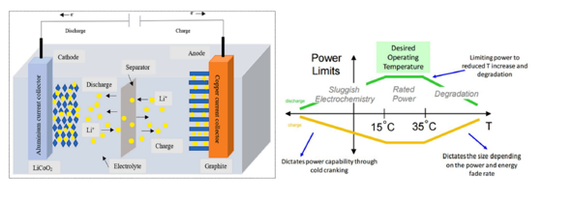
b)
a)
Figure 2.2. Operating principles and temperature window for Li-ion batteries: (a) LiCoO₂/graphite cell during charge/discharge; (b) performance vs. temperature, with an ideal 15–35 °C range [60].

Table 2.3 compares mainstream BTM cooling methods, summarizing pros/cons and commercialization status.
Cooling Method | Advantages | Disadvantages | Commercialization
Air cooling | Simple configuration and operation; Lightweight; Economical; Extended lifespan; Simple maintenance; Highly popularized; Substantial temperature drops; Suitable for specific cell types | Inefficient cooling capability; Non-uniform temperature distribution; Reduced heat transfer coefficient; Relies on ambient air temperature; Additional weight | Buses, cars
Liquid cooling | High cooling efficiency; Compact structure; Enhanced temperature distribution; Higher heat transfer | High initial cost; Difficult maintenance; Leakage issues; Limited lifespan; Power consumption for pumps | Logistics cars, sports cars
Thermoelectric cooling | Commonly used; Stagnant device; No internal chemical reactions; Noise-free; Reliable; No release of harmful gases; Low maintenance costs | Requires supplementary power; High cost; Low energy efficiency | Not commercialized
Heat pipe cooling | No mechanical components; Compact design; Lightweight and flexible; Minimal maintenance; Long cycle life | Limited storage capacity; Low efficiency; Reduced contact surface area | Currently under experimental evaluation in laboratories
PCM cooling | Simple configuration; High efficiency; Low weight; Good temperature uniformity; Long lifespan; Suitable for specific conditions; High compactness; Good energy storage capacity | Expensive renewal and maintenance; Low thermal conductivity; Risk of leakage; PCM restoration required; Possible supercooling issues; Volume change during phase transition | Currently being tested in laboratories
Table 2.3. Cooling methods for Li-ion battery packs: air, liquid, thermoelectric, heat pipe, and PCM. Key advantages, disadvantages, and commercialization.
PCM-based BTMS: Liquid-Gas phase change system. Liquid–gas phase change systems have been widely investigated as passive thermal management solutions for lithium-ion battery systems (Li-ion BTMS) because of their high heat absorption capacity during vaporization and the fact that the endothermic phase transition does not require external energy input [62]. These systems are often integrated with vehicle air-conditioning cycles to enhance overall energy efficiency. Several studies have explored boiling and evaporation as effective cooling mechanisms. For instance, Zareer et al. [63] used propane as a phase-change medium to cool batteries in hybrid electric vehicles (HEVs), maintaining battery temperatures below 35 °C and a temperature difference of less than 1 °C between cells during charge–discharge cycles. Similarly, Bandhauer and Garimella [64] developed an internal liquid–vapor phase-change cooling system, while En et al. [65] proposed a self-refilling evaporative cooling method based on an ammonium silicate film that continuously regulated battery temperature through water evaporation. In addition, heat pipes (HPs) have been extensively applied to enhance heat transfer efficiency in liquid–gas PCM systems. Wang et al. [66] demonstrated that a water–glycol HP (50:50 ratio) could maintain battery temperatures below 70 °C and further reduce them under controlled conditions. Zhao et al. [67] combined ultra-thin HPs with air and water cooling, showing that HP performance improved by minimizing bubble formation and enhancing heat conduction between the pipe wall and the working fluid. Overall, liquid–gas PCM systems and HP-assisted BTMS provide excellent cooling capacity and temperature uniformity. However, their broader adoption is limited by system complexity, higher costs, and safety issues related to phase-change control and working fluid management.
PCM-based BTMS: Solid-Liquid phase change system. Compared with liquid–gas PCMs, solid–liquid PCMs are more widely used because they have a smaller volume change and are easier to control. Paraffin is a typical solid–liquid PCM and is often used to illustrate the phase change process, which occurs in four stages: a rapid temperature rise before melting, heat dissipation by conduction, thermal equilibrium between heat generation and absorption, and finally natural convection once the PCM is fully melted. To improve the safety of lithium–ion batteries, solid–liquid PCM–based BTMS have shown promising results. Hémy et al. [68] demonstrated that these systems can effectively prevent thermal runaway compared to natural convection or air cooling, keeping the temperature of faulty cells below 60 °C during PCM melting. The physicochemical properties of PCMs, such as thermal conductivity, latent heat, and melting point, strongly influence BTMS performance. Huo and Rao [69] found that maintaining a low thermal conductivity and high latent heat helps reduce temperature rise and improve heat retention at low temperatures. A melting temperature close to ambient conditions can also extend the solidification time, enhancing heat dissipation [70]. Overall, compared with traditional cooling systems, PCM–based BTMS offer compactness and no energy consumption. Solid–liquid PCMs, particularly paraffin, are preferred due to their suitable melting temperature, high latent heat, non–toxicity, and low cost. However, their low thermal conductivity remains a major limitation, and under extreme operating conditions (high temperature or current), thermal runaway may still occur. Therefore, further optimization of PCM properties and BTMS design is necessary to improve the thermal performance of solid–liquid phase change systems.
PFC and FPCM for BTM. Luo et al [55] report that the emergence of the new PCMs, such as phase change fluid (PCF) and flexible PCM (FPCM), has broken the limitations of the traditional PCM in the application of BTM. PCF is a multifunctional multiphase thermal fluid created by dispersing PCM materials in the form of microscopic particles within a heat transfer fluid. Because of its high latent heat value, PCF is mainly used as a channel fluid for the thermal management of power batteries. In a high-temperature environment, a coolant can remove the heat generated during battery operation. According to the dispersion form of PCM particles in the fluid, PCF can be roughly divided into two types: phase change emulsions and microencapsulated PCM suspensions (MEPCMS). A phase change emulsion is a type of micro/nano-emulsion system with stable performance, emulsified and dispersed in a heat transfer fluid under the action of a surfactant. The size of PCM particles typically ranges from tens of nanometers to tens of micrometers. MEPCMS is a type of suspension obtained by dispersing microencapsulated particles of micrometer size with a core–shell structure into the heat transfer fluid, coating the PCM with a layer of stable polymer material. Compared with conventional solid/liquid PCM, PCF shows higher fluidity and a more flexible volume change. However, PCF also has some limitations. For phase change emulsions, phase instability and the supercooling effect caused by the aggregation and precipitation of PCM droplets are fundamental problems that must be addressed in practical applications.
The solid PCM used in the thermal management of the cell should be placed as close as possible to the battery pack to ensure efficient heat transfer. Traditional PCM, on the other hand, has several drawbacks, such as solid stiffness, complex processing, and the inability to be applied in hard-shell batteries. PCM with a fixed shape, high rigidity, and no flexibility can cause installation difficulties, easy breakage, and poor contact with the battery surface, resulting in high contact thermal resistance. Flexible PCM (FPCM) is a type of PCM that has become a key research focus. In recent years, many studies have been conducted on FPCMs. At present, research on FPCMs has made significant progress, but further exploration is still required to apply FPCMs effectively in BTM systems.

Future research directions
Kumar et al [71] write about future research directions in PCM application in battery management systems. Future studies should focus on improving the thermal performance, structural stability, and energy efficiency of hybrid liquid cooling systems based on PCM. A promising direction involves the development of high-conductivity composite PCMs by integrating materials such as metal foams or graphene, which can enhance heat dissipation and reduce thermal hotspots. Further research is needed to optimize particle dispersion, stability, and cost-effectiveness of nano-enhanced PCMs containing thermally conductive nanoparticles. The efficiency of BTMS. Figure 2.4 outlines future directions for PCM-based BTMS.
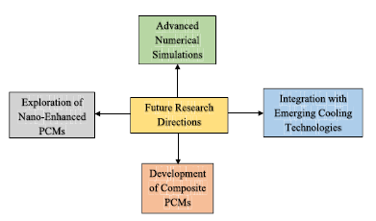
Figure 2.3. Future research roadmap for PCM-based battery thermal management: nano-enhanced PCMs, composite PCMs, integration with new cooling technologies, and advanced numerical simulations [71].
It can be further improved through advanced computational modeling and AI-based thermal management, which enable adaptive control, temperature prediction, and optimized cooling strategies. Integrating PCM-based BTMS with innovative cooling technologies such as immersion cooling, heat pipes, and thermoelectric systems provides an effective approach to enhance thermal regulation in high-performance batteries. To ensure reliability and durability, it is essential to address PCM leakage and stability by developing new encapsulation techniques such as microencapsulation and shape-stabilized PCMs, and by optimizing PCM placement within the battery pack to maximize heat absorption while maintaining a compact design. Reducing the energy consumption of liquid cooling systems can be achieved through low-resistance heat exchanger design, optimized coolant formulations, and high-efficiency pump systems, as well as by implementing adaptive flow control methods that adjust flow rates according to thermal conditions. Finally, to promote commercial adoption, future research should address the scalability and cost-effectiveness of hybrid liquid cooling with PCM-based BTMS by exploring low-cost manufacturing methods, lightweight material alternatives, and comprehensive economic feasibility studies. By tackling these challenges and pursuing innovative research pathways, hybrid BTMS can become an efficient, scalable, and sustainable solution for next-generation battery technologies. The diagram summarizes the future research direction.

Application of PCMs in the cooling of data centers
In the bibliographic research presented above, none of the analyzed articles or reviews reported detailed studies concerning the use of PCM in data centers. This absence indicates a significant gap in research and in the publication of technical material related to this specific application. The limited availability of studies highlights the need for further exploration of PCM-based thermal management solutions in information technology infrastructures, where energy efficiency and effective heat control are critical issues. For this reason, a more targeted bibliographic query was carried out, as reported below, which returned 86 results, of which only six were reviews.
( "phase change material" OR PCM ) AND ( "data center" OR "server room" OR "IT cooling" OR "data centre" ) AND ( "thermal management" OR cooling OR "energy efficiency" OR "heat storage" OR "temperature control")
Ghadim et al [72] in 2025 produced a review in which it is analyzed the thermal management system (TMS) for electronic devices, including data centers (DC). Only a few studies have investigated the improvement of thermal management systems (TMS) in data centers through the use of PCMs. Weng et al. [73] reported that the use of PCMs can lead to a reduction in energy consumption ranging from 46% to 66% in fan and water pump systems commonly employed to remove excess heat from TMS. However, further research is needed to better understand the effects of PCM integration on the overall performance of thermal management systems in data centers.

Application of PCMs in Electric Distribution Networks
Similar to what was done for the application of PCMs in data centers, a more targeted bibliographic search on Scopus was also required for power distribution networks. In fact, the use of PCM in this field did not appear among the most relevant topics identified in the general research. To further investigate the subject, a more specific query was defined, as shown below:
( "phase change material" OR PCM ) AND ( "distribution network" OR "distribution grid" OR "electric distribution" OR "power distribution" OR "smart grid" OR "microgrid" ) AND ( "thermal management" OR cooling OR "heat storage" OR "temperature control" OR "energy efficiency" )
The execution of this search produced 86 results, of which only one was directly relevant to the application of PCM in distribution networks. This was a 2025 research article by Verdugo et al., which currently represents the only significant scientific contribution in this specific field. Verdugo et al. [74] analyze the use of PCM in thermoelectric microgrids (TE-MG), considered an advanced form of local power distribution network. The authors propose an Energy Management System (EMS) based on Model Predictive Control (MPC), capable of jointly optimizing the management of electrical and thermal resources through the integration of a PCM-based thermal system. The proposed system can operate in active or passive modes, contributing to indoor temperature control and the reduction of energy costs. In active mode, the heat flow is regulated through the control of the cold-water mass flow rate, while in passive mode, the PCM functions as a thermal energy storage system, absorbing and releasing heat according to environmental conditions. The model also includes the interaction of the PCM with heat pumps, battery storage systems (BESS), and PV, allowing coordinated energy management. Simulation results, carried out on the Energy Smart Home Lab (ESHL) microgrid at the Karlsruhe Institute of Technology (KIT), show that the inclusion of PCM improves thermal stability and reduces the operating time of heat pumps, resulting in lower costs and reduced battery degradation. In summary, the study by Verdugo et al. (2025) represents a pioneering contribution to the application of PCM in the thermal and energy management of smart distribution networks, demonstrating the potential of these materials to enhance the efficiency and sustainability of microgrids.

PCMs in PV systems
To investigate the state of the art on the application of PCMs in PV systems, a systematic literature review was conducted using the Scopus database. The search query used was as follows:
("phase change materials" OR PCM) AND (photovoltaic OR PV OR "solar panel" OR "solar module") AND (thermal regulation OR temperature control OR efficiency)
The search returned 1,043 results, including research articles, conference papers, and review studies published in various international scientific journals. As in previous phases of the work, the results were filtered based on the relevance of the studies and the quality of the sources, giving priority to publications in high-impact journals recognized for their scientific reliability. The literature analysis thus provided a comprehensive overview of the current state of research, highlighting the main findings and future perspectives concerning the use of PCMs in PV systems, with particular attention to their energy, economic, and environmental implications.
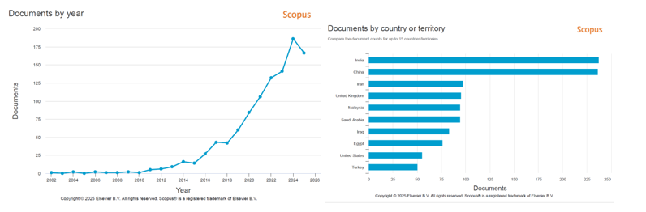
b)
a)
Figure 2.4. Scopus trends for PCM applications in PVs: (a) publications rising sharply since ~2015; (b) country contributions led by India and China, followed by Iran, UK, Malaysia, and others.
Figure 2.5a shows the evolution of scientific publications on the application of PCMs in PV systems from 2002 to 2025. Until 2014, research activity remained limited, but from 2016 onward, there was steady growth, becoming exponential after 2018. The number of publications peaked in 2024 with about 190 papers, reflecting the growing interest in using PCMs to improve the thermal and energy efficiency of PV modules. Figure 2.5b illustrates the geographical distribution of studies. The main contributions come from India and China, followed by Iran, the United Kingdom, Malaysia, and Saudi Arabia. Iraq and Egypt also show significant research output, while the United States and Turkey have produced a smaller number of publications. Overall, research activity is most intense in countries with high solar radiation, where thermal management of PV modules is a key technological concern. Table 2.4 presents a selection of the most relevant research articles concerning the application of PCMs for the thermal regulation of PV systems. The studies summarized investigate the integration of PCM as a passive cooling strategy to mitigate temperature rise in PV modules, thereby improving their efficiency, reliability, and service life. For each work, the main bibliographic information, including title, authors, source, year of publication, number of citations, and the key outcomes extracted from the abstracts, is reported.
Title | Authors | Source | Year | Citations | Abstract summary
Energy and cost saving of a photovoltaic-phase change materials (PV-PCM) System through temperature regulation and performance enhancement of photovoltaics | Hasan, A., McCormack, S.J., Huang, M.J., Norton, B. | Energies, 7(3), pp. 1318–1331 | 2014 | 193 | PCM absorbs excess heat and keeps PV cooler; more cost-effective in hot, high-irradiance sites.
Thermal control of crystalline silicon photovoltaic (c-Si PV) module using Docosane phase change material (PCM) for improved performance | Amalu, E.H., Fabunmi, O.A. | Solar Energy, 234, pp. 203–221 | 2022 | 53 | Cell temperature cut strongly (up to 78% of peak) and conversion efficiency rises by ~10.9%; more power and 34% longer fatigue life.
Experimental investigation of water based photovoltaic/thermal (PV/T) system with and without phase change material (PCM) | Preet, S., Bhushan, B., Mahajan, T. | Solar Energy, 155, pp. 1104–1120 | 2017 | 289 | Water PV/T with PCM cools best; higher flow rates improve both electrical and thermal efficiencies.
Energy and exergy analysis of a switchable solar photovoltaic/thermal-phase change material system with thermal regulation strategies | Zhang, C., Wang, N., Yang, Q., ... Qu, Z., Fang, Y. | Renewable Energy, 196, pp. 1392–1405 | 2022 | 10 | High flow → η_{th} ≈ 86%; intermittent regulation at the same flow improves electrical and exergy efficiency (~+11%).
Study on the temperature control performance of photovoltaic module by a novel phase change material/heat pipe coupled thermal management system | Zhou, X., Cao, X., Leng, Z., Zhou, X., Liu, S. | Journal of Energy Storage, 64, 107200 | 2023 | 13 | PCM/HP combined outperforms single systems; performance grows with HP number and PCM thickness, but needs techno‑economic sizing.
A novel thermal regulation of photovoltaic panels through phase change materials with metallic foam-based system and a concise comparison: An experimental study | Ejaz, A., Jamil, F., Ali, H.M. | Sustainable Energy Technologies and Assessments, 49, 101726 | 2022 | 41 | PCM plus 12 mm foam (RT44) gives the largest PV temperature drop (~24 °C) and the highest electrical efficiency (~12%).
Performance evaluation of direct and indirect thermal regulation of low concentrated (via compound parabolic collector) solar panel using phase change material-flat heat pipe cooling system | Gad, R., Mahmoud, H., Hassan, H. | Energy, 274, 127323 | 2023 | 33 | Indirect PCM/FHP cooling performs best, with CPC=4 and a 30 cm condenser, power can reach ~3.7× the reference panel.
Energy conversion performance of a PV/T-PCM system under different thermal regulation strategies | Xu, H., Wang, N., Zhang, C., Qu, Z., Karimi, F. | Energy Conversion and Management, 229, 113660 | 2021 | 87 | PCM mitigates PV temperature but overheats; intermittent 45 °C strategy delivers the highest energy (~86%) and exergy (~15.5%).
Improving the efficiency of photovoltaic cells using PCM infused graphite and aluminium fins | Atkin, P., Farid, M.M. | Solar Energy, 114, pp. 217–228 | 2015 | 265 | The combined PCM + finned sink is best, adding ~13% efficiency; boosted PCM thermal conductivity is decisive.
Investigation on the thermal management of solar photo voltaic cells cooled by phase change material | Sheik, M.A., Aravindan, M.K., Beemkumar, N., ... Shaik, S., Afzal, A. | Journal of Energy Storage, 52, 104914 | 2022 | 52 | All cool better than PCM alone; alumina nano‑PCM gives the best result: +8.1% electrical efficiency and −17 °C panel temperature.
Experimental evaluation of a hybrid photovoltaic and thermal solar energy collector with integrated phase change material (PVT-PCM) in comparison with a traditional photovoltaic (PV) module | Carmona, M., Palacio Bastos, A., García, J.D. | Renewable Energy, 172, pp. 680–696 | 2021 | 144 | Daily electrical efficiency +7.43%; hybrid (electrical + thermal) efficiency ~31% vs ~13% for plain PV.
Thermal management and uniform temperature regulation of photovoltaic modules using hybrid phase change materials-nanofluids system | Hassan, A., Wahab, A., Qasim, M.A., ... Raza, A., Javaid, N. | Renewable Energy, 145, pp. 282–293 | 2020 | 247 | At 0.1% and 40 L/min: ΔT −24 °C, electrical efficiency +23.9%, overall efficiency +12% vs conventional PV.
Improving the thermal regulation and efficiency enhancement of PCM-Integrated PV modules using nano particles | Nada, S.A., El-Nagar, D.H., Hussein, H.M.S. | Energy Conversion and Management, 166, pp. 735–743 | 2018 | 239 | PCM reduces module temperature; adding Al2O3 drops T by up to 10.6 °C and raises PV efficiency by up to 13.2%.
Thermally geometric design of phase change material and photovoltaic (PV-PCM) for cooling and efficiency improvement | Cai, H., Fan, J., Li, H., Cheng, H., Ji, D. | Renewable Energy, 254, 123533 | 2025 | 1 | Summer HK: PV temperature −7.2 K, energy +35.7%, LCOE −8% thanks to conduction–convection channels.
Evaluation of phase change materials for thermal regulation enhancement of building integrated photovoltaics | Hasan, A., McCormack, S.J., Huang, M.J., Norton, B. | Solar Energy, 84(9), pp. 1601–1612 | 2010 | 412 | With suitable mass/k: −18 °C for 30 min or −10 °C for 5 h → PCM is effective for BIPV temperature capping.
Thermal regulation and performance assessment of a hybrid photovoltaic/thermal system using different combinations of nano-enhanced phase change materials | Abdelrazik, A.S., Saidur, R., Al-Sulaiman, F.A. | Solar Energy Materials and Solar Cells, 215, 110645 | 2020 | 65 | Higher nanoparticle loading (esp. MWCNT) → lower PV temperatures; CaCl2·6H2O runs cooler than RT35, which regulates better.
Experimental study on the performance of a solar photovoltaic/thermal system combined with phase change material | Xu, H., Zhang, C., Wang, N., Qu, Z., Zhang, S. | Solar Energy, 198, pp. 202–211 | 2020 | 94 | Outdoor tests: 45 °C control gives overall efficiencies of about 91%; low PCM k still causes stratification, so control is essential.
Evaluation of thermal management of photovoltaic solar cell via hybrid cooling system of phase change material inclusion hybrid nanoparticles coupled with flat heat pipe | Gad, R., Mahmoud, H., Ookawara, S., Hassan, H. | Journal of Energy Storage, 57, 106185 | 2023 | 83 | Hybrid HP–PCM cuts PV temperature by ~21 °C, raises electrical efficiency 9–12%, and lowers LCOE vs conventional PV.
Effect of varying the thermophysical properties of phase change material on the performance of photovoltaic/thermal-PCM hybrid module numerically | Abd El-Hamid, M., Wei, G. | Journal of Energy Storage, 86, 111326 | 2024 | 17 | Raising PCM Tm (305→323 K) and k (0.1→0.5 W/mK) increases total efficiency by ~13% and 10%; melting temperature is most influential.
Reducing PV module temperature with radiation based PV module incorporating composite phase change material | Karthikeyan, V., Sirisamphanwong, C., Sukchai, S., Sahoo, S.K., Wongwuttanasatian, T. | Journal of Energy Storage, 29, 101346 | 2020 | 85 | 2.5 cm composite PCM with higher k lowers thermal resistance → 14.75% PV efficiency at ~48 °C module temperature.
Development of a thermal model for a hybrid photovoltaic module and phase change materials storage integrated in buildings | Kibria, M.A., Saidur, R., Al-Sulaiman, F.A., Aziz, M.M.A. | Solar Energy, 124, pp. 114–123 | 2016 | 109 | Validated model shows PCM can limit PV temperature rise and boost thermal performance by ~5% for several melting points.
Impact of integrated photovoltaic-phase change material system on building energy efficiency in hot climate | Hasan, A., Alnoman, H., Rashid, Y. | Energy and Buildings, 130, pp. 495–505 | 2016 | 85 | PCM + insulated cavity lowers PV and indoor peaks; PV power +7.2% (peak) and indoor cooling +9.5% (daytime).
Performance enhancement of a building-integrated photovoltaic module using phase change material | Karthick, A., Murugavel, K.K., Ramanan, P. | Energy, 142, pp. 803–812 | 2018 | 120 | PV surface temperature up to 8 °C lower and electrical efficiency ≈10% higher than reference BIPV.
A novel thermal regulation method for photovoltaic panels using porous metals filled with phase change material and nanoparticle additives | Abdulmunem, A.R., Samin, P.M., Rahman, H.A., Hussien, H.A., Ghazali, H. | Journal of Energy Storage, 39, 102621 | 2021 | 75 | Nanotube‑enhanced PCM/foam boosts heat removal; average PV electrical efficiency jumps from 4% to 21% vs uncooled PV.
Table 2.4. Selected studies on PCM for PV thermal management: bibliographic details and key outcomes.
Table 2.5 summarizes a selection of the most relevant review papers on the use of PCMs for the thermal management of PV systems. Each review highlights key developments, challenges, and perspectives regarding PCM integration to enhance PV performance and durability.

Title | Authors | Source | Year | Citations | Abstract summary
Using phase change materials in photovoltaic systems for thermal regulation and electrical efficiency improvement: A review and outlook | Ma, T., Yang, H., Zhang, Y., Lu, L., Wang, X. | Renewable and Sustainable Energy Reviews, 43, pp. 1273–1284 | 2015 | 351 | High PV temperatures cut efficiency; literature on PV cooling highlights PV‑PCM concepts and integration issues (materials, heat‑transfer enhancement, modeling). PV‑PCM alone rarely pays if only electrical gain is sought; coupling with solar‑thermal (PV‑ST‑PCM) to reuse stored heat is more promising, but both are mostly lab‑stage with practical hurdles.
Water and phase change material based photovoltaic thermal management systems: A review | Preet, S. | Renewable and Sustainable Energy Reviews, 82, pp. 791–807 | 2018 | 141 | About half of the solar input becomes heat, degrading output and durability. Reviews show PV‑PCM is effective but limited by low conductivity and overnight solidification; adding heat‑transfer inserts and extracting heat can stabilize temperature and provide space/water heating.
Recent progress in photovoltaic thermal phase change material technology: A review | Gao, L., Zhang, X., Hua, W. | Journal of Energy Storage, 65, 107317 | 2023 | 47 | Explains PCM cooling and catalogs systems: non‑concentrating, concentrating, PV/T, micro‑encapsulated, and nano‑PCM. Progress noted, but the field is immature with clear priorities and open challenges.
Phase change materials for photovoltaic thermal management | Browne, M.C., Norton, B., McCormack, S.J. | Renewable and Sustainable Energy Reviews, 47, pp. 762–782, 4205 | 2015 | 264 | Crystalline‑Si PV benefits most due to the highest temperature sensitivity. PCM improves performance, but reliable solidification/release dynamics need further work for practice.
Photovoltaic panel integrated with phase change materials (PV-PCM): technology overview and materials selection | Tao, M., Zhenpeng, L., Jiaxin, Z. | Renewable and Sustainable Energy Reviews, 116, 109406 | 2019 | 200 | Review of 104 papers: configurations, energy balances, materials selection (triangle criterion for Tm), milestones. Efficiency gains exist, but reliability and cost remain key barriers.
Review of cooling techniques using phase change materials for enhancing efficiency of photovoltaic power systems | Chandel, S.S., Agarwal, T. | Renewable and Sustainable Energy Reviews, 73, pp. 1342–1351 | 2017 | 251 | Efficiency drops ~0.5% per °C; PV‑PCM can add up to ~5% efficiency, and inorganic PCMs look promising. Commercialization is limited by poor k/undercooling, design, and cost; economics favor high-insulation, low‑seasonality sites.
Photovoltaic Panel Integration Using Phase Change Material (PCM): Review | Verma, K., Prakash, O., Paikra, A.S., Tiwari, P. | Evergreen, 10(1), pp. 444–453 | 2023 | 14 | TES with PCM can recover PV waste heat; selecting PCM by operating parameters is critical. Organic PCM paired with fins stands out as a strong PV‑PCM candidate.
A review on the outlook of thermal management of photovoltaic panel using phase change material | Preet, S. | Energy and Climate Change, 2, 100033 | 2021 | 56 | Contrasts sensible vs PCM cooling; PCM offers larger storage/time shift. Reviews nano‑enhanced PCM and PV/T integrations; outlines hurdles and future directions to improve reliability and performance.
Table 2.5. Influential reviews on PCM integration in photovoltaics: key bibliographic details and synthesized insights on concepts.

PCMs for thermal regulation in PV systems
The growing awareness of global warming, energy shortages, and the sharp increase in fossil fuel prices has encouraged significant progress in renewable energy technologies, including solar PV systems. Currently, only about 15–20% of the solar energy incident on a PV panel can be converted into electricity, while the remaining portion is transformed into heat. This heat is absorbed by the PV device itself, causing its operating temperature to rise, which can reach up to 80 °C. As a result, Hasan et al [75] studied that the PV conversion efficiency decreases by approximately 0.4–0.65% for every 1 °C increase in temperature. Many researchers have therefore focused on mitigating the adverse effects of high temperature on PV conversion efficiency by rapidly removing heat from PV module surfaces in order to maintain optimal performance and meet design expectations. However, the PV–PCM system is still in its early development stages, with several unresolved issues that present opportunities for further research. Much of the existing research has concentrated on natural or forced air circulation, heat pipes, and hydraulic or refrigerant cooling systems. Nevertheless, limited attention has been devoted to how the excess heat from PV panels can be effectively managed and utilized for indoor climate control purposes. Huang’s pioneering research [76] numerically and experimentally investigated the incorporation of suitable PCMs within a PV panel to moderate its temperature rise. This hybrid configuration, referred to as PV–PCM or PV/PCM, integrates a PV panel and a PCM into a single unit to achieve more efficient energy conversion. The PCM functions as a passive thermal storage component, absorbing excess heat and thereby reducing the PV temperature, which in turn enhances the overall conversion efficiency of the system.

The effect of temperature on a PV module
The conversion efficiency of PV panels mainly depends on three factors: solar radiation intensity, solar cell materials, and operating temperature. While solar radiation cannot be controlled, extensive research has focused on developing new materials and maintaining low operating temperatures to enhance conversion efficiency. Solar cells convert sunlight into electricity through the PV effect. However, only about 15–20% of the absorbed solar radiation is converted into electrical energy, while the remaining portion is dissipated as heat. The maximum theoretical efficiency is limited by the material’s band gap, as only photons with sufficient energy contribute to the PV effect, whereas the rest generate thermal losses [77]. Landis [78] first expressed the relationship between PV efficiency and temperature through the dependence of open-circuit voltage, short-circuit current, and fill factor, as shown in Eq. (14):
$$\frac{1}{η}\frac{dη}{dT}=\frac{1}{V_{OC}}\frac{dV_{OC}}{dT}+\frac{1}{I_{SC}}\frac{dI_{SC}}{dT}+\frac{1}{FF}\frac{dFF}{dT} (14)$$
Where $η$ is the cell efficiency, $V_{OC}$ is the open circuit voltage, $I_{SC}$ is the short circuit current, T is the solar cell temperature, and FF is the fill factor. A general empirical correlation was later provided by Skoplaki et al. [79], who proposed Eq. (15), widely adopted to describe PV efficiency variation with temperature:
$$η_{T}=η_{ref}\left[1-β_{ref}\left(T-T_{ref}\right)\right] (15)$$
Where $T_{ref}$ is 25°C and $β_{ref}=0,45\%\frac{1}{K}$

PV-PCM models
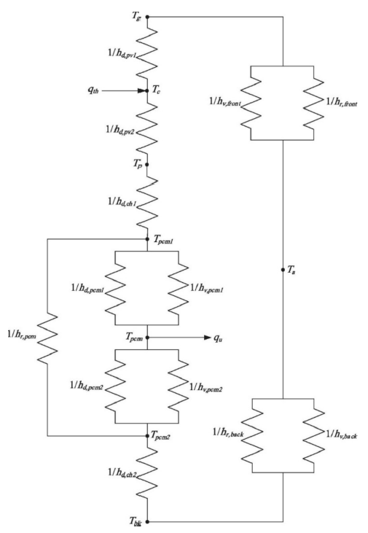
Mazzeo et al. [80], in their review, highlight that to effectively describe the thermal and electrical behavior of PV modules integrated with PCM, several mathematical models of varying complexity have been developed over time. These models are essential for understanding the interactions between the PV module and the PCM, allowing accurate simulation of heat transfer and energy conversion under different operating conditions.
Figure 2.5. Al Najjar et al. [82] energy balance model based on an equivalent electrical circuit.
Thermal models. To analyze the thermal models, the configuration proposed by Zhenpeng et al. [81], shown in Figure 2.7, was considered. When the PV panel absorbs solar radiation, only a portion is converted into electricity, while the remaining part is transformed into heat and dissipated to the surroundings through convective and radiative exchanges. Figure 2.6 shows the thermal balance of the PV–PCM module, formulated by Al Najjar et al. [82], that is based on an equivalent electrical circuit representing the heat exchanges between the module surfaces and the external environment.

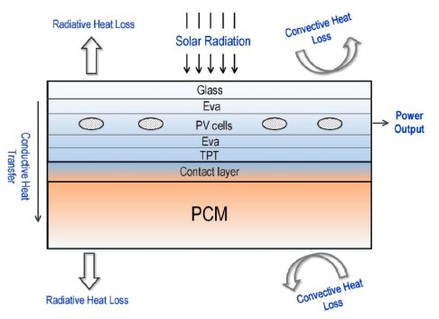
Figure 2.6. Configuration of a typical PV-PCM system and the energy flow path [81].
Among the thermal models, one of the most widely used is the enthalpy model [83] [84], which accounts for latent heat in the energy equations by assigning each computational node a latent heat value as a function of temperature. During the phase change, this value is updated to represent the release or absorption of heat, included in the energy equation as a source or sink term. A key advantage of this approach is that it avoids the need to explicitly define energy conservation conditions at the solid–liquid interface. Advanced formulations of the model couple force balance with melt flow without introducing arbitrary constants and are mainly applied in cases where molten material convection or three-dimensional effects are dominant. Another advanced model used to analyze the behavior of materials undergoing a phase change is based on the integration of the finite difference method with the effective specific heat method [85]. The effective specific heat approximates the phase change over a defined temperature range and typically represents the phase change temperature T_{m}.
Electrical model. For a comprehensive characterization of the PV/PCM system, the thermal models must be coupled with an electrical model capable of describing the PV module’s behavior. Among these, the five-parameter model is one of the most commonly used due to its accuracy [86]. The PV module power is calculated in Eq. (16) as:
$$P_{PV}=V_{PV}∙I_{PV} (16)$$
Where $V_{PV}$ is the output voltage and $I_{PV}$ is the output current. The five-parameter model allows for determining the maximum power $P_{mp}$and the electrical efficiency $η_{el}$ Eq. (17) of the module under real operating conditions, defined by the solar irradiance $G$and cell temperature $T_{c}$:
$$η_{el}=\frac{P_{mp}}{A_{PV}G} (17)$$
The overall efficiency of the PV/PCM system is then expressed in Eq. (18) as the sum of the electrical and thermal efficiencies:
$$η_{Ov}=η_{el}+η_{th} (18)$$
Simplied model. A simplified model for calculating performance indicators of PV–PCM systems. In this context, the energy balance for a PV system is expressed by the following equation Eq. (19).
$$Q_{SOLAR}=Q_{ELEC}+Q_{LOST}+Q_{STORED} (19)$$
Where $Q_{SOLAR}$ is the solar energy incident on the PV module, $Q_{ELEC}$is the electricity output, $Q_{LOST}$ is the thermal energy lost and $Q_{STORED}$ is the thermal energy stored. The heat lost and stored by a system integrated with PCM are calculated in Eq. (20) and Eq. (21), respectively, as:
$$Q_{LOST,PV-PCM}=GA_{PV}\left(1-ατ\right)+h_{ac}A_{PV-PCM}\left(T_{PV-PCM}-T_{amb}\right)Δt (20) \\ Q_{STORED,PV-PCM }=C_{PV}ΔT+V_{PCM}Δρ (21)$$
In the PV system, $Q_{STORED}$ refers to the sensible heat contribution, which depends on the area, thickness, density, heat capacity, and temperature difference. For the PV–PCM system, the latent heat contribution is also included, depending on the PCM volume, density, and latent heat of fusion. The main physical principle behind this simplified model is that integrating PCM behind the PV module enables the storage of thermal energy that would otherwise be dissipated. This heat absorption effectively lowers the PV module temperature, thereby increasing its electrical output. However, since the stored thermal energy is of lower quality than electrical energy, a conversion efficiency of about 30% is typically assumed for this contribution, as shown in Eq. (22).
$$η_{TH}=\frac{0,3 Q_{STORED}}{G A_{PV}} (22)$$
$Q_{SAVED}$ represents the total energy savings, both electrical and thermal, achieved by integrating the PCM into the PV system compared to a reference PV panel. These savings are calculated to evaluate the effectiveness of PV–PCM systems under different climatic conditions, as expressed below Eq. (23).
$$Q_{SAVED}​=\left(Q_{ELEC,PV-PCM}​-Q_{ELEC,PV}\right)+0.3\left(Q_{STORED,PV-PCM}​-Q_{STORED,PV}​\right) (23)$$
This model serves as one of the fundamental bases for estimating the energy savings and overall performance of PV–PCM systems. To improve the accuracy of such formulations, heat transfer methods should be incorporated to calculate the specific terms more precisely.

PV-PCM systems
The main configurations of PV–PCM systems are thoroughly described in the review by A. M. Ali [87], which provides a comprehensive classification of the different design solutions and integration approaches adopted for incorporating PCMs into PV modules.

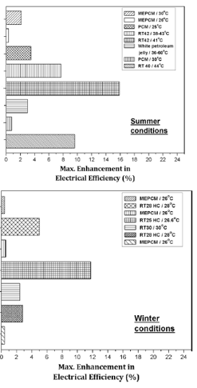
PV with pure PCM. PCM has proven to be highly effective in absorbing the excess heat from PV panels that is not converted into electrical energy. The latent heat of the PCM helps lower the panel temperature, keeping it close to 25 °C and almost constant during daylight hours. Mahamudul et al. [88] reported that a maximum temperature reduction of about 35 °C can be achieved using PCM. As shown in Figure 2.8, PV efficiency can be increased by up to 16% through the use of PCM. Comparison of the two graphs indicates that researchers observed greater improvement in summer than in winter, demonstrating that PCM integration is more effective under high-temperature conditions. This is due to the higher heat absorption capacity of the PCM during summer, stored in the form of latent heat.
b)
a)
PV with finned PCM. Figure 2.9 shows the use of finned PCM. It allows a reduction in PV module temperature ranging between 5 and 20 °C, with a maximum decrease of about 31 °C reported by Huang et al. (2006) [89], who used RT25 with a melting point of 26.6 °C, close to the ideal PV operating temperature of 25°C. The insertion of fins within the PCM enhances its thermal conductivity, which is typically low, promoting more efficient heat transfer from the panel surface to the PCM. This results in improved PV module performance, greater surface temperature uniformity, and an extended thermal regulation period during peak hours (Huang et al., 2011 [90]). In the literature, the best results in terms of efficiency improvement reach around 21% (Indartono et al., 2016 [91]) when using PCM combined with yellow petroleum jelly. The same study also reported a significant increase in power output due to the PCM’s high heat absorption capacity and the enhanced conduction provided by the fins. Other studies show more moderate improvements, ranging between 5% and 12%, still confirming the effectiveness of finned PCM in enhancing both the thermal and electrical performance of PV modules.
Figure 2.7. Effect of pure PCM on PV: maximum electrical-efficiency gain under (a) summer and (b) winter condition [87].
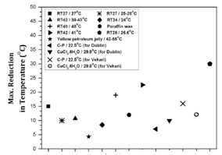
Figure 2.8. Maximum reduction in PV-temperature using finned-PCM [89].
PV with composite PCM. Several studies have proposed methods to improve the thermal conductivity of PCMs, including the addition of nanoparticles, metal turnings, or expandable graphite. The highest increase, reaching 16.35 W/mK, was achieved with graphite-infused PCM (Atkin and Farid, [92]). When comparing pure and composite PCMs, most researchers (Hachem et al. [93]) observed a greater temperature reduction in the latter, due to its improved thermal regulation capability. Even after PCM melting, composite PCMs exhibit a slower temperature rise, making them more effective for PV module cooling. The use of composite PCMs has also led to significant increases in PV output power, in some cases up to 55% like Sharma et al. [94], thanks to the application of nano-PCM combined with rear fins for cooling. Although the addition of nanoparticles slightly reduces the heat storage capacity, it greatly enhances thermal conductivity, allowing more efficient absorption of excess heat and mitigating power decline over time.

Economic and environmental considerations of PV-PCM and PV/T-PCM systems
Mazzeo et al. [80] report an environmental and economic assessment of PV–PCM systems, showing that the integration of PCMs enhances both the sustainability and overall efficiency of PV modules, despite a slight increase in environmental impact. The study by Foteinis et al. [95] found that using PCM as a cooling system increases the environmental footprint by 21.9%, but also boosts electricity generation by 9.4% and extends the PV module’s lifespan by at least five years. The additional energy produced helps reduce ecotoxicity and human toxicity, while also increasing the share of renewable energy in the overall energy mix. From an economic perspective, the cost-effectiveness and efficiency of PV–PCM systems depend on location, material costs, and solar radiation levels. Hasan et al. [96] demonstrated that the system becomes more economically viable in areas with lower material costs and higher solar irradiance. Moreover, by replacing paraffin wax with salt hydrates, the energy payback time (EPBT) was reduced from 10 to 3 years. Finally, Radziemska et al. [97] estimated that a 1 kW PV–PCM system costs about 8.5% more than a conventional one, but produces 7% more energy, leading to a 10% profit margin over a 30-year lifespan.
Cui et al [98] reported that the PV/T system is normally utilized for the conversion of solar energy into heat and power. In their review, they analyze the technical challenges of 4 E (energy, exergy, economic, and environmental) assessments and recommendations for future work. Future perspectives for PV/T–PCM systems focus on improving thermal conductivity, integrating nanofluids, and designing more efficient configurations. It is necessary to develop practical solutions that enable the combined use of PCM for both heating and cooling applications. Currently, paraffin wax is the most commonly used PCM due to its safety and cost-effectiveness, although its low thermal conductivity limits performance. For this reason, research should explore the use of high-conductivity materials and composite PCMs. Long-term studies are essential to ensure system reliability, taking into account the solidification process, which is often incomplete in salt hydrate PCMs. The stability of PCM and nano-PCM also requires further investigation, as interactions between nanoparticles and surfaces strongly affect heat transfer. Although nano-PCMs show great potential, more theoretical models and experimental validation are still needed. From an energy perspective, efforts should focus on minimizing heat losses and improving efficiency through exergy and thermodynamic analyses. From an economic standpoint, sustainability should be assessed using Life Cycle Assessment (LCA) tools, considering costs, energy payback time, and net present value. Finally, from an environmental point of view, the production of PCM and nano-PCM leads to significant greenhouse gas emissions, and their impact should be reduced in accordance with international environmental standards.

PCMs in buildings
To investigate the state of the art on the applications of PCMs in buildings, a systematic literature review was conducted using Scopus. The search query was:
(“phase change materials” OR PCM) AND (building OR construction OR wall) AND (insulation OR “thermal comfort” OR “energy saving”)
The search returned 3,058 results, including research articles, conference proceedings, and review studies published in international journals. In line with the previous phases of this work, the results were filtered based on the relevance of the studies and the quality of the sources.
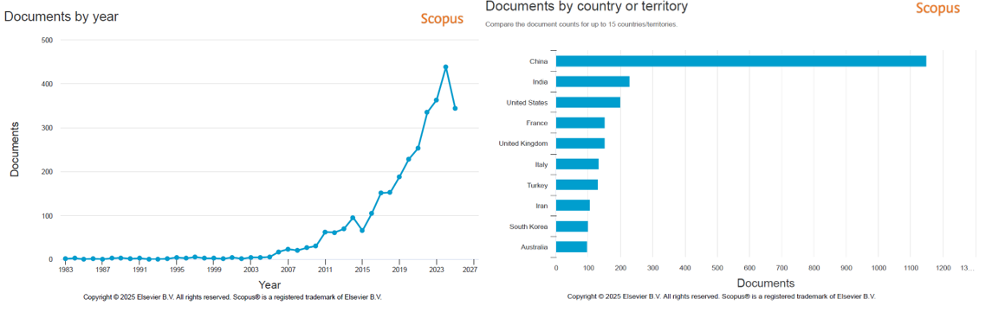
a)
b)
Figure 2.9. Scopus trends for PCMs in buildings: (a) publication trend with a recent peak; (b) country share led by China, then India, and the US.
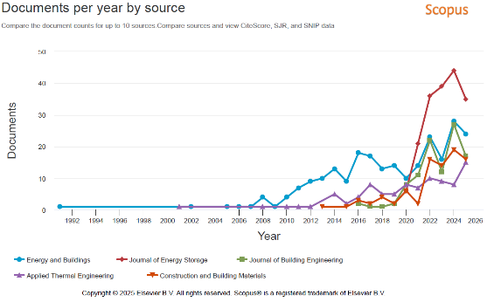
As shown in Figure 2.10a, the number of publications on PCMs in buildings exhibits clear, sustained growth: after a nearly marginal phase up to the early 2000s, scientific output accelerates over the last decade, reaches a very recent peak, and then shows a slight decline. This temporal profile signals the maturation of the topic and the entry of PCMs among established solutions for insulation, thermal comfort control, and energy-use reduction, with growing attention to envelope integration and seasonal heat-management strategies. The geographical distribution of publications, reported in Figure 2.10b, indicates strong activity in Asia, with China clearly leading, followed by India and the United States, and steady contributions from France, the United Kingdom, Italy, Turkey, Iran, South Korea, and Australia. This map reflects the overlap between climatic pressures, energy-efficiency objectives, and industrial momentum on advanced materials; as a result, different emphases emerge, for example, peak-load attenuation and load shifting in hot climates, and retrofit and winter comfort priorities in European contexts. Scopus also helps identify the most authoritative sources in the literature. Figure 2.11 shows the progressive diversification of publication venues on PCMs in buildings. Energy and Buildings acts as the historical driver, growing from 2008 with peaks between 2014–2017, reflecting roots in building physics and thermal comfort. From 2021, the Journal of Energy Storage rose strongly, reaching the highest yearly volumes around 2024 and framing PCMs as storage and demand-shifting technologies. The Journal of Building Engineering accelerates from 2019 with a peak in 2024, consistent with the design integration of PCMs into the building envelope and construction systems. Applied Thermal Engineering and Construction and Building Materials show steady growth in publications, indicating attention to thermo-mechanical, energy, and materials aspects. Table 2.6 presents a selection of the most relevant literature on the use of PCMs in buildings. The studies cover integrations in envelope components and passive systems to enhance insulation, thermal comfort, and energy savings. For each paper, the main bibliographic information as title, authors, source, year of publication, citation count, together with the key findings distilled from the abstracts.
Figure 2.10. Journal trends for PCMs in buildings: Energy and Buildings led early; Journal of Energy Storage and Journal of Building Engineering.
Title | Authors | Source | Year | Citations | Abstract summary
Thermal performance of phase change materials (PCM)-enhanced cellulose insulation in passive solar residential building walls | Lee, K.O., Medina, M.A., Sun, X., Jin, X. | Solar Energy, 163, pp. 113–121 | 2018 | 163 | Mixing PCM directly into cellulose insulation cuts wall heat‑flux peaks (≈−25% daily average). Benefits are measured in all orientations in twin houses.
Thermal comfort enhancement of office buildings located under warm and humid climate through phase change material and insulation coupled with natural ventilation. | Arumugam, P., Ramalingam, V. | Sustainable Energy Technologies and Assessments, 63, 103657 | 2024 | 13 | PCM alone isn’t enough; with proper insulation, operative temperatures stay ~26.6–26.8 °C. Optimal: 50 mm insulation + 30 mm PCM → comfort index < 1.7 year‑round.
Enhancing building energy performance by effectively using phase change material and dynamic insulation in walls | Kishore, R.A., Bianchi, M.V.A., Booten, C., Vidal, J., Jackson, R. | Applied Energy, 283, 116306 | 2021 | 159 | PCM between two dynamic‑insulation layers saves more than PCM or DIMS alone: −15–72% annual heat gains and −7–38% annual heat losses, depending on climate/orientation.
Phase change material's (PCM) impacts on the energy performance and thermal comfort of buildings in a mild climate | Nghana, B., Tariku, F. | Building and Environment, 99, pp. 221–238 | 2016 | 159 | Field tests + simulations: PCM stabilizes air/wall temperatures (oscillation 1.4/−2.7 °C) and can cut winter heating demand up to 57%; limited summer night comfort gains.
Investigation of heat transfer of a building wall in the presence of phase change material (PCM) | Khan, R.J., Bhuiyan, M.Z.H., Ahmed, D.H. | Energy and Built Environment, 1(2), pp. 199–206 | 2020 | 138 | Locating PCM near the heat source best limits indoor heating, flattens peaks, and delays time to peak; air gaps and traditional materials are used for comparison.
Thermal performance analysis of sensible and pcm-integrated thermal insulation layers to improve thermal comfort in building | Kerroumi, N., Touati, B., Virgone, J. | Interfacial Phenomena and Heat Transfer, 8(1), pp. 67–80 | 2020 | 6 | Seasonal simulations: melting‑temperature choice is crucial; encapsulated PCM plus an extra air layer improves indoor comfort vs conventional plasters.
Optimal positioning of phase change material and insulation through numerical investigations to reduce cooling loads in office buildings | Arumugam, P., Ramalingam, V., Vellaichamy, P. | Journal of Energy Storage, 52, 104946 | 2022 | 28 | Exterior‑wall placement outperforms interior in all climates analyzed; recommended schemes cut cooling loads by ~57–64% across cities.
Exterior insulation finishing system using cementitious plaster/microencapsulated phase change material for improving the building thermal storage performance | Wi, S., Yang, S., Yeol Yun, B., Kim, S. | Construction and Building Materials, 299, 123932 | 2021 | 35 | Mortar with 10 wt% MPCM increases time‑lag by ~59% and provides strong thermal storage; favorable thermo‑mechanical tests.
Energy performance based optimization of building envelope containing PCM combined with insulation considering various configurations | Dardouri, S., Mankai, S., Almoneef, M.M., Mbarek, M., Sghaier, J. | Energy Reports, 10, pp. 895–909 | 2023 | 36 | Optimized PCM Tm/location/thickness achieves 74–76% energy‑demand cuts and major CO₂ reduction; optimal thickness ~6 cm; two PCM layers in double walls work best.
Application research and effectiveness analysis of phase change materials in building envelope: A review | Zhao, S., Ming, T., Wu, Y., ... Chen, Y., Zhou, N. | Energy and Buildings, 324, 114923 | 2024 | 11 | Comprehensive survey of wall/roof/floor/window integrations and composites; summarizes impacts on thermal comfort, energy, CO₂, and costs; outlines research needs.
Low-cost phase change material as an energy storage medium in building envelopes: Experimental and numerical analyses | Biswas, K., Abhari, R. | Energy Conversion and Management, 88, pp. 1020–1031 | 2014 | 105 | Fatty‑acid PCM in HDPE pellets blended with cellulose: experiments + annual simulations confirm lower envelope gains/losses and energy consumption.
Potential evaluation of energy flexibility and energy-saving of PCM-integrated office building walls | Dong, Y., Zhang, L., Wang, P., ... Liao, H., Jiang, X. | Journal of Building Engineering, 79, 107857 | 2023 | 21 | Validated model: optimized precooling + time‑of‑use tariffs → flexibility index 69.7%, total load −1.3%, electricity cost −51%; PCM location and Tm dominate.
Thermal performance and energy saving using phase change materials (PCM) integrated in building walls | Anter, A.G., Sultan, A.A., Hegazi, A.A., El Bouz, M.A. | Journal of Energy Storage, 67, 107568 | 2023 | 108 | Various PCMs, thicknesses (1–8 cm), positions: RT‑35HC best; optimal 1.5 cm from inner/outer faces; inner wall temperature 27.7 °C with PCM vs 31.1 °C without; summer energy gain −66%.
A numerical study of building integrated with CaCl2·6H2O/expanded graphite composite phase change material | Ye, R., Lin, W., Fang, X., Zhang, Z. | Applied Thermal Engineering, 126, pp. 480–488 | 2017 | 56 | Simulations/validation: PCM density/k minor; panel thickness, orientation, climate, construction matter—guidelines provided.
Multi-factor analysis on thermal comfort and energy saving potential for PCM-integrated buildings in summer | Qu, Y., Zhou, D., Xue, F., Cui, L. | Energy and Buildings, 241, 110966 | 2021 | 101 | Influence ranking: envelope type > PCM layer layout > PCM type > PCM thickness. Best: BioPCM™ 23, 7 cm on the inner side of walls/roof; savings 4.8–34.8% by climate.
Experimental investigation of phase change materials for insulation of residential buildings | Hasan, M.I., Basher, H.O., Shdhan, A.O. | Sustainable Cities and Society, 36, pp. 42–58 | 2018 | 147 | Twin rooms with PCM in walls/ceiling show lower indoor temperatures and cooling loads, saving electricity; the effect depends on thickness and orientation.
Table 2.6. Selected studies on PCMs in buildings: bibliographic details (title, authors, source, year, citations) and distilled findings from abstracts.
Table 2.7 summarizes a selection of the most influential review papers on the application of PCMs in buildings. These reviews synthesize PCM properties, integration strategies in envelope and passive systems, and assess benefits in insulation, thermal comfort, and energy savings, while outlining challenges and research gaps. For each review, the main bibliographic information as title, authors, source, year of publication, citation count, and the principal insights highlighted by the authors, is reported.
Title | Authors | Source | Year | Citations | Abstract summary
Incorporation of phase change materials into building envelope for thermal comfort and energy saving: A comprehensive analysis | Al-Yasiri, Q., Szabó, M. | Journal of Building Engineering, 36, 102122 | 2021 | 356 | PCMs added to roofs and external walls can cut heating/cooling loads, save energy, and improve comfort by storing/releasing heat around their melting point. The review maps PCM types, desired properties, placement, and modeling methods, and ranks techniques by climate/location—while noting key gaps for future research.
A review of novel methods and current developments of phase change materials in the building walls for cooling applications | Mukram, T.A., Daniel, J. | Sustainable Energy Technologies and Assessments, 49, 101709 | 2022 | 28 | For the building sector’s high energy/GHG footprint, PCM‑impregnated walls and bricks can lower cooling load, peak heat flux, and shift peaks off working hours. Best practice depends on PCM type, melt temperature, and location; keeping the PCM layer near the heat source often yields superior performance.
Recent Advances and Developments in Phase Change Materials in High-Temperature Building Envelopes: A Review of Solutions and Challenges | Rashid, F.L., Dulaimi, A., Hatem, W.A., ... Bernardo, L.F.A., Hu, J.W. | Buildings, 14(6), 1582 | 2024 | 20 | PCMs in envelopes reduce cooling demand and hours above comfort limits by delaying peak temperature, but high daytime heat can hinder night crystallization. Selecting high‑temperature PCMs and tuning insulation density, specific heat, and conductivity are critical; the review proposes quantification methods and research directions.
Phase Change Materials Integration in Building Envelopes Under Different Climatic Conditions: State of the Art, Opportunities, and Challenges | Teamah, H.M., Teamah, M. | Energy Storage, 7(5), e70250 | 2025 | 0 | Across walls, roofs, and floors, PCMs can trim building loads by up to ~30% and keep indoor swings within ~2 °C when well integrated. The paper surveys performance drivers, integration methods, and modeling, and notes uneven global uptake (strong in Europe/Asia; challenging in climates with large temperature swings).
Phase change material incorporation techniques in building envelopes for enhancing the building thermal Comfort-A review | Suresh, C., Kumar Hotta, T., Saha, S.K. | Energy and Buildings, 268, 112225 | 2022 | 10 | A broad review confirms that PCM‑enhanced envelopes (walls/roofs/ceilings/windows) improve comfort and reduce energy use; micro/nano‑encapsulation and shape‑stabilized PCMs outperform macro/impregnation due to better heat transfer and no leakage. It recommends PCMs with melt points near ambient, and highlights in‑situ/emulsion polymerization as effective encapsulation routes, plus remaining research needs.
Table 2.7. Influential reviews on PCMs in buildings: key bibliographic details (title, authors, source, year, citations) and synthesized insights.

Incorporation of PCMs into buildings for thermal comfort and energy optimization
Buildings account for a significant share of global energy consumption and contribute substantially to carbon dioxide emissions, a major driver of global warming, as reported by Zhao et al [99]. Their energy use represents about 21% of total greenhouse gas emissions and is expected to exceed 50% by 2050 due to rising global temperatures and increasing urbanization [100]. To reduce energy consumption and improve efficiency, particular attention must be given to the building envelope. The building envelope acts as a barrier between indoor and outdoor environments and includes walls, roofs, floors, windows, and doors [101]. To address this issue, PCMs are commonly used as effective heat storage materials in building construction. They enhance indoor thermal comfort and reduce overall energy demand. Solid–liquid PCMs are especially suitable for building structures, as they undergo minimal volume changes during phase transition [102]. By melting during the day and absorbing solar radiation, PCMs can delay indoor temperature fluctuations and reduce temperature peaks, improving thermal comfort and lowering cooling loads [103]. At night, they release the stored thermal energy as they solidify, allowing efficient heat recycling between indoor and outdoor environments [104]. When thermal mass is integrated into well-insulated structures, energy savings for residential heating and cooling can range from 5% to 30% [105]. Abass et al. [106], in their review, provide a classification of the various applications of PCMs in buildings. Figure 2.12 illustrates the main ways in which PCMs can be integrated into building components. Integration can occur at two levels: within building materials and within building envelope components. In the first case, PCMs are incorporated into elements such as bricks, cementitious concrete, mortars, and paints, enhancing the thermal capacity of the base materials. In the second case, PCMs are directly applied to envelope components, such as floors, walls, windows, and roofs, to regulate thermal fluctuations and improve indoor comfort. This distinction highlights the wide versatility of PCMs and the different implementation strategies aimed at enhancing the overall energy efficiency of buildings.
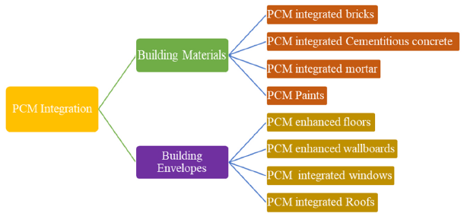
Figure 2.11. Main ways in which PCMs can be integrated into building components [106].

Application of PCMs in building materials
Walls are a key component of a building’s structure, providing support, insulation, and spatial separation. In poorly insulated buildings, external walls can account for around one-third of the total heat loss. Their multilayered configuration also offers several opportunities for integrating PCMs, which can help enhance overall thermal performance.

PCM integrated bricks.
PCM matrix | PCM T_{m} [°C]  ΔH [J/g] | Brick | Main Results
Paraffin | 41.15 /  179.87 | 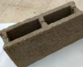 | Cooling load reduced by 26%, equivalent to saving about $2.76/day.
OD–CA | / | 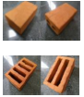 | Peak temperature reduction of 9.97°C to 1.31°C was observed in the PCM brick compared to the normal brick.
RT22–RT30, CA | 22–32 /  190–250 / 152–250 | 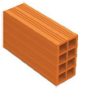 | PCM with melting temperature 26°C saved up to 56% (NE Mediterranean) and 50% (SW Mediterranean).
CA, BC, RT–42 | 31/36/39 /  152.7–141.6 | 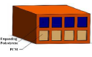 | Reduced inner surface temperature by 6.5°C and heat flux by 73.7%.
RT15, RT18, RT22 | 15/18  155/260 / 190 | 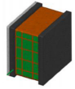 | Reduced heat flux by 66.7%, delayed indoor heat wave by 5.5 h.
Paraffin, OD, CA, BC | 24/27/32  144/243.5/152–241 | 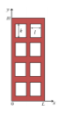 | PCM (T_{m} = 27°C) saved 15–40% energy in different climates.
RT25HC | 22  230 | 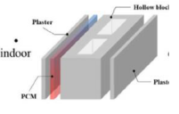 | Reduced heat flux by 48.7%, CO₂ emission by 56.4%.
Ethylene copolymer 40% + paraffin 60% | 22.1-25 / — | 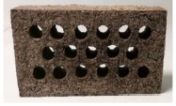 | Hydrated salts offered better thermal inertia than paraffin.
Eicosane, OM35 | 36–38 /  247.3 / 160 | 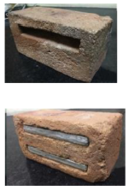 | Double-layer PCM reduced the temperature by 9.5°C, single-layer by 6°C.
— | 18–23 /  178.5 | 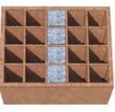 | The PCM near the inner surface performed better.
Table 2.8. PCM-enhanced bricks: PCM type/configuration with reported gains: temperature drop around 5–13 °C, heat-flux reduction around 50–74%, energy savings around 15–40%.
Bricks are essential building materials because of their high compressive strength and long durability. In addition to their mechanical properties, they also enhance the aesthetic appearance of buildings. Table 2.8, taken from the review by Zhao et al. [99], summarizes the main studies on the integration of PCMs into building bricks. It presents different PCM matrices, their thermal properties, and experimental results, highlighting how the use of PCMs helps reduce heat flux, improve indoor comfort, and enhance the overall energy efficiency of buildings. The reviewed studies highlight the significant potential of PCMs when integrated into bricks and masonry walls to improve building energy efficiency and thermal comfort. Overall, research findings show that PCMs reduce heat flux, indoor temperatures, and temperature fluctuations, leading to a lower cooling demand and, in some cases, energy cost savings of up to 50–70%. Different studies have investigated various PCM types (organic, such as paraffin, eicosane, and OM35, and inorganic, such as hydrated salts) and construction configurations (hollow bricks, double layers, metal or aluminum capsules, and microencapsulation). The best results are generally achieved when PCMs are placed near the inner surface of the wall or distributed in multiple cavities, as this positioning allows more effective heat storage and release. Numerical and experimental works (by Mahadaoui [107], Zhang [108], Zhang et al. [109], and Hamidi [110] report heat flux reductions of up to 70–75%, indoor temperature decreases of 4–10 °C, and thermal delay times of up to 5 hours, significantly enhancing indoor comfort. Other studies (by Fraine [111], Silva [112], Heniegal [113]) have shown that PCMs not only improve thermal performance but also help stabilize indoor humidity and reduce annual HVAC energy consumption by several hundred kilowatt-hours. However, researchers emphasize the need to balance thermal and mechanical properties, since PCM integration can weaken structural strength. The overall effectiveness and economic feasibility depend strongly on factors such as PCM thickness, amount, type, placement, and local climate conditions. Integrating PCMs into bricks offers a promising and adaptable solution for enhancing building energy performance, particularly in warm climates, though further optimization is needed to achieve a balance between thermal efficiency, durability, and economic sustainability.

PCM integrated cementitious concrete.
Concrete is a solid material composed of coarse and fine aggregates bound with cement, widely used in construction engineering for its strength and versatility. In recent years, several studies have explored the integration of PCMs into concrete, showing that their use in different positions within concrete blocks can significantly improve the thermal performance of structural elements, with varying results depending on the configuration and amount of PCM used. In particular, non-contact integration techniques between PCMs and concrete have gained increasing attention in sustainable construction research, as they enhance the material’s ability to store and release heat without compromising its mechanical properties. Nevertheless, traditional concrete still poses major environmental challenges, especially regarding the disposal of construction and demolition waste. In this context, combining recycled aggregates with PCMs to produce thermoregulating concrete blocks represents a promising direction for future building research, aligning with the goals of sustainability, energy efficiency, and material recycling. Figure 2.13 illustrates the experimental setup used by Wu et al. [114] to investigate the influence of PCM placement on the thermal and hygric behavior of hemp–lime concrete walls and the related energy performance of the integrated building envelope. The experiment was conducted in a controlled climate chamber, where temperature and humidity conditions were carefully maintained to simulate real environmental variations. (a) included a connection between an outdoor environment and an indoor laboratory environment, separated by the test envelope. Several sensors were installed to record temperature, relative humidity, and heat flux data in real time. (b) shows the actual experimental configuration, consisting of an insulated structure housing the test wall equipped with PCM, and (c) presents the four configurations tested: one reference sample without PCM and three with PCM inserted in different positions (outer, middle, and inner layer). The results demonstrated that when PCM was placed in the middle layer, it effectively stabilized indoor temperature and humidity, reducing internal heat and moisture fluctuations. This configuration provided the best energy-saving performance, confirming the potential of PCM-integrated hemp–lime concrete in improving the thermal stability and efficiency of building envelopes.
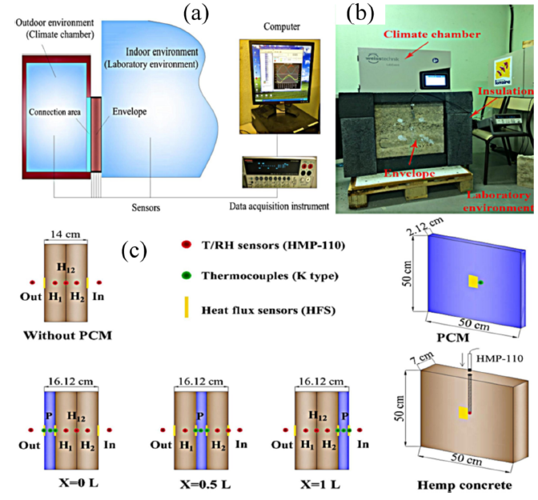
Figure 2.12. (a) Diagram of the experimental set-up, (b) Actual experimental set-up, (c) Four envelope configurations [114].
Several recent studies have investigated the integration of PCMs into concrete, aiming to enhance its thermal efficiency and sustainability. Eddhahak-Ouni et al. [115] and Figueiredo et al. [116] found that adding microencapsulated PCMs increases the heat storage capacity of concrete but decreases its mechanical strength, with compressive strength losses of up to 66%. However, careful control of the water-to-cement ratio and mixing procedures can mitigate these effects, while the thermal behavior tends to stabilize over time. To further improve performance and reduce costs, Shen et al. [117] developed concrete blocks with increasing PCM contents, achieving up to a 41% rise in heat capacity but a decrease in thermal conductivity and strength. Similarly, Christen et al. [118] observed slight mechanical degradation in textile-reinforced concrete (TRC) containing PCM, yet a significant thermal improvement was recorded (−4 °C and +37% energy savings). Innovative approaches by Halder et al. [119] and Zhao et al. [120] introduced advanced microcapsules, using dopamine coatings and styrene-divinylbenzene shells, respectively, which improved thermal stability and allowed up to 68% more heat retention compared to conventional materials. Specific applications include thermal control in pavements: Farnam et al. [121] used PCMs in concrete floors for snow and ice melting, while Refaa et al. [122] incorporated them into asphalt mixtures, lowering surface temperatures and deformation risks while helping to mitigate the urban heat island effect. Overall, PCMs have proven effective in enhancing thermal inertia and reducing energy demand in cement-based materials, though further optimization is needed to maintain sufficient mechanical performance.

PCM integrated mortar.
By customizing building materials such as mortars through the integration of thermal energy storage materials, it is possible to improve the energy performance of building envelopes and achieve better regulation of indoor temperatures. Cement mortar plays two primary roles in construction projects: first, it serves as an adhesive for masonry materials in foundations and wall construction; second, it is used for both interior and exterior plastering applications. Research on the integration of PCMs into cement mortars shows strong potential for improving thermal performance in buildings. Studies by Zhang et al. [123] demonstrated that adding PCMs enhances temperature regulation and reduces thermal fluctuations, although optimal thickness and PCM content must be carefully selected. Other works, such as those by Kontoleon et al. [124], Zhang et al. [125], found that increasing PCM content lowers thermal conductivity and improves insulation, but also causes a notable reduction in mechanical strength. To counter this, Frahat et al. [126] proposed replacing natural sand with ceramic materials, achieving higher tensile and flexural strength. Finally, Li et al. [127] applied microencapsulated PCMs in radiant floor mortars, identifying optimal mixtures that enhance energy efficiency. PCMs have proven effective in improving thermal inertia and indoor comfort, though their integration must be carefully optimized to prevent mechanical performance loss.

Application of PCMs in building envelopes
This section focuses on the application of PCMs within different components of the building envelope. In particular, it examines their integration into ceilings, roofs, floors, and windows, highlighting how PCM implementation in each element can contribute to enhancing thermal comfort, regulating indoor temperatures, and improving overall building energy efficiency.

PCM in ceiling integration.
The integration of PCMs into ceilings has proven to be an effective strategy to improve thermal comfort and reduce building energy demand. Macro-encapsulated PCMs installed directly in ceilings enable efficient passive cooling, lowering indoor temperatures by up to 1.8 °C during summer periods [128]. Their performance strongly depends on capsule geometry: numerical and experimental studies have shown that dendritic structures can double the cooling capacity compared to spherical ones [129]. Coupling PCMs with ventilation or hydronic cooling systems further enhances thermal efficiency, reducing peak loads and achieving energy savings of up to 17 % in temperate climates [130]. In radiant ceilings, PCMs provide a more uniform temperature distribution and help reduce noise levels. Other studies have explored hybrid solutions, such as panels in direct contact with hydronic pipes or combined with nanofluids, improving solidification and heat storage capacity [131]. Finally, the development of thermoelectric panels integrated with PCMs represents a promising innovation: these systems maintain surface temperatures of 16–17 °C for over three hours, ensuring stable cooling and effective thermal load management [132]. Figure 2.14 shows a wall-integrated PCM–air heat exchanger: (a) discharge mode with airflow controlled by dampers; (b) layered module schematic with effective exchange length.
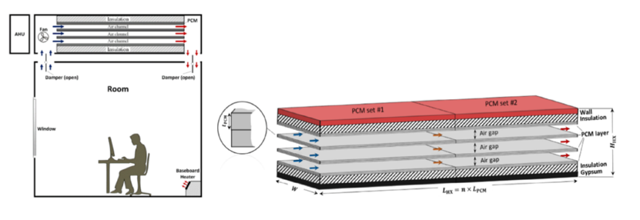
Figure 2.13. (a) PCM-air heat exchanger discharging mode, (b) Schematic of PCM-air heat exchanger [99].

PCM in roof integration.
The integration of PCMs into roof systems is an effective strategy to improve the thermal performance of buildings by reducing the cooling load caused by solar radiation. Figure 2.15 depicts a roof assembly with an embedded PCM layer, highlighting how its placement/thickness modulates heat flows under solar load to cut summer heat gains and improve thermal performance. Although this topic has received limited attention so far, several studies have demonstrated promising results. Research by Pasupathy and Velraj [133] and Elawady et al. [134] highlighted that the arrangement and thickness of the PCM layers have a strong influence on performance: in the first case, a double-layer system with different melting temperatures improved heat storage efficiency, while in the second, a roof with a 40 mm PCM layer reduced summer heat gains by 40%. Similarly, Kośny et al. [135] achieved a 30–55% reduction in heating and cooling loads through a ventilated PV roof incorporating PCM. Other studies have focused on material optimization and configuration. Elarga et al. [136] and Meng et al. [137] found that performance depends on the type and position of the PCM within the roof assembly, while Zhang et al. [138] developed an innovative reversible multi-layer roof with two PCMs and low-e glass, achieving energy savings of up to 33.74% in winter and 14.08% in summer in cold Chinese climates. From a structural perspective, Abass and Muthulingam [139] proposed a biaxial voided roof slab incorporating PCM, which reduced indoor temperature by up to 7.2 °C and heat flux by 60%, with a payback period of less than six years. Likewise, Tokuç et al. [140] identified, through CFD and experimental analysis, an optimal PCM thickness of 2 cm for flat roofs in Istanbul, which reduced heat flux by up to 9.6%.
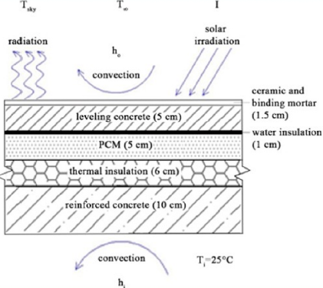
Figure 2.14. PCM-integrated roof schematic showing layer stack and dominant heat-transfer modes under solar irradiation. [106].

PCM in floor integration.
The integration of PCMs into radiant floor systems improves energy efficiency and thermal comfort in lightweight buildings. Karim et al. [141] showed that a hollow concrete panel with PCM can shift the peak load by 7.3 hours, enhancing heat storage and distribution. Guo et al. [142] and Sun et al. [143] found that ventilated or double-layer radiant systems with PCM increase efficiency by up to 7% and extend the duration of thermal comfort. Kitagawa et al. [144] combined PCM with night ventilation, reducing floor temperature by up to 1.5 °C in hot and humid climates. Other studies have developed new composite PCMs for flooring: Wang et al. [145] and Xu et al. [146] produced stable, high-capacity PCMs, while Faraj et al. [147], Jin et al. [148] confirmed improved comfort and operating cost reductions of up to 73%.

PCM in window integration..
The figure below is found in Abass's review [106] and illustrates various configurations of PCM-enhanced windows, developed to improve the energy efficiency and thermal comfort of buildings. In (a), an experimental prototype installed in a real building is shown, used to test the performance of PCM under operational conditions. Images (b), (c), (d), and (e) depict schematic representations of different PCM integration methods within glazing systems: between glass panes, as an inner or reflective layer, or combined with high-efficiency optical surfaces to regulate heat transfer and solar radiation. Finally, (f) presents a more complex multilayer window model equipped with three separate chambers (PCM, water, and air) and a data acquisition system for thermal monitoring [149]. Heat transfer through windows accounts for up to 80% of total heat losses in buildings, leading many studies to explore the integration of PCMs to reduce solar heat gain and improve energy efficiency. Silva et al. [150] showed that window shutters or frames filled with PCM can significantly lower indoor temperatures (by up to 16.6 °C) and reduce heat flux, thanks to the PCM’s ability to absorb excess heat during the hottest hours of the day. Figure 2.16 shows some literature evidence on PCM-integrated glazing/shading: (a) PCM shutter cuts indoor peak heat flux and lowers max room temperature; (b) glazed energy-storage windows provide multi-hour temperature damping; (c) nano-enhanced paraffin PCM improves thermal/optical performance; (d) PCM curtain reduces solar heat gain; (e) Al₂O₃ nanoparticles lower inner-glass temperatures; (f) double-glazing with PCM yields measurable energy savings, with PCM glazing outperforming water glazing on mean temperature.

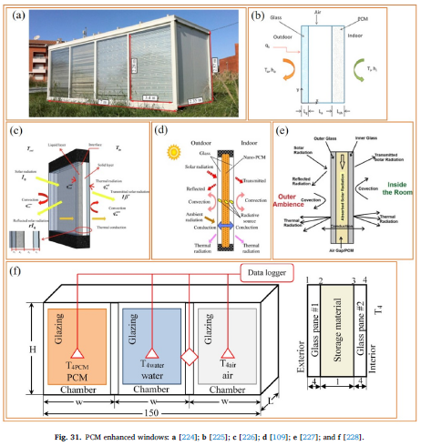
Figure 2.15. (a) PCM shutter cuts indoor (b) glazed energy-storage windows (c) nano-enhanced paraffin PCM (d) PCM curtain (e) Al₂O₃ nanoparticles (f) double-glazing with PCM [106].

Li et al. [151] and Goia et al. [152] found that double or triple glazing systems with PCM help moderate surface temperature fluctuations by up to 5.5 °C, enhancing indoor comfort, while Wang and Zhao [153] and Yang et al. [154] developed PCM curtains and hybrid PCM systems that reduced solar heat gain by up to 31% and achieved energy savings exceeding 1400 kJ/day. More advanced studies by King et al. [155] and Duraković et al. [156] demonstrated that windows incorporating PCM with nanoparticles or PCM-filled glazing systems provide better thermal damping, reduce indoor temperature peaks by up to 9 °C, and lower energy consumption by about 4% compared to conventional systems.

Energy saving, economic, and environmental analysis impact
Zhao et al. [99], in their review, analyzed the energy, environmental, and economic impacts resulting from the application of PCMs in buildings.

Energy impact
Regional climate conditions, the selection and placement of PCMs, as well as building orientation and window openings, all significantly influence energy consumption. The energy savings achieved by integrating PCMs into building envelopes are mainly due to reduced demand for artificial cooling and enhanced use of natural heat regulation. The effectiveness of PCM-based systems depends on parameters such as thermal resistance, latent heat, thermal conductivity, enthalpy, and material thickness. Current research mainly follows two approaches: identifying optimal PCM types and thicknesses for specific climate zones, and developing materials effective across different environmental conditions. However, both rely on simulation models that may not fully capture real-world influences. Gallardo and Berardi [157] developed a radiant ceiling panel with macroscopically encapsulated organic PCM that, in a hot–humid climate, outperformed a conventional all-air system with 22% annual energy savings, and a subsequent year-long whole-building simulation for Honolulu (USA) indicated 34% annual savings versus the all-air baseline. Experimental testing, though more accurate, remains costly and time-consuming, highlighting the need to improve simulation models to better assess the true energy-saving potential of PCM-based systems.

Environmental impact
The integration of PCMs into buildings represents an effective strategy for reducing CO₂ emissions, as it decreases the energy demand associated with heating and cooling. To quantify the contribution of PCMs, Arumugam and Shaik [158] proposed a model based on cooling degree hours (CDH) and heating degree hours (HDH) in Eq. (24) and Eq. (25):
$$CDH=N_{CH}\left(T_{m}-T_{b}\right) (24) \\ HDH=N_{HH}\left(T_{b}-T_{m}\right) (25)$$
where $N_{CH}$and $N_{HH}$represent the number of cooling and heating days, $T_{b}$is the base temperature, and $T_{m}$is the mean daily temperature. The reduced cooling and heating loads resulting from the use of PCMs can be calculated as follows in Eq. (26) and Eq. (27):
$$Q_{RC}=u_{con}​A⋅CDH-\left(\frac{u_{pcm} A⋅CDH-m⋅h_{fg}​⋅0.278⋅n_{c}​​}{n_{c}}\right) (26) \\ Q_{RH}=u_{con}A⋅HDH-\left(\frac{u_{pcm}A⋅HDH-m⋅h_{fg}⋅0.278⋅n_{c}}{η_{c}}\right) (27)$$where $u_{con}$and $u_{pcm}$are the cyclic thermal transmittances of the conventional and PCM-integrated envelopes, $A$is the heat flux through the external surface, $h_{fg}$is the latent heat of the PCM, and $n_{c}$is the number of PCM cycles during summer and winter. The energy savings achieved are then converted into CO₂ emission reduction, estimated in Eq. (28) as follows:
$$m_{r}={10}^{-3}\left(η_{1}\frac{Q_{RC}}{COP}+η_{2}\frac{Q_{RH}}{η}\right) (28)$$where $m_{r}$represents the annual CO₂ reduction due to PCM integration in the building, $COP$is the coefficient of performance of the air conditioning system, and $η$ is the efficiency of the power plant. Two main factors affect the reduction of CO₂ emissions: the amount of energy saved and the type of fuel used for energy generation. Integrating PCMs into buildings is considered a sustainable strategy, particularly in regions where electricity production relies heavily on coal and oil. Studies have shown that PCM integration can lower emissions by up to 203 kg CO₂e/kWh. According to the International Energy Agency (IEA) report (2021), building operations are responsible for 27% of global CO₂ emissions in the energy sector. Moreover, a significant portion of emissions in the construction sector arises from cement manufacturing, which releases 0.6–1.0 kg of CO₂ per kilogram of cement produced. Although the production of PCM materials also generates greenhouse gas emissions, life cycle assessments have shown that the energy invested in producing PCM can be recovered in less than two years. Overall, literature data indicate that the optimized use of PCMs in buildings can lead to annual CO₂ emission reductions of up to 42,004 kg CO₂e.

Economic impact
Cost analysis should include all four stages of the building life cycle — planning, design, construction, and operation — as well as the phases of demolition and recycling. Since the phase change temperature and thickness of PCMs vary depending on the climate, production costs also differ. Therefore, both manufacturing costs (during construction) and energy savings (during operation) should be considered together to assess the true economic feasibility. The use of high-energy-density PCMs can be particularly advantageous in technological systems such as radiant heating or cooling, offering environmental and economic payback times of less than two years. However, the use of PCMs in building envelopes can be less cost-effective, as the addition of PCM materials and their encapsulation significantly increases environmental impact, especially in the case of organic PCMs derived from fossil fuels, such as paraffin. At present, it is therefore essential to develop low-cost PCMs with long lifespan, thermal stability, and safe use, to enable building applications that provide both economic and environmental benefits.

Future research directions
Research on the application of PCMs in buildings has produced promising results, though several challenges remain. The main limitations concern their low thermal conductivity and limited thermal cycling stability; to address these, researchers are experimenting with high-conductivity nanomaterials, though these entail high costs and distribution issues. Therefore, developing stable and cost-effective production processes is essential. A multidisciplinary approach involving materials science, chemistry, and engineering is crucial to design intelligent and adaptive PCMs capable of changing their properties at specific temperatures, ensuring long-term performance and effective integration with building structures. Regarding encapsulation, macroscopic methods are simple but prone to leakage, while microencapsulation offers better sealing but is expensive. New approaches propose using natural porous media and vacuum impregnation to produce modular, replaceable, and low-maintenance PCM units, though improvements are still needed in impregnation efficiency, mechanical stability, and durability through thermal cycles. The effectiveness of PCMs also depends on climatic conditions: in regions with large temperature variations, multilayer or composite PCMs are preferable, whereas in areas with small diurnal ranges, combining PCMs with ventilation or cooling systems can optimize performance. Finally, the use of machine learning offers an innovative path to automatically optimize PCM selection and configuration based on local climate conditions. However, the debate on their environmental benefits remains open: although high-density PCMs can achieve payback periods under two years, materials such as fossil-based paraffin require a thorough life-cycle assessment (LCA) to determine their true impact on energy consumption and emissions.

PCMs in cold chain application
To investigate the state of the art on PCM applications in the cold chain, a systematic search was conducted on Scopus. The first query is
(“phase change materials” OR PCM) AND (“cold chain” OR refrigeration OR “cold storage” OR cooling OR “temperature control”)
That returned 12,227 results. To capture the health-care use case, especially vaccine logistics, an extended query is produced:
(“phase change materials” OR PCM) AND (“cold chain” OR refrigeration OR “cold storage” OR cooling OR “temperature control” OR “vaccine”)
yielded 12,310 results. Results were filtered by relevance and source quality (indexed journals; citation-based screening where appropriate), focusing on rigorous experimental work with clear impact on refrigerated transport, hubs, and storage.
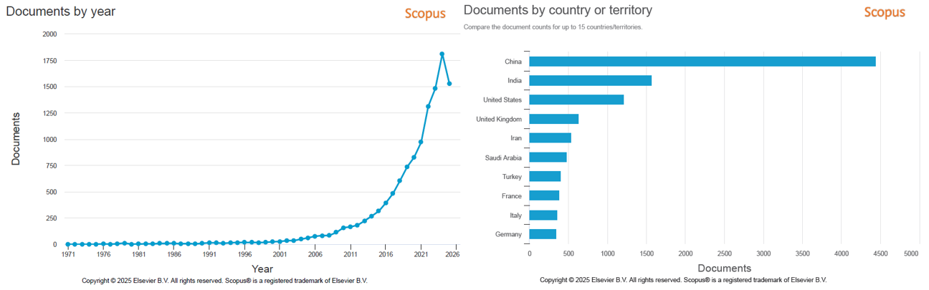
b)
a)
Figure 2.16. Scopus trends for PCM in cold-chain applications: (a) publications trend with a sharp rise in 2020–2024; (b) country contributions led by China and India.
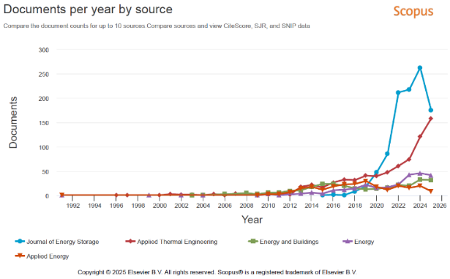
Figure 2.17a shows the trend of publications by year produced by Scopus. After a long, low-activity phase, publications rise sharply from the 2010s and surge in 2020–2024. This acceleration aligns with the maturation of PCM as thermal energy storage for passive cooling, the expansion of e-grocery and biologics logistics, and the COVID-19 vaccine campaigns. Figure 2.17b shows the number of publications by country produced by Scopus. Leadership by China and India, followed by the United States, mirrors large logistics markets, hotter climates demanding robust temperature control, and strong manufacturing capacity for PCM packs and containers. Contributions from the UK, France, Italy, Turkey, Iran, Saudi Arabia, and Germany reflect national programs on food safety, pharmaceuticals, and decarbonization of refrigerated warehouses. Figure 2.18 shows the trend of documents per year by source. The prominence of the Journal of Energy Storage underscores the framing of PCMs as storage solutions for load shifting and peak reduction; growth in Applied Thermal Engineering, Applied Energy, and Energy signals engineering maturity (transient modeling, evaporator coupling, regeneration cycles). The presence of Energy and Buildings points to PCM integration in the cold chain. Table 2.9 presents a selection of the most relevant contributions on the use of PCMs in the cold chain. For each article, the title, authors, source, year of publication, citation count, and the key findings distilled from the abstracts are reported.
Figure 2.17. Publications by source for PCM in the cold chain: Journal of Energy Storage, Applied Thermal Engineering and Applied Energy, Energy and Buildings.
Title | Authors | Source | Year | Citations | Abstract summary
Influencing factors of cooling performance of portable cold storage box for vaccine supply chain: An experimental study | Gan, Q., Zhang, Y., Zhang, Z., ... Zhao, J., Wang, X. | Journal of Energy Storage,72, 108212 | 2023 | 8 | PCM on all six walls and a cubic box performs best; ambient temperature influences cooling much more than vaccine load.
Preparation and stability analysis of glycine water-based phase change materials modified with potassium sorbate for cold chain logistics | Liu, Y., Li, M., Zhang, Y., ... Gu, Z., Tang, R. | Journal of Energy Storage, 72, 108375 | 2023 | 11 | Glycine/mannitol + 0.1 wt% potassium sorbate: Tm ≈ −5.8 °C, high latent heat, excellent cycling; precools faster than ice and holds 0.45–3 °C for ~23 h.
Experimental study on operation characteristics of a novel refrigeration system using phase change material | Chen, X., Zhang, Q., Zhai, Z.J., Wu, D., Liao, S. | Energy and Buildings, 150, pp. 516–526 | 2017 | 23 | Stores night cold from outdoor air/VCR and releases by day; prototype stable. At 15 °C ambient, free‑cooling is more energy‑efficient for small storage but slower to charge.
Heat and cold storage using phase change materials in domestic refrigeration systems: The state-of-the-art review | Mastani Joybari, M., Haghighat, F., Moffat, J., Sra, P. | Energy and Buildings, 106, pp. 111–124 | 2015 | 160 | Summarizes experiments/models using PCM (mainly at the evaporator) to reduce temperature swings and energy use; notes gaps on condenser‑side applications.
Experimental analysis of hydroquinone used as phase change material (PCM) to be applied in solar cooling refrigeration | Gil, A., Oró, E., Miró, L., ... Salmerón, J.M., Cabeza, L.F. | International Journal of Refrigeration, 39, pp. 95–103 | 2014 | 81 | Hydroquinone (166–173 °C, 225 kJ/kg) validated in a pilot; informed a 5‑ton PCM tank deployed in a real solar‑cooling plant (Seville).
Development, characterization and modification of mannitol-water based nanocomposite phase change materials for cold storage | Ma, K., Zhang, X., Ji, J., Han, L. | Colloids and Surfaces A Physicochemical and Engineering Aspects, 650, 129571 | 2022 | 24 | Mannitol/MgCl₂ base + Nano‑CuO + MWCNT‑OH with PAM dispersant: +18% conductivity, no supercooling, strong stability; cold‑storage time reduced by 57%.
Preparation and heat transfer model of stereotyped phase change materials suitable for cold chain logistics | Xu, X., Zhou, Y., Zhang, S., Zhai, X., Zhang, X. | Journal of Energy Storage, 60, 106610 | 2023 | 14 | CA–LA + 8% EG boosts k to 1.41 W/m·K and prevents leakage; coil‑charged panels cut charging time by 58% vs ambient, improving logistics throughput.
Massive Fabrication of Flexible, Form-Stable, and Self-Repairing Brine Phase Change Material Gels toward Smart Cold Chain Logistics | Liu, K., He, Z., Luo, Y., Lin, P., Chen, Y. | ACS Applied Materials and Interfaces, 15(13), pp. 17091–17102 | 2023 | 29 | NaCl brine gels (ionic/covalent/H‑bond cross‑linking) show high latent heat/conductivity, no supercooling, low cost; IoT cold boxes hold ~36.7 h for seafood.
Theoretical study on a vapor compression refrigeration system with cold storage for freezer applications | Yan, G., Liu, Y., Qian, S., Yu, J. | Applied Thermal Engineering, 160, 114091 | 2019 | 29 | PCM subcooling increases COP by 3.3–10.5% and volumetric capacity by 5.5–25.4%; ≥490 g ice can serve as PCM.
Energy, economic and environmental impact analysis of phase change materials for cold chain transportation in Malaysia | Chandran, R., Hasanuzzaman, M., Arıcı, M., Kumar, L. | Journal of Energy Storage, 55, 105481 | 2022 | 30 | Adding paraffin PCM layers cuts daily loads up to 34.4%, payback <3 years, and >2700 kg CO₂/year savings.
Development of low-temperature eutectic phase change material with expanded graphite for vaccine cold chain logistics | Liu, L., Zhang, X., Xu, X., ... Wu, Y., Zheng, H. | Renewable Energy, 179, pp. 2348–2358 | 2021 | 81 | DA–LA/EG (12:1): Tp ≈ 2.1 °C, L ≈ 189 J/g, k ≈ 1.75 W/m·K; 13.8× higher k and 79% shorter phase‑change time; stable over 500 cycles.
Development of composite phase change cold storage material and its application in vaccine cold storage equipment | Zhao, Y., Zhang, X., Xu, X., Zhang, S. | Journal of Energy Storage, 30, 101455 | 2020 | 100 | Enhanced‑k PCM paired with an app‑connected cold box that equalizes cold distribution and provides real‑time temperature tracking.
Phase change material cellulosic composites for the cold storage of perishable products: From material preparation to computational evaluation | Melone, L., Altomare, L., Cigada, A., De Nardo, L. | Applied Energy, 89(1), pp. 339–346 | 2012 | 67 | Cellulose laminates with 25–50% micro‑PCM keep temperature up to 10× longer during warm exposure; validated by simple models.
Characterization and thermal properties of lauryl alcohol-capric acid binary mixture with hybrid-nanoparticles as phase change material for vaccine storage applications | Karthikeyan, K., Mariappan, V., Kalidoss, P., ... Prathiban, S., Anish, R. | Journal of Energy Storage, 74, 109442 | 2023 | 18 | HNePCMs using GNP‑Al₂O₃/CuO/TiO₂ boost conductivity; LA–CA/GNP‑CuO gives strong k‑gain with minimal Tm/enthalpy shift and good durability.
Highly-efficient cold energy storage enabled by brine phase change material gels towards smart cold chain logistics | Liu, K., He, Z., Lin, P., ... Sheng, X., Chen, Y. | Journal of Energy Storage, 52, 104828 | 2022 | 43 | Free‑standing gels: no supercooling, L ≈ 231 J/g, k ≈ 0.59 W/m·K, low cost; 16–21 h hold for seafood/biologicals with GPS/temperature telemetry.
Table 2.9. Selected studies on PCM use in the cold chain: bibliographic details and key findings distilled from the abstracts.
Table 2.10 summarizes a selection of the most influential review papers on the use of PCMs in the cold chain (refrigeration, cold storage, and vaccine/pharmaceutical logistics). These reviews synthesize PCM properties, system integration strategies, and reported benefits for temperature control, load shifting, and energy efficiency, while outlining challenges and research gaps. For each review, the title, authors, source, year of publication, citation count, and the principal insights highlighted by the authors are reported.
Title | Authors | Source | Year | Citations | Abstract summary
Emerging phase change cold storage technology for fresh products cold chain logistics | Li, M., Xie, B., Li, Y., ... Leng, G., Li, C. | Journal of Energy Storage, 88, 111531 | 2024 | 19 | Phase-change cold storage paired with logistics equipment cuts cost, energy use, and emissions while keeping uniform temperatures. Reviews PCM types, selection/optimization, and use across cold-chain devices; outlines current gaps and future R&D needs.
Cold chain transportation energy conservation and emission reduction based on phase change materials under dual‑carbon background: A review | Chen, Y., Zhang, X., Ji, J., Zhang, C. | Journal of Energy Storage, 86, 111258 | 2024 | 24 | Under carbon-reduction targets, PCM-based cold storage aids insulation, temperature control, and energy savings. Surveys PCM integration in truck compartments, temperature-field optimization, new truck designs, LCA methods for carbon footprints, and practical strategies to reduce energy and emissions.
Research progress of energy-saving technology in cold storage with/without phase change materials | Chen, Y., Zhang, X. | Journal of Energy Storage, 103, 114334 | 2024 | 7 | Reviews envelope upgrades, PCM in walls/panels, efficient refrigeration equipment, renewables, and control strategies for cold stores. Concludes with guidance for scaling energy-saving measures across China’s cold-storage sector.
Developments in phase change material (PCM) doped energy efficient polyurethane (PU) foam for perishable food cold-storage applications: A review | Sarkar, S., Mestry, S., Mhaske, S.T. | Journal of Energy Storage, 50, 104620 | 2022 | 83 | Assesses PU–PCM composites (−10 to 15 °C) for cooling‑load reduction. Direct mixing suffers leakage/poor cycling; encapsulated PCM (EPCM)—ideally organic–inorganic hybrid shells with paraffin cores—offers better reliability and bonding. Encapsulation method, particle size, and loading govern thermal and energy performance.
Research progress of cold chain transport technology for storage fruits and vegetables | Qi, T., Ji, J., Zhang, X., ... Ma, K., Gao, Y. | Journal of Energy Storage, 56, 105958 | 2022 | 56 | Because produce is perishable and temperature‑sensitive, PCM cold storage can stabilize temperatures, improve safety, and save energy versus purely mechanical refrigeration. Reviews box design, refrigeration/insulation roles, demonstrated benefits, and research needs for a more efficient produce cold chain.
Review on operation control of cold thermal energy storage in cooling systems | Wang, H., Xie, B., Li, C. | Energy and Built Environment, 6(3), pp. 509–523 | 2025 | 19 | Overviews CTES principles, PCM media, and applications (buildings, cold chain, other refrigeration) with emphasis on operation/control: strategies, load prediction (parametric vs ANN), and economic evaluation (CAPEX/OPEX/LCC). Provides an outlook on optimized CTES‑coupled cooling.
Properties and encapsulation forms of phase change material and various types of cold storage box for cold chain logistics: A review | Sha, Y., Hua, W., Cao, H., Zhang, X. | Journal of Energy Storage, 55, 105426 | 2022 | 50 | Surveys PCM materials, storage units, and diversified passive cold‑storage boxes that can pair with renewable energy. Highlights directions for next‑gen PCM materials and box designs to improve efficiency and sustainability in cold‑chain logistics.
Review on cold thermal energy storage applied to refrigeration systems using phase change materials | Selvnes, H., Allouche, Y., Manescu, R.I., Hafner, A. | Thermal Science and Engineering Progress, 22, 100807 | 2021 | 197 | Classifies PCMs for AC (~20 °C) down to −65 °C; summarizes key properties/characterization and lists commercial options (10 °C to −65 °C). Applications in food transport/packaging and commercial refrigeration are growing; water/ice dominate AC due to cost, with rising use for peak‑shaving and backup cooling.
Performance improvement and energy consumption reduction in refrigeration systems using phase change material (PCM) | Bista, S., Hosseini, S.E., Owens, E., Phillips, G. | Applied Thermal Engineering, 142, pp. 723–735 | 2018 | 113 | Reviews PCM use in vapor‑compression systems, showing reduced compressor cycling and electricity use. Discusses PCM selection and effects of thickness and phase‑change temperature, plus pros/cons of locating PCM at evaporator, condenser, compartment, or near compressor; overall improves temperature stability and efficiency.
Table 2.10. Influential reviews on PCM for the cold chain: key bibliographic details and synthesized insights on technologies, integration challenges, and performance gains.

Cold Chain Logistics and the Use of PCMs for Passive Cooling
Soo et al. [159] report that cold chain logistics have become a fundamental component of modern transportation and distribution systems. The rise in living standards and global economic growth has led to an increasing demand for fresh, frozen, and perishable food products from different parts of the world. The importance of this infrastructure became particularly evident during the COVID-19 pandemic, when the transport and storage of vaccines required strict and continuous temperature control throughout the supply chain. Cold chain logistics now play a crucial role in ensuring the safe and efficient international trade of temperature-sensitive goods such as food, pharmaceuticals, and chemicals. Maintaining optimal thermal conditions along the supply chain helps preserve product quality, extend shelf life, and reduce spoilage and waste, thus contributing to global food security. Depending on the nature of the products, specific temperature ranges are defined: cryogenic (≤ −150 °C) for biological samples and special pharmaceuticals, ultra-low (−50 to −80 °C) for certain biologics such as mRNA vaccines, standard frozen (−20 to −30 °C) for food and pharmaceuticals, chilled (2 to 8 °C) for vaccines, fresh produce, and dairy products, and controlled room temperature (15 to 25 °C) for cosmetics and temperature-sensitive medicines. Each category requires accurate monitoring and insulation systems to prevent thermal fluctuations that could compromise product integrity. With increasingly stringent standards for food safety and pharmaceutical efficacy, a growing number of companies rely on cold chain logistics—a sector expected to continue expanding in the coming years. In this context, a significant contribution comes from PCMs, widely used for thermal energy storage. Thanks to their high latent heat capacity, PCMs can absorb and release large amounts of energy during the phase transition, providing an effective and sustainable passive cooling solution for the transport and storage of temperature-sensitive products. Table 2.11 summarizes standard cold-chain temperature bands and representative products.

Category | Temperature range [°C] | Items
Cool | 8 to 15 | Fresh produce, fruits (usually tropical), vegetables (e.g., tuber)
Pharma | 2 to 8 | Vaccines (e.g., hepatitis A and B, human papillomavirus, influenza, rotavirus, human rabies), medications
Chill | 2 to 4 | Dairy produce, fresh poultry/meat, vegetables, fruits
Frozen | -20 to -16 | Poultry/meat, ice cream, vaccines (e.g., measles, yellow fever, chicken pox, bacillus Calmette–Guérin, polio)
Deep freeze | -30 to -28 | Meat and seafood exports
Table 2.11. Cold-chain categories with target ranges and typical items: Cool, Pharma, Chill, Frozen, Deep freeze.

Analysis of Cold Chain Logistics and the Application of PCMs
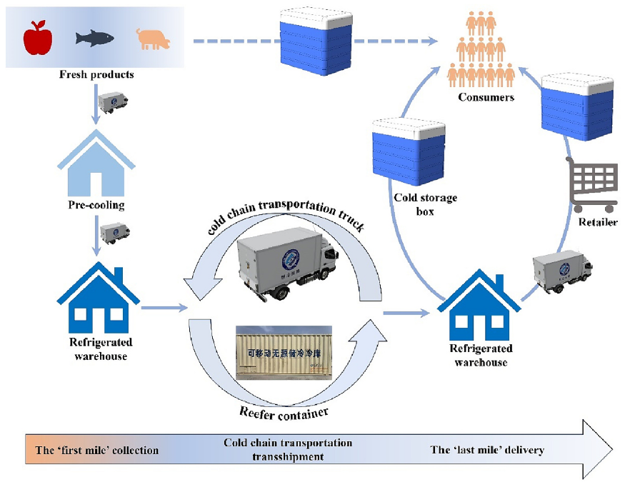
Figure 2.18. Fresh products cold chain logistics process. [160].
Ma et al. [160] reported Figure 2.19 and state that cold chain logistics is composed of three main stages: the “first mile” (initial collection), refrigerated transportation and transshipment, and the “last mile” (final delivery). After production, fresh goods are rapidly pre-cooled to lower their temperature, slow down biological processes, and preserve quality, before being stored in refrigerated warehouses. Transportation can take place over short distances using refrigerated trucks or over long distances through intermodal systems (road, rail, sea, air) with refrigerated containers, thus ensuring low-temperature conditions are maintained throughout the journey to the final destination. With the rise of e-commerce, direct delivery from producers to consumers using insulated containers has become increasingly common, allowing for continuous and efficient distribution of perishable goods. In this context, PCMs play a key role: thanks to their ability to store and release thermal energy during the phase transition, they can be integrated into every stage of the cold chain to provide passive cooling, insulation, temperature control, and energy savings, thereby enhancing the thermal stability and overall efficiency of cold chain logistics systems. In the “first mile” process, pre-cooling is essential to quickly lower the temperature of fresh products, slowing down their deterioration. Techniques such as air, vacuum, water, or ice cooling are already widely used, but the application of PCMs, though still limited, offers advantages in terms of cooling speed and energy efficiency. PCMs can be used as refrigerated packaging materials or in phase change slurries to achieve fast and uniform cooling. In refrigerated warehouses, which ensure preservation and serve as transit points in the cold chain, PCMs allow for cold energy storage and release, reducing energy consumption and stabilizing temperature. The integration of these technologies in the pre-cooling and storage phases represents a promising solution to improve the efficiency and sustainability of cold chain logistics systems. The section on cold chain transportation transshipment concerns the role of refrigerated trucks and containers in transporting fresh products between the different stages of the cold chain. Refrigerated trucks are the primary solution for short-distance transportation, ensuring the connection between production sites, pre-cooling stations, warehouses, and retail outlets. The integration of PCMs in these vehicles allows for stable temperature maintenance and reduced energy consumption, both in passive systems (cold storage plates) and active systems (with dynamic temperature control). Current research focuses on optimizing the arrangement of cold plates, cooling recharge methods, and internal temperature distribution. Intermodal refrigerated containers (reefer containers) can also be converted into passive cooling systems using PCMs, improving safety, energy efficiency, and environmental sustainability. The “last mile” of the cold chain refers to the direct delivery of fresh products from warehouses or retailers to consumers and requires flexible, door-to-door distribution systems. In this phase, the cold storage box represents the most effective solution: it is a passive and portable system made of insulating materials and PCMs that maintain a stable internal temperature by utilizing the latent heat released during the phase change process. Since different fresh products have specific temperature requirements, PCMs with varied phase change temperatures effectively replace traditional ice packs, providing greater efficiency, sustainability, and recyclability, especially when using low-cost materials. Current research focuses on optimizing insulating materials, cold storage plates, and their arrangement to improve temperature uniformity and reduce the amount of PCM needed. With the expansion of e-commerce, direct distribution from producers to consumers using cold storage boxes is becoming increasingly common, enabling lower losses, higher efficiency, and new application opportunities in last-mile logistics. Table 2.12 shows commercially available cold boxes [166].
Company | Sample Name | Melting Temperature (°C) | Payload Volume (L) | Duration (h)
Cold Chain Technologies | CCT EcoFlex™ Standard | 2.0 to 8.0  15.0 to 25.0 | 7.5 to 62 | 45 to 72
Cold Chain Technologies | CCT EcoFlex™ Extended | 2.0 to 8.0  15.0 to 25.0  -15.0 to -25.0  -50.0 to -80.0 | 2.5 to 53.7 | 96 to 144
CoolPac | CoolPac 15 PCM | -20.0 to 8.0  2.0 to 8.0 | 8.5 kg dry ice  2.77 | 105
CoolPac | CoolPac 45 PCM | -20.0 to 8.0  2.0 to 8.0 | 15 kg dry ice  14.65 | 66 to 75  >120
Peli BioThermal | Credo Cube™ | < -40.0  2.0 to 8.0  15.0 to 25.0 | - | 96 to 156
TempAid | SteadyPac Cube – refrigerated shipments | 2.0 to 8.0 | 3 to 96 | 105
TempAid | Water and Gel-based Qualified Cold Chain Packaging | 2.0 to 8.0 | 2 to 50 | 72
TempAid | SteadyPac Cube – frozen shipments | -25.0 to -15.0 | 3 to 96 | 96
Table 2.12. Commercial PCM cold boxes.

Phase change properties of commercial PCMs for cold chain logistics
Table 2.13 [166] summarizes the phase change properties of commercial PCMs developed by four major companies (Croda, Rubitherm, Axiotherm, RGEES LLC), showing a wide operating temperature range from −50 °C to over 50 °C, suitable for various cold chain logistics applications. Inorganic PCMs, used below 0 °C, exhibit higher latent heat and thermal conductivity, while organic PCMs, applied above 0 °C, provide better stability and safety. The performance of commercial PCMs is slightly superior to that reported in the literature, with average latent heats of 150–250 J/g for organic PCMs and above 250 J/g for inorganic ones. However, there is a lack of efficient PCMs below −35 °C, representing a promising area for future development, particularly for vaccine preservation. Moreover, the ability to enhance thermal conductivity without compromising phase change performance allows for adjustable cooling efficiency tailored to different logistical requirements.
Company | Sample Name (Type) | Melting Temperature (°C) | Melting Enthalpy (J/g) | Thermal Conductivity (W/m·K)
Croda | Crodatherm™ 5 (org) | 5.0 | 217.0 | 0.15–0.24
Croda | Crodatherm™ 9.5 (org) | 9.5 | 186.0 | 0.15–0.18
Croda | Crodatherm™ 21 (org) | 21.0 | 190.0 | 0.15–0.18
Croda | Crodatherm™ 37 (org) | 37.0 | 240.0 | 0.17–0.24
Rubitherm Technologies GmbH | RT2 (org) | −2.0 to 2.0 | 204.0 | 0.20
 | RT8 (org) | 6.0 to 8.0 | 180.0 | 0.20
 | RT10 (org) | 8.0 to 10.0 | 175.0 | 0.20
 | RT18 (org) | 16.0 to 18.0 | 155.0 | 0.20
 | RT28 (org) | 26.0 to 28.0 | 245.0 | 0.20
 | RT44 (org) | 42.0 to 44.0 | 230.0 | 0.20
Axiotherm | ATS 50 (inorg) | −51.0 to −49.0 | 345.0 | 0.66
 | ATS 29 (inorg) | −31.0 to −29.0 | 285.0 | 0.66
 | ATP 10 (inorg) | −12.0 to −10.0 | 275.0 | 0.20
 | ATP 18 (inorg) | 16.0 to 18.0 | 275.0 | 0.20
 | ATP 29 (inorg) | 28.0 to 30.0 | 280.0 | 0.20
RGEES LLC | PCM-M30N (inorg) | −30.0 | 254.0 | 0.62
RGEES LLC | PCM-M21N (inorg) | −21.0 | 280.0 | 0.61
RGEES LLC | PCM-M15N (inorg) | −15.0 | 290.0 | 0.56
RGEES LLC | PCM-M06N (inorg) | −6.0 | 365.0 | 0.56
RGEES LLC | PCM-CM09L-06 (org) | −6.0 | 390.0 | 0.56
RGEES LLC | PCMCOOL-8 (org) | −8.0 | 210.0 | 0.20
RGEES LLC | PCMCOOL-18 (org) | 18.0 | 220.0 | 0.20
Table 2.13. Phase-change properties of commercial cold-chain PCMs from Croda, Rubitherm, Axiotherm, and RGEES.

Focus on the application of PCMs in the biomedical field
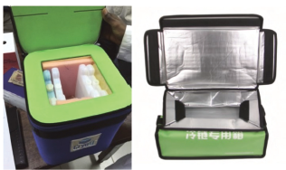
In the review by Ma et al. [167], a comprehensive overview is provided of the biomedical applications of PCMs, showing that precise thermal management is not only a logistics issue but can also be used as an actual therapeutic tool. First, the authors point out that most vaccines must be stored and transported at 2–8 °C, while a smaller group requires lower ranges (down to −20 °C), and some special vaccines, such as the Ebola vaccine, need ≤ −60 °C before dilution and 2–8 °C after dilution. In tropical or low-resource settings, cold-chain equipment based on PCMs has proven particularly useful because it can maintain stable temperatures without a continuous power supply, thus reducing both energy consumption and the risk of accidental vaccine freezing (which is still quite common: a significant fraction of vaccines, even in high-income countries, is exposed to temperatures below the recommended range). However, the authors note that there is still a gap below −35 °C, a temperature band that is becoming increasingly important for new-generation vaccines and therefore represents a clear direction for future research. The review then moves on to PCM applications in controlled drug delivery systems. Here, PCMs act as actual thermal switches: the drug is embedded in a carrier that remains closed as long as the PCM is in the solid state; when the PCM melts (because the local temperature has reached a preset value, often induced by NIR light, a magnetic field, or local hyperthermia), the system “opens” and the drug is released. This approach is especially interesting for localized and on-demand therapies, for example, in oncology (combined chemo–thermotherapy), because it allows release of the active agent only in the heated area, reducing systemic toxicity. The main limitations highlighted are the low thermal conductivity of organic PCMs (which slows the response), the risk of burst release when the material crystallizes, and the limited penetration depth of external activation methods — which is why many of these systems are still closer to proof-of-concept than to clinical application. Another area addressed is thermotherapy and cryotherapy. Many medical procedures must stay for a certain time within a very narrow temperature window (e.g., 40–42 °C for hyperthermia, or 10–15 °C for therapeutic cooling): PCMs are ideal for this because, during phase change, they can keep the temperature almost constant. This leads to applications in wearable or portable devices: warming masks for ENT or dermatological use, heating pads for skin ulcers, cooling caps or bands for pediatric patients, and PCM-based mats for controlled hypothermia/cooling in neonates. The advantage is that you get a stable, repeatable effect without bulky refrigeration equipment, making home or low-resource use feasible. Finally, it has described the use of PCMs in smart dressings and biomedical devices. The idea is that wound healing is improved when the tissue is kept in a stable thermal microenvironment; by incorporating PCMs into gauzes, films, or hydrogels (also as microcapsules), it is possible to dampen temperature fluctuations and, when fatty-acid-based or hybrid systems are used, to add an antibacterial function. The remaining challenges concern leakage of the liquid phase, supercooling, and the need to make the microcapsule shells both biocompatible and functional.
Figure 2.19. Vaccine cold storage equipment (reproduced from Oxford University Press, copyright 2018) [167].

Environmental analysis impact
Chen et al [161] point out that reducing emissions in cold chain transportation must start from real operating data: Yang et al. [162] showed that refrigerated trucks emit about 15% more CO₂ than standard vehicles and that the refrigeration load is the main cause of this excess (≈ +74%). This effect increases with higher ambient temperatures and with frequent door openings/stops. To identify where to intervene, Life Cycle Assessment (LCA) is used, following the general approach of Finnveden [163] and, when applied to refrigerated vehicles, Hoang et al. [164] showed, for example, that switching from a “refrigerated” to a “superchilled” supply chain for salmon can reduce environmental impacts by about 18%. The clearest result comes from Wu et al. [165] who demonstrated that, for Chinese refrigerated trucks, 96% of CO₂ emissions come from the use phase, and that without technological improvements, the sector would grow sharply. From here, three intervention lines are proposed.
Refrigerant control. As Koronaki et al. [166] explain, refrigerant leaks have a double effect: they increase energy consumption and release high-GWP fluids into the atmosphere. Stellingwerf et al. [167] estimate that about 40% of emissions in refrigerated transport come from the combination of fuel consumption and refrigerant leakage. Wu et al. [168] add that, if a ground-charged PCM-based system (PCCSS) is used, emissions from refrigerant leakage decrease further because the refrigeration circuit is no longer mounted on the vehicle.
Improving truck energy efficiency. On the technological side, Song et al. [169] optimized the refrigeration unit of an electric truck using a genetic algorithm, achieving −0.5 kW in power consumption and +0.15 in COP; Yao et al. [170] showed that a truck using a combined power–cooling cycle can meet the cooling demand and save 6.4% of fuel (and therefore CO₂). On the operational side, training drivers in eco-driving with fewer accelerations, fewer stops with the engine running leads on average to −13.6% in fuel consumption.
Building a clean energy system. According to Zhang et al. [171], electrifying transport without decarbonizing power generation can actually increase emissions; however, Yuan et al. [172] show that, in a scenario with 100% penetration of electric vehicles in the Beijing–Tianjin–Hebei region, it is still possible to obtain at least an 11% reduction in CO₂ by 2050 without adding more renewable capacity. The idea of Chen et al. [173] is that PCMs act as a bridge: cold is charged when the grid is cleaner, and the stored cold is used on board when needed. In this way, electrification and flexible energy management are combined.

Future reasearch directions on PCMs in biomedical applications and cold chain logistics
Recent research on PCMs shows that we have moved from simple proof-of-concept to the stage where we need PCMs tailored to specific medical and pharmaceutical uses. Three main issues are highlighted:
- at the nano- and meso-scale, particle size, shell thickness, and pore diameter (in mesoporous composites or microencapsulated PCMs) strongly affect thermal conductivity, latent heat, and cycling stability, but the underlying mechanism is still not fully understood;
- in many clinical applications, the exact therapeutic temperature window is still not clearly defined (for example, for certain local thermotherapies or temperature-triggered drug delivery), and without this information, it is difficult to synthesize a PCM with the precise melting point;
- the long-term safety of PCMs intended for human use (degradation, release products, possible accumulation) still needs to be assessed, also by developing better mesoporous carriers and more stable microcapsules to avoid leakage and phase separation.
In parallel, a significant part of current research is shifting toward PCMs with melting temperatures below −35 °C, because the new generation of vaccines and biologics (including mRNA-based and some emergency vaccines) requires much lower storage temperatures than the traditional 2–8 °C range.
On the cold chain side, the trend is to integrate PCMs into more “intelligent” systems: containers and refrigerated trucks equipped with sensors to monitor temperature, humidity, and door openings in real time, with instant alerts if the load leaves the safe range, modelling and AI tools to select the most suitable PCM (melting point, enthalpy, conductivity, quantity) based on product, trip length, and climate, and to optimize the layout of cold plates inside the box or cargo space. The use of bio-based PCMs and low-impact packaging also makes passive cooling not only energy-efficient but environmentally sustainable. For refrigerated vehicles, the development pathways are equally clear:
- Reduce PCM/freezing time for plates or modules, since freezing time is currently one of the main operational bottlenecks.
- Design more robust PCMs for transport: high latent heat, good thermal conductivity, low or no supercooling, no phase separation, shape stability, long cycling life, and low cost.
- Link PCMs to electrification and clean energy: charge cold when the grid is greener (solar PV, wind, H₂/fuel cells) and use it on the road, shifting the load in time and reducing emissions; in the future, LNG vehicles with cold recovery and integrated PCMs are also a promising line.
- Make the truck “intelligent”: precise temperature control, automatic modulation of refrigeration capacity, optimized airflow, and even low-carbon route planning — thus protecting product quality and reducing CO₂ at the same time.

PCMs in textile and cooling garments applications
To assess the state of the art on PCM applications in textiles and clothing, a systematic search was run on Scopus using the following query:
(“phase change materials” OR PCM) AND (textile OR clothing OR fiber) AND (“thermal comfort” OR “temperature regulation” OR cooling OR heating OR “thermal management”)
The query returned 1,005 results.
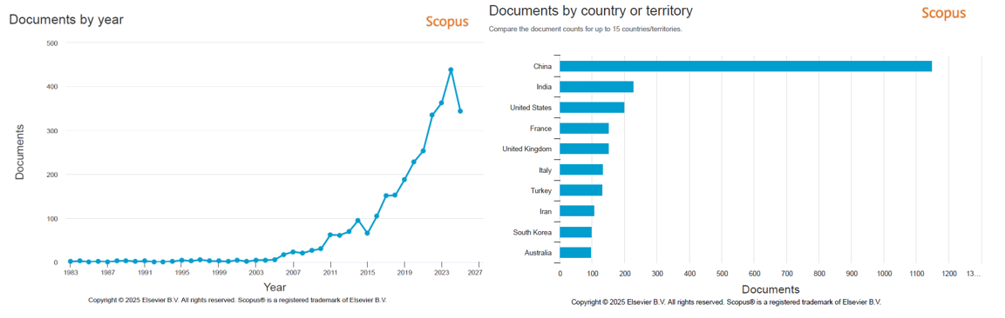
b)
a)
Figure 2.20. Scopus trends for PCM in textiles: (a) publication trends and surge from 2015; (b) country publication contributions led by major textile producers.
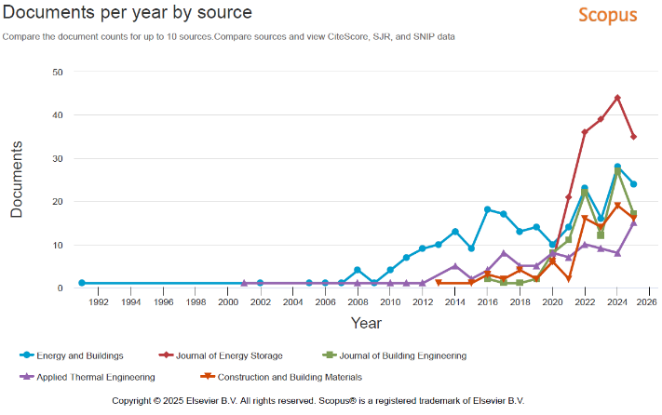
Figure 2.21a shows the trend of publications by year produced by Scopus. After a long period of low activity, publications start to climb in the late 2000s, accelerate from 2015, and show a marked surge in 2020–2024. The rise aligns with the maturity of microencapsulated PCM technologies, the growth of wearables and smart textiles, and increasing focus on mitigation in industry, defense, sport, and urban environments. Figure 2.21b shows the number of publications by country produced by Scopus. he leading contributors are large textile-producing countries (notably in Asia), followed by the United States and several European nations. This pattern reflects strong manufacturing bases, hot-climate exposure, and active programs on occupational health and advanced materials. Figure 2.22 shows the trend of documents per year by source. The chart shows a diversification of publication venues on PCMs in buildings. Energy and Buildings is the historical outlet: it grows from 2008, peaks around 2014–2017, then stabilizes. From 2021, the Journal of Energy Storage rose sharply, leading annual volumes and reaching highs in 2022–2024, indicating that PCMs are framed as storage and load-shifting technologies. The Journal of Building Engineering has grown rapidly since 2019, with peaks in 2023–2024, consistent with PCM envelope and construction integration. Applied Thermal Engineering and Construction and Building Materials show steady growth with recent highs, pointing to attention on thermo-mechanical performance and materials development. Table 2.14 compiles the most relevant contributions on the use of PCMs in textiles and cooling garments. For each article, the title, authors, source, year, citation count, and key findings are reported.
Figure 2.21. Publications by source for PCMs in textiles: Energy and Buildings; Journal of Energy Storage and Journal of Building Engineering.
Title | Authors | Source | Year | Citations | Abstract summary
Phase change materials for smart textiles - An overview | Mondal, S. | Applied Thermal Engineering, 28(11-12), pp. 1536–1550 | 2008 | Over  1,100 | How PCMs store/release latent heat; coating/encapsulation in fabrics for thermo‑regulated clothing; comfort basics, integration methods, applications, market, and challenges.
Effect of the cooling clothing integrating with phase change material on the thermal comfort of healthcare workers with personal protective equipment during the COVID-19 | Hu, C., Wang, Z., Bo, R., Li, C., Meng, X. | Case Studies in Thermal Engineering, 42, 102725 | 2023 | 53 | Human tests: PCM clothing cuts head/facial discomfort (−25%/−41% at 26 °C), lowers mean skin (~−0.65 °C), and shifts thermal sensation toward neutral at 26–32 °C.
Numerical analysis of cooling effect of hybrid cooling clothing incorporated with phase change material (PCM) packs and air ventilation fans | Wan, X., Wang, F., Udayraj | International Journal of Heat and Mass Transfer, 126, pp. 636–648 | 2018 | 98 | Validated coupled model shows hybrid garments lower clothing system, core, and mean skin temperatures versus fan‑only or PCM‑only in warm environments.
Personal cooling with phase change materials to improve thermal comfort from a heat wave perspective | Gao, C., Kuklane, K., Wang, F., Holmér, I. | Indoor Air, 22(6), pp. 523–530 | 2012 | 173 | Manikin + subject tests: torso skin −2–3 °C (≈33.3 °C) and improved thermal sensation; wearable PCM cooling can reduce AC reliance and protect vulnerable people.
Performance enhancement of hybrid personal cooling clothing in a hot environment: PCM cooling energy management with additional insulation | Udayraj, Wang, F., Song, W., ... Chow, C.S.W., Noor, N. | Ergonomics, 62(7), pp. 928–939 | 2019 | 54 | At 36 °C, RH 59%: adding insulation to PCM+fan (HYB+INS) further lowers mean skin/torso vs HYB; insulation adds little with PCM‑only (no fans).
Phase-change materials (PCMs) for warming or cooling in protective clothing | Gao, C. | Protective Clothing Managing Thermal Stress, pp. 227–249 | 2014 | 23 | Types, working principles, textile incorporation routes, effectiveness factors, applications, standards/testing, and future challenges.
Study of ultra-light modular phase change cooling clothing based on dynamic human thermal comfort modeling | Li, W., Liang, Y., Liu, C., Ji, Y., Cheng, L. | Building and Environment, 222, 109390 | 2022 | 24 | 1.39 kg garment keeps comfort ~30 min; average skin −1.10 to −1.78 °C (outdoor walking/indoor sitting & walking); modular design eases PCM re‑solidification.
Modeling the efficiency and heat gain of a phase change material cooling vest: The effect of ambient temperature and outer isolation | Mokhtari Yazdi, M., Sheikhzadeh, M., Dabirzadeh, A., Chavoshi, E. | Journal of Industrial Textiles, 46(2), pp. 436–454 | 2016 | 23 | Raising the ambient 30→40 °C can cut efficacy up to 70%; using protective clothing is feasible; insulating PCM pouches boost cooling by ~20–34%.
Table 2.14. Key studies on PCMs in textiles and cooling garments: bibliographic details and concise findings.
Table 2.15 summarizes the most influential review papers on PCMs in textiles and cooling garments. For each review, the title, authors, source, year, citation count, and principal insights are reported.

Title | Authors | Source | Year | Citations | Abstract summary
An overview of phase change materials, their production, and applications in textiles | Das, A., Apu, M.M.H., Akter, A., Reza, M.M.A., Mia, R. | Results in Engineering, 25, 103603 | 2025 | 15 | PCMs store/release heat around a set transition temperature and can be integrated into fabrics via coating or encapsulation to create thermo-regulated “smart” textiles. The review explains PCM principles, thermal comfort, and cold-weather clothing, surveys textile integration methods and recent applications, and notes market prospects alongside challenges (e.g., durability, cost, washability, and comfort trade-offs).
Research and development on phase change material-integrated cloth: A review | Shahid, M.A., Hossain, M.T., Hossain, I., ... Rabbani, M., Rahim, A. | Journal of Industrial Textiles, 54 | 2024 | 19 | PCMs offer high latent heat, narrow operating ranges, long life, and compatibility with textile processing, enabling energy savings and improved comfort. The paper reviews fundamentals, characterization, and advanced applications—from spacewear and medical dressings to sportswear, bedding, building textiles, automotive, and footwear—highlighting recent advances, remaining hurdles, and opportunities for wider deployment.
Novel personal cooling textiles revolutionizing human thermal management: principles, designs and applications | Hu, X., Li, T.-T., Shou, B., ... Ren, H.-T., Lou, C.-W. | Chemical Engineering Journal, 499, 155729 | 2024 | 15 | Driven by climate change, modern cooling fabrics combine fiber design, nanomaterials, functional coatings, and PCMs to enhance heat removal via radiation, convection, evaporation, and respiration. The review links fabric structure (porosity, spacing, networks) to comfort and mechanics, outlines measurement methods (thermal conduction, moisture/infrared properties), and flags sustainability and environmental concerns as key ongoing challenges.
Progress in application of phase-change materials to cooling clothing | Wang, F., Pang, D., Liu, X., ... Zhang, Y., Cheng, X. | Journal of Energy Storage, 60, 106606 | 2023 | 70 | Prolonged heat/humidity raises core temperature and heat-illness risk; PCM-enhanced garments buffer the microclimate by absorbing latent heat. The paper gives practical guidance: choose PCM by transition temperature, form, and composition; optimize melting point, latent heat, thermal conductivity, dosage, coverage, and placement to maximize heat dissipation; and pursue research on extending PCM lifetime, reactivating degraded PCMs, and integrating portable cooling/dehumidification modules.
Table 2.15. Influential reviews on PCMs for textiles and wearables: key bibliographic details and synthesized insights.

Clothing comfort using PCMs
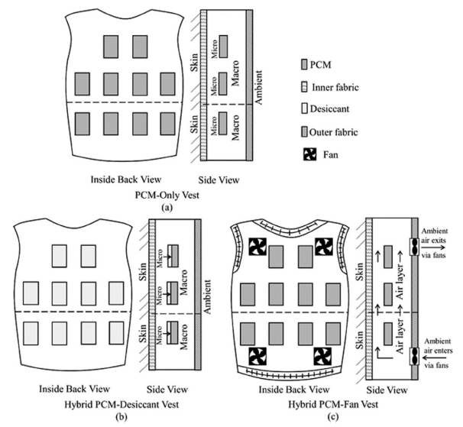
Das et al. [174] wrote a review focusing on the application of PCMs in the textile field, in which they report that under high-temperature conditions and physically demanding activities—such as those performed by firefighters, military personnel, or athletes—personal cooling systems help improve the body’s microclimate and reduce heat stress. PCMs, due to their ability to store latent heat, enable the development of “smart” textiles capable of maintaining body temperature within comfort limits. During the 2003 heatwave in France, over 15,000 deaths were attributed to dehydration and heat stroke, highlighting the importance of thermal protection solutions. Among these, vests containing PCMs (such as salts or paraffins) have proven highly effective: Gao et al. [175] observed that a PCM vest with a melting point of 24 °C provided the highest cooling rate, with an average temperature difference of about 6 °C compared to the surface of the thermal manikin, thereby reducing heat strain both in the manikin and in human subjects. For hot and humid climates, Mneimneh et al. [176] proposed a hybrid PCM–Fan system, effective under various thermo-hygrometric conditions: the PCM–Fan vest is suitable for high temperatures and low humidity, whereas under higher humidity, a PCM–dehumidifying vest is preferred. Itani et al. [177] also found that PCMs with lower melting points allow for faster cooling, while those with higher melting points provide longer-lasting effects. Fabric ventilation is a key factor for breathability and thermal comfort. Lai et al. [178] demonstrated that, in a hybrid PCM + Fan vest, the cooling rate is significantly higher when the fan is active, confirming the effectiveness of the combined system. Figure 2.23 illustrates three different configurations of cooling vests: (a) the PCM-only vest, (b) the hybrid PCM–desiccant vest, and (c) the hybrid PCM–Fan vest. The front and side views show the arrangement of the PCM packs, inner and outer fabric layers, desiccant material, and ventilation fans. The purpose of these configurations is to optimize heat exchange between the body and the environment, thereby enhancing cooling efficiency and improving the wearer’s thermal comfort under various climatic conditions.
Figure 2.22. (a) the PCM-only vest (b) the hybrid PCM–desiccant vest (c) ) the hybrid PCM–Fan vest [174].

Working Principle of PCMs in Textiles
PCMs are typically encapsulated in very small spheres before being integrated into textile materials, in order to confine them during their liquid state. These microcapsules generally range from 1 to 30 μm in diameter and are produced using melamine, urea-formaldehyde, or acrylic resins. The capsule shell accounts for about 20% of the total weight, while the PCM core represents the remaining 80%. These capsules are resistant to mechanical stress, heat, and chemicals, and they respond to temperature variations by absorbing or releasing latent heat. When the ambient temperature rises, the PCM melts, absorbing heat from the surroundings and storing it within the capsule; as the temperature decreases, the PCM solidifies and releases the stored heat. This provides several thermal benefits in textile structures:
- cooling effect during heat absorption;
- heating effect during heat release;
- thermoregulating action maintaining an approximately constant temperature;
- active heat barrier effect that regulates heat transfer between the human body and the environment, depending on activity level and ambient conditions.
A fabric treated with 22.9% microcapsules (melamine–formaldehyde capsules containing eicosane, obtained via in situ polymerization) can absorb up to 4.44 J/g of heat, slowing temperature rise within the clothing microclimate and improving thermophysiological comfort while preventing overheating [184]. Pause et al. [179] investigated heat-protective garments incorporating PCMs. When the PCM temperature exceeded its melting point (28 °C), it melted and absorbed heat energy; as it cooled below 27 °C, it solidified and released the stored heat, acting as a thermal buffer. A clothing assembly consisting of PCM-coated spunbond fabric with a conductive layer consumed 30.9% less electrical energy than a similar assembly without PCM, demonstrating that conductive fabrics combined with PCMs effectively enhance thermal regulation and overall comfort. Das et al. [181] report Table 2.16, which compares the main types of PCMs used in the textile field. The table illustrates their thermal properties, environmental impact, durability, cost, and the reasons why each type is preferred in textiles, highlighting the balance between thermal performance, sustainability, and wearer comfort.

PCM Type | Thermal Properties | Environmental Impact | Durability / Cost | Why Preferred in Textiles
Polyalcohols & Derivatives | Moderate latent heat capacity; melting and freezing suitable for body temperature regulation. | Biodegradable; low environmental impact due to natural origin. | Moderate; has good durability but can degrade under high temperatures or chemical exposure. | Preferred for their biocompatibility and regulation of body temperature; often used for wearable applications and sportswear.
Fatty Acids / Mixtures | High latent heat and narrow melting/freezing range; good for thermal buffering. | Biodegradable and often sourced from renewable resources; low environmental impact. | Generally durable but may degrade with repeated phase change cycles. Cost: Moderate. | Frequently used due to availability, renewability, and non-toxicity; it provides good thermal comfort.
Esters from Fatty Acids | Moderate thermal properties; wide range of phase change temperatures depending on formulation. | Derived from renewable sources; low to moderate environmental impact. | Typically stable under repeated phase changes, but some degradation may occur under extreme conditions. | Their renewable origin and tunable properties make them advantageous for textile applications.
Animal & Plant-based Fatty Acids | High latent heat capacity; maintains constant temperature within a defined range. | Renewable, biodegradable, low carbon footprint; plant-based sources more sustainable than animal-based. | Generally safe and stable under multiple phase cycles; some animal-based options may degrade faster. | Preferred for sustainable textile applications where eco-friendliness is critical.
Organic PCMs | Broad melting point range; excellent thermal storage properties for specific temperature ranges. | Low environmental impact when derived from natural sources; synthetic types may have a higher carbon footprint. | Durable and stable over repeated cycles; performance can diminish under extreme conditions. Cost: Moderate to high. | Widely used due to chemical stability and customizability; organic PCMs enable flexible textile integration.
Organic Paraffin | High latent heat with well-defined phase change temperature; efficient at storing and releasing heat. | Derived from petrochemicals; non-biodegradable and higher environmental impact than natural PCMs. | Highly durable and stable over numerous phase cycles; resistant to chemical and environmental degradation. | Preferred for durability and reliability in high-performance textiles; cost-effective despite environmental concerns.
Inorganic PCMs | Very high latent heat capacity with a wide range of phase change temperatures (e.g., salts, salt hydrates). | Can have a high environmental impact; some are non-renewable. | Very durable under certain conditions, but can corrode or degrade if exposed to moisture or extreme conditions. | Less common in clothing; used in industrial or protective textiles where high thermal storage is needed.
Table 2.16. Textile PCM types with thermal properties, environmental impact, durability/cost, and reasons for preference in garments.

Performance evaluation of PCMs cooling garments
Rahimi et al. [180] report that cooling systems based on PCMs are energy-efficient, portable, and impose minimal movement restrictions. In PCM-based garments, these materials are embedded in various parts of the clothing to enhance thermal comfort [181]. PCMs act as passive localized cooling media, typically integrated into specific areas such as collars, helmets, or upper-body garments. They are usually enclosed in separate packages distributed across the garment, with the total weight of a PCM cooling vest reaching up to 3 kg [182]. Figure 2.24 shows the PCM packages and their placement within a cooling jacket, illustrating how the cooling elements are strategically positioned to maximize heat absorption and comfort.
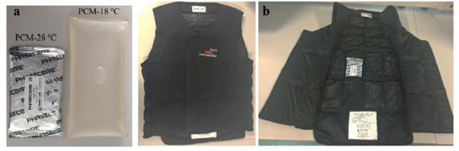
Figure 2.23. PCM cooling vest: (a) example PCM packs and (b) front/interior views showing pack placement to maximize heat absorption and wearer comfort [180].
PCM vests are widely used due to their practicality and cost-effectiveness. Experimental and modeling studies have evaluated their physiological effects under controlled temperature and humidity conditions. Research indicates that cooling garments improve both physiological and cognitive responses in hot environments [183] Chou et al. [184] tested different PCMs (ice, PCM5, PCM20) during firefighter exercises and found that PCM20 offered the best performance in reducing physiological strain.. Further human trials confirmed that PCM vests containing Glauber’s salt (Na₂SO₄·10H₂O) effectively reduce core and skin temperatures during high-heat exposure, improving thermal comfort without affecting heart rate [185]. During exercise, the rectal temperature continued to rise, but during recovery, it increased more slowly when wearing a PCM vest. The mean skin temperature dropped by about 1–1.5 °C, especially with the 24 °C vest, which also improved thermal sensation and reduced heart rate compared to the 28 °C model [186]. Tests with Glauber’s salt PCMs showed that lower melting points provide greater cooling under hot–humid conditions [187]. House et al. [188] determined that a vest melting at 10 °C offered the best balance between cooling performance and comfort. Further studies confirmed that PCM vests, particularly hybrid PCM–fan systems, effectively lower core and skin temperatures, heart rate, and perceived heat strain in both laboratory and field conditions [189]. Overall, PCMs with melting points between 10 °C and 28 °C proved most suitable for maintaining thermal comfort during activity and recovery [190].

Application of PCMs integrated in clothing
Shaid et al [191] report the application of PCM-integrated clothing (PCMIC). This application has grown significantly across multiple sectors due to its ability to regulate temperature and enhance wearer comfort. These smart textiles combine conventional fabrics with PCMs capable of absorbing, storing, and releasing heat according to environmental and body temperature variations. As a result, PCM-based garments have found widespread use in space wear, medical and protective textiles, sportswear, bedding, automotive interiors, and flame-retardant fabrics, among others. Their adaptive thermal behavior makes them particularly suitable for environments requiring controlled microclimates and protection from thermal stress, as illustrated in Figure 2.25.
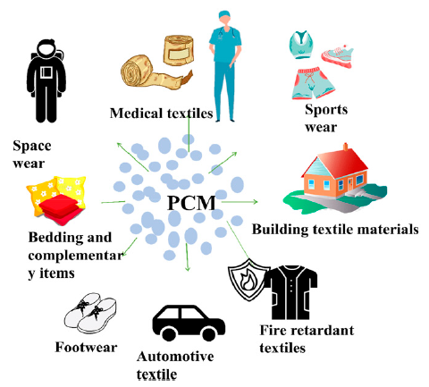
Figure 2.24. Application of PCMs integrated in clothing [191].
Table 2.17 summarizes the main applications of PCMs integrated into textiles, highlighting for each sector the developed products and the most active companies in the field. The applications range from space and medical wear to technical, sports, and automotive textiles, demonstrating the versatility of PCMs in enhancing thermal comfort and safety across various industrial contexts.
Applications area | PCM incorporated products | Popular developers
Space wear | Space suits and gloves. | NASA, ESA, Roscosmos, Space X, Boeing.
Medical textile | Bandages, gown tops, bedding, gloves, blankets, nappies, and surgical gowns are all available. | 3M Health Care, Smith & Nephew, Johnson & Johnson, Paul Hartmann AG, Halyard Health.
Sporting goods | Gloves for ice climbing, active wear, and underwear for cycling and running. | Nike, Adidas, Puma, Reebok, Salomon.
Fire-retardant cloths | Gloves and suits for firefighters. | DuPont, Milliken & Company, TenCate Protective Fabrics, Teijin Aramid, Glen Raven Technical Fabrics.
Bedding and other accessories | Mattress covers, pillows, sleeping bags, and blankets. | Tempur-Pedic, Sleep Number, Sealy, Serta, Simmons.
Building textile materials | Architecture structure embedded in concrete. | Saint-Gobain, Owens Corning, DuPont, BASF, Sika AG.
Automotive textile | Automobile interiors and seat covers. | Lear Corporation, Audient, Faurecia, Yanfeng Automotive Interiors, Autoneum, Sage Automotive Interiors, Seiren Co. Ltd.
Footwear textile | Hiking boots, skiing boots, golf shoes, and driver boots. | Reebok, Salomon, Asics, Hoka One One, Brooks Running.
Table 2.17. Application area of integrated clothing, products, and developers of PCMs.
Space wear. PCM-integrated space suits can significantly improve astronaut comfort and performance by regulating temperature and reducing fatigue during long missions. These garments offer high thermal storage without compromising mobility, enhancing both physical and mental well-being in extreme conditions. Future designs will focus on ergonomics, moisture control, and customization, making PCMIC suits essential for extended space exploration once material reliability and integration challenges are addressed.
Medical textile. PCM-integrated medical textiles offer advanced thermal regulation, maintaining comfortable skin temperature for applications such as bandages, surgical garments, and patient bedding. Ongoing research focuses on improving washability, durability, and thermal efficiency. These smart materials show strong potential in healthcare, rehabilitation, and wearable monitoring, where integration with sensors could enable personalized heat management and real-time health tracking.
Sporting goods. PCM-integrated sportswear helps regulate athletes’ body temperature, preventing overheating or overcooling. Research focuses on improving durability, breathability, and moisture control while maintaining thermal efficiency. Despite challenges in cost and large-scale production, advances in coating and weaving technologies, along with smart sensors for adaptive thermal regulation, are enhancing performance and comfort.
Bedding. PCM-integrated bedding, such as duvets, pillows, and mattress covers, enables active thermal regulation by absorbing excess body heat and releasing it as the temperature drops, maintaining comfort during sleep. Recent developments focus on improving temperature control and durability, with applications also extending to hospital bedding for enhanced patient comfort.
Fire-retardant clothes. PCM-integrated fire-retardant fabrics (PCMIC) help maintain a safe internal temperature, improving comfort and protection in extreme heat. Advances in PCM technology and fabric engineering have enhanced flame resistance, durability, and wearer comfort, making these materials particularly effective for firefighting and thermal protective clothing.
Automotive textiles. In the automotive sector, PCMICs are used to regulate cabin temperature by storing and releasing heat, improving passenger comfort and thermal management efficiency. Recent advancements include optimized PCM compositions, fabric engineering, and smart integration for enhanced performance.

Environmental impact and safety of PCMs
PCMs used in textiles for thermal regulation differ in environmental impact depending on their composition. Organic PCMs, derived from renewable plant or animal sources, are more sustainable and emit fewer greenhouse gases [192], while inorganic and synthetic PCMs, often petrochemical-based, have higher emissions and are non-biodegradable [193]. Recycling PCM textiles remains difficult due to the inseparability of materials [194]. Recent advances include the development of bio-based and recyclable PCMs [195], which help reduce fossil fuel dependency and emissions, as well as energy savings during use through improved heating and cooling efficiency [196]. However, achieving full sustainability will require further progress in recycling technologies and green manufacturing processes. The integration of PCMs into textiles, especially those in direct contact with the skin, raises important safety concerns. In general, microencapsulated PCMs are considered safe for skin contact, since the active material is enclosed in protective shells that prevent leakage or degradation during normal use. Organic PCMs, such as bio-based fatty acids or paraffins, are generally harmless when properly encapsulated, whereas inorganic PCMs, such as salt hydrates, may cause skin irritation and are therefore mainly used in applications with limited skin contact, such as industrial workwear or insulating materials [197]. A major concern relates to the durability of the encapsulation, which may degrade over time due to repeated washing or environmental stress, potentially leading to PCM leakage and skin irritation. For this reason, manufacturers perform stability and durability tests to ensure material safety under long-term usage conditions [198].

Future reasearch directions
From the analysis of the reviews by Shahid et al. [199] and Das et al. [181], it can be understood that PCM-Integrated Clothes (PCMIC) and Personal Phase Change Garments (PPCGs) represent a rapidly evolving field with significant potential for improving personal thermal comfort, energy efficiency, and environmental sustainability. Future research should primarily focus on the development of novel composite PCMs with higher energy storage density and improved heat absorption efficiency, as well as on the optimization of PCM pack design, taking into account key parameters such as PCM mass, coverage area, and layer thickness. Another promising direction involves the combined use of PCMs with different melting temperatures to meet the specific cooling needs of different body areas, and the integration of active cooling and dehumidification systems to create portable, efficient, and durable garments. Market prospects are also highly promising: according to Strategic Market Research [199], the global PCM market, valued at USD 1.66 billion in 2021, is expected to reach USD 5.1 billion by 2030, representing a compound annual growth rate (CAGR) of 15%. Companies such as Outlast Technologies LLC, Cocona Inc., and Phase Change Energy Solutions Inc. are leading innovation in PCM-coated textiles, providing advanced solutions for thermal regulation and energy efficiency, with strong potential for expansion into emerging market.

Patents review
To complete the analysis of phase change material applications, the study was extended to include a patent search. For this purpose, the Google Patents platform was used with the following search query:
“(Phase change material) AND energy status:GRANT language:ENGLISH type:PATENT”
The results were then filtered by considering only patents granted in the period 2015–2025 and were ordered by relevance. A systematic reading of the abstracts was subsequently carried out to assess their actual relevance to PCM energy applications and to select only the most significant cases. Table 2.18 summarises the main patents identified, reporting for each one the assignee, inventors, patent number and year of publication, title, a brief summary of the invention, and a representative image of the invention layout.
By analysing the patents, it becomes clear how phase change materials are deployed across different fields – thermal and electrochemical batteries, photovoltaics, buildings, packaging and even electronics – and what the genuinely innovative elements are in each case.
For thermal batteries, PCM is no longer conceived as a simple “heat tank”, but as part of advanced energy management systems. The invention by John Field and co-authors introduces a network of “heat batteries”, consisting of multiple storage banks with different operating temperature ranges, connected as nodes and edges of a thermal graph. In this perspective, PCM becomes the key to exploiting excess or low-grade waste heat, stored in “cold” banks and, when needed, transferred to hotter banks via heat pumps, while a central controller selects, at each step, the most efficient exchange configuration. Andrew John Bissell et al. (Sunamp) focus instead on the internal control of the battery, systematically linking case pressure and temperature to the solid/liquid fraction of the PCM: these quantities become true indicators of state of charge, supported by specific design solutions for expansion management and by stackable casings with optimised heat exchangers, so as to obtain robust, sealed and “measurable” modules, ready to be integrated into complex systems. Still in the area of thermal storage, but at the building–grid scale, Xiaobing Liu and co-authors propose a system in which a “battery” tank is placed inside an underground “reservoir” tank, separated by a wall that contains PCM with a critical temperature chosen close to the undisturbed ground temperature. The phase boundary thus moves within the thickness of the wall during charge and discharge, stabilising the system temperature and exploiting the ground as a source/sink. The system is designed to operate in different daily modes (charging with a heat pump off-peak, discharging during peak hours, combined use of the reservoir in the evening), with the explicit aim of flattening the electrical load profile and mitigating the “duck curve” using a shallow, low-cost geothermal reservoir. In the automotive field, David Karl Bidner et al. tackle the problem of correctly estimating the state of charge of a thermal battery integrated into the cooling circuit: the refrigerant flow is temporarily stopped to allow thermal equilibrium between PCM, structure and fluid, and only then is the outlet temperature used – together with the known properties of the PCM – to infer the state of charge. This scheme, embedded in a complete thermal management circuit with exhaust heat recovery, enables a more reliable control of the stored energy. Alongside thermal batteries, Jie Liu proposes an original use of PCM in Li-ion batteries: the central mandrel of cylindrical cells is turned into a sealed metal mandrel filled with PCM, placing the storage material directly inside the cell, close to the hottest regions, without substantially changing the manufacturing process. The reported results show reduced peak temperatures and improved temperature uniformity compared to solutions with external PCM, with less cooling material and the possibility of using multiple PCMs with different melting points to “tune” the thermal response of the battery pack.
In the photovoltaic sector, the patents examined shift the focus from simple module cooling to a functional integration between PCM and the PV system. Reyad I. Sawafta et al. (Phase Change Energy Solutions) propose composite building panels that act as an active underlayment for roofing membranes and PV modules: PCM is distributed in multi-region mats and can be combined in layers with different transition temperatures to obtain synergistic effects. The spacers define air channels that may be passive, ventilated, or sealed, and the same structure integrates flame-retardant materials and extinguishing agents, up to filling hollow spacers with PCM or fire-fighting media. The result is a building envelope component that combines thermal control, mechanical support for PV modules, air-flow management and safety functions. Irshad and co-authors go one step further by defining a hybrid PV–PCM–TEG module: a tailored composite PCM (PEG–MgCaCO₃ with a melting range in the typical operating temperature band of PV modules) is contained in a copper housing, coupled to a full-area aluminium plate that evens out the heat flux at the back of the panel, while the cold side hosts thermoelectric generators and a water-cooled heat sink with coil, fins and fan. The device is built as a modular cartridge, with a dual junction box for PV power and thermoelectric power, designed for both new installations and retrofit; the reported experimental results, in terms of temperature reduction and efficiency gain, are consistent with the material and system-level design choices.
In the building sector, the patents highlight both the development of new PCM composites and their integration into construction systems. Zhengguo Zhang, Xiaoming Fang and Lulu Fu directly address the limitations of hydrated salt PCMs (supercooling, phase separation, leakage) by proposing composites in which the salt is adsorbed in porous carriers, combined with nucleating agents and coated with light-cured, fire-resistant and corrosion-resistant resins. The resulting boards are inserted into complete wall build-ups, and tests in experimental rooms show a significant reduction in indoor temperature swings and a phase shift of the peak compared to traditional walls. Sheldon Q. Shi, Weihuan Zhao and Liping Cai (US 11,352,783) instead propose a technological framework to impregnate molten PCM under pressure into porous insulating materials, in particular bio-based supports such as kenaf/hemp woody core, obtaining standard panels (e.g. SIPs) that combine insulation and latent storage with an effective R-value higher than conventional foams. The patent explicitly addresses leakage and fire performance through binders, surface coatings and flame-retardant additives, and shows how the same approach can be applied both to the building envelope and to refrigerated compartments. In this context, the composite panel by Sawafta et al., although conceived as a PV underlayment, is in all respects a building envelope component with integrated thermal, mechanical and safety functions.
In thermal packaging and the cold chain, the patent by Byron Craig Owens and Reyad I. Sawafta (Vesture LLC) illustrates how PCM can be incorporated into containers for transporting foodstuffs and medical products, with a combined focus on thermal performance and logistical constraints. Thermoformed non-woven walls provide insulation, breathability and dimensional stability, limiting condensation problems; PCM, integrated into the fabric or placed in pouches/liners, is selected with different transition temperatures to cover both hot and cold applications. The system is designed to operate even in fully passive mode, using heat exchange with the product to bring the PCM into the desired range, while the foldable geometry and reversible closures make the containers reusable and compatible with handling and storage requirements.
Finally, the invention by Didier Belot et al. (CEA) is a significant example of PCM application in RF electronics. Here the PCM is not used for heat storage, but as the active element of a radio-frequency switch: the material is laid out in a continuous, elongated portion, heated locally by currents flowing transversely between distributed electrodes, so as to ensure a uniform phase transition and thus good ON and OFF performance. The heating currents are kept separate from the RF path, and control through MOS current sources driven by a single signal makes it possible to optimise the trade-off between resistance, parasitic capacitance and line losses. This example shows how the logic of PCM use is extending beyond thermal storage, towards reconfigurable devices in high-frequency electronics.

Assignee/Inventors | Patent No. | Date | Title | Brief Invention Summary | Invention Layout
Sunamp Limited (GB)/ J. Field, A. Bissell | US 11,378,282 B2 | 2022 | Energy storage system | Thermal energy storage system using modular banks filled with PCMs, designed to store heat or cold from various sources at different temperature levels and supply heating and/or cooling on demand, especially in buildings and domestic hot-water systems. | 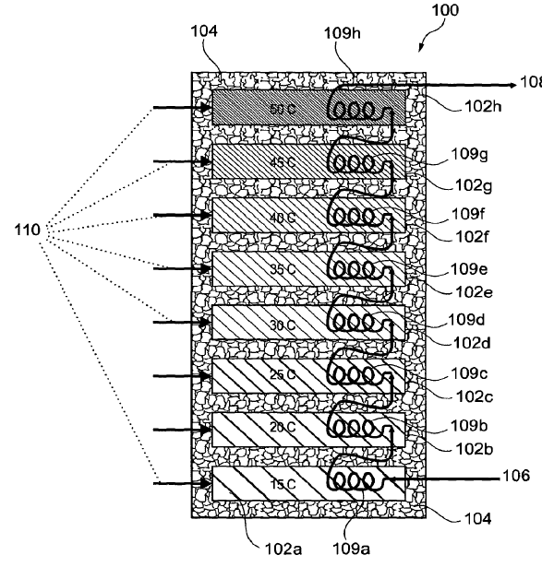  Figure 2.25. Schematic representation of an energy storage system according to a first embodiment of the present invention.
Sunamp Limited (GB)/ A. John ,S.S. Gataora, ,M. Zaglio | US 11,428,477 B2 | 2022 | Heat battery assemblies and monitoring system therefor | Heat battery system comprising one or more phase-change-material (PCM) heat battery assemblies with internal heat exchangers, combined with a monitoring and control system that uses temperature, pressure and flow sensors to estimate state of charge and stored thermal energy and to protect the batteries from over-pressure and unsafe operating conditions. | 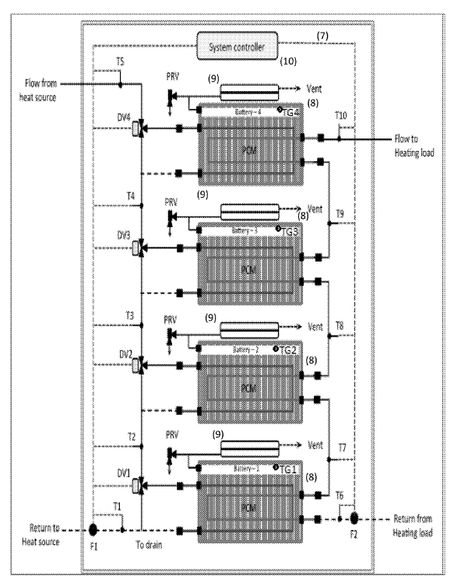  Figure 2.26. Schematic view of a thermal storage system according to John's patent.
U T -Battelle, LLC (US ), University of Tennessee Research Foundation (US)/ X.Liu, M. Qu, J.K. Warner, L.Shi | US 11,421,914 B2 | 2022 | Thermal storage system with coupled tanks | Thermal storage system with a fluid-filled “battery” tank placed inside an underground fluid-filled “reservoir” tank and connected to a heat pump and a building by configurable fluid loops, so that heating or cooling can be stored and supplied in different operating modes to shift electricity demand and improve overall efficiency; PCMs can be integrated in the tanks or tank wall to regulate temperature. | 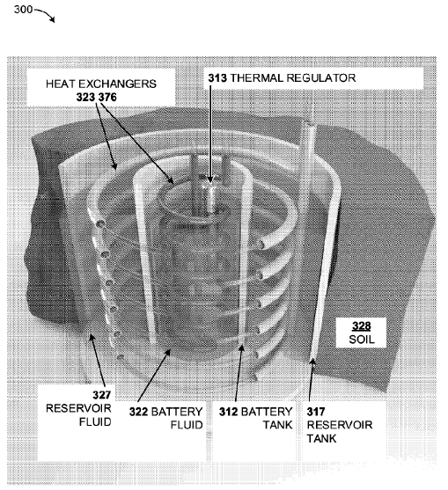  Figure 2.27. Cutaway view of an example dual tank embodiment of the disclosed technologies.
Phase Change Energy Solutions, Inc. (US)/ R.I. Sawafta, K. Farrish, B.C. Owens, P.F. Horwath, J.D. Thornsberry | US 11,519,171 B2 | 2022 | Composite construction panels and applications therof | Composite construction panels containing mats with multiple PCM regions or pouches, arranged between substrate and cover layers, to provide thermal regulation for roofs, ceilings or underlayments, optionally using different PCMs with different phase transition temperatures. | 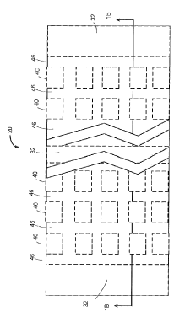  Figure 2.28. Top view of a composite panel according to a first example embodiment according to Sawafta's patent.
Commissariat a l’energie atomique et aux energies alternatives (FR)/ D. Belot, A. Larie, B. Martineau | US 10,164,608 B2 | 2018 | Switch with phase change material | RF switch using a continuous PCM portion whose amorphous or crystalline state determines the ON/OFF state of the switch, with a control circuit that drives heating currents through the PCM to induce phase changes while keeping good RF performance. | 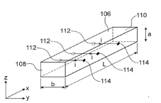  Figure 2.29. PCM portion of a switch according to one particular embodiment.
Vesture LLC (US)/ B.C. Owens, R.I. Sawafta | US 11,549,745 B2 | 2023 | Product transport containers | Product transport containers made of thermoformed non-woven fabric, in which the fabric and/or internal pouches incorporate PCMs with selected phase transition temperatures, so that food or medical products can be kept hot or cold for extended periods without active heating or cooling. | 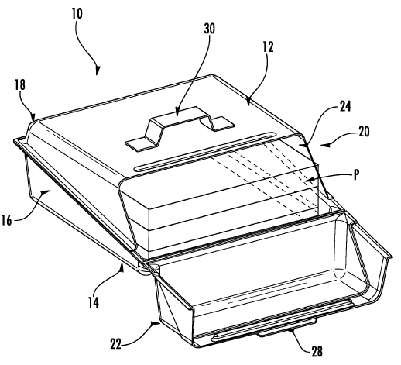  Figure 2.30. perspective view of a product transport container according to one embodiment described herein wherein the container is illustrated in an open position.
J.Liu (CA)/ J. Liu | US 10,916,816 B2 | 2021 | Internal battery thermal management system for secondary batteries | Rechargeable battery and battery pack with an internal battery thermal management system based on a sealed mandrel filled with PCM, placed inside the Li-ion cell to absorb heat and improve temperature uniformity, achieving lower peak temperature with less PCM and without expensive graphite matrices compared to external PCM. | 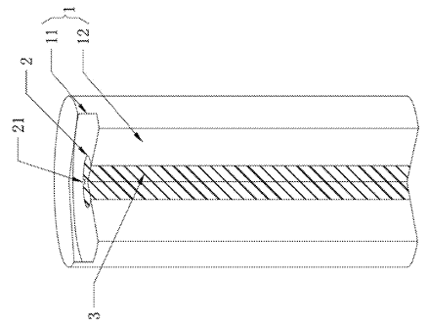  Figure 2.31. Three-dimensional (3D) perspective cross-section of a cylindrical Li-ion battery exploiting a PCM based internal BTM system according to an embodiment of the invention.
King Fahd University of Petroleum and Minerals (SA)/ K.Irshad, H.Zahir | US 12,113,143 B2 | 2024 | Phase change photovoltaic thermal management device | Thermal management device for a photovoltaic panel using a PCM layer attached to the back of the panel, combined with a thermoelectric generator and a water-cooled heat sink, to store heat, convert part of it into electricity and reduce panel temperature, thereby increasing overall PV efficiency. | 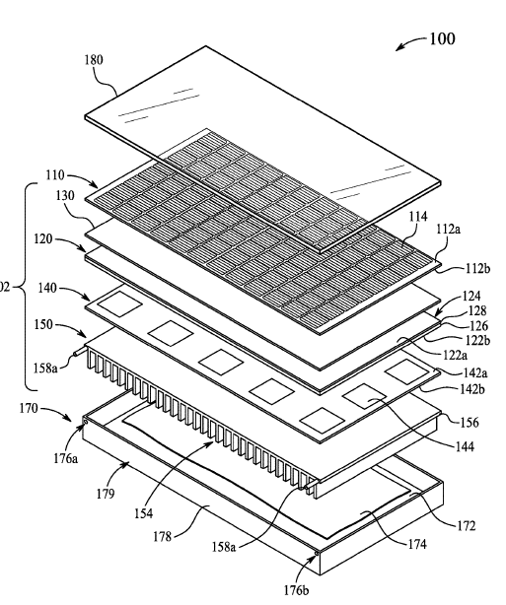  Figure 2.32. Perspective exploded diagram of the thermal management device, according to certain embodiments.
Ford Global Technologies LLC (US) / D. K. Bidner, W. C. Cole, P. Bonkoski, S. Katragadda, M. Levin | US 11,518,212 B2 | 2022 | Systems and methods for thermal battery control | Vehicle thermal battery system including a thermal storage device with two PCMs having different melting points, and control methods that estimate battery state of charge from coolant temperature and PCM properties to more accurately store and release heat for warming engine, cabin and other vehicle components | 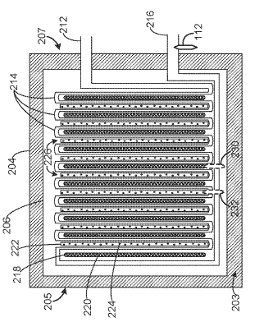  Figure 2.33. Example of the thermal storage device of vehicle's thermal management system.
South China University of Technology (CN) / Z. Zhang, X. Fang, L. Fu | US 11,530,880 B2 | 2022 | Phase-change energy-storage structure for building insulation | Building wall structure incorporating a shaped phase-change energy-storage insulation board made of an inorganic hydrated-salt composite PCM in a porous carrier, encapsulated in a fire-resistant resin and packaging sheet, to store coolness from outdoor night air and release it indoors during the day, improving thermal inertia and reducing energy use. | 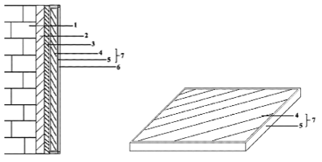  Figure 2.34. Diagram of the phase-change energy-storage structure for building insulation and of the shaped phase-change energy-storage insulation board.
University of North Texas (US)/ S.Q. Shi, W.Zhao, L.Cai | US 11,352,783 B2 | 2022 | Fabrication of a phase change material (PCM) integrated insulation | Method of fabricating composite insulation in which a melted PCM is impregnated into porous insulating materials (e.g. biomass fibers, foams) or stored in containers to form panels that combine conventional insulation with latent heat storage, increasing effective R-value and improving energy performance in building envelopes and refrigerated compartments. | 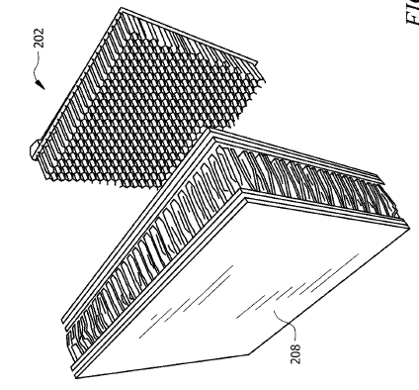  Figure 2.35. Illustration of an embodiment of a microencapsulated PCM honeycomb wallboard.
Table 2.18. Selection of recent patents on PCM for energy applications.

PCM Models

Introduction to the Stefan problem
A Stefan problem is a specific type of boundary value problem for a partial differential equation that describes heat distribution in a medium undergoing a phase change. Since the evolving interface is a priori unknown, part of the solution consists precisely in determining its position. A classical example is the diffusion of heat during the melting of ice: as melting progresses, the boundary between ice and water changes its position. To obtain a unique solution for a Stefan problem, two boundary conditions are required: one to determine the a priori unknown interface and another to define an appropriate condition on the fixed boundary. Although it is not possible to provide a single, general formulation of this type of problem, some common characteristics can be identified:
- heat distribution and heat transfer are described by differential equations;
- there exists a well-defined interface (or phase-change boundary) between two or more distinguishable phases;
- the temperature of the interface is a priori known.
The first known study on heat diffusion in a medium undergoing a phase change was published in 1831 by the French mathematicians Gabriel Lamé and Benoît Paul Émile Clapeyron. The problem considered involved the cooling of a liquid occupying the half-space $x>0$and the determination of the thickness of the solid crust formed, with a constant boundary condition at $x=0$. Almost sixty years later, in 1889, the issue was revisited and formulated in a more general way by the Austrian physicist and mathematician Joseph Stefan, who published four papers describing mathematical models for real physical problems involving phase change. This was the first systematic study of such problems, and since then, equations involving a moving or free interface during melting or solidification have been known as Stefan problems. Among the four papers published by Stefan, the one that attracted the most attention was dedicated to the formation of ice in polar seas. However, the mathematical solution he presented had already been found in 1860 by the German physicist and mathematician Franz Ernst Neumann, and it is now known as the Neumann solution. During a phase change (melting or solidification), a discontinuous change occurs in the material’s properties, and a latent heat appears; energy is exchanged without a temperature change. By applying the conservation of energy, Eq. (29), to a control volume
$$\frac{d}{dt}​\int{udV}=-\int{div F} (29)$$
The result is Eq. (30)
$$u_{t}=-div F (30)$$
It follows that the time variation of the heat density equals the net outgoing heat flux. The heat flux $F$is proportional to the negative temperature gradient, Eq. (31)
$$F=-α∇u (31)$$
where $α$is the thermal diffusivity. Combining these relations gives the differential form of the heat equation, Eq. (32):
$$u_{t}=αΔu (32)$$
which describes thermal diffusion and forms the mathematical basis of the Stefan problem.

Stefan problem
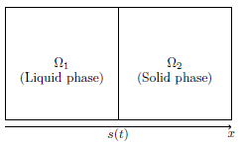
Figure 3.1. Stefan Problem control volume.
Figure 3.1 shows the control volume. The interface is denoted by $x=s\left(t\right)$, and the temperature at this boundary is constant, equal to the phase-change temperature $u_{m}$. The two regions, liquid ($Ω_{1}$) and solid ($Ω_{2}$), are separated by this interface, whose position varies with time. During melting (interface moving to the right), the heat absorbed in the phase change is written as follows, Eq. (33):
$$Q=S\left[s\left(t_{1}\right)-s\left(t_{0}\right)\right]ρH_{F} (33)$$
Where S is the surface area, $ρ$is the density, and $H_{F}$the specific latent heat. By energy conservation, this heat must equal the net heat flux entering and leaving the two phases, expressed in terms of the spatial temperature gradients and the thermal conductivities $K_{L}$and $K_{S}$. Applying the Mean Value Theorem for integrals and taking the limit for infinitesimal time intervals yields the differential relation Eq. (34) linking the velocity of the interface to the difference between the temperature gradients in the two phases:
$$H_{F}ρ\frac{ds}{dt}=K_{S}\frac{∂u_{S}}{∂x}\left(s\left(t\right),t\right)-K_{L}\frac{∂u_{L}}{∂x}\left(s\left(t\right),t\right) (34)$$
This equation is the Stefan condition, representing the boundary condition on the free interface: the velocity of the moving boundary is proportional to the difference in heat flux between the solid and liquid phases. The one-dimensional one-phase Stefan problem can be represented as a semi-infinite solid medium, for example, a thin block of ice occupying the domain $0≤x<∞$at the solidification temperature $u=0$. It is assumed that the volume of the material does not change during the phase transition. At the fixed boundary $x=0$, a thermal condition is imposed, which can be either constant or time-dependent. The objective of the problem is to determine the temperature distribution in the liquid phase and the position of the moving boundary $s\left(t\right)$ that separates the liquid and solid phases. Since the temperature in the solid phase is assumed to remain constant, the problem is called a one-phase problem, because the unknown temperature field exists only in the liquid region.
LIQUID REGION $0≤x<s\left(t\right)$
$\frac{∂u}{∂t}=\frac{K_{L}}{C_{L}ρ}\frac{∂^{2}u}{∂x^{2}}=α_{L}\frac{∂^{2}u}{∂x^{2}}$ The heat equation $0≤x<s(t)$
$u\left(0,t\right)=f(t)$ Boundary condition
$u\left(x,0\right)=0$ Initial condition
THE SOLID REGION
$u\left(x,t\right)=0$ for all t, $x≥s(t)$
THE FREE BOUNDARY $x=s(t)$
$H_{F}ρ\frac{ds}{dt}=-K_{L}\frac{∂u}{∂x}$ Stefan condition
$s\left(0\right)=0$ Initial position of surface
$u\left(s\left(t\right),t\right)=0$ freezing temperature

Table 3.1. Boundary conditions.

The problem is made dimensionless by introducing the scaled variables according to the following relations:
$$u→av, \\ t→γτ, \\ α=γ^{2}=a,$$which simplifies the original system. A single dimensionless parameter appears, linking the latent heat to the thermal conductivity, Eq. (35).
$$β=\frac{H_{F}ρ}{k_{L}} (35)$$The final dimensionless form of the problem becomes a simpler form suitable for mathematical and numerical analysis, Eqs. (36)-(39)
$$u_{t}=u_{xx} (36) \\ u\left(0,t\right)=f\left(t\right) (37) \\ u\left(x,0\right)=0 (38) \\ β\frac{ds}{dt}=-u_{x}\left(s\left(t\right),t\right) (39)$$the similarity solution of the one-dimensional one-phase Stefan problem is derived, considering the boundary condition $u(0,t)=u_{0}$. The system of equations describing the phenomenon is described by Eqs. (40)-(44):
$$u_{t}=α_{L}u_{xx} (40) \\ u\left(s\left(t\right),t\right)=0 (41) \\ H_{F} ρ\frac{ds}{dt}=-K_{L}u_{x}\left(s\left(t\right),t\right) (42) \\ s\left(0\right)=0 (43) \\ u\left(0,t\right)=u_{0} (44)$$To obtain an analytical solution, a similarity variable is introduced as follows, Eq. (45):
$$ξ=\frac{x}{\sqrt{t}} (45)$$which reduces the problem to a single independent variable. The solution is then assumed in the form of Eq. (46)
$$u\left(x,t\right)=F\left(ξ\right) (46)$$
Substituting this form into the heat equation yields a second-order ordinary differential equation, Eq. (47):
$$\frac{d^{2}F}{dξ^{2}}+\frac{ξ}{2α_{L}}\frac{dF}{dξ}=0 (47)$$
which can be integrated to give Eq. (48)
$$F\left(ξ\right)=A\operatorname{erf}\left(\frac{ξ}{2\sqrt{α_{L}}}\right)+D (48)$$where erf denotes the error function. Applying the boundary conditions allows for determining the integration constants. From $u(0,t)=u_{0}$, we have $D=u_{0}$, while from $u\left(s\left(t\right),t\right)=0$ we obtain Eq. (49)
$$A=\frac{0-u_{0}}{\text{erf}(λ)} (49)$$where $λ$ is written in the following Eq. (50)
$λ=\frac{s(t)}{2\sqrt{α_{L}t}} 50)$
Since $A$ is constant, $λ$must also be constant, and therefore, the moving boundary can be expressed as Eq. (51)
$$s\left(t\right)=2λ\sqrt{α_{L}t} (51)$$E
The complete solution of the problem is written in Eq. (52) and Eq. (53):
$$u\left(x,t\right)=u_{0}-\frac{u_{0}}{\text{erf}\left(λ\right)}\operatorname{erf}\left(\frac{x}{2\sqrt{α_{L}t}}\right) (52) \\ s\left(t\right)=2λ\sqrt{α_{L}t} (53)$$Finally, applying the Stefan condition yields a transcendental equation, Eq. (54), for determining $λ$:
$$λe^{λ^{2}}\text{erf}\left(λ\right)=\frac{K_{L}u_{0}}{ρ_{l}\sqrt{πα_{L}}}=\frac{St_{L}}{\sqrt{π}} (54)$$where $St_{L}$is the Stefan number, representing the ratio between sensible and latent heat, Eq. (55)
$$St=\frac{C_{L}\left(T_{L}-T_{m}\right)}{H_{f}} (55)$$
The Stefan problem admits a similarity solution that depends on the variable $ξ=x/\sqrt{t}$. The moving interface grows proportionally to $\sqrt{t}$, and the proportionality constant $λ$is determined from the transcendental equation involving the Stefan number. This form of the solution shows how the melting front’s evolution depends on the material’s thermophysical parameters and on the energy balance between heat conduction and phase change.
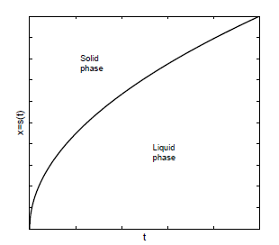
Figure 3.2. Evolution of the free boundary,
Figure 3.2 shows the evolution of the free boundary $x=s(t)$, which separates the solid phase from the liquid phase. It can be observed that the position of the interface increases over time with a nonlinear trend, proportional to $\sqrt{t}$. This behavior reflects the nonlinear nature of the Stefan problem: the velocity of the moving boundary depends nonlinearly on the temperature gradient, since the heat flux and the position of the interface are closely coupled. In other words, the evolution of the boundary does not follow a constant rate but gradually slows down, as shown by the curve, due to the dynamic balance between heat conduction and latent heat of fusion.

Neumann solution
Neumann extended Stefan’s classical formulation to the two-phase phase-change problem. In this more realistic version, the material initially exists in the solid state, and the process considered is melting. Unlike the original Stefan problem, the initial temperature of the solid does not coincide with the melting temperature, and during the phase transition, the temperature is not held constant at the melting point. Let us consider a semi-infinite slab $(0<x<∞)$, initially at a uniform temperature $T_{s}$, which is lower than the melting temperature $T_{m}$. Assuming that the thermophysical properties remain constant, the mathematical formulation of the problem can be expressed as follows:
$\frac{∂T_{L}}{∂t}=α_{L}\frac{∂^{2}T_{L}}{∂x^{2}}$ Heat conduction in liquid region
$\frac{∂T_{S}}{∂t}=α_{S}\frac{∂^{2}T_{S}}{∂x^{2}} α$ Heat conduction in solid region
$T\left(s\left(t\right),t\right)=T_{m}$ Interface temperature
$k_{s}\frac{∂T_{S}}{∂x}-k_{L}\frac{∂T_{L}}{∂x}=H_{F}ρ\frac{ds}{dt}$ Stefan condition
$T\left(x,0\right)=T_{s}<T_{m}$ Initial condition
$T\left(0,t\right)=T_{L}>T_{m}$ Boundary conditions
$T\left(x,t\right)=T_{S}$

Table 3.2. Mathematical formulation of Neumann's problem.

Figure 3.3. Space-time behaviour of the problem.

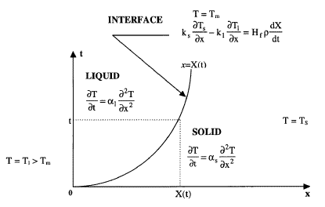

Figure 3.3 shows the space–time behavior of the problem, highlighting the evolution of the liquid and solid regions and the movement of the interface over time. Neumann obtained an analytical solution to this two-phase problem by introducing a similarity variable in Eq. (56)
$$η=\frac{x}{2\sqrt{α_{L}t}} (56)$$which transforms the parabolic partial differential equations into ordinary differential equations. The final Neumann solution can then be expressed as:
1) Interface position Eq. (57):
$$s\left(t\right)=2λ\sqrt{α_{L}t} (57)$$2) Temperature in the liquid phase Eq. (58):
$$T\left(x,t\right)=T_{L}-\left(T_{L}-T_{M}\right)\frac{\operatorname{erf}\left(\frac{x}{2\sqrt{α_{L}t}}\right)}{\operatorname{erf}\left(λ\right)} (58)$$3) Temperature in the solid phase Eq. (59):
$$T\left(x,t\right)=T_{s}+\left(T_{m}-T_{s}\right)\frac{\operatorname{erfc}\left(\frac{x}{2\sqrt{α_{s}t}}\right)}{\operatorname{erfc}\left(λ\sqrt{\frac{α_{L}}{α_{s}}}\right)} (59)$$
The parameter $λ$is found by enforcing the Stefan condition at the moving interface, leading to the following transcendental equation Eq. (60):
$$\frac{St_{L}}{\exp\left(λ^{2}\right)\operatorname{erf}{(λ)}}-\frac{St_{S} \sqrt{α_{S}}}{\sqrt{α_{L}}\exp\left(\frac{α_{L}λ^{2}}{α_{S}}\right)erfc \left(λ\sqrt{\frac{α_{L}}{α_{s}}}\right)}=λ\sqrt{π} (60)$$The dimensionless Stefan numbers for the liquid and solid phases are in Eq. (61) and Eq. (62), defined as:
$${\text{St}}_{L}=\frac{C_{L}\left(T_{L}-T_{m}\right)}{H_{f}} (61) \\ {\text{St}}_{s}=\frac{C_{s}\left(T_{m}-T_{s}\right)}{H_{f}} (62)$$
which represent the ratio between sensible heat and latent heat, thus quantifying the relative contribution of thermal conduction to the phase-change process.

Numerical models
The analytical formulation of the Stefan problem and its generalization through the Neumann method provide a rigorous description of solid–liquid phase change phenomena, allowing the determination of the moving front based on the energy balance at the interface. However, these classical models are applicable only to simple geometries, ideal boundary conditions, and constant thermophysical properties. In practical applications, the exact tracking of the phase interface becomes computationally demanding and often unfeasible. To overcome these limitations, several approximate models have been developed, which reformulate the phase-change problem in terms of continuous field variables, thus avoiding the explicit treatment of the moving boundary. Among these, the most widely used are the enthalpy method and the effective and apparent heat capacity methods.

Enthalpy model
Li et al. [200] present A Review of the Mathematical Models for the Flow and Heat Transfer of Microencapsulated Phase Change Slurry and devote a specific section to the enthalpy model. The enthalpy model is based on the formulation of a single energy equation for the entire PCM domain, including the liquid phase, the solid phase, and the two-phase interface, by introducing the concept of enthalpy. With this approach, the phase-change problem becomes much simpler, since the energy equations for the different phases of the PCM are unified into the same form, and explicit boundary conditions at the phase-change interface are no longer required. This allows the numerical computation to be performed on a fixed grid. The total enthalpy H is defined as the sum of the sensible heat and the latent heat of the slurry, as expressed in the following equation Eq. (63):
$$H=h_{e}+Δh (63)$$
Where the sensible heat hₑ is given by Eq. (64), where h_{e, ref} is the reference enthalpy at the temperature T_{ref}:
$$h_{e}=h_{e,ref}+\int_{T_{ref}}^{T}{c∙dT} (64)$$
The latent heat Δh is expressed by Eq. (65), where H_{f} is the latent heat of the PCM, $ϕ$ is the mass fraction of particles, and x_{L} is the volume fraction of the liquid phase within the capsule Eq. (66). The PCM starts melting at the temperature T_{S} and becomes completely melted at T_{L}. The liquid fraction x_{L} varies from zero at T_{S} to one at T_{L}
$$Δh=x_{L} ϕ H_{F} (65) \\ x_{L}=\left\{\begin{aligned}0 if T<T_{S} \\ \frac{T-T_{S}}{T_{L}-T_{S}} if T_{S}≤T≤T_{L} \\ 1 if T>T_{L}\end{aligned}\right. (66)$$
The enthalpy model is the most widely used approach for analyzing the phase-change process due to its simplicity and low computational cost, as it does not require temperature-dependent specific heat measurements. However, like the effective heat capacity model, it relies on the assumption of a homogenized temperature, which oversimplifies the actual phase-change process. Moreover, this model has limitations in addressing supercooling and temperature fluctuation phenomena. Within the enthalpy framework, both single-phase and two-phase formulations are commonly employed.

Single-phase enthalpy model
The formulation of the single-phase enthalpy model is conceptually very similar to that of the equivalent specific heat model; the main difference lies in how the latent heat associated with the phase-change process is treated within the energy equation. In this approach, the energy equation is expressed directly in terms of enthalpy, as shown in the following relation Eq. (67):
$$∇⋅\left[u\left(ρ_{L}H_{F}\right)\right]=∇⋅\left(k_{eff}∇T_{L}\right) (67)$$
Single-phase enthalpy models belong to the category of macroscopic models, and therefore offer the advantages of simple numerical implementation and reduced computational time. However, they do not completely overcome the typical limitations of macroscopic formulations, particularly the difficulty of accurately representing the microscopic details of the phase-change process. In the case of the phase transition occurring inside the microcapsules, the model retains the homogenized temperature assumption, which simplifies the actual thermal behavior of the material. Moreover, it does not explicitly account for the heat transfer between the capsule and the carrier fluid, which may lead to significant deviations between numerical predictions and experimental results under certain operating conditions. Several studies have applied the single-phase enthalpy model to analyze the thermal behavior of MEPCS, confirming its reliability. Inaba et al. [201] investigated heat storage and transfer in a horizontal rectangular shell, reporting a deviation of 10% between numerical and experimental results. Zeng et al. [202] analyzed convective heat transfer in a circular tube, validating the Nusselt number with a deviation of 9.4%. Sabbah et al. [203] developed a three-dimensional model to study laminar flow and heat transfer in a microchannel heat sink, achieving good agreement with experimental data. Finally, Hasan [204] applied the model to a counterflow microchannel heat exchanger, obtaining a deviation of 2.1% from the experimental results.

Two-phase enthalpy model
The two-phase enthalpy model treats the carrier fluid and the particles as two interacting continuous phases. It is likewise a macroscopic model, which defines the conservation equations of mass, momentum, and energy for each phase, allowing for a clearer and more realistic description of the thermal and fluid-dynamic interactions between them. Since the conservation equations are formulated separately for the two phases, the numerical resolution of the model is more computationally demanding, requiring roughly twice the calculation time of the single-phase enthalpy model and often exhibiting lower numerical stability. Although two-phase models share some of the same limitations as single-phase formulations, they are generally more accurate and versatile, and for this reason, they have been widely adopted in recent scientific studies. Within this framework, the continuity, momentum, and energy equations are established for both the liquid phase and the solid phase. Several studies have applied the two-phase enthalpy model to analyze the thermal and fluid-dynamic behavior of MEPCS in microchannels. Hao et al. [205] developed a model capable of describing the separation between solid and liquid flow and the coupling between thermal diffusion, convection, and inter-particle interactions, obtaining numerical results in good agreement with experimental observations. Subsequently, Xing et al. [206] used the same model to investigate the laminar flow and heat transfer of MEPCS in microchannels, reporting a deviation of 3.8% compared with experimental data. Finally, Lian [207] et al. applied the two-phase enthalpy model to evaluate the cooling performance of MEPCS in a liquid-cooled plate, achieving results consistent with experimental measurements.

Equivalent specific heat capacity model
The information reported in the review by Li et al. [208] clearly describes the functioning and characteristics of the equivalent specific heat capacity model, one of the main thermo-hydraulic approaches used to analyze the thermal behavior of MEPCS. In this model, the effect of the phase change of the particles is represented through the variation of the equivalent specific heat capacity of the slurry. The effective specific heat of the suspension is determined from the correlation between temperature and enthalpy, which can be experimentally obtained using calorimetric techniques such as DSC. The main advantage of this method lies in its simplicity of implementation: it avoids the need to introduce complex heat source terms into the mathematical equations, thereby simplifying the modeling of the phase-change process and enabling results with reasonable accuracy. However, as noted by the authors, this model has some inherent limitations. In particular, the equivalent specific heat capacity method becomes unreliable when the phase-change temperature range is narrow and is unsuitable for describing stepwise phase-change processes. Moreover, it relies on the assumption of a homogenized temperature inside the capsule, which tends to oversimplify the actual phase-change behavior and may lead to significant deviations from experimental results. Depending on the complexity of the analyzed system, Li et al. distinguish between two variants of this approach: the single-phase equivalent specific heat capacity model and the two-phase equivalent specific heat capacity model, which differ in their treatment of the interactions between the carrier fluid and the PCM particles.

Single-phase equivalent specific heat capacity model
The single-phase equivalent specific heat capacity model, described by Li et al. [208], treats the MEPCS as a homogeneous single-phase fluid, in which the phase-change effect is represented by variations in the equivalent specific heat capacity. In this approach, the PCM particles are modeled as a continuous part of the carrier fluid, and the thermal behavior is described through the continuity Eq. (68), momentum Eq. (69), and energy Eq. (70) equations:
$$∇⋅u=0 (68) \\ ρ_{ef}\left(u⋅∇\right)u=-∇p+μ_{ef}∇^{2}u+\left(∇u+∇u^{T}\right) (69) \\ ρ_{ef}c_{p,ef}\left(u⋅∇T\right)=∇⋅\left(k_{ef}∇T\right)+Φ^{2} (70)$$
where $k_{ef}$ represents the effective thermal conductivity of the slurry, accounting for the influence of PCM particles. This model is characterized by its ease of implementation, low computational cost, and fast calculation speed, as it avoids the need to explicitly track the solid–liquid interface. Several studies have validated this approach under different thermal configurations. Hu et al. [208] simulated laminar forced convection in a circular tube, identifying the Stefan number and PCM mass fraction as key influencing parameters. Languri et al. [209] and Ran et al. [210] applied the model to spiral heat exchangers, obtaining deviations from experimental data below 5%. Finally, Shaukat et al. [211] analyzed laminar flow in a microchannel heat sink, reporting a maximum deviation of 16.4%. Despite its efficiency and simplicity, the model has some limitations: it assumes a uniform temperature within the capsules and neglects thermal interactions between the microcapsules and the carrier fluid, thus oversimplifying the phase-change process and occasionally leading to discrepancies with experimental results.

Two-phase equivalent specific heat capacity model
The two-phase equivalent specific heat capacity model, also discussed in Li et al. [208], improves upon the single-phase formulation by treating the carrier fluid and the microencapsulated particles as two interacting continuous phases. This approach provides a more accurate description of the heat and momentum transfer between phases, as well as the effects of particle sedimentation and dispersion under gravity. In this framework, separate continuity Eq. (71), momentum Eq. (72), and energy equations Eq. (73) are established for each phase — liquid and solid — as follows:
$$\frac{∂\left(α_{i}ρ_{i}\right)}{∂t}+∇⋅\left(α_{i}ρ_{i}v_{i}\right)=0 (71) \\ \frac{∂\left(α_{i}ρ_{i}v_{i}\right)}{∂t}+∇⋅\left(α_{i}ρ_{i}v_{i}v_{i}\right)=-α_{i}∇P-∇P_{s}+∇⋅{\overset{̿}{τ}}_{i}+α_{i}ρ_{i}g+F_{D,i}+F_{L,i}+F_{td,i} (72) \\ \frac{∂(α_{i}ρ_{i}c_{p,p,e}T_{i})}{∂t}+∇⋅\left(α_{i}ρ_{i}c_{p,p,e}v_{i}T_{i}\right)=∇⋅\left(λ_{e,i}∇T_{i}\right)+{\overset{̿}{τ}}_{i}:∇v_{i}-h_{sl}\left(T_{i}-T_{q}\right) (73)$$
where $i=l,s$denotes the liquid and solid phases, respectively. The latent heat of the PCM is expressed in Eq. (74) as the effective specific heat capacity $c_{p,p,e}$, defined by:
$$\int_{T_{ref}}^{T}{c_{p,p,e}dT}=ΔH_{p}+\frac{c_{p,p,s}+c_{p,p,l}}{2}\left(T_{p,l}-T_{p,s}\right) (74)$$
Compared with the single-phase model, the two-phase approach offers a more realistic representation of the physical processes by accounting for phase separation and thermal coupling between the liquid and solid components. However, it requires a higher computational cost and may experience numerical stability issues. Several studies have validated this model. Bai et al. [212] applied it to laminar flow in circular ducts, reporting good agreement with experimental data and a maximum deviation of 10%. Dai et al. [213] investigated heat and mass transfer in a two-layer microchannel, with deviations below 1%. Finally, Dai et al. [214] [215] extended the model to porous microchannels, obtaining numerical predictions consistent with experimental observations.

Apparent specific heat capacity model
The apparent heat capacity formulation provides an implicit representation of the phase change interface by solving a single heat conduction equation for both phases, using effective material properties. The contribution of latent heat associated with the phase transition is accounted for by modifying the equivalent heat capacity. This approach is particularly suitable for materials that exhibit a mushy or partially melted zone around the phase change interface, and it also allows the topological variations of the interface to be described. The PCM domain condition is applied to both phase regions in order to solve the energy equation after defining the thermophysical properties of the PCM according to the apparent heat capacity formulation. Instead of explicitly adding the latent heat $H_{F}$ to the energy balance equation at the point where the material reaches the phase change temperature $T_{pc}$, it is assumed that the transformation occurs over a finite temperature interval $ΔT$. Within this interval, the material gradually changes from phase 1 to phase 2. The corresponding volume fractions of the phases are described by the phase transition function $α_{1→2}$, where $θ_{1}$ is found as written in Eq. (75)
$$θ_{1}=1-α_{1→2} (75)$$
and represents the fraction of the material in the initial phase, and $θ_{2}$ is written in Eq. (76)
$$θ_{2}=α_{1→2} (76)$$
and represents the fraction of the material in the transformed phase. In the apparent heat capacity method, the thermal properties of the material are expressed as a weighted combination of the two phases, solid and liquid. The density and specific enthalpy of the material are given by Eq. (77) and Eq. (78):
$$ρ=θ_{1}ρ_{1}+θ_{2}ρ_{2} (77) \\ H=\frac{1}{ρ}\left(θ_{1}ρ_{1}H_{1}+θ_{2}ρ_{2}H_{2}\right) (78)$$By differentiating the enthalpy with respect to temperature, the apparent heat capacity can be obtained in Eq. (79):
$$C_{p}=\frac{1}{ρ}\left(θ_{1}ρ_{1}C_{p,1}+θ_{2}ρ_{2}C_{p,2}\right)+\left(H_{2}-H_{1}\right)\frac{dα_{m}}{dT} (79)$$Where $α_{m}$ is the mass faction defined in Eq. (80) as:
$$α_{m}=\frac{1}{2}\frac{θ_{2}ρ_{2}-θ_{1}ρ_{1}}{θ_{1}ρ_{1}+θ_{2}ρ_{2}} (80)$$
The first term represents the contribution of the sensible heat of the two phases, while the second term accounts for the latent heat associated with the phase change. In this way, the effect of the phase transition is incorporated into the total heat capacity of the material, eliminating the need to explicitly track the interface between the phases. The way the transition from phase 1 to phase 2 occurs is described by the phase transition function $α_{1→2}$. By default, COMSOL uses a smoothed step function with a continuous second derivative (Heaviside function). Figure 3.4 represents a continuous transition from phase 1 to phase 2 within the temperature interval $ΔT$around the phase transition temperature $T_{pc}$. In addition to the Heaviside function, a linear function is also commonly used and available as a predefined option. When a user-defined phase transition function is used, the value range of $α_{1→2}$ is explicitly specified. For reasonable results, the value of $α_{1→2}$should be between 0 and 1, satisfying $θ_{1}+θ_{2}=1$.
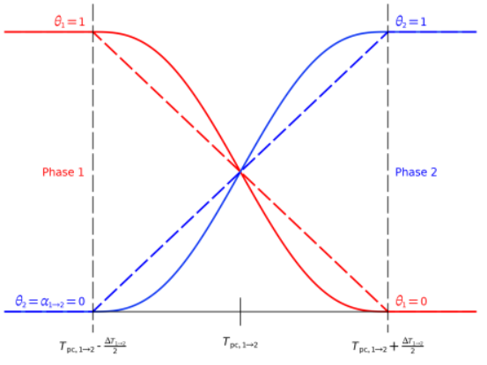
Figure 3.4. Phase fraction vs. temperature: smoothed step (solid) and linear (dashed) transitions from Phase 1 to Phase 2.
The Apparent Heat Capacity (AHC) Method is a simple and widely used approach to model phase change processes in PCMs. Its main advantage lies in the fact that it allows the description of the melting and solidification process through a single energy equation, in which the latent heat is incorporated into the effective heat capacity of the material. This eliminates the need to explicitly track the phase interface and significantly reduces numerical complexity and computational cost. Furthermore, the method is particularly suitable for materials exhibiting a mushy or gradual transition zone, where temperature varies smoothly during the phase change. However, the method also presents some limitations. The assumption of homogenized thermal properties between the two phases may lead to an oversimplification of the physical phenomenon, especially when the transition occurs over a very narrow or nearly isothermal temperature range. In such cases, the method may fail to accurately represent the sharp enthalpy jump. Moreover, since it relies on a temperature-dependent apparent heat capacity curve $C_{p}(T)$, the accuracy of the results strongly depends on the proper experimental definition and calibration of this function.

COMSOL Multiphysics
COMSOL Multiphysics is a simulation software based on the Finite Element Method (FEM), widely used in engineering and research to model and analyze complex physical systems. Unlike other programs focused on a single field of physics, COMSOL is designed to couple multiple physical phenomena within a single model, offering a truly multiphysics approach. This makes it especially useful for studying phase change phenomena (such as melting, solidification, or evaporation), which involve the interaction of several physical fields, particularly thermodynamics and heat transfer. COMSOL allows users to analyze in an integrated way the thermal, mechanical, and fluid-dynamic effects that occur during these processes. The software can accurately manage the variation of material properties during phase transitions, such as thermal conductivity or density, and calculate the latent heat absorbed or released. Moreover, with specialized modules like the Heat Transfer Module and the Metal Processing Module, it is possible to study heat transfer, metal melting and solidification, as well as related mechanical and structural effects. At the end of the simulation, COMSOL provides advanced tools for result visualization and analysis, enabling a complete understanding of the studied phenomena and a realistic representation of fusion and solidification processes.
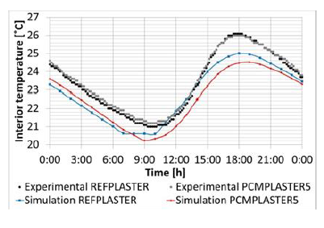
Fokaides et al. [216] conducted a heat transfer analysis of novel building materials to evaluate the thermal performance and impact of innovative plasters incorporating PCMs. The study focused on the thermal behavior of a building wall under summer-dominant climatic conditions. To this end, three-dimensional (3D) time-dependent models of building walls with PCM-enhanced plasters were developed using COMSOL Multiphysics. COMSOL was employed to perform the numerical investigation of thermal performance and to analyze the conjugate heat transfer problem, both with and without phase change. The simulation results were reported in Figure 3.5 and experimentally validated, showing good agreement between numerical and measured data, and allowing for further analysis aimed at optimizing the thermal performance of PCM-based plaster systems. Four model configurations were considered: a reference wall with conventional lime plaster (REFPLASTER) and three PCM-enhanced lime plasters containing 5%, 10%, and 20% PCM by weight (PCMPLASTER5, PCMPLASTER10, PCMPLASTER20). Experimental validation of the reference and 5% PCM models revealed minor deviations (less than 1.5 °C) between simulated and experimental values, as well as good consistency in temperature response timing. Numerical results demonstrated that PCM-enhanced plasters effectively reduce the diurnal temperature fluctuations within buildings compared to the reference case, due to their lower thermal conductivity and density combined with a higher heat storage capacity. Moreover, a positive correlation was found between PCM content and the ability of the wall system to mitigate indoor temperature variations. Authors propose an optimized design approach for PCM-enhanced plasters in buildings located in summer-dominant climates, aiming to improve thermal comfort and reduce overall energy consumption.
Figure 3.5. Simulation and experimental temperature results of interior surfaces for REFPLASTER and PCMPLASTER5 [216].
Groulx et al. [217] conducted a two-dimensional numerical study using COMSOL Multiphysics (versions 4.0a and 4.1) to simulate the melting of a PCM, taking into account both heat conduction and natural convection. The simulations, based on the Heat Transfer in Fluids and Laminar Flow interfaces, allowed for a detailed analysis of the thermal and fluid-dynamic behavior of the PCM during melting. To model natural convection, an appropriate body force was applied to the PCM, while the dynamic viscosity was defined as a continuous piecewise function with a second derivative. This approach describes the viscosity of the liquid PCM in the melted region and keeps the solid PCM fixed by assigning it an artificially high viscosity of ${10}^{8}$. During the simulations, the molten PCM rises toward the top of the cavity, moves along the insulated wall, and then cools upon contact with the still-solid region, generating recirculating convection currents. This behavior confirms the importance of accounting for natural convection to accurately describe the melting process. Compared to earlier COMSOL-based studies, the work extends the modeling approach by including convective heat transfer in the liquid phase. The latent heat of fusion was modeled through a modified specific heat, written in Eq. (81)
$$C_{p,m}=C_{p}+\frac{L_{f}}{ΔT_{m}} (81)$$
calculated over a user-defined melting temperature range $ΔT_{m}$, while the body force driving convection was expressed in Eq. (82) as
$$F=ρgβ\left(T-T_{m}\right) (82)$$

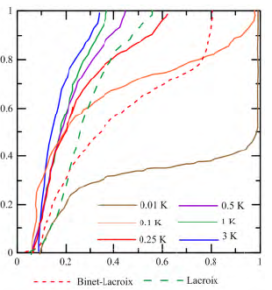
After 5,000 seconds of simulation, approximately 21% of the PCM (octadecane) was melted. Comparison with the results of Bertrand et al. [218] showed good qualitative agreement, although the COMSOL model predicted slightly less melting. This discrepancy is attributed to the numerical definition of viscosity, as the PCM begins to behave as a liquid only above 304 K, delaying the onset of natural convection. The authors also investigated the influence of the melting temperature range ($ΔT_{m}$) on the position of the melting interface, testing values between 0.01 K and 3 K. The best agreement with Bertrand et al.’s results was obtained for melting ranges of 0.1 K and 0.5 K, confirming that overly narrow or wide ranges reduce model accuracy. Interface positions are represented in Figure 3.6. A parametric analysis was further conducted to evaluate the influence of three key parameters: dynamic viscosity, thermal conductivity, and the presence of fins. Lower viscosity enhances natural convection and accelerates melting; higher thermal conductivity promotes a more uniform heat distribution; and fins improve heat transfer efficiency, provided their spacing does not inhibit convective flow. The study highlights that a proper balance between conduction and convection is essential for accurately modeling PCM melting. The choice of melting temperature range and numerical viscosity definition strongly affects the shape and progression of the melting front. Since the material properties of the PCM used in the LHESS are fixed, the authors conclude that adding fins is an effective way to increase melting rates and promote natural convection, thereby improving the overall thermal performance of the system.
Figure 3.6. Melting interface position for varying ΔTm after 5,000 s [217].
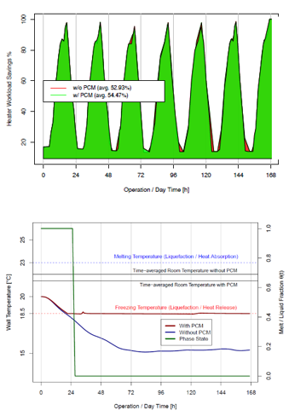
Rubinetti et al. [219] present a numerical modeling approach for the application of PCMs in the building sector, developed using COMSOL Multiphysics®. The model introduces a “mushy zone”, a transition region between the solid and liquid phases where thermophysical properties are distributed over a user-defined melting temperature range. This allows for a more realistic representation of the material behavior during the phase change process. The model was first tested in a two-dimensional (2D) configuration to analyze the influence of natural convection on the melting front propagation and was later adapted to a one-dimensional (1D) configuration representative of the wall cross-section of a typical Norwegian wooden house. This simplified version enables a rapid estimation of the energy optimization potential and supports the selection of the most suitable PCM according to climatic and structural conditions. Numerical results show that the PCM can release stored latent heat, thereby reducing the building’s heating demand and stabilizing indoor temperatures. As shown in Figure 3.7a, during the simulated week, the heater remained idle for about half of the time, with an energy saving of approximately 1.54% compared to the case without PCM. Figure 3.7b further illustrates how the PCM maintains a nearly constant temperature once the freezing point is reached, effectively damping thermal oscillations and limiting the temperature fluctuations compared to the non-PCM configuration. The use of PCMs proves to be more effective in reducing cooling demand during summer than in decreasing heating demand during winter. Nevertheless, it significantly contributes to lowering temperature peaks, improving indoor thermal comfort. From a numerical perspective, the enthalpy-porosity formulation adopted in the model provides an optimal balance between physical accuracy and computational efficiency, allowing for the simultaneous solution of momentum, continuity, and energy equations. The authors note that the model can be employed both for detailed analysis of melting and solidification processes and as a rapid assessment tool to estimate the energy benefits of using PCMs in external walls. Moreover, they emphasize the importance of including indoor thermal dynamics—such as internal heat gains and radiation—in the simulations, to accurately assess PCM performance and define the optimal selection parameters for the material.
Figure 3.7. (a) Heating at 21 °C: PCM saves around 1.5% energy/week (b) Wall temperatures: no-PCM cools faster [219].
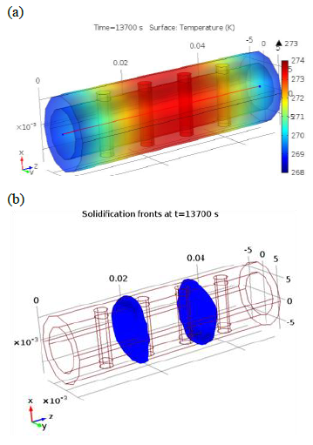
Salvador et al. [220] proposed an innovative and relatively simple approach for the characterization of Phase Change Materials (PCM), aimed at studying their thermal behavior during melting and solidification cycles. The method consists of subjecting a PCM sample, placed inside a tube, to cyclic heating and cooling while monitoring its thermal evolution through temperature sensors. The numerical analysis of the process, conducted using COMSOL Multiphysics®, allowed the authors to evaluate the sensitivity of the PCM to its main thermal parameters. Since PCMs tend to degrade over time due to repeated melting and solidification cycles, the authors emphasize the need for an accurate experimental approach to quantify the variations in thermal properties and possible material degradation. For this purpose, they developed an original experimental setup consisting of a Plexiglas tube filled with PCM and enclosed between two aluminum blocks, insulated with foam to minimize heat losses. Figure 3.8 depicts an example of the results obtained with the numerical simulations performed for the sample holder. The temperature distribution was monitored through four thermocouple probes and a dedicated cooling/heating system. Three-dimensional numerical simulations, performed in COMSOL using the Heat Transfer Module and a time-dependent solver, reproduced the temperature field and the solidification front, showing good agreement with experimental data. Minor discrepancies at the beginning of the test were attributed to measurement errors and to the model’s lack of natural convection representation. The preliminary study, carried out with well-known materials such as distilled water and Plexiglas, confirmed the validity of the model and demonstrated that the “Normal Physical” mesh provides the best balance between accuracy and computational efficiency. The proposed approach combines experimental investigation and numerical modeling to monitor irreversible thermal effects in PCMs, offering a reliable method for their characterization and for assessing material aging. The developed setup has been successfully designed, assembled, and tested.
Figure 3.8. Comsol results at t=13,700s: (a) temperature field; (b) solidification fronts [220].

Bibliography

- R. Newman, I. Noy. "The global costs of extreme weather that are attributable to climate change". Nature Communications 14 (2023) 6103. https://doi.org/10.1038/s41467-023-41888-1
- F. Chebli, F. Mechighel. "Phase change materials: classification, use, phase transitions, and heat transfer enhancement techniques: a comprehensive review". Journal of Thermal Analysis and Calorimetry (2025). https://doi.org/10.1007/s10973-024-13877-z
- A.Elouali, T. Kousksou, T. El Rhafiki, S. Hamdaoui, M. Mahdaoui, A. Allouhi, Y. Zeraouli. "Physical models for packed bed sensible heat storage systems". Journal of Energy Storage 23 (2019) 69–78. https://doi.org/10.1016/j.est.2019.03.004
- A.J. Carrillo, J. Gonzalez-Aguilar, M. Romero, J.M. Coronado. "Solar energy on demand: a review on high temperature thermochemical heat storage systems and materials". Chemical Reviews 119 (7) (2019) 4777–4816. https://doi.org/10.1021/acs.chemrev.8b00315
- P.Saini, D.V. Patil, S. Powar. "Review on Integration of Solar Air Heaters with Thermal Energy Storage". Applications of Solar Energy. (2018) 163–186. https://doi.org/10.1007/978-981-10-7206-2_9
- A. Abhat. "Low temperature latent heat thermal energy storage: heat storage materials". Solar Energy 30 (4) (1983) 313–332. https://doi.org/10.1016/0038-092X(83)90186-X
- S.S. Chandel, T. Agarwal. "Review of current state of research on energy storage, toxicity, health hazards and commercialization of phase changing materials". Renewable and Sustainable Energy Reviews 67 (2017) 581–596. https://doi.org/10.1016/j.rser.2016.09.070
- United States Department of Agriculture (USDA), 2025. BioPreferred® Program [online]. Available on : https://www.biopreferred.gov
- D. Zhou, C.Y. Zhao, Y. Tian. "Review on thermal energy storage with phase change materials (PCMs) in building applications". Applied Energy 92 (2012) 593–605. https://doi.org/10.1016/j.apenergy.2011.08.025
- C.R. Raj, S. Suresh, R.R. Bhavsar, V.K. Singh. "Recent developments in thermo-physical property enhancement and applications of solid–solid phase change materials". Journal of Thermal Analysis and Calorimetry 139 (2020) 3023–3049. https://doi.org/10.1007/s10973-019-08703-w
- W. Gao, W. Lin, T. Liu, C. Xia. "An experimental study on the heat storage performances of polyalcohols NPG, TAM, PE, and AMPD and their mixtures as solid–solid phase-change materials for solar energy applications". International Journal of Green Energy 4 (3) (2007) 301–311. https://doi.org/10.1080/15435070701332112
- D.K. Benson, R.W. Burrows, J.D. Webb. "Solid state phase transitions in pentaerythritol and related polyhydric alcohols". Solar Energy Materials 13 (2) (1986) 133–152. https://doi.org/10.1016/0165-1633(86)90040-7
- N. Doshi, M. Furman, R. Rudman. "The formation of the plastic crystal phase in several pentaerythritol derivatives". Acta Crystallographica Section B: Structural Crystallography and Crystal Chemistry 29 (1) (1973) 143–144. https://doi.org/10.1107/S0567740873002104
- E. Nakano, K. Hirotsu, A. Shimada. "The crystal structures of pentaglycerol and neopentylglycol". Bulletin of the Chemical Society of Japan 42 (11) (1969) 3367. https://doi.org/10.1246/bcsj.42.3367
- K. Pielichowski, K. Flejtuch. "Differential scanning calorimetry studies on poly(ethylene glycol) with different molecular weights for thermal energy storage materials". Polymer Advanced Technologies 13 (10–12) (2002) 690–696. https://doi.org/10.1002/pat.276
- K.Y. Leong, M.R. Abdul Rahman, B.A. Gurunathan. "Nano-enhanced phase change materials: a review of thermo-physical properties, applications and challenges". Journal of Energy Storage 21 (2019), 18-31. https://doi.org/10.1016/j.est.2018.11.008
- K. Kant, P. Biwole, I. Shamseddine, G. Tlaiji, F. Pennec, F. Fardoun. "Recent advances in thermophysical properties enhancement of phase change materials for thermal energy storage". Solar Energy Materials and Solar Cells 231 (2021). https://doi.org/10.1016/j.solmat.2021.111309.
- D.G. Atinafu, W. Dong, X. Huang, H. Gao, G. Wang. "Introduction of organic–organic eutectic PCM in mesoporous N-doped carbons for enhanced thermal conductivity and energy storage capacity". Applied Energy 211 (2018) 1203–1215. https://doi.org/10.1016/j.apenergy.2017.12.025
- M. Mehrali, S. Tahan Latibari, M. Mehrali, T.M.I. Mahlia, E. Sadeghinezhad, H.S.C. Metselaar. "Preparation of nitrogen-doped graphene/palmitic acid shape stabilized composite phase change material with remarkable thermal properties for thermal energy storage". Applied Energy 135 (2014) 339–349. https://doi.org/10.1016/j.apenergy.2014.08.100
- X. Chen, H. Gao, L. Xing, W. Dong, A. Li, P. Cheng, P. Liu, G. Wang. "Nanoconfinement effects of N-doped hierarchical carbon on thermal behaviors of organic phase change materials". Energy Storage Materials 18 (2019) 280–288. https://doi.org/10.1016/j.ensm.2018.08.024
- D.G. Atinafu, W. Dong, C. Hou, R.S. Andriamitantsoa, J. Wang, X. Huang, H. Gao, G. Wang. "A facile one-step synthesis of porous N-doped carbon from MOF for efficient thermal energy storage capacity of shape-stabilized phase change materials". Materials Today Energy 12 (2019) 239–249. https://doi.org/10.1016/j.mtener.2019.01.011
- R.J. Warzoha, A.S. Fleischer. "Improved heat recovery from paraffin-based phase change materials due to the presence of percolating graphene networks". International Journal of Heat and Mass Transfer 79 (2014) 314–323. https://doi.org/10.1016/j.ijheatmasstransfer.2014.08.009
- H. Sun, Z. Xu, C. Gao. "Multifunctional, ultra-flyweight, synergistically assembled carbon aerogels". Advanced Materials 25 (2013) 2554–2560. https://doi.org/10.1002/adma.201204576
- I.Okechukwu, N.N. Duru, V. Oluwatosin, T.C. Erinosho, M.O. Eyube, U.C. Akomah, H. Sam Samuel, G. Okibe. "Nano-engineered organic solid–solid phase change materials for high-efficiency thermal energy storage in renewable systems: a review". ChemRxiv (2025). https://doi.org/10.26434/chemrxiv-2025-62hqs
- A.P. Mouiritz, A.G. Gibson. "Fire reaction properties of the composites". Fire Properties of Composite Polymer Materials. Solid Mechanics and Its Applications 143 (2006) 59-101. https://doi.org/10.1007/978-1-4020-5356-6_3
- I.Shamseddine, F. Pennec, P. Biwole, F. Fardoun. "Supercooling of phase change materials: A review". Renewable and Sustainable Energy Reviews 158 (2022). https://doi.org/10.1016/j.rser.2022.112172
- H. Reichert, O. Klein, H. Dosch, M. Denk, V. Honkimäki, T. Lippmann, G. Reiter. "Observation of five-fold local symmetry in liquid lead". Nature 408 (2000) 839–841. https://doi.org/10.1038/35048537
- S.H. Oh, Y. Kauffmann, C. Scheu, W.D. Kaplan, M. Rühle. "Ordered liquid aluminum at the interface with sapphire". Science 310 (2005) 661-663. https://doi.org/10.1126/science.1118611
- A.L. Greer. "Supercool order". Nature Materials 5 (2006) 13–14. https://doi.org/10.1038/nmat1557
- A. Di Pretoro, F. Manenti. "Crystallization". SpringerBriefs in Applied Sciences and Technology (2020) 109–114. https://doi.org/10.1007/978-3-030-34572-3_13
- J. Mullin. Crystallization. 2001. 4th ed. Butterworth-Heinemann, Oxford. ISBN 978-0-7506-4833-2 (print); 978-0-08-053011-6 (eBook). Available on: https://www.sciencedirect.com/book/9780750648332/crystallization.
- M. Dannemand, J. Dragsted, J. Fan, J.B. Johansen, W. Kong, S. Furbo. "Experimental investigations on prototype heat storage units utilizing stable supercooling of sodium acetate trihydrate mixtures". Applied Energy 169 (2016) 72-80. https://doi.org/10.1016/j.apenergy.2016.02.038
- L. Liu, X. Zhang, X. Xu, Y. Zhao, S. Zhang. "The research progress on phase change hysteresis affecting the thermal characteristics of PCMs: A review". Journal of Molecular Liquids 317 (2020). https://doi.org/10.1016/j.molliq.2020.113760
- L. Klimeš, P. Charvat, M. Mastani Joybari, M. Zalešak, F. Haghighat, K. Panchabikesan, M. El Mankibi, Y. Yuan. "Computer modelling and experimental investigation of phase change hysteresis of PCMs: The state-of-the-art review". Applied Energy 263 (2020). https://doi.org/10.1016/j.apenergy.2020.114572
- Q. Zhou, J. Zhang, Q. Zou. "Preparation and properties of hysteresis low temperature phase change energy storage microcapsules". Chinese Journal of Colloid & Polymer 37 (2) (2019) 58–61.
- J.A. Noël, S. Kahwaji, L. Desgrosseilliers, D. Groulx, M.A. White, 2016. “Phase Change Materials”. Storing Energy: With Special Reference to Renewable Energy Sources (2016) 249–272. https://doi.org/10.1016/B978-0-12-803440-8.00013-0
- B. Delcroix, M. Kummert, et al. "Influence of experimental conditions on measured thermal properties used to model phase change materials". Building Simulation 8 (2015) 637–650. https://doi.org/10.1007/s12273-015-0241-8
- T.-H. Hsu, et al. "Thermal hysteresis in phase-change materials: encapsulated metal alloy core-shell microparticles". Nano Energy 51 (2018) 563–570. https://doi.org/10.1016/j.nanoen.2018.06.021
- F. Mehdaoui, M. Hazami, A. Messaouda. "Thermal testing and numerical simulation of PCM wall integrated inside a test cell on a small scale and subjected to the thermal stresses". Renewable Energy 135 (2019) 597–607. https://doi.org/10.1016/j.renene.2018.12.029
- M.A. Rady, E. Arquis., C. Le Bot. “Characterization of granular phase changing composites for thermal energy storage using the T-history method”. International Journal of Energy Research 34 (2009) 333–344. https://doi.org/10.1002/er.1560.
- V.V. Tyagi, D. Buddhi. "PCM thermal storage in buildings: a state of the art". Renewable and Sustainable Energy Reviews 11 (2007) 1146–1166. https://doi.org/10.1016/j.rser.2005.10.002
- A. Sharma, V.V. Tyagi, C.R. Chen, D. Buddhi. "Review on thermal energy storage with phase change materials and applications". Renewable and Sustainable Energy Reviews 13 (2009) 318–345. https://doi.org/10.1016/j.rser.2007.10.005
- V.V. Tyagi, K. Chopra, R.K. Sharma, A.K. Pandey, S.K. Tyagi, M. Shakeel Ahmad, A. Sarı, R. Kothari. "A comprehensive review on phase change materials for heat storage applications: Development, characterization, thermal and chemical stability". Solar Energy Materials and Solar Cells 234 (2022) 111392. https://doi.org/10.1016/j.solmat.2021.111392
- G.W.H. Höhne, W.F. Hemminger, H.-J. Flammersheim. "Introduction" Differential Scanning Calorimetry (2003) 1–7. https://doi.org/10.1007/978-3-662-06710-9_1
- S.M. Sarge, E. Gmelin, G.W.H. Höhne, H.K. Cammenga, W. Hemminger, W. Eysel. "The caloric calibration of scanning calorimeters". Thermochimica Acta 247 (1994) 129–168. https://doi.org/10.1016/0040-6031(94)80118-5
- Z. Yinping, J. Yi. "A simple method, the T-history method, of determining the heat of fusion, specific heat and thermal conductivity of phase-change materials". Measurement Science and Technology 10 (1999) 201–205. https://doi.org/10.1088/0957-0233/10/3/015
- A. Solé, L. Miró, C. Barreneche, I. Martorell, L.F. Cabeza. "Review of the T-history method to determine thermophysical properties of phase change materials (PCM)". Renewable and Sustainable Energy Reviews 26 (2013) 425–436. https://doi.org/10.1016/j.rser.2013.05.066
- J. Xie, Y. Li, W. Wang, S. Pan, N. Cui, J. Liu. "Comments on thermal physical properties testing methods of phase change materials". Advances in Mechanical Engineering 5 (2013) 695762. https://doi.org/10.1155/2013/695762
- D. Mazzeo, G. Oliveti, A. de Gracia, J. Coma, A. Solé, L.F. Cabeza. "Experimental validation of the exact analytical solution to the steady periodic heat transfer problem in a PCM layer". Energy 140 (2017) 1131–1147. https://doi.org/10.1016/j.energy.2017.08.045
- V. Bianco, M. De Rosa, K. Vafai. "Phase-change materials for thermal management of electronic devices". Applied Thermal Engineering 214 (2022) 118839. https://doi.org/10.1016/j.applthermaleng.2022.118839
- T. Markandeyulu, J.K. Devanuri, K. Kumar. "On the suitability of phase change material (PCM) for thermal management of electronic components". Indian Journal of Science and Technology 9 (S1) (2016) 1–4. https://doi.org/10.17485/ijst/2016/v9iS1/107939
- M.S. Lori, K. Vafai. "Heat transfer and fluid flow analysis of microchannel heat sinks with periodic vertical porous ribs". Applied Thermal Engineering 213 (2022) 118059. https://doi.org/10.1016/j.applthermaleng.2022.118059
- S. Lu, K. Vafai. "Optimization of the thermal performance of three-dimensional integrated circuits utilizing rectangular-shaped and disk-shaped heat pipes". Journal of Heat Transfer 144 (6) (2022) 061901. https://doi.org/10.1115/1.4053803
- S. Lu, K. Vafai. "A comparative analysis of innovative microchannel heat sinks for electronic cooling". International Communications in Heat and Mass Transfer 76 (2016) 271–284. https://doi.org/10.1016/j.icheatmasstransfer.2016.04.024
- J. Luo, D. Zou, Y. Wang, S. Wang, L. Huang. "Battery thermal management systems (BTMs) based on phase change material (PCM): A comprehensive review". Chemical Engineering Journal 430 (2022) 132741. https://doi.org/10.1016/j.cej.2021.132741
- L. Huat, Y. Ye, A.A.O. Tay. "Integration issues of lithium-ion battery into electric vehicles battery pack". Journal of Cleaner Production 113 (2016) 1032–1045. https://doi.org/10.1016/j.jclepro.2015.11.011
- Z. Rao, S. Wang, M. Wu, Z. Lin, F. Li. "Experimental investigation on thermal management of electric vehicle battery with heat pipe". Energy Conversion and Management 65 (2013) 92–97. https://doi.org/10.1016/j.enconman.2012.08.014
- J.R. Patel, M.K. Rathod. "Recent developments in the passive and hybrid thermal management techniques of lithium-ion batteries". Journal of Power Sources 480 (2020) 228820. https://doi.org/10.1016/j.jpowsour.2020.228820
- D. Bernardi, E. Pawlikowski, J. Newman. "General energy balance for battery systems". Journal of the Electrochemical Society 132 (1) (1985) 5–12. https://doi.org/10.1149/1.2113792
- G. Xia, L. Cao, G. Bi. "A review on battery thermal management in electric vehicle application". Journal of Power Sources 367 (2017) 90–105. https://doi.org/10.1016/j.jpowsour.2017.09.046
- Y. Zeng, D. Chalise, S.D. Lubner, S. Kaur, R.S. Prasher. "A review of thermal physics and management inside lithium-ion batteries for high energy density and fast charging". Energy Storage Materials 41 (2021) 264–288. https://doi.org/10.1016/j.ensm.2021.06.008
- G. Zhang, F. Qin, H. Zou, C. Tian. "Experimental study on a dual-parallel-evaporator heat pump system for thermal management of electric vehicles". Energy Procedia 105 (2017) 2390–2395. https://doi.org/10.1016/j.egypro.2017.03.687
- M. Al-Zareer, I. Dincer, M.A. Rosen. "A novel phase change based cooling system for prismatic lithium ion batteries". International Journal of Refrigeration 86 (2018) 203–217. https://doi.org/10.1016/j.ijrefrig.2017.12.005
- T.M. Bandhauer, S. Garimella. "Passive, internal thermal management system for batteries using microscale liquid–vapor phase change". Applied Thermal Engineering 61 (2) (2013) 756–769. https://doi.org/10.1016/j.applthermaleng.2013.08.004
- Y. Ren, Z. Yu, G. Song. "Thermal management of a Li-ion battery pack employing water evaporation". Journal of Power Sources 360 (2017) 166–171. https://doi.org/10.1016/j.jpowsour.2017.05.116
- Q. Wang, B. Jiang, Q.F. Xue, H.L. Sun, B. Li, H.M. Zou, Y.Y. Yan. "A critical review of thermal management models and solutions of lithium-ion batteries for the development of pure electric vehicles". Renewable and Sustainable Energy Reviews 64 (2016) 106–128. https://doi.org/10.1016/j.rser.2016.05.033
- R. Zhao, J. Gu, J. Liu, “An experimental study of heat pipe thermal management system with wet cooling method for lithium-ion batteries”. Journal of Power Sources 273 (2015) 1089–1097. https://doi.org/10.1016/j.jpowsour.2014.10.007.
- C.-V. Hémery, F. Pra, J.-F. Robin, P. Marty. “Experimental performances of a battery thermal management system using a phase change material” Journal of Power Sources 270 (2014) 349–358. https://doi.org/10.1016/j.jpowsour.2014.07.147.
- Y. Huo, Z. Rao. “Investigation of phase change material based battery thermal management at cold temperature using lattice Boltzmann method”. Energy Conversion Management 133 (2017) 204–215. https://doi.org/10.1016/j.enconman.2016.12.009.
- R. Zhao, J. Gu, J. Liu. "Optimization of a phase change material based internal cooling system for cylindrical Li-ion battery pack and a hybrid cooling design". Energy 135 (2017) 811–822. https://doi.org/10.1016/j.energy.2017.06.168 DA QUI
- A. Kumar, A.K. Dewangan, A.K. Yadav. "A state-of-the-art review on modelling and simulation of battery thermal management system using phase change material and liquid cooling: Enhancing performance, sustainability, and future research needs". Journal of Energy Storage 133 (2025) 117978. https://doi.org/10.1016/j.est.2025.117978
- H. Ghadim, A. Godin, A. Veillere, M. Duquesne, D. Haillot. "Review of thermal management of electronics and phase change materials". Renewable and Sustainable Energy Reviews 208 (2025) 115039. https://doi.org/10.1016/j.rser.2024.115039
- Y.-C. Weng, H.-P. Cho, C.-C. Chang, S.-L. Chen. "Heat pipe with PCM for electronic cooling". Applied Energy 88 (5) (2011) 1825–1833. https://doi.org/10.1016/j.apenergy.2010.12.004
- P. Verdugo, C. Cañizares, M. Pirnia, T. Leibfried. "Modeling and optimal operation of sustainable thermoelectric microgrids with phase-change material thermal system". Sustainable Energy, Grids and Networks 43 (2025) 101814. https://doi.org/10.1016/j.segan.2025.101814
- A. Hasan, S.J. McCormack, M.J. Huang, B. Norton. "Evaluation of phase change materials for thermal regulation enhancement of building integrated photovoltaics". Solar Energy 84 (2010) 1601–1612. https://doi.org/10.1016/j.solener.2010.06.010
- M.J. Huang, P.C. Eames, B. Norton. "The application of computational fluid dynamics to predict the performance of phase change materials for control of photovoltaic cell temperature in buildings". In: A.A.M. Sayigh (Ed.), World Renewable Energy Congress VI, Pergamon, Oxford, 2000, pp. 2123–2126.
- M. Sandberg. "Cooling of building-integrated photovoltaics by ventilation air". In: Proceedings of the First International Forum on Natural and Hybrid Ventilation, Sydney, Australia, 1999.
- G.A. Landis. "Review of solar cell temperature coefficients for space". In: Proceedings of the 13th Space Photovoltaic Research and Technology Conference (SPRAT 13), NASA Lewis Research Center, 1994, pp. 385–399.
- E.Skoplaki, J.A. Palyvos. "On the temperature dependence of photovoltaic module electrical performance: A review of efficiency/power correlations". Solar Energy 83 (2009) 614–624. https://doi.org/10.1016/j.solener.2008.10.008
- D. Mazzeo, L.P.M. Colombo, S. Leva. "A review of photovoltaic cooling with phase change materials: Technical advances, modeling approaches, efficiency gains, and economic/environmental impact". Applied Thermal Engineering 280 (2025) 128222. https://doi.org/10.1016/j.applthermaleng.2025.128222
- Z. Li, T. Ma, J. Zhao, A. Song, Y. Cheng. "Experimental study and performance analysis on solar photovoltaic panel integrated with phase change material". Energy 178 (2019) 471–486. https://doi.org/10.1016/j.energy.2019.04.166
- H.M.T. Al-Najjar, J.M. Mahdi. "Novel mathematical modeling, performance analysis, and design charts for the typical hybrid photovoltaic/phase-change material (PV/PCM) system". Applied Energy 315 (2022) 119027. https://doi.org/10.1016/j.apenergy.2022.119027
- V.R. Voller, C.A. Prakash. "A fixed grid numerical modelling methodology for convection–diffusion mushy region phase-change problems". International Journal of Heat and Mass Transfer 30 (8) (1987) 1709–1719. https://doi.org/10.1016/0017-9310(87)90317-6
- W.D. Bennon, F.P. Incropera. "A continuum model for momentum, heat and species transport in binary solid–liquid phase change systems—I. Model formulation". International Journal of Heat and Mass Transfer 30 (10) (1987) 2161–2170. https://doi.org/10.1016/0017-9310(87)90094-9
- M. Cui, C. Zhang, B. Zhang, B. Xu, H. Peng, X.W. Gao. "Numerical solution of phase change heat transfer problems by effective heat capacity model and element differential method". Journal of Computational Science 60 (2022) 101593. https://doi.org/10.1016/j.jocs.2022.101593
- V. Lo Brano, A. Orioli, G. Ciulla, A. Di Gangi. "An improved five-parameter model for photovoltaic modules". Solar Energy Materials and Solar Cells 94 (8) (2010) 1358–1370. https://doi.org/10.1016/j.solmat.2010.04.003
- H. Ali. "Recent advancements in PV cooling and efficiency enhancement integrating phase change materials-based systems – A comprehensive review". Solar Energy 197 (2020) 163–198. https://doi.org/10.1016/j.solener.2019.11.075
- M.H. Mahamudul, M.M. Rahman, H.S.C. Metselaar, S. Mekhilef, S.A. Shezan, R. Sohel, S.A. Sohel. "Temperature regulation of photovoltaic module using phase change material: A numerical analysis and experimental investigation". International Journal of Photoenergy (2016) 5917028. https://doi.org/10.1155/2016/5917028
- M.J. Huang, P.C. Eames, B. Norton. "Phase change materials for limiting temperature rise in building integrated photovoltaics". Solar Energy 80 (9) (2006) 1121–1130. https://doi.org/10.1016/j.solener.2005.10.006
- M.J. Huang, P.C. Eames, B. Norton, N.J. Hewitt. "Natural convection in an internally finned phase change material heat sink for the thermal management of photovoltaics". Solar Energy Materials and Solar Cells 95 (2011) 1598–1603. https://doi.org/10.1016/j.solmat.2011.01.008 DA QUI
- Y.S. Indartono, A. Suwono, F.Y. Pratama. "Improving photovoltaics performance by using yellow petroleum jelly as phase change material". International Journal of Low-Carbon Technologies 11 (2016) 333–337. https://doi.org/10.1093/ijlct/ctu033
- P. Atkin, M.M. Farid. "Improving the efficiency of photovoltaic cells using PCM infused graphite and aluminium fins". Solar Energy 114 (2015) 217–228. https://doi.org/10.1016/j.solener.2015.01.037
- Hachem, B. Abdulhay, M. Ramadan, H. El Hage, M.G. El Rab, M. Khaled. "Improving the performance of photovoltaic cells using pure and combined phase change materials – Experiments and transient energy balance". Renewable Energy 107 (2017) 567–575. https://doi.org/10.1016/j.renene.2017.02.032
- S. Sharma, L. Micheli, W. Chang, A.A. Tahir, K.S. Reddy, T.K. Mallick. "Nano-enhanced phase change material for thermal management of BIPV". Applied Energy 208 (2017) 719–733. https://doi.org/10.1016/j.apenergy.2017.09.076
- S. Foteinis, N. Savvakis, T. Tsoutsos. "Energy and environmental performance of photovoltaic cooling using phase change materials under the Mediterranean climate". Energy 265 (2023) 126355. https://doi.org/10.1016/j.energy.2022.126355
- A. Hasan, S.J. McCormack, M.J. Huang, J. Sarwar, B. Norton. "Increased photovoltaic performance through temperature regulation by phase change materials: Materials comparison in different climates". Solar Energy 115 (2015) 264–276. https://doi.org/10.1016/j.solener.2015.02.003
- E. Klugmann-Radziemska, E. Wcisło-Kucharek. "Photovoltaic module temperature stabilization with the use of phase change materials". Solar Energy 150 (2017) 538–545. https://doi.org/10.1016/j.solener.2017.05.016
- Y. Cui, J. Zhu, F. Zhang, Y. Shao, Y. Xue. "Current status and future development of hybrid PV/T system with PCM module: 4E (energy, exergy, economic and environmental) assessments". Renewable and Sustainable Energy Reviews 158 (2022) 112147. https://doi.org/10.1016/j.rser.2022.112147
- S. Zhao, T. Ming, Y. Wu, C. Cai, K. Yin, Y. Fang, R. de Richter, Y. Chen, N. Zhou. "Application research and effectiveness analysis of phase change materials in building envelope: A review". Energy and Buildings 324 (2024) 114923. https://doi.org/10.1016/j.enbuild.2024.114923
- M. Alam, J. Sanjayan, S. Ramakrishnan. "Energy saving performance assessment and lessons learned from the operation of an active phase change materials system in a multi-storey building in Melbourne". Applied Energy 238 (2019) 1582–1595. https://doi.org/10.1016/j.apenergy.2019.01.116
- T. Kuczyński, T. Staszczuk. "Experimental study of the thermal behavior of PCM and hemp shiv composite structures during summer in a temperate climate". Energy and Buildings 279 (2023) 128033. https://doi.org/10.1016/j.energy.2023.128033
- O. M’ghari, F.-Z.S. Aouragh Hassani, M.E.M. Mekhzoum, N. Zari, R. Bouhfid, A.E.K. Qaiss, Elaboration of a composite material based on plaster reinforced with phase change material/oakum fiber: physical, thermal and mechanical properties, Journal of Energy Storage 35 (2021) 102321. https://doi.org/10.1016/j.est.2021.102321.
- Y.P. Chua, F. Haghbin, B. Panchelbazari, J. Xuan. "Application of PCM-based thermal energy storage system in buildings: A state of the art review on the mathematical modeling approaches and experimental investigations". Journal of Thermal Science 31 (6) (2022) 1821–1852. https://doi.org/10.1007/s11630-022-1650-5
- M. Song, F. Niu, M. Ning, H. Yanxin, D. Shiming. "Review on building energy performance improvement using phase change materials". Energy and Buildings 158 (2018) 776–793. https://doi.org/10.1016/j.enbuild.2017.10.066
- J. Kośny. PCM-Enhanced Building Components: An Application of Phase Change Materials in Building Envelopes and Internal Structures. Springer International Publishing, Cham, 2015. https://doi.org/10.1007/978-3-319-14286-9
- P.J. Abass, S. Muthulingam. "Incorporation of phase change materials into building materials and envelopes for thermal comfort and energy optimization: A comprehensive review". Journal of Building Engineering 103 (2025) 112106. https://doi.org/10.1016/j.jobe.2025.112106
- M. Mahdaoui, S. Hamdaoui, A. Ait Msaad, T. Kousksou, T. El Rhafiki, A. Jamil, M. Ahachad. "Building bricks with phase change material (PCM): Thermal performances". Construction and Building Materials 269 (2021) 121315. https://doi.org/10.1016/j.conbuildmat.2020.121315
- Y. Zhang. "Impact of structural configuration on the thermal performance of a PCM hollow block wall". Science and Technology for the Built Environment 24 (2018) 945–961. https://doi.org/10.1080/23744731.2018.1469918
- Y. Zhang, S. Zhuang, Q. Wang, J. He. "Experimental research on the thermal performance of composite PCM hollow block walls and validation of phase transition heat transfer models". Advances in Materials Science and Engineering 2016 (2016) 6359414. https://doi.org/10.1155/2016/6359414
- Y. Hamidi, M. Malha, A. Bah. "Analysis of the thermal behavior of hollow bricks walls filled with PCM: Effect of PCM location". Energy Reports 7 (2021) 105–115. https://doi.org/10.1016/j.egyr.2021.08.108
- Y. Fraine, C. Seladji, A. Aït-Mokhtar. "Effect of microencapsulation phase change material and diatomite composite filling on hygrothermal performance of sintered hollow bricks". Building and Environment 154 (2019) 145–154. https://doi.org/10.1016/j.buildenv.2019.02.036
- T. Silva, R. Vicente, N. Soares, V. Ferreira, E. Pereira. "Experimental testing and numerical modelling of masonry wall solution with PCM incorporation: A passive construction concept". Energy and Buildings 49 (2012) 235–245. https://doi.org/10.1016/j.enbuild.2012.02.010
- A.M. Heniegal, O.M. Omar Ibrahim, R.N. Rasha. "Numerical and experimental study of the energy saving of sustainable buildings by using phase change materials". Journal of Building Engineering 41 (2021) 102418. https://doi.org/10.1016/j.jobe.2021.102418
- D. Wu, M. Rahim, M. El Ganaoui, R. Djedjig, R. Bennacer, B. Liu. "Experimental investigation on the hygrothermal behavior of a new multilayer building envelope integrating PCM with bio-based material". Building and Environment 201 (2021) 107995. https://doi.org/10.1016/j.buildenv.2021.107995
- A. Eddhahak-Ouni, S. Drissi, J. Colin, J. Neji, S. Care. "Experimental and multi-scale analysis of the thermal properties of Portland cement concretes embedded with microencapsulated phase change materials (PCMs)". Applied Thermal Engineering 64 (2014) 32–39. https://doi.org/10.1016/j.applthermaleng.2013.11.050
- A. Figueiredo, J. Lapa, R. Vicente, C. Cardoso. "Mechanical and thermal characterization of concrete with incorporation of microencapsulated PCM for applications in thermally activated slabs". Construction and Building Materials 112 (2016) 639–647. https://doi.org/10.1016/j.conbuildmat.2016.02.225
- Y. Shen, S. Liu, C. Zeng, Y. Zhang, Y. Li, X. Han, L. Yang, X. Yang. "Experimental thermal study of a new PCM-concrete thermal storage block (PCM-CTSB)". Construction and Building Materials 293 (2021) 123540. https://doi.org/10.1016/j.conbuildmat.2021.123540
- Z.I. Djamaï, F. Salvatore, A. Si Larbi, G. Cai, M. El Mankibi. "Multiphysics analysis of effects of encapsulated phase change materials (PCMs) in cement mortars". Cement and Concrete Research 119 (2019) 51–63. https://doi.org/10.1016/j.cemconres.2019.02.002
- S. Halder, J. Wang, Y. Fang, X. Qian, M.A. Imam. "Cenosphere-based PCM microcapsules with bio-inspired coating for thermal energy storage in cementitious materials". Materials Chemistry and Physics 291 (2022) 126745. https://doi.org/10.1016/j.matchemphys.2022.126745 DA QUI
- K. Zhao, J. Wang, H. Xie, Z. Guo. "Microencapsulated phase change n-octadecane with high heat storage for application in building energy conservation". Applied Energy 329 (2023) 120284. https://doi.org/10.1016/j.apenergy.2022.120284
- Y. Farnam, H.S. Esmaeeli, P.D. Zavattieri, J. Haddock, J. Weiss. "Incorporating phase change materials in concrete pavement to melt snow and ice". Cement and Concrete Composites 84 (2017) 134–145. https://doi.org/10.1016/j.cemconcomp.2017.09.002
- Z. Refaa, M.R. Kakar, A. Stamatious, J. Worlitschek, M.N. Partl, M. Bueno. "Numerical study on the effect of phase change materials on heat transfer in asphalt concrete". International Journal of Thermal Sciences 133 (2018) 140–150. https://doi.org/10.1016/j.ijthermalsci.2018.07.014
- Y. Zhang, R.K.L. Su "Experimental investigation of the process of corrosion-caused cover cracking". Construction and Building Materials 253 (2020) 119166. https://doi.org/10.1016/j.conbuildmat.2020.119166 DA QUI
- S.I. Kontoleon, M. Stefanidou, S. Saboro, D. Maseo, A. Karasouli, D. Zegeni, et al. "Defensive behaviour of building envelopes in indoor environments through thermal energy retention by incorporating PCMs in cement mortar layers". Sustainable Energy Technologies and Assessments 47 (2021) 101439. https://doi.org/10.1016/j.seta.2021.101349
- Z. Zhang, Q. Shi, S. Wang, K. Pang, X. Liu. "Thermal energy storage cement mortar containing n-octadecane expanded graphite composite phase change material". Renewable Energy 50 (2013) 670–675. https://doi.org/10.1016/j.renene.2012.08.024
- N.B. Frahat, M. Amin, A. Mohamemed H. Meddah. " Optimizing microencapsulated PCM ratios of sustainable cement mortar for energy savings in buildings". Construction and Building Materials 391 (2023) https://doi.org/10.1016/j.conbuildmat.2023.131844
- G. Li, Q. Xu, J. Zhang. "Experimental investigation of thermal and mechanical performance of cement mortar with PCM for radiant floors". Case Studies in Construction Materials 20 (2024) e02958. https://doi.org/10.1016/j.cscm.2024.e02958
- M. Alam, I. Sanjayan, P.X.W. Zou, S. Ramakrishnan, J. Wilson. "A comparative study on the effectiveness of passive and free cooling application methods of phase change materials for energy efficient retrofitting in residential buildings". Procedia Engineering 180 (2017) 993–1002. https://doi.org/10.1016/j.proeng.2017.04.259
- Y. Zhang, M.V. Boregy, J.F. Torres, Y. Zhao, X. Wang. "Dynamic melting of encapsulated PCM in various geometries driven by natural convection of surrounding air: A modelling-based parametric study". Journal of Energy Storage 48 (2022) 103975. https://doi.org/10.1016/j.est.2022.103975
- A. Weinlader, F. Klinker, M.Yasin. "PCM cooling ceilings in the Energy Efficiency Centre – Passive cooling potential of two different system designs". Energy and Buildings 119 (2016) 93–100. https://doi.org/10.1016/j.enbuild.2016.03.031
- J. Mustafa, S. Alqaed, M. Sharifpur. "PCM embedded radiant chilled ceilings with nanofluid heat exchangers for improved solidification and cooling efficiency". Journal of Building Engineering 57 (2022) 104894. https://doi.org/10.1016/j.jobe.2022.104894
- H. Lim, S.Z. Kang, B.W. Olsen, K. Hah. "Thermoelectric air-conditioning using applications with heat-transfer technologies in PCM panels". Journal of Air Conditioning and Refrigeration 27 (2019) 1–17. https://doi.org/10.1142/S2010132519300027.
- A. Pasupathy, R. Velraj. "Effect of double layer phase change material in building roof for year round thermal management". Energy and Buildings 40 (2008) 193–203. https://doi.org/10.1016/j.enbuild.2007.02.016
- J.Kośny, K. Biswas, M. Wifler, S. Kriner. "Field thermal performance of naturally ventilated solar roof with PCM heat sink". Solar Energy 86 (2012) 2504–2514. https://doi.org/10.1016/j.solener.2012.05.020
- M. Elawady, M.R. Bekheit, A.A. Sultan, A. Radwan. "Energy assessment of a roof-integrated phase change materials, long-term numerical analysis with experimental validation". Applied Thermal Engineering 202 (2022) 117773. https://doi.org/10.1016/j.applthermaleng.2021.117773
- H. Elarga, S. Fantucci, V. Serra, R. Zecchin, B. Benini. "Experimental analyses on thermal performance of different typologies of PCMs integrated in the roof space". Energy and Buildings 157 (2017) 554–557. https://doi.org/10.1016/j.enbuild.2017.06.038
- E. Meng, J. Wang, H. Ryu, B. Cai, Y. Shen, B. Zhou. "Experimental thermal performance of the high reflectivity-phase change material (PCM) in summer". Building and Environment 164 (2019) 106381. https://doi.org/10.1016/j.buildenv.2019.106381
- S. Zhang, Y. Ma, D. Li, C. Liu, R. Yang. "Thermal performance of a reversible multiple-glazing roof filled with two PCM". Renewable Energy 182 (2022) 1080–1093. https://doi.org/10.1016/j.renene.2021.11.008
- P.J. Abass, S. Muthulingam. "Thermal energy storage performance of biaxial voided RCC roof slab integrated with macroencapsulated PCM for passive cooling of buildings". Journal of Energy Storage 88 (2024) 111478. https://doi.org/10.1016/j.est.2024.111478
- A. Tokuc, G. Taspinar, A. Yesilata. "An experimental and numerical investigation of the use of phase change materials in building elements: The case of a flat roof in Istanbul". Energy and Buildings 102 (2015) 91–104. https://doi.org/10.1016/j.enbuild.2015.04.039
- L. Karim, F. Barbeon, P. Gegout, A. Bontemps, L. Royon. "New phase-change material composites for thermal management of the lightweight envelope of buildings". Energy and Buildings 68 (2014) 703–706. https://doi.org/10.1016/j.enbuild.2013.08.056
- J.Guo, Y. Jiang. "A semi-analytical model for evaluating the thermal storage capacity and heat use efficiency of flexible thermal storage heating floor". Applied Thermal Engineering 198 (2021) 117448. https://doi.org/10.1016/j.applthermaleng.2021.117448
- W. Sun, Y. Zhang, Z. Ling, X. Fang, Z. Zhang. "Experimental investigation on the thermal performance of double-layer PCM radiant floor system containing two types of inorganic composite PCMs". Energy and Buildings 211 (2020) 109806. https://doi.org/10.1016/j.enbuild.2020.109806
- H. Kitagawa, T. Asawa, T. Kubota, A.R. Trihamdani, H. Mori. "Thermal storage effect of radiant floor cooling system using phase change materials in the hot and humid climate of Indonesia.". Buildings and Environment 207 (2022) 108442. https://doi.org/10.1016/j.buildenv.2021.108442
- X. Yang, D. Li, R. Yang, Y. Ma, X. Tong, Y. Yu, M. Mann. "Comprehensive performance evaluation of double-glazed windows containing hybrid nanoparticle-enhanced phase change materials". Applied Thermal Engineering 223 (2023) 119976. https://doi.org/10.1016/j.applthermaleng.2023.119976
- X. Xu, W. Wang, Z. Zhang. "Preparation and thermal performances of Na₂HPO₄·12H₂O/SiO₂ hydrophilic modified expanded graphite form-stable composite phase change material for radiant floor heating system". Solar Energy Materials and Solar Cells 220 (2021) 111221. https://doi.org/10.1016/j.solmat.2021.111221
- M.Faraj, M. Khaled, J. Faraji,F. Hachem, C. Castelain. "Experimental study on the use of coconut oil and paraffin wax phase change material in active radiant floor heating systems". Journal of energy storage (2021) 102815. https://doi.org/10.1016/j.est.2021.102815.
- X. Jin, J. Yang, M. Li, G. Huang, A.C.K. Lai. " Experimental and numerical study on the thermal energy storage performance of a novel phase-change material for radiant floor heating systems". Building and Environment 223 (2022) 109491. https://doi.org/10.1016/j.buildenv.2022.10949
- E.M. Alawadhi. "Effect of an incompletely closed window shutter on indoor illuminance level and heat gain". Energy and Buildings 110 (2016) 112–119. https://doi.org/10.1016/j.enbuild.2015.10.040
- T. Silva, R. Vicente, F. Rodrigues, A. Samagaio, C. Cardoso. "Development of a window shutter with phase change materials: Full scale outdoor experimental approach". Energy and Buildings 88 (2015) 110–121. https://doi.org/10.1016/j.enbuild.2014.11.053 DA QUI
- S. Li, G. Sun, X. Zhang, K. Zou. “Experimental research on the dynamic thermal performance of a novel triple-pane building window filled with PCM". Sustainable Cities and Society 27 (2016) 15–22.
- F. Goia, M. Perino, V. Serra. "Improving thermal comfort conditions by means of PCM glazing systems". Energy and Buildings 60 (2013) 442–452. https://doi.org/10.1016/j.enbuild.2013.01.029
- Q. Wang, C.Y. Zhao. "Parametric investigation of using a PCM curtain for energy efficient buildings". Energy and Buildings 94 (2015) 33–42. https://doi.org/10.1016/j.enbuild.2015.02.024
- X. Yang, D. Li, R. Yang, Y. Ma, X. Tong, Y. Wu, M. Arici. "Comprehensive performance evaluation of double-glazed windows containing hybrid nanoparticle-enhanced PCM material". Applied Thermal Engineering 223 (2023) 119976. https://doi.org/10.1016/j.applthermaleng.2023.119976
- M.F. King, P.N. Rao, A. Sivakumar, V.K. Mamidi, S.Richard, M. Vijakumar, P.M. Kumar. "Thermal performance of a double glazed window integrated with a phase change material (PCM)". Materials Today: Proceedings 50 (2022) 1516–1521. https://doi.org/10.1016/j.matpr.2021.09.099
- B. Duraković, S. Mešetović. "Thermal performance of glazed energy storage systems with various storage materials: An experimental study". Sustainable Cities and Society 45 (2019) 420–430. https://doi.org/10.1016/j.scs.2018.12.003
- A. Gallardo, U. Berardi. “Design and control of radiant ceiling panels incorporating phase change materials for cooling applications” Applied Energy 304 (2021) 117736. https://doi.org/10.1016/j.apenergy.2021.117736.
- A. Arumugam, S. Shaik. "Air-conditioning cost saving and CO₂ emission reduction prospective of buildings designed with PCM integrated blocks and roofs". Sustainable Energy Technologies and Assessments 48 (2021) 101657. https://doi.org/10.1016/j.seta.2021.101657
- X.Y.D. Soo, P.J. Ong, Y.K.Z. Lim, S. Wang, W. Thitsartarn, F. Wang, J. Kong, R. Ji, N. Tomczak, B.H. Tan, P. Wang, J. Xu, X.J. Loh, Q. Zhu. “Recent advances in low-temperature phase change materials for cold chain logistics". International Journal of Refrigeration (2025) 174, 232–251. https://doi.org/10.1016/j.ijrefrig.2025.03.011.
- K. Ma, X. Zhang, J. Ji, L. Han, X. Ding, W. Xie. "Application and research progress of phase change materials in biomedical field". Biomaterials Science 9 (2021) 5762–5783. https://doi.org/10.1039/D1BM00880J
- Y. Chen, X. Zhang, J. Ji, and C. Zhang, “Cold chain transportation energy conservation and emission reduction based on phase change materials under dual-carbon background: A review,” Journal of Energy Storage 86 (2024) 111258. https://doi.org/10.1016/j.est.2024.111258
- Z. Yang, J.E. Tate, E. Morganti. "Real-world CO₂ and NOₓ emissions from refrigerated vans". Science of the Total Environment 763 (2021) 142974. https://doi.org/10.1016/j.scitotenv.2020.142974 eprints.whiterose.ac.uk
- A. Finnveden, M.Z. Hauschild, T. Ekvall. "Recent developments in life cycle assessment". Journal of Environmental Management 91 (2009) 1–21. https://doi.org/10.1016/j.scitotenv.2020.142974
- H.M. Hoang, T. Brown, E. Indergard, T. Schütz. "Life cycle assessment of salmon cold chains: Comparison between chilling and superchilling technologies". Journal of Cleaner Production 126 (2016) 363–372. https://doi.org/10.1016/j.jclepro.2016.03.049
- W. Wu, C. Beretta, P. Cronje, S. Hellweg, T. Defraeye. "Environmental trade-offs in fresh-fruit cold chains by combining virtual cold chains with life cycle assessment". Applied Energy 254 (2019) 113586. https://doi.org/10.1016/j.apenergy.2019.113586
- I.P. Koronaki, D. Cowan, G. Maidment, K. Beerman, M. Schreurs, K. Kaar. "Refrigerant emissions and leakage prevention across Europe – Results from the RealSkillsEurope project". Energy 45 (2012) 71–80. https://doi.org/10.1016/j.energy.2012.05.040
- H.M. Stellingwerf, A. Kanellopoulos, J.G.A.J. van der Vorst, J.M. Bloemhof. "Reducing CO₂ emissions in temperature-controlled road transportation using the LDVRP model". Transportation Research Part D: Transport and Environment 58 (2018) 80–93. https://doi.org/10.1016/j.trd.2017.11.008
- J. Wu, G. Liu, A. Marson, A. Fedele, A.Scipioni, A.Manzardo. "Mitigating environmental burden of the refrigerated transportation sector: Carbon footprint comparisons of commonly used refrigeration systems and alternative cold storage systems". Journal of Cleaner Production 372 (2022) 133514. https://doi.org/10.1016/j.jclepro.2022.133514
- H. Song, M. Cai, J. Cen, C. Xu, Q.Zeng. "Research on energy saving optimization method of electric refrigerated truck based on genetic algorithm". International Journal of Refrigeration 137 (2022) 62–69. https://doi.org/10.1016/j.ijrefrig.2022.02.003
- Y. Yao, L. Shi, J. He, H. Tian, X. Wuang, X. Zhang, X. Sun, B. Lu, G. Shu. "Dynamic analysis of refrigerated truck integrated with combined cooling and power cycle under various driving conditions". Energy Conversion and Management 278 (2023) 116716. https://doi.org/10.1016/j.enconman.2023.116716
- R. Zhang, S. Fujimori. "The role of transport electrification in global climate change mitigation scenarios". Environmental Research Letters 15 (3) (2020) 034019. https://iopscience.iop.org/article/10.1088/1748-9326/ab6658
- M. Yuan, J.Z. Thellufsen, H. Lund, Y.Liang. "The electrification of transportation in energy transition". Energy 236 (2021) 121564. https://doi.org/10.1016/j.energy.2021.121564
- W. Chen, D. Zhang, T. Van Woensel, et al. "Green vehicle routing using mixed fleets for cold chain distribution". Expert Systems with Applications 233 (2023) 120979. https://doi.org/10.1016/j.eswa.2023.120979
- A. Das, M.M.H. Apu, A. Akter, M.M.A. Reza, R. Mia. "An overview of phase change materials, their production, and applications in textiles". Results in Engineering 25 (2025) 103603. https://doi.org/10.1016/j.rineng.2024.103603
- C. Gao, K. Kuklane, I. Holmér. "Cooling vests with phase change materials: the effects of melting temperature on heat strain alleviation in an extremely hot environment". European Journal of Applied Physiology 111 (2011) 1207–1216. https://doi.org/10.1007/s00421-010-1748-4
- F. Mneimneh, C. Moussallem, N. Ghaddar, K. Ghali, I. Omeis. "Experimental study on the effectiveness of the PCM cooling vest in persons with paraplegia of varying levels". Journal of Thermal Biology 91 (2020) 102634. https://doi.org/10.1016/j.jtherbio.2020.102634
- M. Itani, R. Bachnak, N. Ghaddar, K. Ghali. "Evaluating performance of hybrid PCM-fan and hybrid PCM-desiccant vests in moderate and hot climates". Journal of Building Engineering 22 (2019) 383–396. https://doi.org/10.1016/j.jobe.2019.01.003
- M. Pan, W. Lai. "Cutting copper fiber/paraffin composite phase change material discharging experimental study based on heat dissipation capability of Li-ion battery". Renewable Energy 114 (2017) 408–422. https://doi.org/10.1016/j.renene.2017.07.004
- B. Pause. "Nonwoven protective garments with thermo-regulating properties". Journal of Industrial Textiles 33 (2) (2003) 93–99. https://doi.org/10.1177/152808303038859
- E. Rahimi, A. Babapoor, G. Moradi, S. Kalantary, M.M. Esmaeelpour. "Personal cooling garments and phase change materials: A review". Renewable and Sustainable Energy Reviews 190 (2024) 114063. https://doi.org/10.1016/j.rser.2023.114063
- Y. Udayraj, F. Wang, W. Song, Y. Ke, P. Xu, C.S.W. Chow. "Performance enhancement of hybrid personal cooling clothing in a hot environment: PCM cooling energy management with additional insulation". Ergonomics 62 (7) (2019) 928–939. https://doi.org/10.1080/00140139.2019.1596318
- H. Pourghayoomi, H. Dehghan, M.J. Tarrahi. “The effect of an optimized cooling vest for controlling women’s thermal strain in hot laboratory conditions”. Health Scope 9(2) (2020), e94739. https://doi.org/10.5812/jhealthscope.94739.
- C.L. Butts, C.R. Smith, M.S. Ganio, B.P. McDermott. "Physiological and perceptual effects of a cooling garment during simulated industrial work in the heat". Applied Ergonomics 59 (2017) 442–448. https://doi.org/10.1016/j.apergo.2016.10.001.
- C. Chou, Y. Tochihara, T. Kim. "Physiological and subjective responses to cooling devices on firefighting protective clothing". European Journal of Applied Physiology 104 (2008) 369–374. https://doi.org/10.1007/s00421-007-0665-7
- S. Marks. “An investigation of the thermal energy storage capacity of Glauber’s salt with respect to thermal cycling”. Solar Energy 25 (3) (1980), 255–258. https://doi.org/10.1016/0038-092X(80)90332-1
- C. Gao, K. Kuklane, F. Wang, I. Holmér. "Personal cooling with phase change materials to improve thermal comfort from a heat wave perspective". Indoor Air 22 (6) (2012) 523–530. https://doi.org/10.1111/j.1600-0668.2012.00778.x
- M. Zhao, C. Gao, F. Wang, K. Kuklane, I. Holmér, J. Li. "The torso cooling of vests incorporated with phase change materials: a sweat evaporation perspective". Text. Res. J. 83 (4) (2013) 418–425. https://doi.org/10.1177/0040517512460294
- J.R. House, H.C. Lunt, R. Taylor, G. Milligan, J.A. Lyons, C.M. House. "The impact of a phase-change cooling vest on heat strain and the effect of different cooling pack melting temperatures". European Journal of Applied Physiology 113 (2013) 1223–1231. https://doi.org/10.1007/s00421-012-2534-2.
- M. Zhao, C. Gao, J. Li, F. Wang. "Effects of two cooling garments on post-exercise thermal comfort of female subjects in the heat". Fibers Polym 16 (2015) 1403–1409. https://doi.org/10.1007/s12221-015-1403-0
- D. Ouahrani, M. Itani, N. Ghaddar, K. Ghali, B. Khater. "Experimental study on using PCMs of different melting temperatures in one cooling vest to reduce its weight and improve comfort". Energy and Buildings 155 (2017) 533–545. https://doi.org/10.1016/j.enbuild.2017.09.057
- M.A. Shahid, M.T. Hossain, I. Hossain, M.G.M. Limon, M. Rabbani, A. Rahim. "Research and development on phase change material-integrated cloth: A review". Journal of Industrial Textiles 54 (2024) 1–45. https://doi.org/10.1177/15280837241262518
- K.H. Ryu et al. "Spacesuit textiles from extreme fabric materials: aromatic amide polymer and boron nitride nanotube composite fiber for neutron shielding and thermal management". Advanced Fiber Materials 6 (2024) 1509–1520. https://doi.org/10.1007/s42765-024-00432-6
- S. Gulati, A. Amar, L. Chhabra, R. Katiyar, T. Sahu, R.S. Varma. "Greener nanobiopolymers and nanoencapsulation: environmental implications and future prospects". RSC Sustain. 2 (2024) 2805–2832. https://doi.org/10.1039/D4SU00411F
- A. Kumar, R. Kumar. "Enhancement and estimation of thermo-physical properties of organic-phase change materials (O-PCMs) and their applications in solar thermal technologies: a review". Journal of Energy Storage 101 (2024) 113741. https://doi.org/10.1016/j.est.2024.113741
- M.T. Hossain, M.A. Shahid, M.Y. Ali, S. Saha, M.S.I. Jamal, A. Habib. "Fabrications, classifications, and environmental impact of PCM-incorporated textiles: current state and future outlook". ACS Omega 8 (48) (2023) 45164–45176. https://doi.org/10.1021/acsomega.3c05702
- M.A. Rahman, R. Zairov, N. Akylbekov, R. Zhapparbergenov, S.M. Hasnain. "Pioneering heat transfer enhancements in latent thermal energy storage: passive and active strategies unveiled". Heliyon 10 (19) (2024) e37981. https://doi.org/10.1016/j.heliyon.2024.e37981
- M.T. Rahaman, M.S.H. Khan. "Applications of green nano textile materials for environmental sustainability and functional performance: past, present and future perspectives". Nano-Structures & Nano-Objects 40 (2024) 101332. https://doi.org/10.1016/j.nanoso.2024.101332
- M. Zare, K.S. Mikkonen. "Phase change materials for life science applications". Advanced Functional Materials 33 (12) (2023) 2213455. https://doi.org/10.1002/adfm.202213455
- Strategic Market Research. Phase Change Materials Market Size, Share, Growth Analysis. New York: SM Strategic Market Research, 2024. URL: https://www.strategicmarketresearch.com/market-report/phase-change-materials-market
- H. Li, G. Yu, H. Xu, H. Han, H. Liu. "A review of the mathematical models for the flow and heat transfer of microencapsulated phase change slurry (MEPCS)". Energies 16 (16) (2023) 6030. https://doi.org/10.3390/en16062914
- H. Inaba, Y. Zhang, A. Horibe. "Transient heat storage characteristics on horizontal rectangular enclosures filled with fluidity slurry of micro-encapsulated phase-change material dispersed in water". Journal of Thermal Science and Technology 1 (2006) 66–77. https://doi.org/10.1299/jtst.1.66
- R. Zeng, X. Wang, B. Chen, Y. Zhang, J. Niu, X. Wang, H. Di. "Heat transfer characteristics of microencapsulated phase change material slurry in laminar flow under constant heat flux". Applied Energy 86 (2009) 2661–2670. https://doi.org/10.1016/j.apenergy.2009.04.025
- R. Sabbah, M.M. Farid, S. Al-Hallaj. "Micro-channel heat sink with slurry of water with micro-encapsulated phase change material: 3D numerical study". Applied Thermal Engineering 29 (2009) 445–454. https://doi.org/10.1016/j.applthermaleng.2008.03.027
- M.I. Hasan. "Numerical investigation of counter flow microchannel heat exchanger with MEPCM suspension". Applied Thermal Engineering 31 (2011) 1068–1075. https://doi.org/10.1016/j.applthermaleng.2010.11.032
- Y.L. Hao, Y.X. Tao. "A numerical model for phase-change suspension flow in microchannels". Numerical Heat Transfer, Part A: Applications 46 (2004) 55–77. https://doi.org/10.1080/10407780490457545
- K.Q. Xing, Y-.X. Tao, L. Hao. "Performance evaluation of liquid flow with PCM particles in microchannels". Journal of Heat Transfer 127 (2005) 931–940. https://doi.org/10.1115/1.1929783
- C. Lian, Y. Wang, Q. Li, H. Li, X. He. "Numerical investigation on the performance of microencapsulated phase change material suspension applied to liquid cold plates". Numerical Heat Transfer, Part A: Applications 75 (2019) 342–358. https://doi.org/10.1080/10407782.2019.1595817
- X. Hu, Y. Zhang. "Novel insight and numerical analysis of convective heat transfer enhancement with microencapsulated phase change material slurries: Laminar flow in a circular tube with constant heat flux". International Journal of Heat and Mass Transfer 45 (2002) 3163–3172. https://doi.org/10.1016/S0017-9310(02)00034-0
- E.M. Languri, H.B. Rokni, J. Alvarado, B. Takabi, M. Kong. "Heat transfer analysis of microencapsulated phase change material slurry flow in heated helical coils: A numerical and analytical study". International Journal of Heat and Mass Transfer 118 (2018) 872–878. https://doi.org/10.1016/j.ijheatmasstransfer.2017.10.130
- F. Ran, C. Xu, Y. Chen, R. Cong, G. Fang. "Numerical flow characteristics of microencapsulated phase change slurry flowing in a helically coiled tube for thermal energy storage". Energy 223 (2021) 120–128. https://doi.org/10.1016/j.energy.2021.120128
- R. Shaukat, M.S. Kamran, S. Imran, Z. Anwar, H. Ali. "Numerical investigation of melting heat transfer during microencapsulated phase change slurry flow in microchannels". Journal of Enhanced Heat Transfer 26 (2019) 551–575. https://www.dl.begellhouse.com/journals/4c8f5faa331b09ea,0659af8a587efd7c,7e1cefa62403b1a0.html
- F. Bai, W.Q. Lu. "Numerical analysis of laminar forced convection heat transfer in microencapsulated phase change material suspensions". Journal of Enhanced Heat Transfer 10 (2003) 311–322. https://doi.org/10.1615/JEnhHeatTransf.v10.i3.60
- H. Dai, W. Chen. "Numerical investigation of heat transfer in the double-layered minichannel with microencapsulated phase change suspension". International Communications in Heat and Mass Transfer 119 (2020) 104918. https://doi.org/10.1016/j.icheatmasstransfer.2020.104918
- H. Dai, W. Chen, Q. Cheng, Y. Liu, X. Dong. "Analysis of thermo-hydraulic characteristics in the porous-wall microchannel with microencapsulated phase change slurry". International Journal of Heat and Mass Transfer 176 (2021) 120634. https://doi.org/10.1016/j.ijheatmasstransfer.2020.120634
- H. Dai, W. Chen, X. Dong, Y. Liu, Q. Cheng. "Thermohydraulic performance analysis of graded porous media microchannel with microencapsulated phase change material suspension". International Journal of Heat and Mass Transfer 176 (2021) 121459. https://doi.org/10.1016/j.ijheatmasstransfer.2021.121459
- A. Kylli, M. Theodoridou, I. Ioannou, and P. A. Fokaides, “Numerical Heat Transfer Analysis of Phase Change Material (PCM)–Enhanced Plasters”. Proceedings of the 2016 COMSOL Conference, Munich, Germany, 2016
- R.E. Murray, D. Groulx. Modeling convection during melting of a phase change material. Proceedings of the 2011 COMSOL Conference, Boston, USA, 2011.
- A. Bertrand, B. Binet, et al. "Melting driven by natural convection – A comparison exercise: First results". International Journal of Thermal Sciences 38 (1999) 5–26. https://doi.org/10.1016/S0035-3159(99)80013-0
- D. Rubinetti, D. A. Weiss, A. Chaudhuri, and D. Kraniotis, “Modeling Approach to Facilitate Thermal Energy Management in Buildings with Phase Change Materials” Proceedings of the 2018 COMSOL Conference, Lausanne, Switzerland, 2018
- L. Salvador, J. Hastanin, F. Novello, A. Orléans, and F. Sente, “A Simple Method for Thermal Characterization of Low-Melting Temperature Phase Change Materials (PCMs)” Proceedings of the 2016 COMSOL Conference, Munich, Germany, 2016

List of Figures
Figure 0.1. Classification of thermal energy storage (TES) systems: sensible heat storage, latent heat storage, and thermochemical storage; PCMs are a subclass of latent heat storage. 2
Figure 1.1. Phase-change pathways in PCM: solid–liquid, solid–solid, solid–gas, and liquid–gas. 5
Figure 1.2. Classification of solid–liquid PCMs into organic, inorganic, and eutectic families. 6
Figure 1.3. Classification of solid–solid PCMs: organic, organometallic, and polymeric. 10
Figure 1.4. Phase transition behavior of organic polyol SS-PCM [10]. 12
Figure 1.5. Phase transition behavior of polymeric SS-PCM [10]. 13
Figure 1.6. Phase transition behavior of organometallic SS-PCM [10]. 13
Figure 1.7. Methods to improve the thermal conductivity of PCMs: chemical modification and addition of conductive structures at different length scales. 16
Figure 1.8. (a) The changing curve of latent heat value in the practical phase change transition [26]. (b) Plot of liquid undergoing supercooling upon cooling [27]. 23
Figure 1.9. Enthalpy–temperature diagram without supercooling (black) and with supercooling (green) [17]. 24
Figure 1.10. The position of solidification initiation for three different volumes having a measured degree of supercooling for the same PCM of a) 88 °C, b) 58 °C, and c) 48 °C [28]. 24
Figure 1.11. Top: DSC curve of ideal phase change transition [33]. Bottom: Difference in phase change temperature range of the PCM during solidification and melting [34]. 25
Figure 1.12. Enthalpy-temperature curve for (a) symmetric model with no phase change hysteresis, and for (b) asymmetric model considering phase change hysteresis [34]. 26
Figure 1.13. Typical heat flux DSC system [43]. 29
Figure 1.14. Power compensation DSC system [45]. 29
Figure 1.15. Setup for T-hystory method [47]. 30
Figure 1.16. a) Cooling temperature recorded versus time when PCM shows subcooling in the T-history method. b) Cooling temperature recorded versus time when PCM shows no subcooling in the T-history method [47]. 31
Figure 1.17. Cooling temperature recorded versus time of the reference substance (water) in the T-history method [47]. 31
Figure 1.18. Schematization of surface temperature trends Ttop and Tbot, on the left, and of surface heat flux trends F_{top} and F_{bot}, and of the stored sensible energy ES, on the right, during the thermal transient between an initial steady state and a final one [49]. 34
Figure 1.19. Schematization of the temperature trend in a j-th node, on the left, and of the surface heat flux trends F_{top} and F_{bot}, and of the total stored energy ET, on the right, during the thermal transient between an initial steady state and a final one. [49]. 35
Figure 2.1. Scopus trends for PCM applications in electronic devices: (a) publications rising exponentially since the early 2010s; (b) country share led by China, then India, and the United States. 52
Figure 2.2. Operating principles and temperature window for Li-ion batteries: (a) LiCoO₂/graphite cell during charge/discharge; (b) performance vs. temperature, with an ideal 15–35 °C range [60]. 60
Figure 2.3. Future research roadmap for PCM-based battery thermal management: nano-enhanced PCMs, composite PCMs, integration with new cooling technologies, and advanced numerical simulations [71]. 64
Figure 2.4. Scopus trends for PCM applications in PVs: (a) publications rising sharply since ~2015; (b) country contributions led by India and China, followed by Iran, UK, Malaysia, and others. 67
Figure 2.5. Al Najjar et al. [82] energy balance model based on an equivalent electrical circuit. 75
Figure 2.6. Configuration of a typical PV-PCM system and the energy flow path [81]. 76
Figure 2.7. Effect of pure PCM on PV: maximum electrical-efficiency gain under (a) summer and (b) winter condition [87]. 78
Figure 2.8. Maximum reduction in PV-temperature using finned-PCM [89]. 79
Figure 2.9. Scopus trends for PCMs in buildings: (a) publication trend with a recent peak; (b) country share led by China, then India, and the US. 81
Figure 2.10. Journal trends for PCMs in buildings: Energy and Buildings led early; Journal of Energy Storage and Journal of Building Engineering. 81
Figure 2.11. Main ways in which PCMs can be integrated into building components [106]. 87
Figure 2.12. (a) Diagram of the experimental set-up, (b) Actual experimental set-up, (c) Four envelope configurations [114]. 91
Figure 2.13. (a) PCM-air heat exchanger discharging mode, (b) Schematic of PCM-air heat exchanger [99]. 93
Figure 2.14. PCM-integrated roof schematic showing layer stack and dominant heat-transfer modes under solar irradiation. [106]. 94
Figure 2.15. (a) PCM shutter cuts indoor (b) glazed energy-storage windows (c) nano-enhanced paraffin PCM (d) PCM curtain (e) Al₂O₃ nanoparticles (f) double-glazing with PCM [106]. 95
Figure 2.16. Scopus trends for PCM in cold-chain applications: (a) publications trend with a sharp rise in 2020–2024; (b) country contributions led by China and India. 99
Figure 2.17. Publications by source for PCM in the cold chain: Journal of Energy Storage, Applied Thermal Engineering and Applied Energy, Energy and Buildings. 99
Figure 2.18. Fresh products cold chain logistics process. [160]. 107
Figure 2.19. Vaccine cold storage equipment (reproduced from Oxford University Press, copyright 2018) [167]. 111
Figure 2.20. Scopus trends for PCM in textiles: (a) publication trends and surge from 2015; (b) country publication contributions led by major textile producers. 114
Figure 2.21. Publications by source for PCMs in textiles: Energy and Buildings; Journal of Energy Storage and Journal of Building Engineering. 115
Figure 2.22. (a) the PCM-only vest (b) the hybrid PCM–desiccant vest (c) ) the hybrid PCM–Fan vest [174]. 119
Figure 2.23. PCM cooling vest: (a) example PCM packs and (b) front/interior views showing pack placement to maximize heat absorption and wearer comfort [180]. 122
Figure 2.24. Application of PCMs integrated in clothing [191]. 123
Figure 2.25. Schematic representation of an energy storage system according to a first embodiment of the present invention. 130
Figure 2.26. Schematic view of a thermal storage system according to John's patent. 130
Figure 2.27. Cutaway view of an example dual tank embodiment of the disclosed technologies. 131
Figure 2.28. Top view of a composite panel according to a first example embodiment according to Sawafta's patent. 131
Figure 2.29. PCM portion of a switch according to one particular embodiment. 132
Figure 2.30. perspective view of a product transport container according to one embodiment described herein wherein the container is illustrated in an open position. 132
Figure 2.31. Three-dimensional (3D) perspective cross-section of a cylindrical Li-ion battery exploiting a PCM based internal BTM system according to an embodiment of the invention. 133
Figure 2.32. Perspective exploded diagram of the thermal management device, according to certain embodiments. 133
Figure 2.33. Example of the thermal storage device of vehicle's thermal management system. 134
Figure 2.34. Diagram of the phase-change energy-storage structure for building insulation and of the shaped phase-change energy-storage insulation board. 134
Figure 2.35. Illustration of an embodiment of a microencapsulated PCM honeycomb wallboard. 135
Figure 3.1. Stefan Problem control volume. 138
Figure 3.2. Evolution of the free boundary, 141
Figure 3.3. Space-time behaviour of the problem. 142
Figure 3.4. Phase fraction vs. temperature: smoothed step (solid) and linear (dashed) transitions from Phase 1 to Phase 2. 149
Figure 3.5. Simulation and experimental temperature results of interior surfaces for REFPLASTER and PCMPLASTER5 [216]. 151
Figure 3.6. Melting interface position for varying ΔTm after 5,000 s [217]. 152
Figure 3.7. (a) Heating at 21 °C: PCM saves around 1.5% energy/week (b) Wall temperatures: no-PCM cools faster [219]. 153
Figure 3.8. Comsol results at t=13,700s: (a) temperature field; (b) solidification fronts [220]. 154

List of Tables
Table 1.1. Selection criteria for PCMs grouped by thermophysical, kinetic, chemical, and economic properties. 5
Table 1.2. Advantages and disadvantages of different categories of PCMs. 8
Table 1.3. Key thermophysical properties of common PCMs, grouped into organic, inorganic, and eutectic. 10
Table 1.4. Representative thermophysical properties of organic solid–solid PCMs: phase transition and melting temperatures, latent heat, specific heat, and density. 11
Table 1.5. Thermophysical properties of polymeric solid–solid PCMs: phase transition temperature, latent heat of transition, and melting temperature. 13
Table 1.6. Thermophysical properties of organometallic solid–solid PCMs: phase transition temperature, latent heat of transition, and melting temperature. 14
Table 1.7. Common flame retardants for PCMs. 20
Table 1.8. Suitable container materials for important PCMs. 20
Table 1.9. Advantages and disadvantages of various encapsulation techniques. 22
Table 1.10. Factors influencing the phase-change behavior of PCMs, grouped by container, PCM, cooling, and other. 24
Table 1.11. Comparison of DSC and T-history methods for PCM characterization: test specification, temperature range, instrumentation, measured outputs and key advantages/limitations. 32
Table 1.12. Overview of major PCM manufacturers and their commercial products/applications, distinguishing pure PCMs from PCM-based solutions. 37
Table 1.13. Honeywell PCM thermal-interface materials (pads and pastes): reported thermal conductivity, thermal impedance, and density. 38
Table 1.14. CrodaTherm PCM Wax product line: melting and crystallization temperatures, heat capacities (melting/crystallization), flash point, and density, with range summaries. 39
Table 1.15. CrodaTherm™ microencapsulated PCMs: product form (powder/dispersion), shell type, particle size (d90), melting and crystallization temperatures, and latent heat of melting. 40
Table 1.16. Overview of representative PCM products: pure PCMs with melting-temperature ranges and heat-storage capacity; bound PX powders; and encapsulated solutions with brief application notes. 42
Table 1.17. Key properties of BioPCM® Q20/Q23/Q25 (plant-based): melting point, density, latent heat, specific heat, thermal conductivity, and heat-storage capacity; typical range. 44
Table 1.18. PCM® commercial solutions: ENRG Blanket and Apollo™ Panel. 44
Table 1.19. PCM Products Ltd: properties of PCM types (S, A, E, X, H) and examples of encapsulated products. 46
Table 1.20. Axiotherm products: ATS and ATP: phase transition ranges and heat-storage capacity. 47
Table 1.21. Axiotherm products: BlackIce, HeatSel, and HeatStaxx Air: brief descriptions and typical TES applications. 48
Table 1.22. PureTemp bio-based PCMs: melting point, solid/liquid density, latent heat, thermal conductivity, and heat-storage capacity. 49
Table 1.23. BlockVesl and MatVesl: brief product overview. 50
Table 2.1. Selected studies on PCM-based thermal management for electronic devices: bibliographic details (title, authors, source, year, citations) and key findings from abstracts. 56
Table 2.2. Influential review papers on PCM applications for electronic devices and batteries: bibliographic details (title, authors, source, year, citations) and key insights from abstracts. 58
Table 2.3. Cooling methods for Li-ion battery packs: air, liquid, thermoelectric, heat pipe, and PCM. Key advantages, disadvantages, and commercialization. 62
Table 2.4. Selected studies on PCM for PV thermal management: bibliographic details and key outcomes. 72
Table 2.5. Influential reviews on PCM integration in photovoltaics: key bibliographic details and synthesized insights on concepts. 73
Table 2.6. Selected studies on PCMs in buildings: bibliographic details (title, authors, source, year, citations) and distilled findings from abstracts. 85
Table 2.7. Influential reviews on PCMs in buildings: key bibliographic details (title, authors, source, year, citations) and synthesized insights. 86
Table 2.8. PCM-enhanced bricks: PCM type/configuration with reported gains: temperature drop around 5–13 °C, heat-flux reduction around 50–74%, energy savings around 15–40%. 89
Table 2.9. Selected studies on PCM use in the cold chain: bibliographic details and key findings distilled from the abstracts. 102
Table 2.10. Influential reviews on PCM for the cold chain: key bibliographic details and synthesized insights on technologies, integration challenges, and performance gains. 105
Table 2.11. Cold-chain categories with target ranges and typical items: Cool, Pharma, Chill, Frozen, Deep freeze. 106
Table 2.12. Commercial PCM cold boxes. 109
Table 2.13. Phase-change properties of commercial cold-chain PCMs from Croda, Rubitherm, Axiotherm, and RGEES. 111
Table 2.14. Key studies on PCMs in textiles and cooling garments: bibliographic details and concise findings. 117
Table 2.15. Influential reviews on PCMs for textiles and wearables: key bibliographic details and synthesized insights. 118
Table 2.16. Textile PCM types with thermal properties, environmental impact, durability/cost, and reasons for preference in garments. 122
Table 2.17. Application area of integrated clothing, products, and developers of PCMs. 124
Table 2.18. Selection of recent patents on PCM for energy applications. 135
Table 3.1. Boundary conditions. 139
Table 3.2. Mathematical formulation of Neumann's problem. 142

