Theoretical investigation and reaction rate rules for propargyl radical addition to polycyclic aromatic hydro-carbons
  - TESI DI LAUREA MAGISTRALE IN
  - CHEMICAL ENGINEERING
  - INGEGNERIA CHIMICA
Author: Zihao Dong
Student ID: 10966046
Advisor: Luna Pratali Maffei
Academic Year: 2025-26

Abstract
The phenomenon of soot formation derives from incomplete combustion of carbon- based fuels, driven by the formation and growth of polycyclic aromatic hydrocarbons (PAHs). Among PAH precursors, propargyl radical is one of the simplest but most important resonance stabilized free radicals (RSFRs), present in significant quantity in flames. Reaction rate constants have mostly been determined with theoretical ab initio calculations. However, for larger PAH systems, accurate calculations are demanding in computation. As a result, reaction rate rules specialized in such calculations are a useful tool to extend accurate rate constants for smaller aromatics to larger ones. In most kinetic mechanisms, analogy rules are adopted from one-ring aromatics to larger ones. While the contributions of propargyl radical are widely acknowledged in PAH formation and growth, few theoretical calculations investigate explicit mechanisms for propargyl radical addition to aromatic hydrocarbons with more than one aromatic ring. Moreover, analogy rules that extrapolate the mechanisms of mono-aromatic species to larger PAHs miss possible significant divergence in reactivity attributed to stronger resonance stabilization and differentiation of reaction sites on larger PAHs.
This work investigates the propargyl radical addition to PAHs up to 4 aromatic rings with theoretical methods in order to construct physically-based rate rules suitable to be extended to large PAHs up to carbon particles. In total, 6 PAH species (acenes from benzene through pentacene, then phenanthrene and pyrene), 3 types of sites (edge, zigzag, bay), and up to 34 different combinations between propargyl radical (from the CH₂ or CH side) and PAHs were included. In addition, a new mechanism for the ring closure initiated by propargyl radical addition to naphthalene was addressed to assess the effective reaction pathway leading to the formation of an additional aromatic ring. In particular, relevant reaction channels on that potential energy surface (PES) leading to phenalene are displayed in detail and could serve as a multi-ring reference basis for scaling studies. Concerning addition channels to different aromatics, this thesis has successfully identified several distinct reaction patterns in the attempt to establish rate rules, which has revealed some systematic features of interactions between small radicals and close-shell PAH species. Eventually, this work can improve the kinetic accuracy in existing large kinetic mechanisms for PAH growth and soot formation.

Key-words: PAH growth, soot formation, propargyl radical, rate rules,

Abstract in italiano
Il fenomeno della formazione del soot deriva dalla combustione incompleta dei combustibili idrocarburici ed è guidato dalla formazione e crescita degli idrocarburi policiclici aromatici (PAH). Tra i precursori dei PAH, il radicale propargilico è uno dei radicali liberi stabilizzati per risonanza più semplici ma più importanti, presente in quantità significative nelle fiamme. Le costanti di velocità delle reazioni sono state per lo più determinate tramite calcoli ab initio; tuttavia, per sistemi PAH di dimensioni maggiori tali calcoli risultano computazionalmente onerosi. Di conseguenza, regole di velocità basate su questi calcoli rappresentano uno strumento utile per estendere valori accurati da aromatici piccoli a sistemi più grandi. Nella maggior parte dei meccanismi cinetici vengono adottate regole per analogia, ma tali estensioni possono trascurare divergenze significative nella reattività di PAH più estesi dovute alla maggiore stabilizzazione per risonanza.
Questo lavoro investiga l’addizione del radicale propargilico a PAH fino a quattro anelli aromatici mediante metodi teorici, con l’obiettivo di costruire regole di velocità basate su principi fisici ed estendibili ai grandi PAH fino alle particelle carboniose. Sono state considerate sei specie PAH (la serie degli aceni dal benzene al tetracene, oltre a fenantrene e pirene), tre tipi di siti reattivi (edge, zig-zag e armchair) e fino a trentaquattro combinazioni tra radicale propargilico (dal lato CH₂ o CH) e PAH. È stato inoltre analizzato un nuovo meccanismo di chiusura d’anello innescato dall’addizione del radicale propargilico al naftalene, valutando i canali di reazione rilevanti sulla superficie di energia potenziale che portano alla formazione della fenalene e fornendo una base di riferimento multi-anello per studi di scaling. L’identificazione di diversi pattern reattivi nelle addizioni ai vari aromatici rivela caratteristiche sistematiche nelle interazioni tra piccoli radicali e PAH a guscio chiuso, coerenti con risultati teorici precedenti. Questo lavoro può contribuire a migliorare l’accuratezza della cinetica nei meccanismi estesi di crescita dei PAH e formazione del soot.

Parole chiave: idrocarburi policiclici aromatici, particolato, propargile, regole di reazione

Contents
Abstract i
Abstract in italiano iii
Contents v
1 Background Introduction 3
1.1. The role of polycyclic aromatic hydrocarbons and soot in the energy transition 3
1.2. Kinetic modelling for PAHs and soot formation 4
1.3. Importance of kinetics investigation on mechanism of PAHs + propargyl radical 6
1.4. Tasks and aims 7
2 Theoretical Methods 9
2.1. Electronic structure determination 9
2.1.1. Hartree–Fock method 10
2.1.2. Basis set 11
2.1.3. Density Functional Theory 11
2.1.4. Coupled Cluster Theory 12
2.2. Rate constant calculation 13
2.2.1. Potential energy surface and minimum energy path 13
2.2.2. Statistical thermodynamics 13
2.2.3. Transition state theory 15
2.2.4. Pressure dependence of chemical reactions 17
2.3. EStokTP code 20
2.4. Reaction rate rules 21
3 Results and Discussions 23
3.1. Addition Channel 24
3.1.1. Free Edge 24
3.1.2. Zigzag 30
3.2. H-dissociation Channel 41
3.3. H-transfer Channel 46
3.4. PES example from Naphthalene-α-Propargyl 49
4 Conclusion and future developments 55
Bibliograph 59
A Appendix: High pressure limit rate constants 63
A.1. Propargyl radical addition channels 63
A.2. H atom dissociation channels 65
A.3. H atom transfer channels 67
List of Figures 73
List of Tables 75
Acknowledgments 79

Background Introduction

The role of polycyclic aromatic hydrocarbons and soot in the energy transition
Global energy demand cannot yet be met solely by renewables such as solar and wind. In 2023 renewables supplied about 30 percent of global electricity generation [1]. Nonetheless fossil fuels remain the backbone of the global energy system: they account for roughly 80 to 86 percent of primary energy and global fossil fuel consumption reached a record near 505 exajoules in 2023 [2] [3]. Even with rapid renewables deployment and continued growth expected throughout the decade, forecasts indicate that renewables will not displace the need for firm, dispatchable energy sources in the near term, so combustion will continue to play an important role in energy conversion and transport [4] [5]. However, mainly from the incomplete combustion in engines for energy generation and transportation [6], fine soot particles are major air pollutants emitted in reported quantity of about 5.8 million tons in 2019, which is Recently, an epidemiological investigation by Yang et al. has observed significant associations between long-term exposure to black carbon particles and cardiovascular mortality [7]. Additionally, quite a lot of PAH molecules could be dispersed within the soot phase, which is widely known carcinogenic to human body.
Meanwhile, formation of soot in some cases is intentionally controlled as byproducts or even main products in high added values. One example is from methane pyrolysis technology, where the product hydrogen is called turquoise hydrogen. In pyrolysis plants, at around 800℃ - 1000℃, methane decomposes mainly to hydrogen and heavy carbon species, e.g. PAHs and carbon thermal black, where carbon element is concentrated to condensed substance rather than escape to atmosphere. Therefore, due to its CO₂-free characteristics, methane pyrolysis can be viewed as a bridge between fossil fuels to renewable energies for hydrogen production. Moreover, fuel-rich flames have been proved effective production techniques of carbonaceous nanoparticles (CNPs) as advanced materials, like carbon quantum dots (or carbon dots) [8], which has aroused academic research interest in the potential biomedical applications due to its special fluorescent property [9].
Therefore, it is of great significance to research on the detailed mechanism of soot formation to provide instructions for industrial productions or in case avoiding air pollution of particle soot. Notably, with consideration of heavy tasks of kinetic experiments due to the complexity of the mechanism, theoretical calculation based on quantum chemistry is a convenient but also effective way to provide kinetic data for potentially numerous reactions of different reaction types and evolution channels at a wide temperature and pressure range.
However, the core issue for kinetic modelling is that comprehensive, or even sufficient knowledge has not been reached for various pathways in the formation mechanisms of CNPs, which is essential to develop predictive kinetic modelling.

Kinetic modelling for PAHs and soot formation
Generally, soot (or carbon black) tends to be formed from carbon-based fuels at high temperature in fuel-rich scenario, e.g. incomplete combustion, thermal cracking and pyrolysis. This solid phase is built up from the numerous carbon nanoparticles while the inception of these nanoparticles is mainly related to the formation and growth of large polycyclic aromatic hydrocarbons (PAHs) [10]. PAH growth is more favorable in thermodynamics with negative $ΔG^{0}$ at higher temperatures. In the literature, several mechanisms for PAH formation and growth were proposed. Examples include:
- Formation of PAH $σ$-radical after H atom abstraction, followed by addition of close-shell unsaturated pieces, e.g. acetylene and vinyl acetylene. Hydrogen abstraction and acetylene or carbon addition (HACA) [11], proposed by Frenklach et al., is one of the most classical mechanisms. However, HACA is still insufficient to fully explain PAH formation and growth, and specific to certain environments (e.g., combustion of small hydrocarbon fuels).
- Direct addition of radicals on close-shell aromatics, e.g. ethynyl and propargyl. These might be relevant at high temperatures where persistent radicals such as propargyl are abundant, and for large PAHs where the addition reactions are particularly favored if the PAH behaves as a multiradical.
- Resonantly stabilized hydrocarbon-radical chain reactions (RSHRCR): addition of resonantly stabilized radicals (RSR) on close-shell PAHs. Upon H-loss, new RSRs are formed, thus restarting the chain of growth reactions.
With increasing numbers of competing pathways added, kinetic models could become more flexible and predictive in various conditions.
Kinetic modelling for PAHs and soot formation is challenged from the outset by the sheer size and complexity of the required mechanisms. Detailed mechanisms for pyrolysis and oxidation may contain from 10^2 to 10^4 species and from 10^3 to 10^5 reactions, and the number of intermediate species increases roughly exponentially with molecular weight. The computational cost of kinetic simulations rises steeply with mechanism size and typically scales as approximately the square to the cube of the number of species, so that most computational fluid dynamics calculations cannot be performed with fully detailed mechanisms. To make predictive modelling feasible one must therefore combine reduction and lumping strategies with physically grounded rules to extend scarce data. Theory can supply those rules because rate constants computed for specific pathways can be transferred to analogue reactions. The analogy idea developed by Benson groups reactions by local reactive moieties so that the thermochemistry and kinetics of the same functional unit are considered similar across molecules, and reactions belonging to the same class may be assigned the same or closely related kinetic parameters. This reaction-class and rate-rule approach constrains mechanism size and enforces internal consistency.
PAH chemistry adds further complications. Over the last two decades theory has shown that PAHs grow by several distinct processes, and recent findings indicate that large PAHs often behave differently from small ones and should in many cases be modelled as resonance-stabilized π-radicals or as diradicals. Such size-dependent behaviour makes the derivation of transferable rate rules far more difficult. At the same time accurate theoretical calculations for the many relevant pathways are hard to obtain. The recent proliferation of theoretical studies has not been matched by extensive validation of the methods used, and the large number of heavy atoms in mono-substituted PAHs makes state-of-the-art treatments costly. Density functional methods typically scale roughly as the cube of system size and can be unreliable for strong delocalization, while correlated methods such as CASPT2 or coupled cluster may scale as the fifth to the seventh power of the number of correlated electrons. Local correlation approaches sometimes recover high accuracy with lower cost, but they have not been extensively tested on aromatic systems and may fail when delocalization is important. These combined experimental and theoretical limits hinder the derivation of reliable rate rules and the construction of compact, predictive mechanisms for PAH growth and soot formation. Additional complexity derives from the intricate number of possible reaction pathways so that simplification techniques are required in practice to limit the size of kinetic mechanisms. For instance, master equation-based lumping tools provide a simple and efficient reduction in the size of the reaction network derived from theoretical calculations [12].
An example of simplification in the chemistry of PAHs formation and growth is that of the global CRECK kinetic mechanism. The CRECK kinetic mechanism was developed by the CRECK modelling group at Politecnico di Milano over the last approximately 40 years [13] [14] [15] [16]. It describes oxidation and pyrolysis across a wide range of fuels, from hydrogen and syngas to heavy biodiesels, and includes oxygenated species such as alcohols, aldehydes and ethers, more recent extensions for nitrogen-containing fuels, and the formation chemistry of NOx and SOx. The mechanism is modular and hierarchical, built on a core that controls macroscopic combustion behaviour such as ignition and flame speed; Larger aliphatic fuels, including reference fuels, jet and diesel components, are added on top of the lower-level modules in order of increasing molecular weight, so that introducing a new large fuel requires defining only its initial decomposition and oxidation steps while the combustion of its fragments is handled by the underlying modules. Aromatic chemistry in the main mechanism includes benzene, toluene and phenol, the latter being central to benzene oxidation. PAH chemistry is described in a separate module and contains the main reaction pathways highlighted as relevant in the literature. In this subset, reaction rate rules are generally quite broad and assume that essentially the chemistry of a given aromatic growth reaction is governed by the radical nature of the reactants. For example, most of the growth reactions regarding molecule+molecule, radical+radical, radical+molecule, RSR+radical, RSR+molecule, RSR+RSR are assigned similar parameters. However, this description might be accurate insufficiently to capture the competition among different pathways, as well as to describe the effective ring-closure reactions, i.e., a reaction that effectively grows to a larger aromatic rather than for instance forming an aromatic with an aliphatic branch. In this context, this thesis focuses on the addition of propargyl radical to aromatic hydrocarbons, which was identified among representative PAH growth reactions that require refinement in the rate constants and rate rules.

Importance of kinetics investigation on mechanism of PAHs + propargyl radical
Propargyl radical (C₃H₃) is one of the simplest species within resonance stabilized free radicals (RSFRs). As illustrated in Figure 1.1, propargyl radical has two resonance structures characterized by two different radical sites.
Figure 1.1 Resonance structure of propargyl radical
Firstly, RSFRs, including propargyl, are not only more favorable than non-resonance resonant ones by the pyrolysis of stable hydrocarbons thermodynamically, but also less reactive to dissociations and the reactions with molecular oxygen, resulting in an accumulation of considerable amount [17]. Secondly, some propargyl radical involved pathways have been discovered as unignorable contributions to PAH growth [18] [19] [20]. Thirdly, although HACA mechanism is a rather critical pathway for PAH formation and growth, its accuracy may not be satisfying enough, with absence of other mechanisms as supplements, especially those related to RSFRs. [20] [21] [22]
To sum up, RSFRs play an important role in the growth of PAHs and subsequent soot formation, and it could be a very effective way to improve the predictive capability of existing mechanisms and models, through exploring RSFRs-related mechanisms. Particularly, studies on reactions of “PAHs + propargyl radical” should be emphasized, since propargyl is the smallest RSFR and abundant in combustion flames [23].
In terms of kinetics and rate rule derivation, Mebel et al. [24] and Raj et al. [20]. explored the kinetics of propargyl radical addition to benzene and naphthalene, just to find relatively large addition barriers (15.6 and 14.1 kcal/mol, 11 and 12 kcal/mol, respectively). However, this behaviour might not be representative of larger aromatics that converge towards a multi-radical behaviour. For instance, Nobili et al. [25] has revealed the patterns of addition channels at different reactive sites of acenes for H atom and methyl radicals, highlighting that acenes larger than octacene show a diradical behaviour and addition rate constants that resemble those of recombination reactions. In spite of the fact that reactivities could vary in different molecular sizes, and that PAHs larger than one ring decrease in degeneracy with differentiation of kinetics among the sites, it is quite usual in practice to extrapolate the rate constants of benzene to larger PAHs in order to cut heavy calculation tasks. However, a good mechanism should be thought of to find and involve these influences. As discussed earlier, propargyl radical should be the ideal choice for studying the patterns or rate rules for those critical reaction steps in the RSFR mechanism for PAH growth.

Tasks and aims
With help of EStokTP, this thesis has managed mainly two tasks:
- Finding patterns for the addition reaction of propargyl to different PAHs (from benzene to tetracene for the acene series, phenanthrene, and pyrene) in terms of different reactive sites on selected PAH molecules, which could be possibly universal among the addition reactions of simple radicals on close-shell PAH species. Meanwhile, derive rate rules for some of them with regard to PAH size.
- Proposing a new mechanism for the ring closure initiated by propargyl radical addition by analyzing relevant reaction pathways on the potential energy surface (PES) of propargyl radical addition on naphthalene leading to phenalene, as an example of PAH growth from 2 rings to 3. A multi-well master equation analysis has been conducted to assess the relevance of phenalene formation against other competing reaction paths.
The aim of this thesis is therefore to assess how molecular size influences the growth rate of PAHs with RSRs, as well as to provide a basic mechanism example of ring closure from two-ring system to three-thing, rather than from one-ring system to two-ring as usually seen, which could be used either in the examination for the rate rules derived from single-ring species, or serve as a reference basis to establish new rate rules. Eventually, this work would contribute to improving the description of large kinetic mechanisms for the pathways of PAH growth and soot formation.

Theoretical Methods

Electronic structure determination
Schrödinger equation is a partial differential equation for describing wave functions:
$$iℏ\frac{∂}{∂t}Ψ\left(r,t\right)=[-\frac{ℏ^{2}}{2m}∇^{2}+V(r,t)]Ψ(r,t)$$ | (2.1)
where $h$ is Planck constant while $ℏ$ is the reduced Plank constant with $h=2πℏ$, $m$ is particle mass, $V(r,t)$ is potential energy function and $Ψ(r,t)$ is wave function in complex form describing quantum state of a particle.
And the time-independent Schrödinger equation for stationary states is:
$$\left[-\frac{ℏ^{2}}{2m}∇^{2}+V\left(r,t\right)\right]ψ\left(r\right)=Hψ\left(r\right)=Eψ\left(r\right)$$ | (2.2)
where $ψ\left(r\right)$ is the time-independent wave function, $H$ is the Hamiltonian operator, and $E$ is the energy eigenvalue of system.
For atoms and molecules, the wave functions describe the coupled quantum states of nuclei and electrons, and the knowledge of electronic structures originate from the solution of the Schrödinger equation with independence on time.
However, except for single-electron systems, analytical solutions have not so far been found in multi-electron systems, the determination of electronic properties in most cases should be based on numerical solutions with several approximations.
Born–Oppenheimer approximation is one of the most common approximations introduced, where wave functions of atomic nuclei and electrons are thought able to decouple in Schrödinger equation, with recognitions of the giant discrepancy between nuclei and electrons in mass and time scales of motion
The equation solely for electron motion within a fixed nuclei grid governs mainly electronic energy and electronic structure:
$$H_{e}\left(r,R\right)ψ_{e}\left(r,R\right)=E_{e}ψ_{e}\left(r,R\right)$$ | (2.3)
Where $H_{e}\left(r,R\right)$ is the electronic Hamiltonian, $ψ_{e}$ is the electronic wavefunction within the fixed nuclei grid, $E_{e}$ is the electronic energy, $r$ and $R$ present the position of electrons and the fixed nuclei, respectively.
While another one based on the former one with consideration of nuclei motions is: covers electronic energy and energies of translation, rotation, and vibration.
$$H_{n}\left(R\right)ψ_{n}\left(R\right)=Eψ_{n}\left(R\right)$$ | (2.4)
Where $H_{n}$ is the nuclear Hamiltonian containing $E_{e}$, $ψ_{n}$ is the nuclear wavefunction, $E$ is the total energy of molecules covering the electronic energy and the energies of translation, rotation, and vibration.

Hartree–Fock method
Hartree–Fock (HF) method is a self-consistent field (SCF) method for ab initio electronic structure calculation based on Born–Oppenheimer approximation. Additionally, HF method replaces all of the interactions between each individual electron and other electrons with the average field generated by other electrons, which is namely the mean-field approximation. Therefore, the multi-electron wave function is simplified to a single Slater determinant with energy calculated as:
$$ψ_{e}=\frac{1}{\sqrt{N!}}\left|ϕ_{j}\left(x_{i}\right)\right|$$ | (2.5)
where $ψ_{e}$ is the electronic wave function of the multi-electron system; $ϕ$is spin orbital; $N$ is the total number of electrons in the system with indexes $i$ and $j$ for electrons and spin orbitals respectively, iterating numbers from 1 to N; $x$ is the special coordinates for electrons, including spatial coordinates $r$ and spin coordinate $σ$.
Diving the coordinate the $x_{i}$, the spin orbital could be also expressed as:
$$ϕ_{j}\left(x_{i}\right)=ψ_{j}(r_{i})ω\left(σ\right)$$ | (2.6)
where the spatial part $ψ_{j}(r_{i})$ physically corresponds to molecular orbitals, and $ω\left(σ\right)$ is the electron spin function.
Hartree–Fock function for each spin orbital is:
$$\hat{F}\left(x_{i}\right)ϕ_{j}\left(x_{i}\right)=\left[\hat{h}\left(x_{i}\right)+\hat{J}\left(x_{i}\right)-\hat{K}\left(x_{i}\right)\right]ϕ_{j}\left(x_{i}\right)=ε_{j}ϕ_{j}\left(x_{i}\right)$$ | (2.7)
where: $\hat{F}$ is Fock operator, $\hat{h}$ is one-electron operator, $\hat{J}$ is Coulomb operator, $\hat{K}$ is Exchange operator, $ε_{j}$ is orbital energy.
Because of the significant nonlinearity of the Fork operator, FC function is solved by iteration, that is the solved spin orbital generates a self-consistent field (SCF) with itself.

Basis set
In computational practice, a set of basic functions is usually applied to represent wave functions in HF methods and density function theory, converting the partial differential equations into algebra equations. The set of those basis functions is called Basis Set, through which each molecular orbital $ψ_{j}$ in HF method is expanded to a linear combination of $N_{b}$ basis functions $χ$:
$$ψ_{j}(r_{i})=\sum_{μ}^{N_{b}}{C_{μi}χ_{μ}(r_{i})}$$ | (2.8)
where $ψ_{j}(r_{i})$ is the $j$-th molecular orbital evaluated at the spatial coordinate of the $i$-th electron; $C_{μi}$ is the linear combination coefficient and $χ_{μ}(r_{i})$ is the $μ$-th basis function evaluated at position $r_{i}$.
The basis set could be constituted by atomic orbitals, among which Gaussian-type orbitals are the most common atomic orbital type. With various linear combinations (or contractions), Gaussian-type functions (GTOs) serve as primitive functions to form the actual basis functions used in calculations. Especially, to improve the flexibility in the calculations of valence electrons, which dominate bond formation in molecules, split-valence basis sets allocate more than one basis functions to each valence orbital. 6-311+G(d,p) is the major, Pople-style, basis set used in this thesis, containing 6 primitives Gaussian functions contracted for core orbitals, triple-primitive contraction for the inner-valence component and two single-primitive contractions for the outer-valence components; + indicates the addition of s diffuse functions on heavy atoms while (d,p) specifies polarization functions, that is, d functions on all non-hydrogen atoms and p functions on hydrogen.

Density Functional Theory
In HF, it is barely infeasible to treat large system due to its huge calculation tasks, since electron wave function is determined by 3N coordinate variables. While Hohenberg–Kohn theorems reveals that the ground-state properties of multiple-electron system is unique functional of electron density that depends on only three coordinates. Based on Hohenberg–Kohn theorems, Density functional theory (DFT) is a modeling method focusing on electron density instead, which is achieved through Kohn-Sham equations:
$$\left[-\frac{1}{2}∇^{2}+V_{ext}\left(r\right)+V_{H}\left(r\right)+V_{XC}\left(r\right)\right]φ_{i}\left(r\right)=ε_{i}φ_{i}\left(r\right)$$ | (2.9)
where $V_{ext}\left(r\right)$ represents the external potential arising from the attraction between electrons and atomic nuclei, $V_{H}\left(r\right)$ denotes the Hartree potential accounting for the classical electrostatic (Coulomb) repulsion among electrons, and $V_{XC}\left(r\right)$ represents the exchange–correlation potential, which incorporates all many-body quantum effects beyond the classical Hartree term.
To improve the accuracy for molecules in gas phase, DFT method usually involves some features of Hartree–Fock method, constituting Hybrid functionals method:
B3LYP, or Becke, 3-parameter, Lee–Yang–Parr, is widely used hybrid GGA functional that mixes 20% Hartree–Fock exchange with Becke88 exchange and LYP correlation, offering generally reliable geometries and thermochemistry for organic systems but known to underestimate dispersion and occasionally to misestimate barrier heights.
ωB97X-D is a range-separated (long-range corrected) hybrid functional augmented with an empirical dispersion correction, providing improved accuracy for long-range charge-transfer problems and noncovalent interactions.
M062X is a meta-hybrid functional from the improved Minnesota functionals group, featuring a high fraction (~54%) of Hartree–Fock exchange and was parametrized for main-group thermochemistry and kinetics, often yielding accurate reaction energies and barrier heights for organic reaction pathways. Due to its higher accuracy but heavier task, M062X usually takes the results from B3LYP as initial guess in this study.

Coupled Cluster Theory
Coupled-Cluster (CC) theory gives a post-Hartree–Fock method ab initio in quantum chemistry, providing a more accurate to the time-independent Schrödinger equation including both static and dynamical correlation. The wave function in CC is expressed as an exponential ansatz:
$$\left|\left.Ψ\right\rangle \right.=e^{T} \left|\left.Φ_{0}\right\rangle \right.$$ | (2.10)
$T$ is the cluster operator with an expansion form:
$$T=\sum_{n}^{∞}{T_{n}}$$ | (2.11)
Where $T_{1}$, $T_{2}$, $T_{3}$ … are operators representing all single, double, triple … excitations, respectively. Popular truncations are CCSD, which includes $T_{1}$ and $T_{2}$ with a scaling roughly as $N^{6}$, and CCSD(T), i.e. CCSD with a perturbative triples correction, scaling roughly as $N^{7}$. The latter widely regarded as the “gold-standard” for single-reference systems since it balances high accuracy and calculation cost.
FNO-CCSD [26], the coupled cluster implementation adopted in this work, is a practical cost-reduction variant that diagonalizes a correlated virtual-space one-particle density to obtain natural orbitals. The occupation numbers of natural orbitals truncate the virtual space by very low occupation freezing orbitals, perform CCSD(T) in the reduced virtual space, and apply small corrections for the truncation error. This approach typically reduces the virtual dimension and thus memory requirements by factors up to an order of magnitude while keeping energy errors small and controllable via the occupation cutoff. To sum up, FNO-CCSD(T) is widely used to obtain energies close to CCSD(T) in accuracy for much larger systems.
For example, FNO-CCSD(T) is used in thesis to correct energies from density functional theories at level1 for systems in size equivalent to C13H11 (naphthalene + propargyl radical), where the application of canonical CCSD(T) is unfeasible.

Rate constant calculation

Potential energy surface and minimum energy path
Every system of N atoms has 3N Cartesian degrees of freedom, where there could be 3 of them corresponding to translation motions and another 3 (or 2 in linear molecules) contributes to the rotations about the principal axes. The energy of the system (electronic energy after SCF calculation + ZPE) depends only on the remaining 3N - 6 (or 3N – 5 for linear molecules) degrees of freedom, i.e. internal coordinates, and the space spanned by internal coordinates consists of the domain of the energy, which is called Potential Energy Surface (PES). Generally, internal coordinates are expressed in the format of distances, angles and dihedral angles. On the PES of a certain reactive system, reactants, intermediates and products are mapped to points of local minimal (wells), i.e., those with zero gradient vector and a hessian matrix of only positive eigenvalues, and the eigenvalues are one-to-one related to vibration frequencies. Among all the possible paths between wells, there is a special one, along which every point should be the local minimum with respect to all the directions except for the tangent direction, and this path that reaction is assumed to actually follow, is the minimum energy path (MEP). Along this path, changes of all internal coordinates are viewed as implicit functions of uniquely one parameter, i.e. reaction coordinate λ. Therefore, the motion of the molecule from one well to another well is the motion just straight along MEP, making it possible to display PES through E-λ graph.

Statistical thermodynamics

Partition Functions
In canonical ensemble, a closed system exchanges energy in thermal equilibrium with a thermal bath at a fixed temperature $T$. In this case, each microstate $i$ of the system, characterized by its energy $E_{i}$, occurs with a probability $p_{i}$ that depends exponentially on its energy according to Boltzmann distribution. The probability for the system to stay in a particular microstate is therefore given:
$$p_{i}=\frac{e^{-\frac{E_{i}}{k_{B}T}}}{Q}$$ | (2.12)
Where $k_{B}$ is Boltzmann constant, and the normalization factor $Q$ represents (molecular) partition functions, with a clear mathematical definition:
$$Q=\sum_{i}^{∞}{e^{-\frac{E_{i}}{k_{B}T}}}$$ | (2.13)
Since partition function is the infinite series of microscopic items independent on microscopic variables, it serves as an important macroscopic property of the system.

Rigid Rotor Harmonic Oscillator Approximation
The rigid-rotor–harmonic-oscillator (RRHO) approximation states the rotational and vibrational motions of the molecule at well position could be decoupled from each other and treated with models of rigid rotor and of harmonic oscillator, respectively. In the rigid rotor model, the molecule rotates with internal coordinates keeping still. In the harmonic oscillator model, the vibrational frequency (as well as the vibrational force constant) is directly related to the eigenvalues of the mass-weighting Hessian matrix of SCF electronic energy with regard to internal coordinates.
Therefore, within a defined box space occupied with ideal gas, a specific molecule at well is thought to store energy in motions of translation, rotation and vibration, as well as in the form of electronic energy. Due to the exponential relation, there exists independent partition functions: $Q_{trans}$, $Q_{rot}$, $Q_{vib}$ and $Q_{el}$, accordingly, and there is:
$$Q=Q_{trans}Q_{rot}Q_{vib}Q_{el}$$ | (2.14)
Derived from the solutions of Schrödinger equation with time independence, the explicit expressions for every part of partition functions are:
$$Q_{trans}={(\frac{2πmk_{B}T}{h^{2}})}^{\frac{3}{2}}$$ | (2.15)
$$Q_{rot}=\frac{8π^{2}{(2πk_{B}T)}^{\frac{3}{2}}\sqrt{I_{x}I_{y}I_{z}}}{σh^{3}}$$ | (2.16)
$$Q_{vib}=exp⁡(-\frac{ZPE}{k_{B}T})\prod_{i=1}^{N_{vib}}{\frac{1}{1-exp⁡(-\frac{hv_{i}}{k_{B}T})}}$$ | (2.17)
$$Q_{elec}=g_{elec}exp⁡(-\frac{E_{e,tot}}{k_{B}T})$$ | (2.18)
where $I_{x}$, $I_{y}$, $I_{z}$ are the principal moments of inertia, $σ$ is the rotational symmetry number, $g_{e}$ is the electronic degeneracy, and $ZPE$ is the zero point energy ($ZPE$ = $0.5h\sum{ν_{i}}$). ZPE is the energy of the harmonic oscillators at 0 K, the lowest possible energy of a quantum mechanical oscillator with no classical correspondence.
However, for internal torsional motions with small energy barriers (< 10 kcal/mol), usually RRHO should be combined with one-dimensional hindered rotor (1DHR) model and the contributions from the according RRHO frequencies are replaced by the hindered rotor results as:
$$-\frac{ℏ^{2}}{2I_{red}}\frac{∂^{2}Ψ}{∂θ^{2}}+V\left(θ\right)Ψ=EΨ$$ | (2.19)
where $I_{red}$ is the reduced moment of inertia determined through the method proposed by East and Radom [27], $θ$ is the dihedral angle, and $V(θ)$ is the torsional potential.
Given those parameters of system, partition functions construct a bridge between from microscopic energy spectrum to all macroscopic properties (e.g. Helmholtz free energy $F$, internal energy $U$, isochoric heat capacity $C_{V}$, and entropy $S$) in thermodynamics:
$$F=-k_{B}​TlnQ$$ | (2.20)
$$U=\left\langle E\right\rangle =k_{b}{​T}^{2}\frac{∂lnQ}{∂T}$$ | (2.21)
$$C_{V}={(\frac{∂U}{∂T})}_{V}=k_{B}\frac{∂}{∂T}(T^{2}\frac{∂lnQ}{∂T})$$ | (2.22)
$$S=-{\left(\frac{∂F}{∂T}\right)}_{V}=k_{B}(lnQ+\frac{U}{k_{B}​T})$$ | (2.23)

Transition state theory
Along the MEP, generally, there exists a saddle point, which is the local maximum along MEP, characterized by zero gradient vector and a hessian matrix with only one negative eigenvalue. Conventional transition state theory (TST) insists that that saddle point is the transition state (TS) of the reaction, and the normal plane of MEP through the saddle point is the dividing surface that separates reactants and products region. The reaction flux reaches minimum when going through the dividing surface so that TS is critical to determine reaction rate constants with two fundamental hypotheses:
- Born-Oppenheimer approximation: motion of electrons is treated independently, and electrons are always in equilibrium positions during the transition of nuclei.
- The velocity distribution of molecules is defined by the Maxwell-Boltzmann distribution function.
Besides,
- Along the track of reaction coordinate, once reactants pass the TS right to another side, it proceeds into products without possibility to invert and return back
- Near the TS, the vibrational motion along the reaction coordinate is treated as translation motion separately from other internal vibrational motions.
- An Equilibrium is established throughout between the molecules in the transition state and the reactants of the reaction.
Among, point 3) is the strictest one, which is named non-recrossing assumption.
For a conventional TS, the reaction rate constant is:
$$k_{CTST}=\frac{k_{B}T}{h}\frac{Q_{TS}^{tr}Q_{TS}^{rot}Q_{TS}^{{vib}_{0}^{*}}g_{TS}^{e}}{Q_{R}^{tr}Q_{R}^{rot}Q_{R}^{{vib}_{0}}g_{R}^{e}}exp⁡(-\frac{∆E_{TS}}{k_{B}T})$$ | (2.24)
Where $Q_{ }^{{vib}_{0}}$ signify that the ZPE exponential appearing in (3.27) is not excluded, as it contributes to $∆E_{TS}$:
$$∆E_{TS}={(E_{e}+ZPE)}_{TS}-{(E_{e}+ZPE)}_{R}$$ | (2.25)
While the frequencies of TS are related to the positive eigenvalues of Hessian matrices.
However, in real cases, the dividing surface is not identical to the normal plane at the saddle point of MEP, and the deviation depends on the imaginary frequency of TS. The conventional TS, or (tight TS), has an imaginary frequency large in absolute value, otherwise the TS is thought of loose and the error from recrossing could become unignorable, and the rate constant from the Formula (2.24) gives only the upper limit.
In the framework of variational TST, entropy plays a more important role in deciding the position of the dividing surface, therefore, the position could vary with temperatures. In this way, the "intrinsic reaction coordinate" (IRC) scan is necessary, for which the choice of theories and interval lengths is critical.
Furthermore, Variational TST works well also for bond fission reactions, where the saddle point does not exist at all.
However, these TST do not include quantum tunneling in rate constant calculations, i.e. the probability that a light particle penetrates through a potential barrier that exceeds its kinetic energy. As a consequence, TST tends to underestimate the rate constant for reactions 1) at low temperatures, 2) with a large energy barrier, 3) with a TS of imaginary frequency large in absolute value.
The tunneling effect, specified as a factor $κ(T)$, always makes positive contributions to rate constants. For example, it is typically between 1.5 – 3 for H-transfer reactions around 500 K. At higher temperatures, normally above 1000 K, $κ(T)$ approaches 1, and the tunneling contribution becomes minor.
This thesis applies Eckart model [28] for tunneling calculations.

Pressure dependence of chemical reactions
In low-pressure scenario, collisions might not be enough to recover the population of higher energy state species continuously consumed by reactions, which contradicts to the TS hypothesis related to Boltzmann distribution.
Lindermann’s theory provides a simplified method to include the pressure influence on reaction rate, where the reactant R could gain energy from activating collisions with inert bath gas (or third body) M and becomes the excited species R* with enough energy to overcome the energy barrier. R* could either transit over the TS state to react into the product, or be deprived of energy from deactivating collisions with M. With a pseudo steady state approximation between R and R*, there is:
$$r=kC_{R}=\frac{k_{1}k_{R}C_{M}}{k_{-1}C_{M}+k_{R}}C_{R}$$ | (2.26)
Where $k_{1}$, $k_{-1}$ and $k_{R}$ stand for the effective first-order rate constants for activating collision, deactivating collision, and reaction, respectively; $C_{M}$ is the Concentration of the bath gas (or third body) $M$, introducing the influence of pressure according to equation of state for gas phase.
At very high pressure, deactivation collision is way faster than reaction, and the reaction rate $r_{∞}$ approaches:
$$r_{∞}=\frac{k_{1}k_{R}}{k_{-1}}C_{R}$$ | (2.27)
At low pressure, the reaction rate $r_{0}$ approaches:
$$r_{0}=k_{1}C_{M}C_{R}$$ | (2.28)
Instead, pressure becomes the limiting factor. Basically, $C_{M}$ follows ideal gas law, therefore, $r_{0}$ is proportional to pressure.
The transition region between linear pressure dependence and high-pressure limit is referred to as “fall-off regime”.
As a canonical model, Lindemann’s theory provides a good first approximation. In reality, however, energy is distributed in quantum among many discrete states in Boltzmann distribution, while collisions and reactions continuously re-distribute population between levels. If high-energy states are not repopulated sufficiently fast by collisions, a non-equilibrium energy distribution develops.
These issues introduce the need for a microcanonical model, where the population of states is solved according to the competition between energy redistribution via collisional phenomena and chemical reactions.
The master equation is the natural framework to follow population dynamics among discrete energy levels. Discretizing the internal energy into grains and calling $n_{i}$ the population of grain $i$, the master equation is expressed as:
$$\frac{dn_{i}}{dt}=-k_{R,i} n_{i}-\sum_{j≠i}{W_{j←i} n_{i}}+\sum_{j≠i}{W_{i←j} n_{j}}+S_{i}(t)$$ | (2.29)
where $W_{j←i}$ is the collisional transition rate from grain $i$ to grain $j$, $k_{R,i}$ is the microcanonical rate for reaction out of grain $i$, and $S_{i}$ collects source terms. This formulation generalizes Lindemann by replacing the canonical lumping of all above-threshold configurations into a single activated complex with an explicit, energy-resolved balance between collisional energy transfer and reaction. Solving the master equation gives the steady or time dependent energy distribution $p(E;T,P)$ from which observable, pressure dependent rate constants are obtained by folding with microcanonical reaction probabilities.
To include these effects of pressure on reactivity, Rice–Ramsperger–Kassel–Marcus (RRKM) theory insists that reaction happens only among reactant species with total intramolecular energy $E>E_{TS}$, with rate constants:
$$k\left(E\right)=\frac{\int_{E_{TS}}^{E}{ρ^{vib}\left(E-E^{*}\right)d(E^{*})}}{hρ(E)}$$ | (2.30)
Where $ρ$ represents the density of states in specific energy, and $ρ^{vib}$ stands for the density of states in specific vibration energy.
While RRKM provides the expressions for microcanonical unimolecular rate constants in a TST-like formulation, the master equations (ME) describe how populations are redistributed among energy levels and species by collisions and through reaction channels, which is capable even when extended to multi-well system. A multi-well ME independent of angular momentum, according to the work from Georgievskii et al. [29] and Miller et al. [30], could be:
$$\frac{dn_{i}(E,J)}{dt}=Z\left(\sum_{J^{'}}{\sum_{E^{'}=0}^{E_{max}}{P\left(E,J;E^{'},J^{'}\right)n_{i}\left(E^{'},J^{'}\right)-}P\left(E^{'},J^{'};E,J\right)n_{i}\left(E,J\right)}\right)+\sum_{j≠i}{\left(k_{ji}\left(E,J\right)n_{j}\left(E,J\right)-k_{ij}\left(E,J\right)n_{i}\left(E,J\right)\right)}-\sum_{Pr}{k_{iPr}\left(E,J\right)n_{i}\left(E,J\right)+k_{iR}}(E,J)K_{eq,iR}n_{i,eq}(E,J)n_{R_{1}}n_{R_{2}}$$ | (2.31)
Where $Z$ is the collision rate with the bath gas with pressure dependence; $n_{i}(E, J)$ is the population of species $i$ with energy between $E$ and $E+dE$, and $J$ is angular momentum; $P(E, J;E', J')$ is the probability that $i$ converts from state $(E', J')$ to state $(E, J)$ upon collision; $k_{ij}(E, J)$ and $k_{ji}(E, J)$ are rate constants from RRKM; $k_{iPr}(E, J)$ are unimolecular dissociation rate constants to bimolecular products $P_{r}$, including the reactants $R$; $n_{i,eq}(E, J)$ is the equilibrium population of $i$ in line with Boltzmann distribution; $n_{R_{1}}n_{R_{2}}$ are the population of the non-abundant fragment $R_{1}$ and of the abundant bimolecular reactant $R_{2}$; $K_{eq,iR}$ is the equilibrium constant for reaction $i=R$, where $R$ is $R_{1}+R_{2}$.
In this thesis, the ME is assumed independent of the angular momentum $J$, therefore Eqn. (3.46) can be re-written in its simpler one-dimensional form:
$$\frac{dn_{i}(E)}{dt}=Z\left(\sum_{E^{'}=0}^{E_{max}}{P\left(E;E^{'}\right)n_{i}\left(E^{'}\right)-}P\left(E^{'};E\right)n_{i}\left(E\right)\right)+\sum_{j≠i}{\left(k_{ji}\left(E\right)n_{j}\left(E\right)-k_{ij}\left(E\right)n_{i}\left(E\right)\right)}-\sum_{Pr}{k_{iPr}\left(E\right)n_{i}\left(E\right)+k_{iR}}(E)K_{eq,iR}n_{i,eq}(E)n_{R_{1}}n_{R_{2}}$$ | (2.32)
The solution requires also the population of $R_{1}:$
$$\frac{dn_{R_{1}}}{dt}=\sum_{j}{\left(\sum_{E^{'}=0}^{E_{max}}{k_{jR}n_{j}\left(E\right)}\right)-n_{R_{1}}n_{R_{2}}\sum_{j}{(K_{eq,jR}\sum_{E^{'}=0}^{E_{max}}{k_{jR}{(E)n}_{j,eq}\left(E\right)})}}$$ | (2.33)
where $n_{i}(E)$ denotes the population in well $i$at energy $E$and time $t$; $k_{ij}(E)$is the microcanonical rate constant for the transition from well $i$ to well $j$
There are several standard methods to solve the master equation, including direct time propagation, matrix exponential techniques and eigen-decomposition of the kinetic operator, as well as stochastic or Monte Carlo approaches and steady-state reductions. Many practical algorithms reduce the ME to eigenvalue problems where eigenmodes and eigenvalues describe the relaxation dynamics of the energized ensemble. From the long-time eigenmodes one extracts phenomenological rate constants that depend on temperature and pressure by projecting microcanonical reaction probabilities onto canonical energy distribution. In this way a fully microcanonical description is connected to the observable $k_{R}\left(T,P\right)$ used in kinetic models.
Finally, from the solution of ME, the rate constant for each reaction is:
$$k_{R}\left(T,P\right)=\sum_{E_{TS}}^{E_{max}}{n\left(E\right)k\left(E\right)}$$ | (2.34)
Generally, temperature and pressure dependent rate constants are finally fit with a modified Arrhenius expression, which captures well the exponential dependence of rate constants on temperature:
$$k=A⋅T^{n}⋅exp(-\frac{E_{a}}{RT})$$ | (2.35)
Where: $A$ is the pre-exponential Arrhenius factor introducing the dependence on pressure. The parameter $n$ is the temperature exponent introduced in the modified Arrhenius expression to improve the fit over wide temperature ranges.

EStokTP code
EStokTP, or Electronic Structure to temperature and pressure dependent rate constants k(T, p), is an integral framework for automatically predicting kinetic properties of gas phase reactions. EStokTP covers most of the reaction types commonly researched, including addition, β-scission, abstraction, isomerization, and intersystem crossing (ISC) [31]. The determination of rate constant is through the following steps:
- construct the initial geometry guess of reactants, products in program molden, then generate input files for EStokTP with help of program x2dat
- adjust the parameters in TS input file for searching for the TS structure in the grid, which could vary for different reaction type protocols. Protocols for isomerization and β-scission are used for calculations in this thesis.
- optimize the internal coordinates of reactants at theory level 0, then level 1. After optimization at level 1, partition functions are obtained at the same time. In this thesis, calculation at level 0 provides an appropriate initial guess, based on which calculation at level 1 allows to obtain the more accurate structure with vibrational frequencies. The major combination of DFT theory plus the basis set is b3lyp/6-31+g(d,p) and m062x/6-311+g(d,p) for level 0 and level 1, respectively.
- optimize the internal coordinates of products through the same procedure
- staring from the optimized structure of the reactant, the optimize every grid point along the direction of transition motion at level 0, then optimize the point with the highest electronic energy as TS at level 0, furthermore, based on the TS structure at level 0, scan the critical dihedral to find the structure with the lowest energy and finally, optimize it at level 1.
- calculate the hindered rotors of reactants, TS, and products.
- calculate the symmetric numbers according to the results of hr.
- do irc scanning to verify the consistency of TS structures with the reaction direction, as well as to obtain the master equation input of variational TS if required.
- calculate the rate constants with dependence on temperature and pressure.

Reaction rate rules
Rate rules are a series of summarized patterns to provide instructions for the attempt to predict rate constants for reactions of interest with reference to other reactions that have been already researched in previous work. It is a powerful method to generate reliable rate constants data, and in the scenario of large molecular systems especially, it could even be the only feasible choice due to the unaffordable calculation costs. Specific rate rules are limited to a certain reaction type, from which the rate rules are obtained by approximations, while the reactants to be studied should be as similar as possible to the reference reactant in local structure around the reactive region. For example, starting from the reference to the reaction on methane, Carstensen et al. [32] has successfully discovered the rate rules for H atom abstraction reactions by H atom from sp3 C-H bonds in different position in alkane molecules. However, applied to another group of species in a different structure e.g. cycloalkanes, the rate rules established from alkanes group did not fit in very well.
In this work, scaling relations were explored. Considering the close similarity of the reactions studied and the similarity in the transitions states (i.e., propargyl addition to different aromatic sites), rate rules were explored according to differences in the geometry of the reactants (number of reactive sites) and in the energy barriers found with ab initio calculations to correct the activation energies.
The adopted method was:
- find a reference reactant as simple as possible and calculate $k_{ref}(T,P)$
- propose a predicting model for deriving rate constants from the results of the reference reaction. In this thesis, the model is simply:
$$k_{rule}=k_{ref}\frac{N_{eq}}{N_{eq,ref}}e^{-\frac{E_{TS}-E_{TS,ref}}{RT}}$$ | (2.36)
where $E_{TS}$ are transition state energies, R is the universal gas constant, and N is the number of reactive sites of the considered type (e.g., free edge, zig zag, bay).
- verify the consistency by checking the similarity among the ratios $k_{rule}/k_{clc}$
- revise the model with external parameters or items, and determine the rate rules
Finally, a relation between the transition state energies and the number of rings was searched, in order to extrapolate the results to larger aromatics.

Results and Discussions
This thesis has investigated several neutral aromatic species in bimolecular reactions with propargyl radical (·C₃H₃), according to a ring closure mechanism primarily proposed in this thesis, which includes propargyl addition on aromatics to provide raw molecular feedstock, H-dissociation to recover aromatic structure by dissociating one hydrogen atom, H-transfer to recover aromatic structure by transfer one hydrogen atom to the propargyl branch, ring closure, and other reactions thought necessary to finalize a new 6-member ring. In fact, as is suggested by Mebel et al. [24], for aromatic species larger than 2 rings, ring closure will be easier compared to the mono-aromatic ring. Selected aromatics include benzene, acenes (naphthalene, anthracene, tetracene), as well as phenanthrene and pyrene. While mainly focusing on linear acenes group, the work on PAHs with planar arrangement reflects the core idea of this thesis that, the discrepancy, among the reactivities of the sites in various PAH structures, should not be thought of ignorable for granted unless with conclusive evidence from research.
For convenience of distinguishing and comparing, this thesis classifies and names all of the reaction sites on aromatics, which is represented in Figure 3.1 below. Each site has a name consisting of a capital Latin letter from the first letter in the word of the site type it belongs to, plus a lowercase subscript Greek letter signifying the position on the aromatic molecule. In each aromatic molecule, sites in the same chemical environment have the same reactivity so they share one common name as expected. More importantly, among the aromatics, sites of the same type stay in similar chemical environment, indicating that they might have similar reactivities and be comparable. Following this assumption, this thesis firstly investigated propargyl addition channels for all of the species and sites, then compared propargyl addition products at zigzag sites in H-dissociation channel Furthermore, H-transfer channel was also studied for naphthalene-α-C₃H₃ and anthracene-β-C₃H₃. Eventually the whole potential energy surface (PES) from naphthalene to phenalene was illustrated as a foundational example for the future studies of ring closure mechanism on larger PAHs.
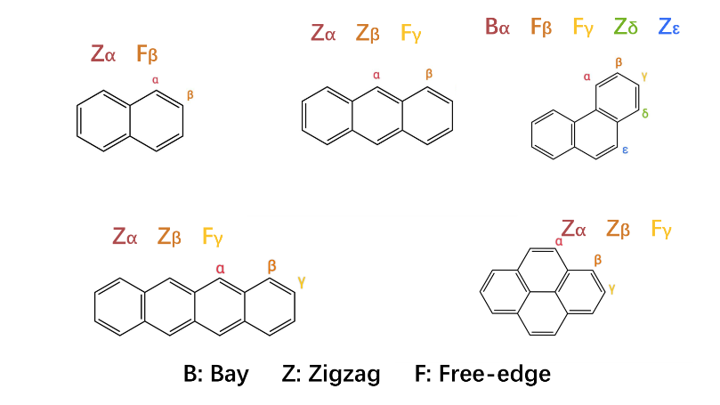
Figure 3.1: Notations of reaction sites

Addition Channel
In EStokTP, the β-scission algorithm was adopted to find the Transition States (TS) for addition reaction channels. In practice, the adduct (the well) was optimized first, and the C-C bond of interest was then elongated to find a suitable TS structure. In the final output files, rate constants in both directions, i.e., β-scission and addition, are given with dependence on temperature and pressure.
Overall, this thesis identified four obvious trends among the propargyl addition channels of different aromatic species. In particular, the addition of the methylene side of the propargyl radical (aromatic-CH₂-C-CH) is more favored over that of the alkenyl side (aromatic-CH-C-CH₂). Also, the addition to zigzag sites is preferable to that to free edge sites. Finally, addition rate constants of heavier aromatic species and of acenes in particular are faster. These trends could be well explained by the difference among the activation energy of propargyl addition channels. Furthermore, within each channel group of zigzag sites and of free edge sites, it was found that the values of addition energy barriers and high-pressure limits are quite predictable based on appropriate reference and scaling factors. These aspects are discussed in detail in next sections.

Free Edge
Free edge refers to the positions of hydrogen-bearing carbons that are connected to another two hydrogen-bearing carbons, staying farther from the aromatic center.
Figure 3.2 and Figure 3.3 record TS structures of all propargyl addition channels on free edge sites and Table 3.1 reports energy barriers and the energies of adducts (well):
- With PAH size increasing, addition barriers tend to decrease with more stable wells produced, which reflects that the enhanced π-delocalization has stronger effects of dispersion and stabilization on the unpaired electron in larger aromatic networks.
- Of the same molecular size, channels of linear acenes have lower addition barriers and are headed to more stable adducts. This could be explained by the constrained orbital overlap due to the rigid structure with highly fused rings in planar PAHs.
- Attack of propargyl radical by CH side must overcome a higher energy barrier due to its larger distortion of C-H bond (from sp to sp²) than CH₂ side (from sp² to sp³). However, products of aromatic-CH₂CCH are slightly less stable, probably because of the greater local steric stain caused by the two methylene H atoms after addition.
Pyrene is an exception with the most unstable TS and addition product with even positive addition enthalpy. Besides the fact that pyrene has a rigid structure as a planar PAH rather than linear acene, additional contribution might come from the high local symmetry at the γ site of pyrene, which leads to poor orbital overlap and a large loss of aromatic stabilization upon σ-bond formation.
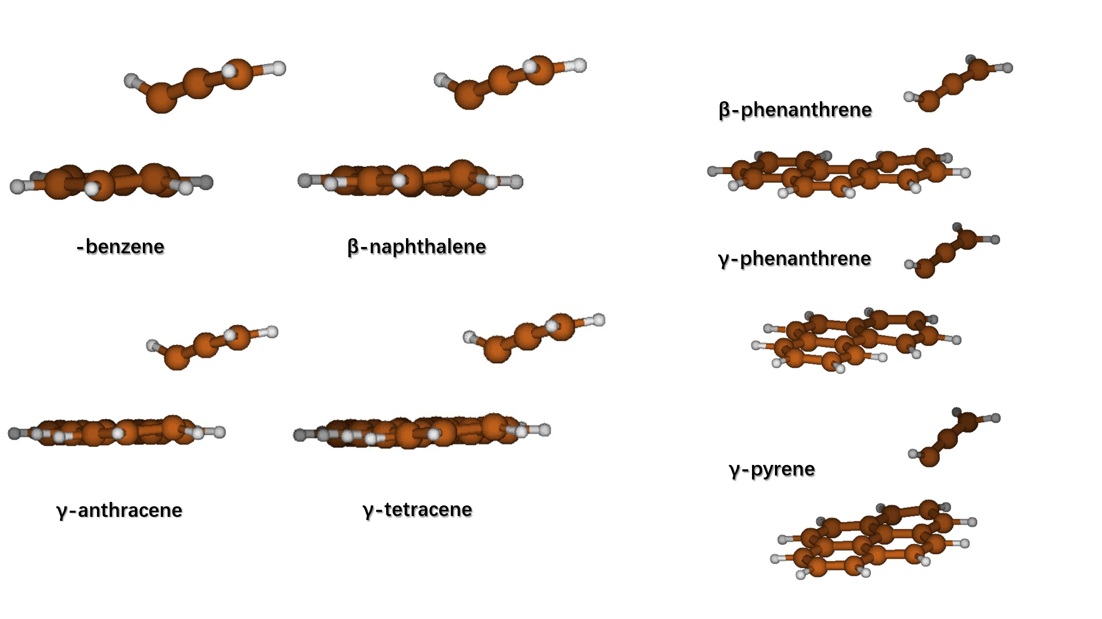
Figure 3.2: TS structure of aromatics-free edge-CHCCH2

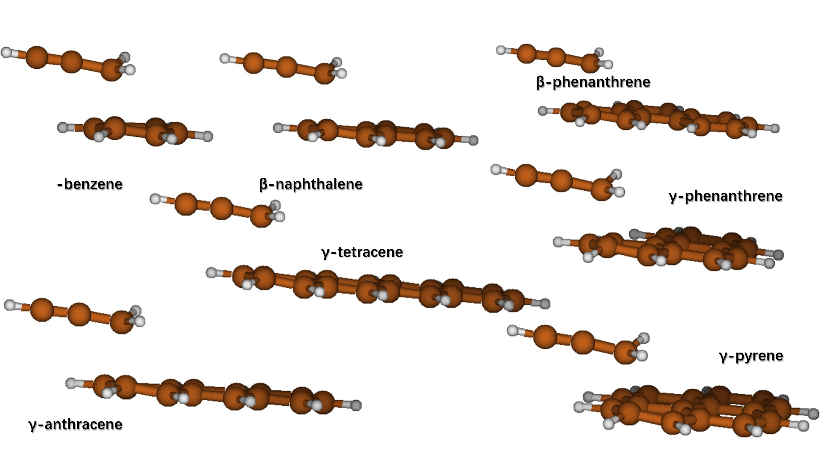
Figure 3.3: TS structure of aromatics-free edge-CH2CCH

Table 3.1: Basic data of propargyl radical addition to free edge
ΔE_{TS,add} |  |  | ΔH_{add} | kcal/mol
Benzene+Propargyl |  |  | Benzene+Propargyl
 | -chcch2 | -ch2cch |  | -chcch2 | -ch2cch
 | 15.4 | 14.0 |  | -0.7 | 0.2
Naphthalene+Propargyl |  |  | Naphthalene+Propargyl
 | -chcch2 | -ch2cch |  | -chcch2 | -ch2cch
β | 14.2 | 12.6 | β | -4.3 | -3.2
Anthracene+Propargyl |  |  | Anthracene+Propargyl
 | -chcch2 | -ch2cch |  | -chcch2 | -ch2cch
γ | 12.7 | 11.0 | γ | -9.2 | -8.0
Phenanthrene+Propargyl |  |  | Phenanthrene+Propargyl
 | -chcch2 | -ch2cch |  | -chcch2 | -ch2cch
β | 14.1 | 12.6 | β | -3.9 | -3.0
γ | 14.5 | 13.0 | γ | -2.6 | -1.6
Tetracene+Propargyl |  |  | Tetracene+Propargyl
 | -chcch2 | -ch2cch |  | -chcch2 | -ch2cch
γ | 11.6 | 9.7 | γ | -12.8 | -11.7
Pyrene+Propargyl |  |  | Pyrene+Propargyl
 | -chcch2 | -ch2cch |  | -chcch2 | -ch2cch
γ | 15.7 | 14.3 | γ | 0.8 | 1.8
Figure 3.4 compares high-pressure limit constants at T = 1000 - 2500 K. Almost all the rate constants follow the trends of energy barriers of propargyl addition to free edge sites, with visible impact of the exponential dependence on transition state energies at lower temperatures.
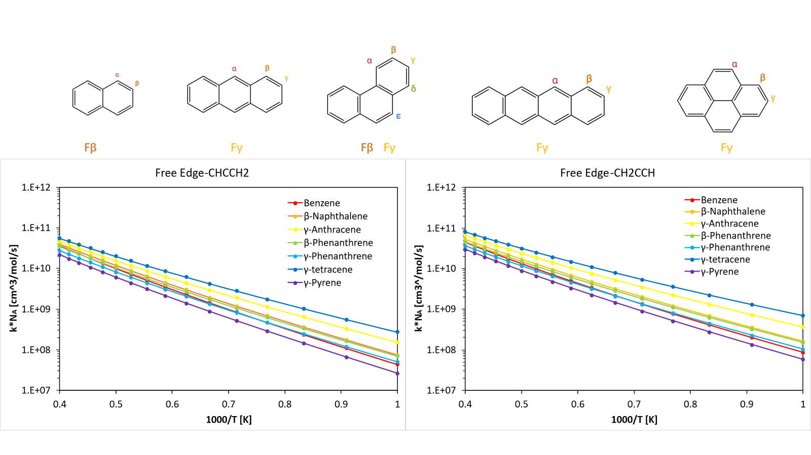
Figure 3.4: High pressure limits of propargyl radical addition to free edge sites
As stated above, channels at γ site of pyrene does not follow the same trends due to the uncommonly high energy barriers.
It should be especially mentioned that as the number of degrees of freedom and the stability of the well increases, higher energy thresholds for master equation simulations have to be set to obtain consistent trends, i.e., to avoid loss of high energy states at high temperatures. For instance, in this thesis the energy threshold for master equation simulations was increased to 1000 kcal/mol for tetracene channel while 400 kcal/mol was already enough for anthracene. It is noted that while energy thresholds should not affect high-pressure limit rate constants computed with transition state theory, a master equation simulation code was used for all rate constants. Hence the impact of energy thresholds also on high-pressure limits.
While the main scope of this thesis is to compare the high-pressure limit behavior to derive rate rules, the pressure dependence for each reaction is also discussed. Figure 3.5 compares pressure dependence among the free edge channels, according to the threshold temperature at 1 atm for well thermochemical stabilization, i.e., the highest one in temperature grid below which the product is still thermochemically stable:
- Considering the same number of rings, acenes are less affected by pressure.
- Wells produced from larger acenes stabilize up to higher temperatures.
- Except for tetracene group, addition of aromatics-CH₂-C-CH is more sensitive to pressure, in the sense that the wells produced are less stable compared to aromatics-CH-C-CH₂ addition.
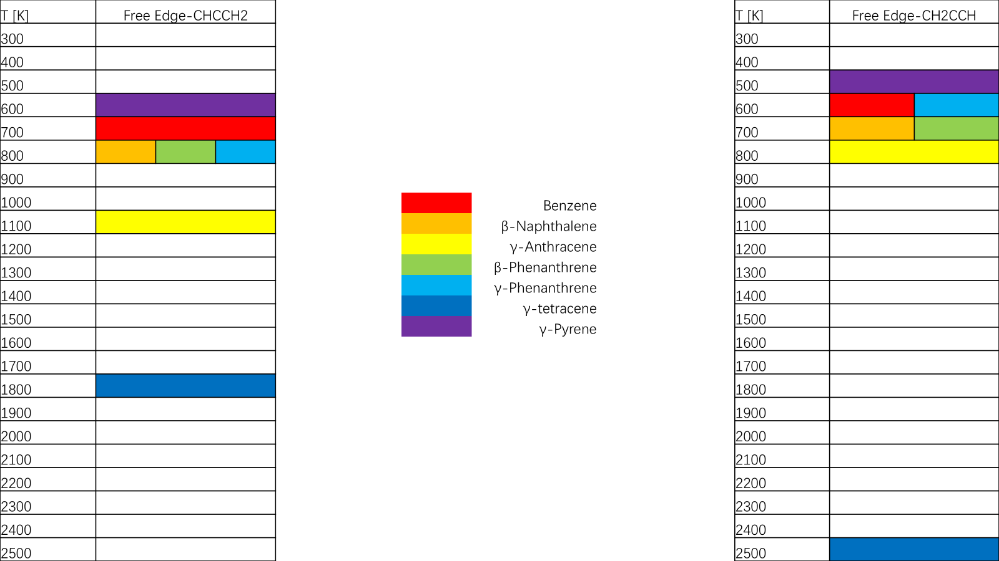
Figure 3.5: Threshold temperatures of propargyl radical addition to free edge at 1 atm
Note: For each site, the colored temperature is the highest one in the temperature grid below which the product is still thermochemically stable

This behavior is due to the higher stability of propargyl addition products: in fact, the ranking of low-pressure sensitivity is identical to that of the addition reaction enthalpy (i.e., the more stable the well, the smaller the pressure dependence).
Figure 3.6 depicts the ratio between the estimated rate constant and the calculated one $k_{rule}/k_{calc}$ using the method defined in Chapter 2.4 with benzene as reference. Overall, the estimated rate constants are in good agreement with the calculated ones, with deviations up to factors of about 1.5 for the γ sites of pyrene and phenanthrene. The vicinity among the curves seems to be related to the structural similarity of TS, such as the case among linear acenes. In turn, it shows that the distant part in the molecule unexpectedly has less influence on entropy than the local structure around reaction site. For instance, curve of β-phenanthrene almost submerges into the curve cluster of linear acenes, suggesting that the correction for the activation energy is already enough to approximate the scaling from benzene. In this case, it is possible that the geometric relationship between the β site with the whole aromatic molecule is more similar to the free edge in linear acenes like γ-anthracene. In such configuration, the most distant aromatic ring is effectively decoupled from the forming bond and contributes little to the TS entropy. By contrast, γ-phenanthrene lies on the transverse axis and is more tightly coupled to three fused rings, which leads to a similar local structure in TS and similar curve to γ-pyrene. Worth attention, all of other curves stay above benzene reference and increase the discrepancy at higher temperature. It could be attributed to the reduced vibrational entropy gain of TS (seen in Figure 3.3): the attacked aromatic ring relaxes more freely upon bond formation, producing additional low-frequency modes, whereas the corresponding ring in a fused PAH remains mechanically constrained by adjacent rings and therefore contributes less to entropy. This could also explain the even smaller $k_{rule}/k_{calc}$ ratio of γ-phenanthrene and γ-pyrene, where the local part around the attacked site has more and stronger connections with neighboring rings. Consequently, the rate constants of γ-phenanthrene are overtaken by benzene in higher temperature region, although its energy barrier is lower.
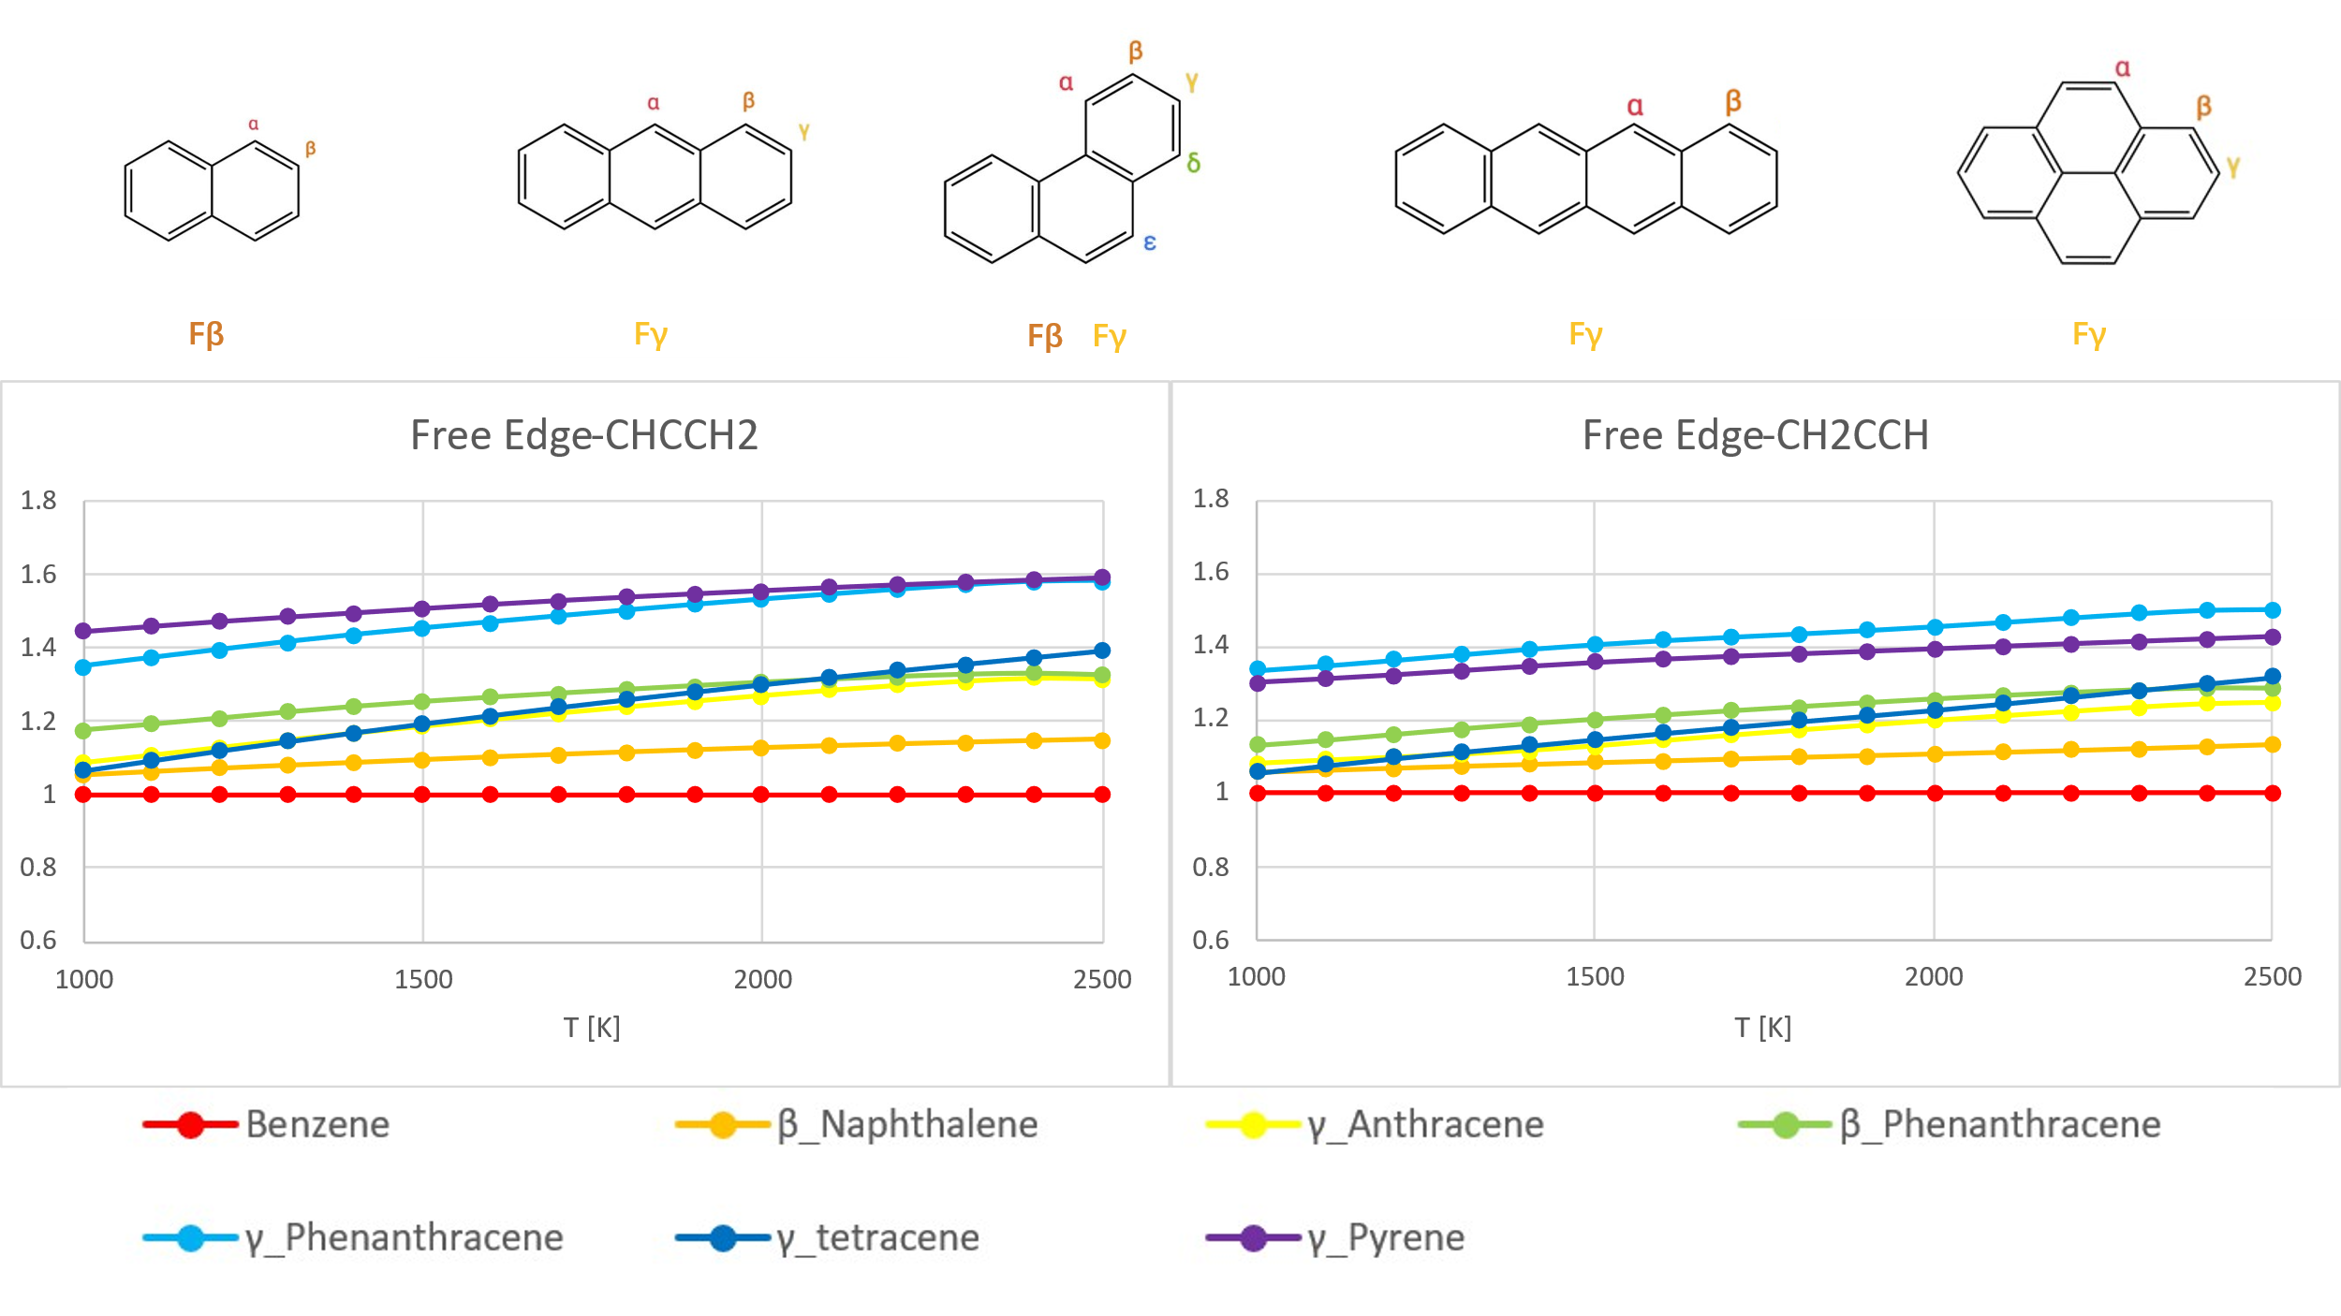
Figure 3.6: Scaling factors for rate constants of propargyl radical addition to free edge sites
Note: The reference of other free edge sites for scaling is the sites in benzene

To sum up, these results indicate the potential of adding a certain scaling factor on a simple reference of small molecules, to approximate pre-exponential coefficients for cases where system becomes bulky and infeasible to conduct theoretical calculations, or where accuracy is not a demanding issue. For the addition to the free edge, an additional scaling factor of 0.8 to the rate rule might provide better predictions compared to rough scaling only based on the activation energy.
Finally, it is useful to try to derive an approximate linear relationship between the energy barrier for the addition of propargyl to the free edge of acenes to also approximate rate constants for larger species.
Figure 3.7 is the attempt to approximate the energy barrier of propargyl addition on the free edge sits of acenes as a function of the number of aromatic rings. The barriers decrease almost linearly, with negative slopes of -1.28 / -1.44 kcal/mol/ring for the -CH and -CH₂ additions, respectively, and the difference between -CH₂-C-CH / -CH-C-CH₂ increases gently by circa. 0.154 kcal/mol per one new ring added. And as in previous discussions, it is likely reasonable as well to apply scaling factors on planar PAHs.

Figure 3.7: Linear approximation for energy barriers of propargyl radical addition to free edge sites with regard to the size of acenes
Furthermore, the linear relationship extended to larger acene shows that the activation energies for the -CH₂ and -CH additions may become negative with more than 10 and 13 rings, respectively. Above these values, the current linearity is not thought of accurate anymore. In fact, very negative energy barriers are unreasonable. However, as highlighted in the work of Nobili et al [25], the addition reaction will behave in a similar way to barrierless reactions for additions of hydrogen atom and methyl radical on acenes with up to just 8 rings. Notably, in such large acenes the triplet configuration will become more favorable that the propargyl addition will effectively become a radical recombination reaction. Therefore, the present findings are in line with those of previous works. The fact that the current relationship predicts below-zero energy barriers at n=11-13 instead of n=8 is probably due to the resonance stabilized nature of the propargyl radical, which increases the energy barriers and therefore the number of rings required to get a near-zero value.

Zigzag
Zigzag sites are hydrogen-bearing carbons that form at least one bond to a non-hydrogen-bearing carbon, being located closer to aromatic center than free edge sites. Specifically, marginal zigzag sites are also connected to another one hydrogen-bearing carbon while central zigzag sites form bonds only to non-hydrogen-bearing carbons, which is even closer to the molecular center. More importantly, besides following the general trends of propargyl addition, although they are quite similar in geometry and in chemical environment, central zigzag not only reacts faster with smaller addition energy barrier, but also forms addition products much more stable in enthalpy. This behavior is due to the higher electron and spin density in the central part of the acene, as described in the work of Nobili et al [25]. Therefore, considering their reactivity difference, this thesis divides the discussion on zigzag into two parts below. To avoid repeating, the visible comparison between these two zigzag types is just displayed in Chapter 3.1.2.2. Central Zigzag below.

Marginal Zigzag
Figure 3.8 and Figure 3.9 display the TS structures of all propargyl addition channels on marginal zigzag sites, and Table 3.2 complies the energy barriers and the energies of adducts (well). Basically, marginal zigzag group follows the same trends as free edge. However, in contrast with γ-pyrene, these unsymmetrical marginal zigzag sites in pyrene, i.e. α and β, gives lower energy barriers and more stable wells than the marginal zigzag sites in phenanthrene, which conforms to the trend regarding PAH size and demonstrates the role of local symmetry in the TS and adducts. More importantly, in channel group of each aromatic species, marginal zigzag sites, closer to the molecular center, report lower activation energy and negatively larger addition enthalpy because of better condition of dispersion for the unpaired electron.
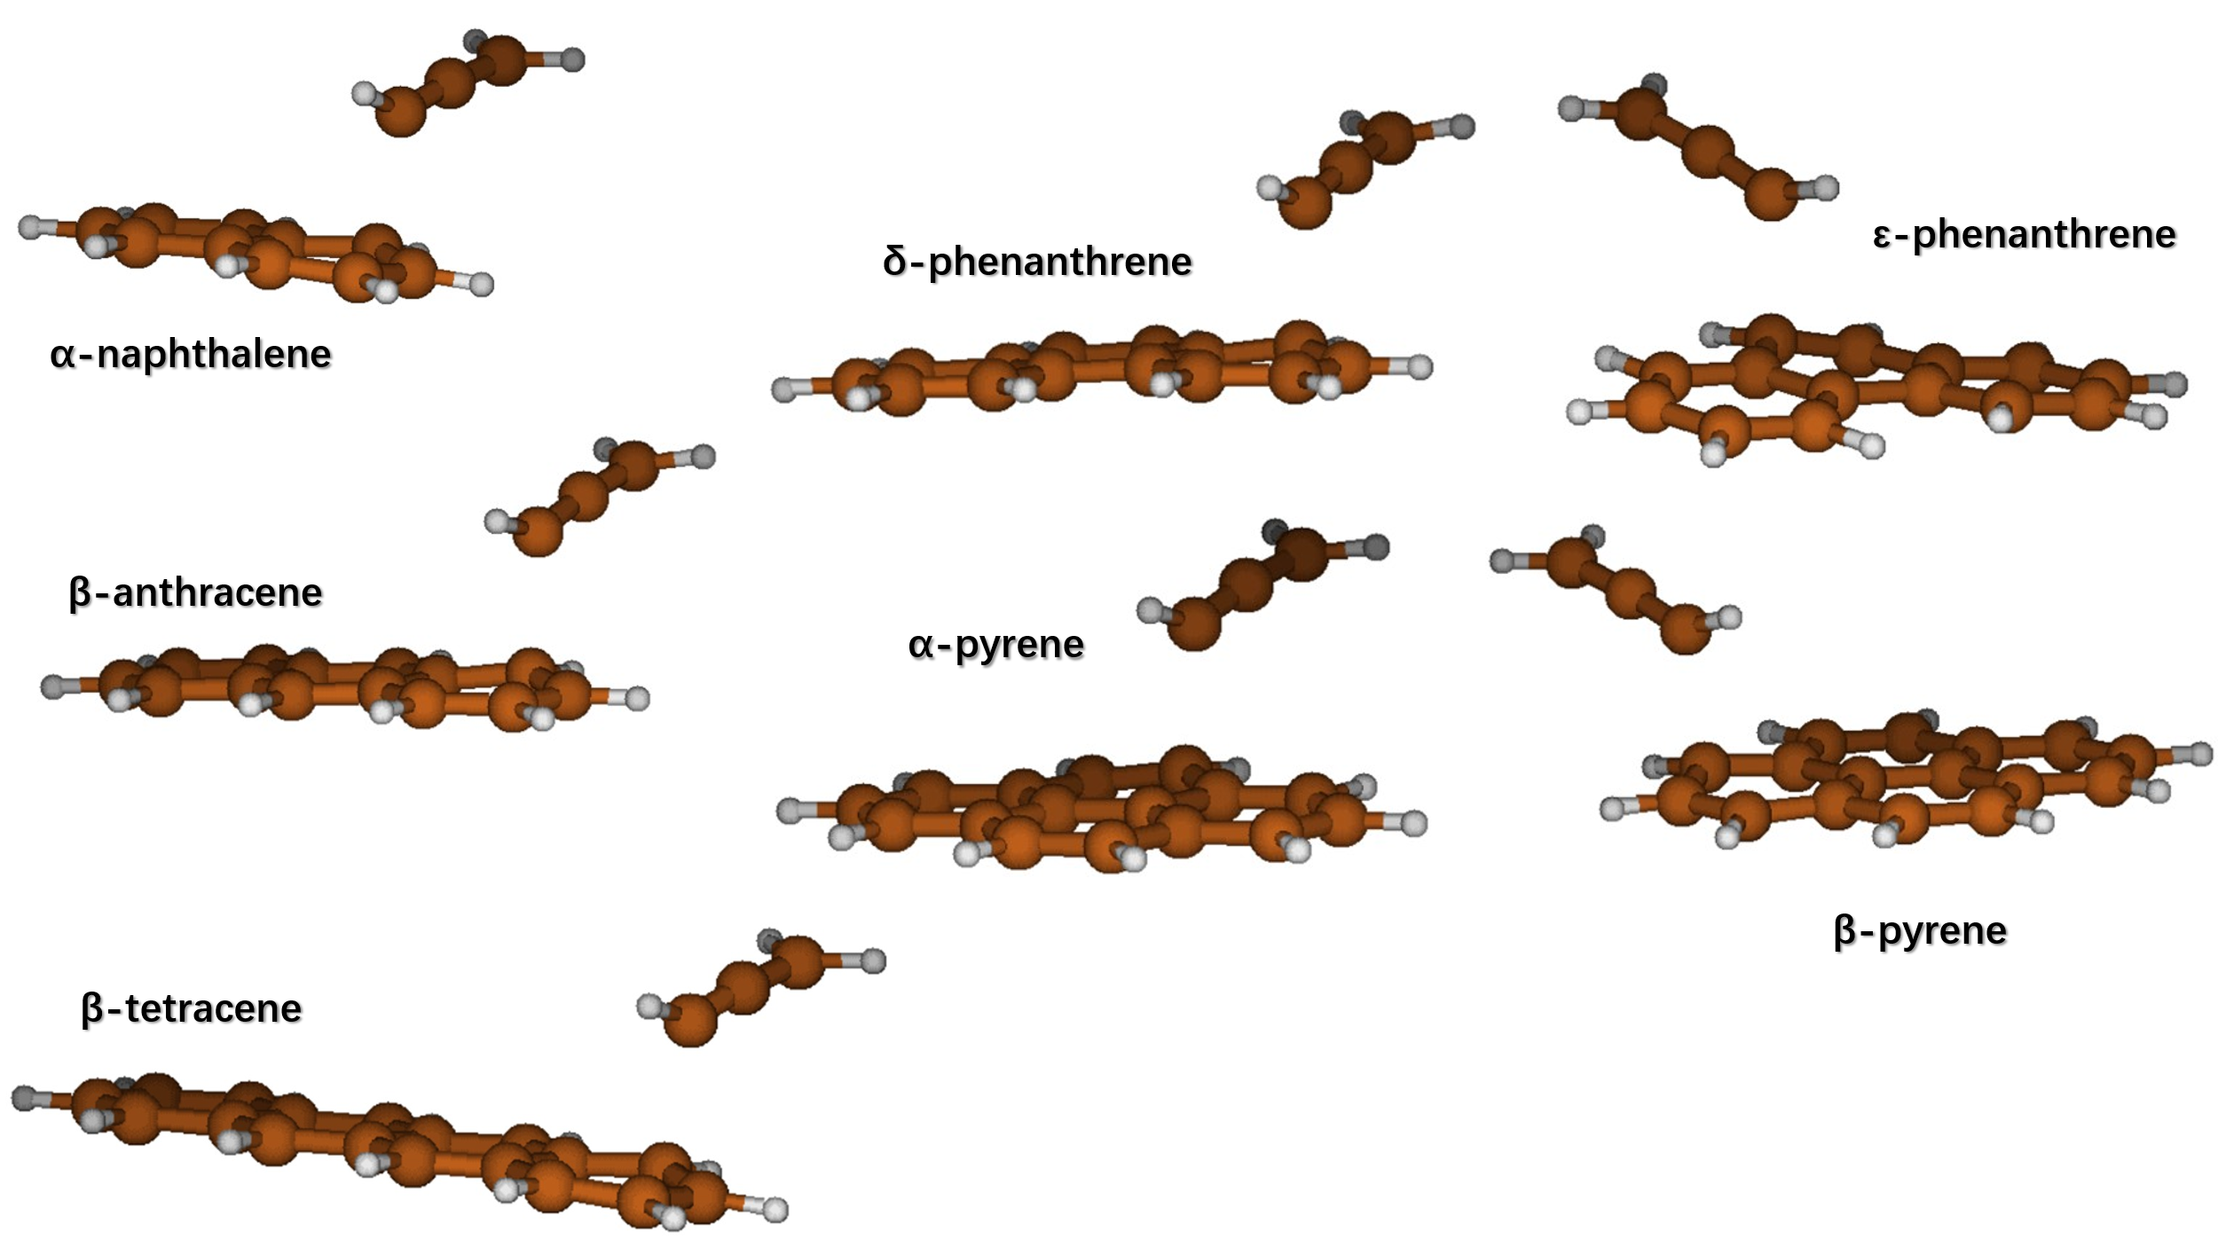
Figure 3.8: TS structure of aromatics-marginal zigzag-CHCCH2

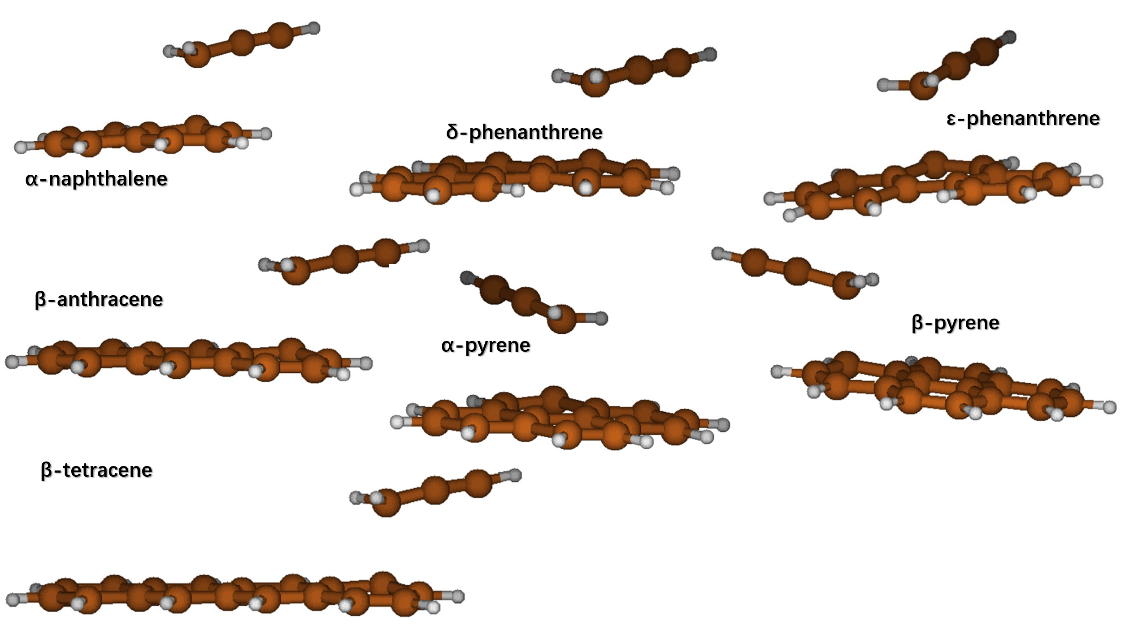
Figure 3.9: TS structure of aromatics-marginal zigzag-CHCCH2

Table 3.2: Basic data of propargyl radical addition to marginal zigzag
ΔE_{TS,add} |  |  | ΔH_{add} | kcal/mol
Naphthalene+Propargyl |  |  | Naphthalene+Propargyl
 | -chcch2 | -ch2cch |  | -chcch2 | -ch2cch
α | 12.2 | 10.3 | α | -9.4 | -8.2
Anthracene+Propargyl |  |  | Anthracene+Propargyl
 | -chcch2 | -ch2cch |  | -chcch2 | -ch2cch
β | 11.0 | 9.0 | β | -13.6 | -12.5
Phenanthrene+Propargyl |  |  | Phenanthrene+Propargyl
 | -chcch2 | -ch2cch |  | -chcch2 | -ch2cch
δ | 12.6 | 10.8 | δ | -7.1 | -5.8
ε | 12.0 | 10.1 | ε | -9.3 | -8.1
Tetracene+Propargyl |  |  | Tetracene+Propargyl
 | -chcch2 | -ch2cch |  | -chcch2 | -ch2cch
β | 10.3 | 7.4 | β | -16.1 | -15.0
Pyrene+Propargyl |  |  | Pyrene+Propargyl
 | -chcch2 | -ch2cch |  | -chcch2 | -ch2cch
α | 11.9 | 9.9 | α | -10.4 | -9.2
β | 11.0 | 9.1 | β | -13.0 | -11.6

Figure 3.10 compares high-pressure limit constants under 1000 K to 2500 K. Basically, marginal zigzag sites follow the trends seen among free edge sites but are a little bit more reactive than free edge sites because of smaller energy barriers. Again due to their unsymmetric property, the α and β sites on pyrene obviously have increased rate constants with effectively decreased activation energy with respect to the γ site.
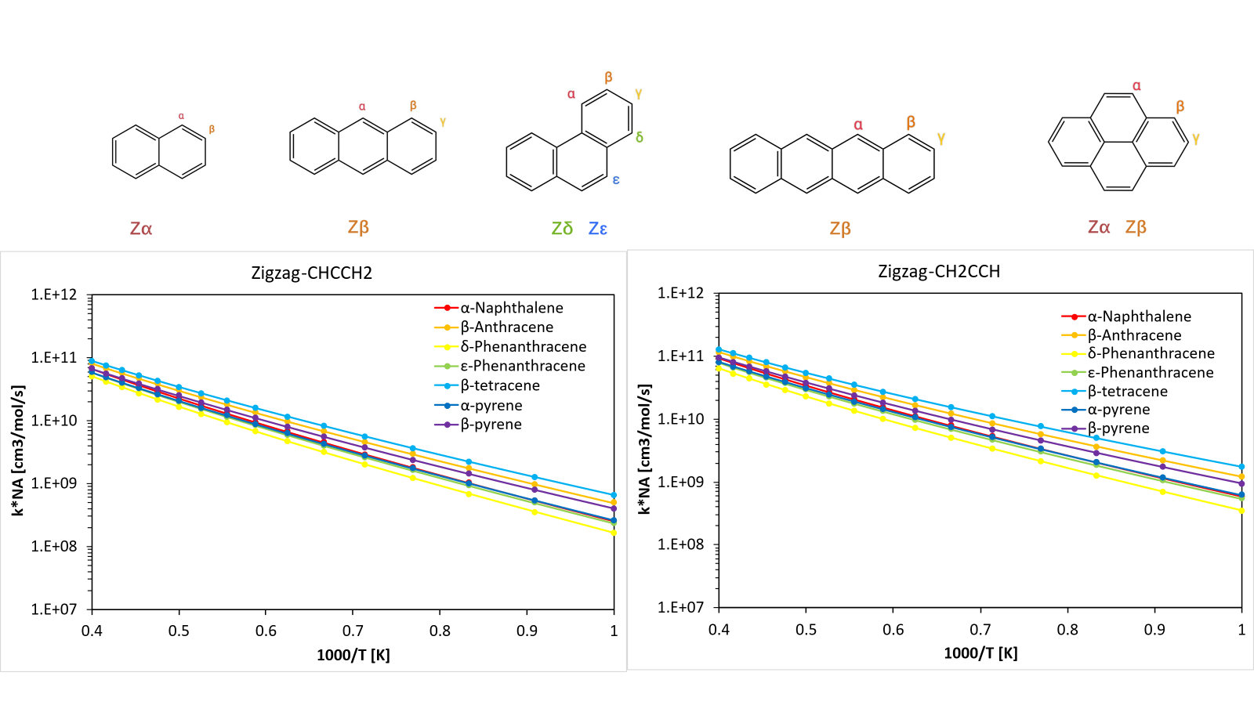
Figure 3.10: High pressure limits of propargyl addition to marginal zigzag sites

Figure 3.11 compares pressure sensitivity among the marginal zigzag channels in the same way. Overall, besides following the similar trends as free edge, propargyl addition channels on almost all the aromatic species are less sensitive to the influence of low pressure. Again, the pressure sensitivity of propargyl addition at marginal zigzag sites has a strong relationship with the stability of adducts.

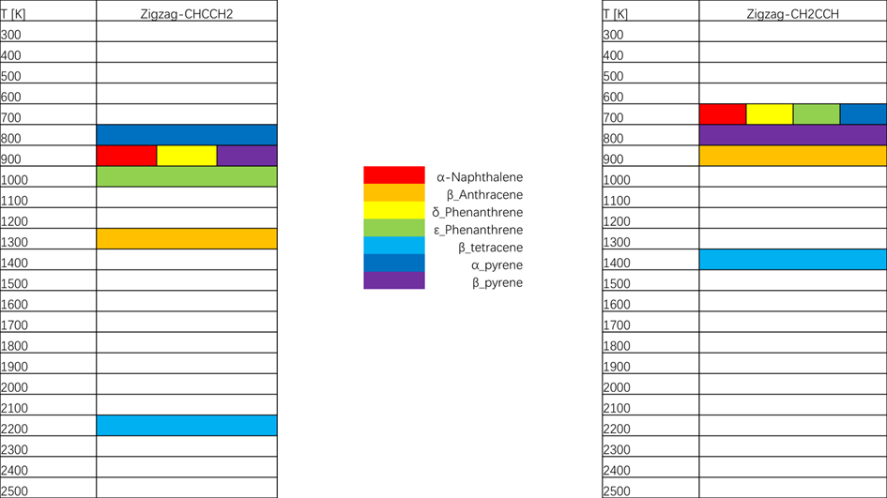
Figure 3.11: Threshold temperatures of propargyl radical addition to marginal zigzag sites at 1 atm
Note: For each site, the colored temperature is the highest one in the temperature grid below which the product is still thermochemically stable

Figure 3.12 depicts the ratio between the estimated rate constant and the calculated one $k_{rule}/k_{calc}$ with the method defined in Chapter 2.4 by setting α-naphthalene as reference i.e., the simplest marginal zigzag site. Slightly different from free edge channel, within each channel group of marginal zigzag -CH-C-CH₂ and -CH₂-C-CH, there exists a clear discrepancy between the curve clusters of linear acenes and planar PAHs, while an appropriate additional scaling factor for acenes could be 0.95 after correction of activation energy, or be 1.2 for planar PAHs.
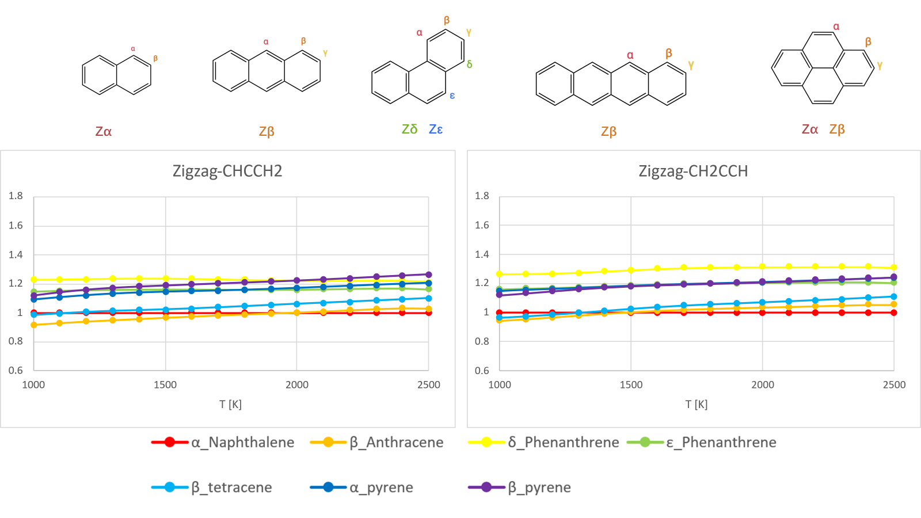
Figure 3.12: Scaling factors for rate constants of propargyl addition on marginal zigzag sites
Note: The reference of other marginal zigzag sites for scaling is α-naphthalene

Figure 3.13 plots the linear approximation for the energy barrier of propargyl addition on the marginal zigzag sites of acenes. With respect to free edge, the slope of -CH group and -CH₂ group is flattened to -0.94 and -1.04, respectively, and the pseudo zero point for each group is postponed to around 15 and 12. Consequently, it becomes a paradox that according to linear approximation, activation energies at free edge sites are lower than those of zig zag sites in certain rings number before the zero points, implying a smaller applicable region of linear model than thought earlier.

Figure 3.13: Linear approximation for energy barriers of propargyl radical addition to marginal zigzag sites with regard to the size of acenes

Central Zigzag
The propargyl addition at central zigzag sites is characterized by its outstandingly low energy barrier and large bond enthalpy of the new C-C bond, resulting in much larger values of rate constant and deeply lowered quench pressure. Those investigated central zigzag sites, i.e. α-anthracene and α-tetracene, lie along the central axis and thus have even larger spin and electron density, which favor the reactivity.
Notably, with 4 aromatic rings arranged in a line, tetracene is long enough to provide sufficient area for overlapping, making it possible to happen π-interaction between tetracene and propargyl radical and thus to decrease the energy of system. Actually, this thesis has discovered two different TS structures since two different DFT theories are used to calculate electronic energy of sampling points when scanning the critical dihedral angle to find the TS structure with the lowest energy. M062X theory makes better evaluations on dispersion interactions and manages to figure out the TS with lower energy, where propargyl radical has a sufficient projected overlapping area on the tetracene plane to form π-interaction. While the scanning by B3LYP theory, which poorly retains dispersion interactions, points to the TS with higher energy by circa. 1.73 kcal/mol (in Table 3.3). However, the latter one is very similar in configuration to the TS in other channels of PAH-CHCCH₂/CH₂CCH. Furthermore, although with a decreased energy barrier, the rate constant based on the former TS is smaller by factors of 1.5 - 3 in high temperature domain due to the entropy deficit by π-interaction. However, in other tetracene channels instead, M062X theory does not report similar phenomena that the overlapping configuration is more stable than others.
This thesis provides two choices to deal with two sets of rate constants of the same reactions: 1) since the energy difference is not large, the error might be acceptable with only the faster one taken into consideration. 2) take the weighted average with the format of Boltzmann distribution:
$$\overline{k}=\frac{e^{-\frac{E_{a}^{*}}{k_{B}T}}k^{*}+e^{-\frac{E_{a}}{k_{B}T}}k}{e^{-\frac{E_{a}^{*}}{k_{B}T}}+e^{-\frac{E_{a}}{k_{B}T}}}$$ | (3.1)
Where * donates the TS with higher energy
Figure 3.14 records the TS structures of all propargyl addition channels on central zigzag sites and Table 3.3 reports the energy barriers and the energies of adducts (well).

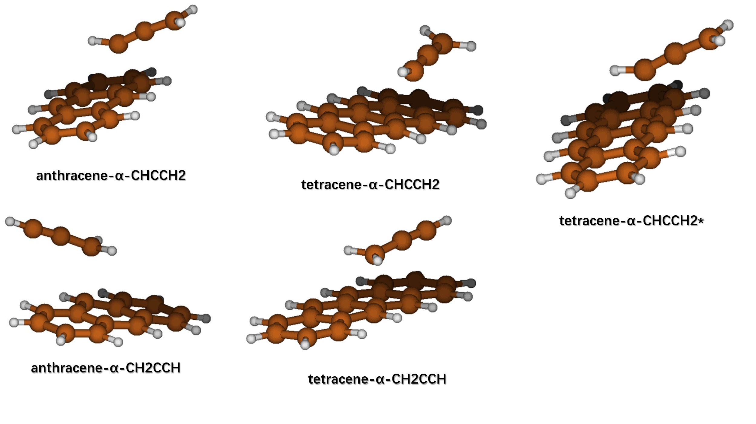
Figure 3.14: TS structure of aromatics-marginal zigzag-CHCCH2
Note: * corresponds to the TS found with higher energy

Table 3.3: Basic data of propargyl radical addition to central zigzag and marginal zigzag sites
ΔEa,add |  |  | ΔH,add | kcal/mol
Naphthalene+Propargyl |  |  | Naphthalene+Propargyl
 | -chcch2 | -ch2cch |  | -chcch2 | -ch2cch
α | 12.2 | 10.3 | α | -9.41 | -8.20
Anthracene+Propargyl |  |  | Anthracene+Propargyl
 | -chcch2 | -ch2cch |  | -chcch2 | -ch2cch
α | 8.03 | 5.30 | α | -21.6 | -20.3
β | 11.0 | 8.95 | β | -13.6 | -12.5
Phenanthrene+Propargyl |  |  | Phenanthrene+Propargyl
 | -chcch2 | -ch2cch |  | -chcch2 | -ch2cch
ε | 12.0 | 10.1 | ε | -9.29 | -8.14
Tetracene+Propargyl |  |  | Tetracene+Propargyl
 | -chcch2 | -ch2cch |  | -chcch2 | -ch2cch
α | 6.32 | 2.73 | α | -27.9 | -27.0
α* | 4.59 | \ | α* | -27.9 | \
β | 10.3 | 7.40 | β | -16.1 | -15.0
Pyrene+Propargyl |  |  | Pyrene+Propargyl
 | -chcch2 | -ch2cch |  | -chcch2 | -ch2cch
β | 11.0 | 9.10 | β | -13.0 | -11.6
Note: data of α* donates the TS with higher energy

Figure 3.15 compares high-pressure limit constants at T = 1000 – 2500 K among central zigzag sites and selected marginal zigzag sites of high reactivities.
Because of the unexpectedly lower energy barriers, curves of central zigzag form an obvious gap above the curve cluster of marginal zigzag. Even between the two central zigzag, there is a considerable discrepancy with the tetracene curve staying above.

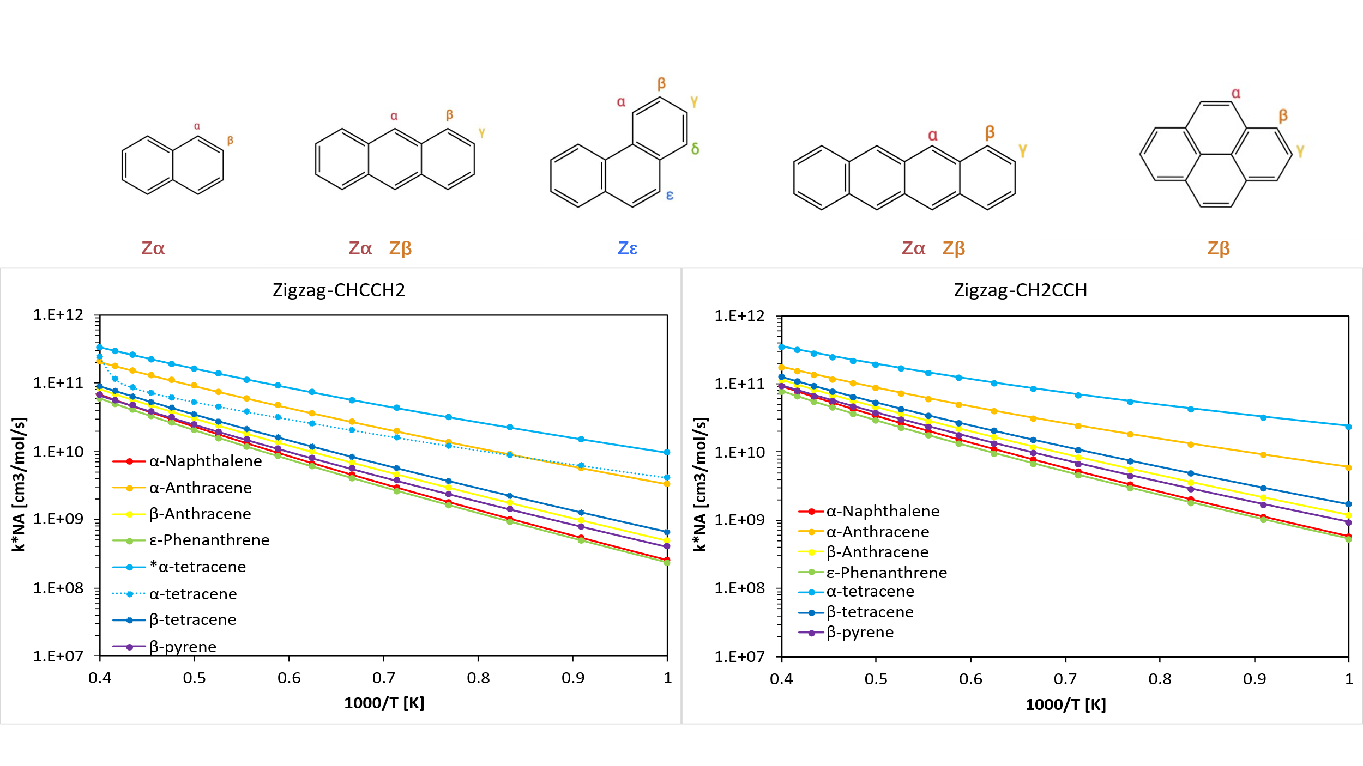
Figure 3.15: High pressure limits of propargyl addition to central zigzag sites and selected marginal zigzag sites
Note: * corresponds to the TS found with higher energy
Figure 3.16 depicts the ratio between the estimated rate constant and the calculated one $k_{rule}/k_{calc}$ for central zigzag sites and selected marginal zigzag sites, with the method defined in Chapter 2.4 by setting α-naphthalene as reference.

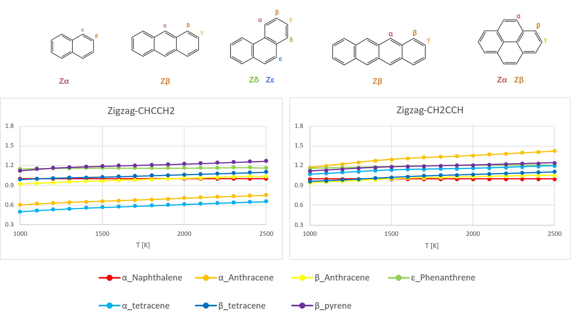
Figure 3.16: Scaling factors for rate constants of propargyl addition on all central and selected marginal zigzag sites
Note: The reference of other marginal zigzag sites for scaling is α-naphthalene
Among channels of -CHCCH₂, there are three distinguishable curve clusters belonging to marginal zigzag in planar PAHs, marginal zigzag in linear acenes, and central zigzag in linear acenes, respectively, while among the -CH2CCH channels, clusters of the former two are fused. Furthermore, The constant scaling factor for central zigzag with reference to α-naphthalene is 1.67 and 0.8 for -CHCCH₂ and -CH₂CCH respectively. So far, central zigzag-CHCCH₂ is the only case with scaling factor larger than 1. The peculiar behavior of the tetracene and anthracene central sites, where the rate rule underestimates the computed rate constants by a factor of 2-2.5, might be attributed to the peculiarity of these reactive sites. As the radical center and the highest spin density lies towards the center of the acene molecules, it is likely that the interactions between the propargyl moiety and the rest of the ring are less evident than in the marginal cases. However, in the TS of PAH-central zigzag-CH2CCH, the overlapping configuration for π-interaction between PAHs and propargyl radical results in the entropy deficit, which even over-offsets the “PAH center effect” mentioned above.
With recognition of the complexity to determine the rate constants of tetracene-α-CHCCH₂ channel, where two reasonable TS structures are found and contributes to the rate constant at the same time by Formula (3.1)(3.1), the general rate rules for propargyl radical addition on central zigzag channels are that:
- The energy barrier is obtained by linear approximation. With respect to those two different TS configurations, there should be two different approximation lines. One is for the TS with higher energy, starting from anthracene while another one is for the TS lower in energy, starting from the tetracene
- The scaling factor, upon the calculated rate constant through the method in chapter 2.4, should be different for those two TS configurations as well, which is similar to what is mentioned in point 1)
- Combine the corrected rate constants according to Formula (3.1).
Therefore, to derive the rate constant in higher accuracy with the method mentioned above, the kinetic knowledge at least of hexacene is necessary. With considerations of the fact that larger linear acenes are very rare in real combustion cases, and that the calculation cost is expensive for larger linear acenes, it is more practical to ignore the contribution from the TS with lower energy, and derive the rate constants through the similar steps that has been described for many times in the discussion on other sites.

H-dissociation Channel
After propargyl addition, the system is pushed by a strong driving force to recover the complete aromatic structure in thermodynamics, through three competing channels: hydrogen transfer (isomerization), hydrogen dissociation (h-dissociation), as well as reverse channel of propargyl addition. Along the h-dissociation channel, the hydrogen atom, originally bonded to the addition site, leaves the system to form a new branched close-shell aromatic molecule. In total, a propargyl addition followed by h-dissociation consists of an aromatic radical substitution reaction. Just like other common β-scission, this channel is more competitive against its reverse direction, due to the large entropy penalty of h-addition. However, under low temperature, h-dissociation becomes less competitive due to its higher energy barrier.
In comparison with propargyl addition channel, the discussion on this β-scission channel is a good supplement in the reverse direction for researching the scaling principles of aromatics-radical reactions. More importantly, this channel is directly involved in the competition with h-transfer, which is a critical step towards the formation of new aromatic rings. Considering the conclusions in earlier subchapters, to avoid repetition, this thesis investigates the h-dissociations only of the propargyl addition products of zigzag sites on acenes, plus benzene-propargyl and naphthalene-propargyl as smaller examples of free-edge sites for comparison.
Figure 3.17 and Figure 3.18 exhibit the TS structures of h-dissociation channels and Table 3.4 records the energy barriers and reaction enthalpies. Consistently with what can be expected, data of H-dissociation barriers represents completely opposite characteristics with respect to propargyl addition channels: 1) lower dissociation barriers happen in channels of smaller PAHs, 2) channels of aromatics-CHCCH₂ have smaller activation energy than those of aromatics-CH₂CCH, 3) the ranking of energy barrier is central zigzag > marginal zigzag > free edge.
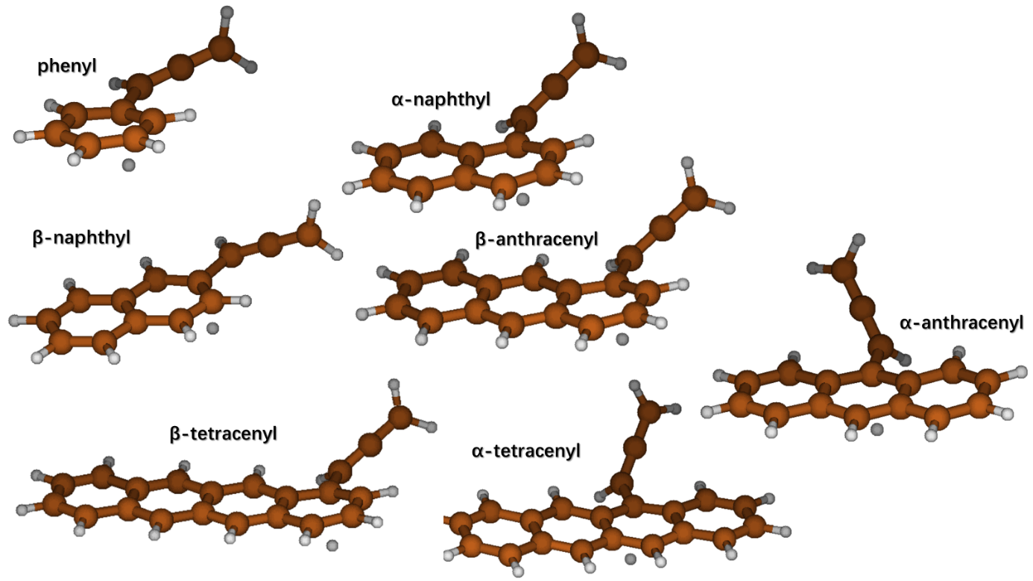
Figure 3.17: TS structure of H-dissociation from aromatics-CHCCH2

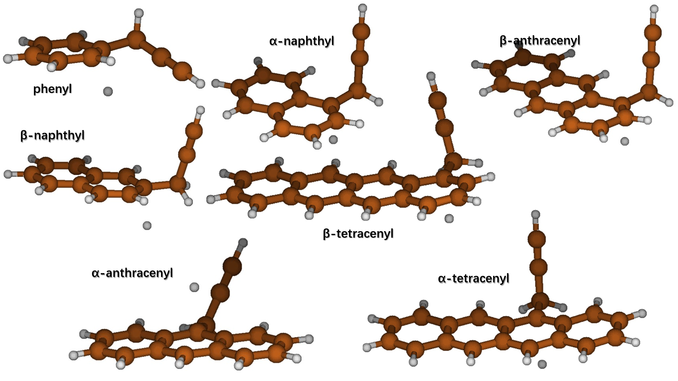
Figure 3.18: TS structure of H-dissociation from aromatics-CH2CCH

Table 3.4: Basic data of propargyl radical addition to central zigzag and marginal zigzag sites
ΔE_{TS,sciss} |  |  | ΔH_{sciss} | kcal/mol
benzene-Propargyl |  |  | benzene-Propargyl
 | -chcch2 | -ch2cch |  | -chcch2 | -ch2cch
α | 24.6 | 26.7 | α | 15.7 | 20.0
naphthalene-Propargyl |  |  | naphthalene-Propargyl
 | -chcch2 | -ch2cch |  | -chcch2 | -ch2cch
β | 27.1 | 30.0 | β | 18.7 | 23.4
α | 32.8 | 34.5 | α | 26.4 | 28.7
anthracene-Propargyl |  |  | anthracene-Propargyl
 | -chcch2 | -ch2cch |  | -chcch2 | -ch2cch
β | 36.2 | 37.9 | β | 30.5 | 32.7
α | 44.8 | 46.3 | α | 40.5 | 43.4
tetracene-Propargyl |  |  | tetracene-Propargyl
 | -chcch2 | -ch2cch |  | -chcch2 | -ch2cch
β | 38.2 | 40.1 | β | 32.9 | 35.1
α | 50.0 | 52.0 | α | 46.6 | 49.9

However, from the opposite perspective, h-addition channels behave very similarly to propargyl additions: 1) smaller addition barriers and stable wells tend to be present in larger PAHs, 2) the ranking of energy barrier is free edge > marginal zigzag > central zigzag while the ranking of well stability is the opposite. The explanation is the same as it in chapters of propargyl addition. More importantly, in addition to the work of Nobili et al [25], these two points could probably be the general principles in the bimolecular addition reactions between neutral aromatics and small singlet radicals.
Furthermore, Figure 3.19 gives the schematic diagram for the potential energy surface of aromatic radical substitution reaction between aromatics and propargyl radicals, i.e., the combination of the two channels discussed so far. With respect to the reference energy of aromatics + propargyl radical reactants, the discrepancies among the relative energies of TS and among bimolecular products of h-dissociation are not as significant, which means the size of PAHs has smaller influence on H addition barriers.
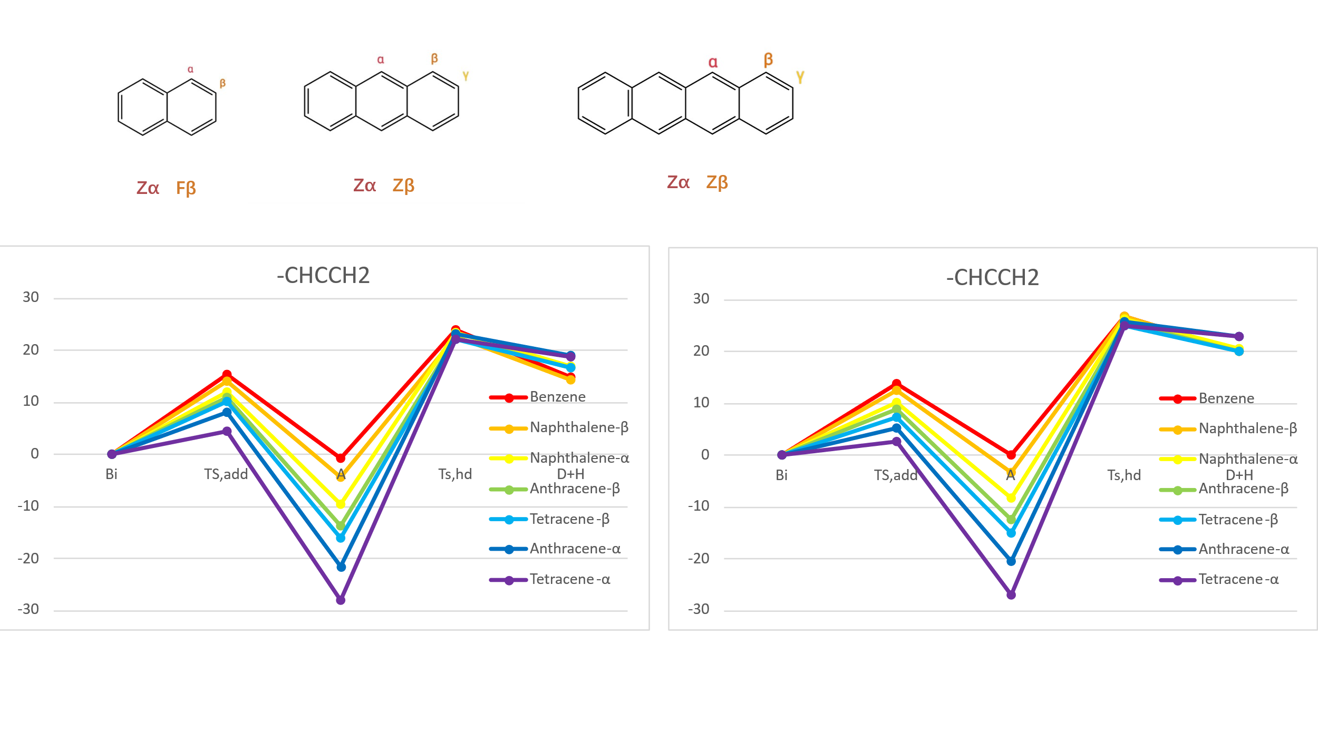
Figure 3.19: Schematic diagram for PES of aromatic radical substitution reactions
Note: Bi = Bimolecular starting point of aromatics + propargyl radical; TS,add = Transition state of propargyl addition; A = Adducts; TS,hd = Transition state of H- dissociation; D+H = bimolecular ending after H-dissociation

Figure 3.20 compares high pressure limits at T = 1000 – 2500 K of h-dissociations. Similarly, the height of energy barrier is still the determinate factor among zigzag channels. Although benzene-propargyl has the smallest barrier among the species investigated, the channel becomes gradually less competitive than other channels under higher temperature due to its smaller entropy of more planar TS configuration. This suggests that benzene is a poor reference aromatic for this reaction class.
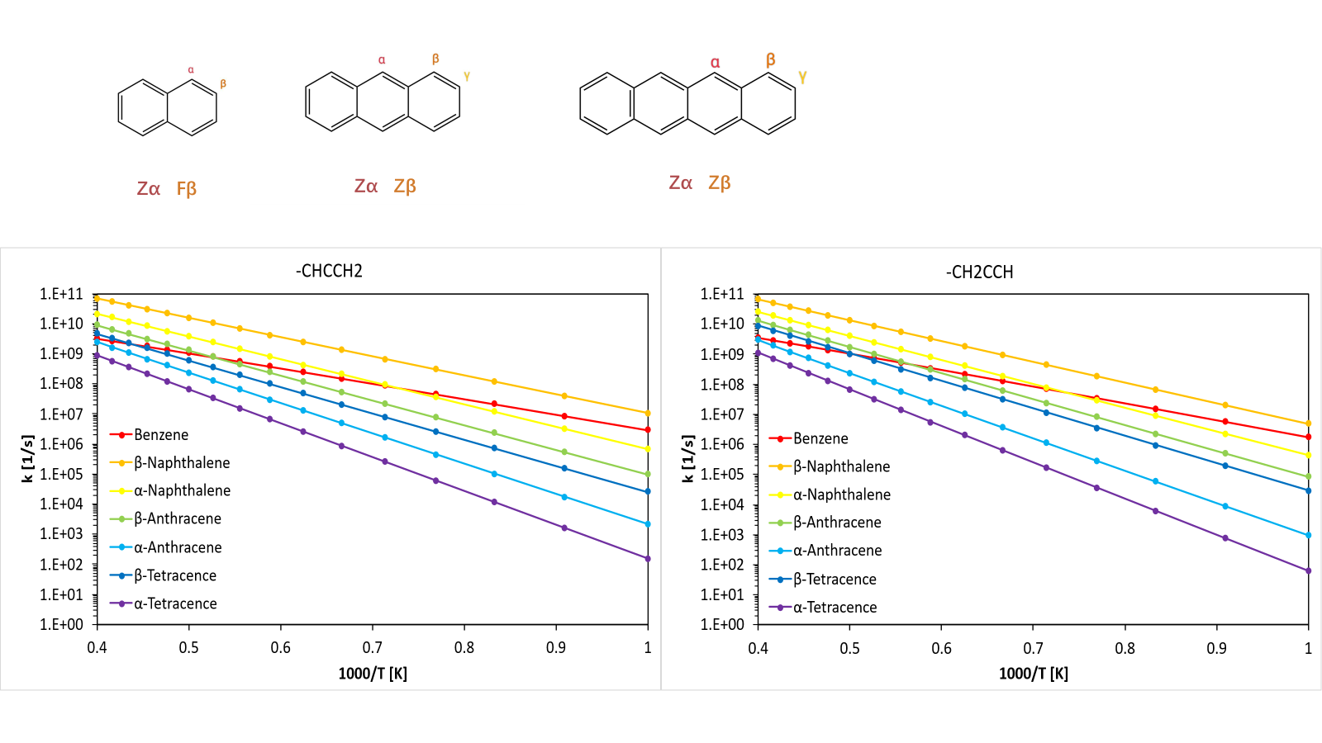
Figure 3.20: High pressure limits of H-dissociation
In contrast with propargyl addition/β-scission, h-dissociation is substantially less vulnerable to low pressure. Under 1 atm, only channels of benzene/naphthalene-propargyl have threshold temperatures less than 2500 K (between 1300 K-1700 K). As pressure is increased to 10 atm, at least by 2500 K, all the channels investigated do not form products thermochemically unstable anymore. The reason could be the stronger coupling of bimolecular complex between aromatics and atomic hydrogen, which is somehow reflected by the higher bond energy of the C-H bond than the C-C bond at the reaction site in the propargyl addition products.
Figure 3.21 depicts the ratio between the estimated rate constant and the calculated one $k_{rule}/k_{calc}$ by setting α-naphthalene as reference. Actually, with reference to benzene-propargyl, there is a giant discrepancy between the reference line and all of other curves, and under temperatures higher than 1000 K, these curves decrease to the scale of 10⁻², which indicates small entropies of the planar TS of benzene-propargyl. For channels of -CH-C-CH2 branched species, an explicit scaling factor seems not to exist. A good explanation could be that, along the h-dissociation channel, as the parent ring regains its aromatic characteristics, the π bond on propargyl is progressively coupled with the delocalized π system. The gradual formation along the channel of partial π-π orbital overlap effectively restricts the internal motion of the propargyl fragment, and results in an upward shift in frequency of several relaxed vibrations and a corresponding loss of entropy, which dominates the decrease in the pre-exponential factor. Since the shifting degree does not vary simply linearly with larger acenes, the scaling factor is not as clear in this case, and it cannot be well described by constant values upon simple scaling of the activation energy. However, constant scaling factor still works for -CH2-C-CH branched species of central zigzag and other sites (including marginal zigzag and free edge except for benzene). The scaling factor of central zigzag should be inferred from the reference to anthracene while the remaining species have another scaling factor (equal to 1 circa.) in common with reference to naphthalene. It could be well interpreted from the good geometric similarity between reactant and TS in -CH₂-C-CH group, as well as the insulation effect of methylene between the π orbitals of parent ring and propargyl.
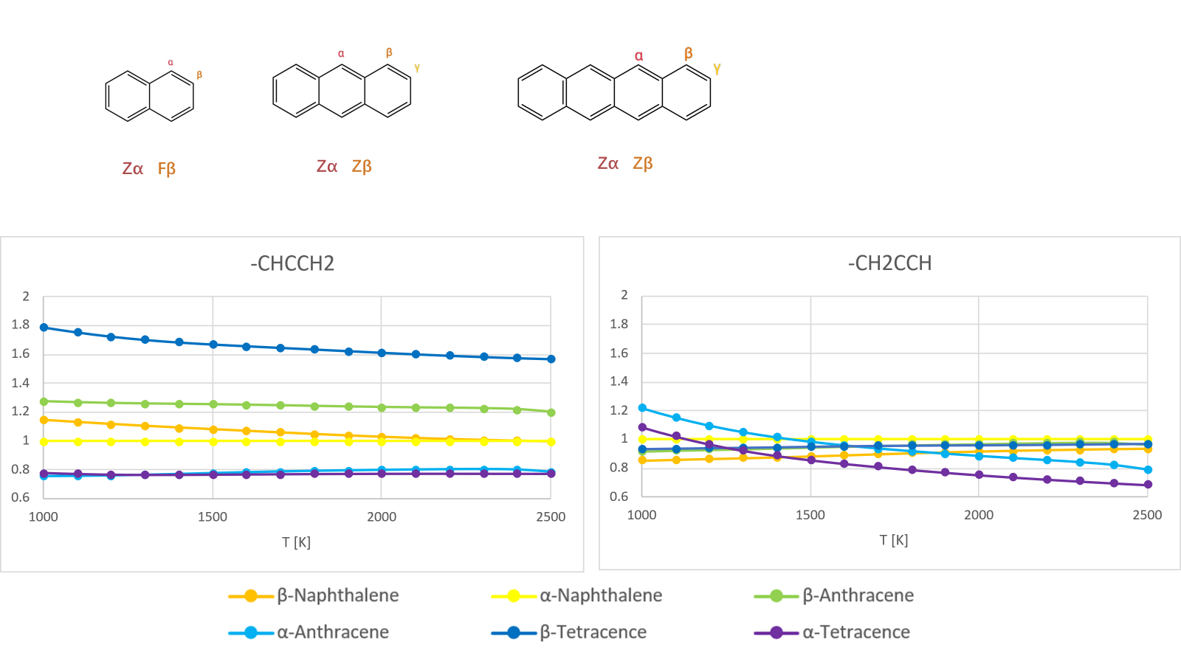
Figure 3.21: Scaling factors for rate constants of H-dissociation
Note: The reference for scaling is α-naphthalene

H-transfer Channel
Along the h-transfer channel, the hydrogen atom, escapes from the propargyl addition site, and forms bond with the bare carbon atom, which lies in the middle of propargyl branch. During the isomerization motion, on the one hand, the parent ring gradually recovers its aromatic structure, on the other hand, the new C-H bond bends the rigid, linear branch by transforming the carbon from sp to sp² hybridization, making it possible that the branch attacks back to close a new 6-member ring. Nevertheless, the channel must go through a steep, unstable 4-member ring TS structure with an imaginary frequency around i2000 cm⁻¹. Based on the experience of former two channels, this thesis investigates only α-naphthalene and β-anthracene. However, in H-transfer channels, DFT theory M062X, the major theory used in this thesis failed to find the abovementioned TS. Therefore, ωB97X-D is applied to calculate the energy barrier, TS structure and rate constant. To keep the consistency in the final multi-well master equation simulations, pseudo-M062X electronic energies were obtained scaling ωB97X-D energy barriers from the M062X well energies, while the vibrational frequencies by ωB97X-D multiply the factor between these two theories.
Figure 3.22 exhibits the TS structures of h-transfer channels and Table 3.5 records the energy barriers and reaction enthalpies. From 2 rings to 3 rings, the energy barrier changes rather limited. However, channels of -CHCCH₂ are destinated a much more stable well characterized by a planar π-conjugated structure with spin delocalization over the π-system, while due to the isolation of methylene group -CH₂-, the product of -CH2CCH channels heritages the 3-D configuration with a twisted branch.
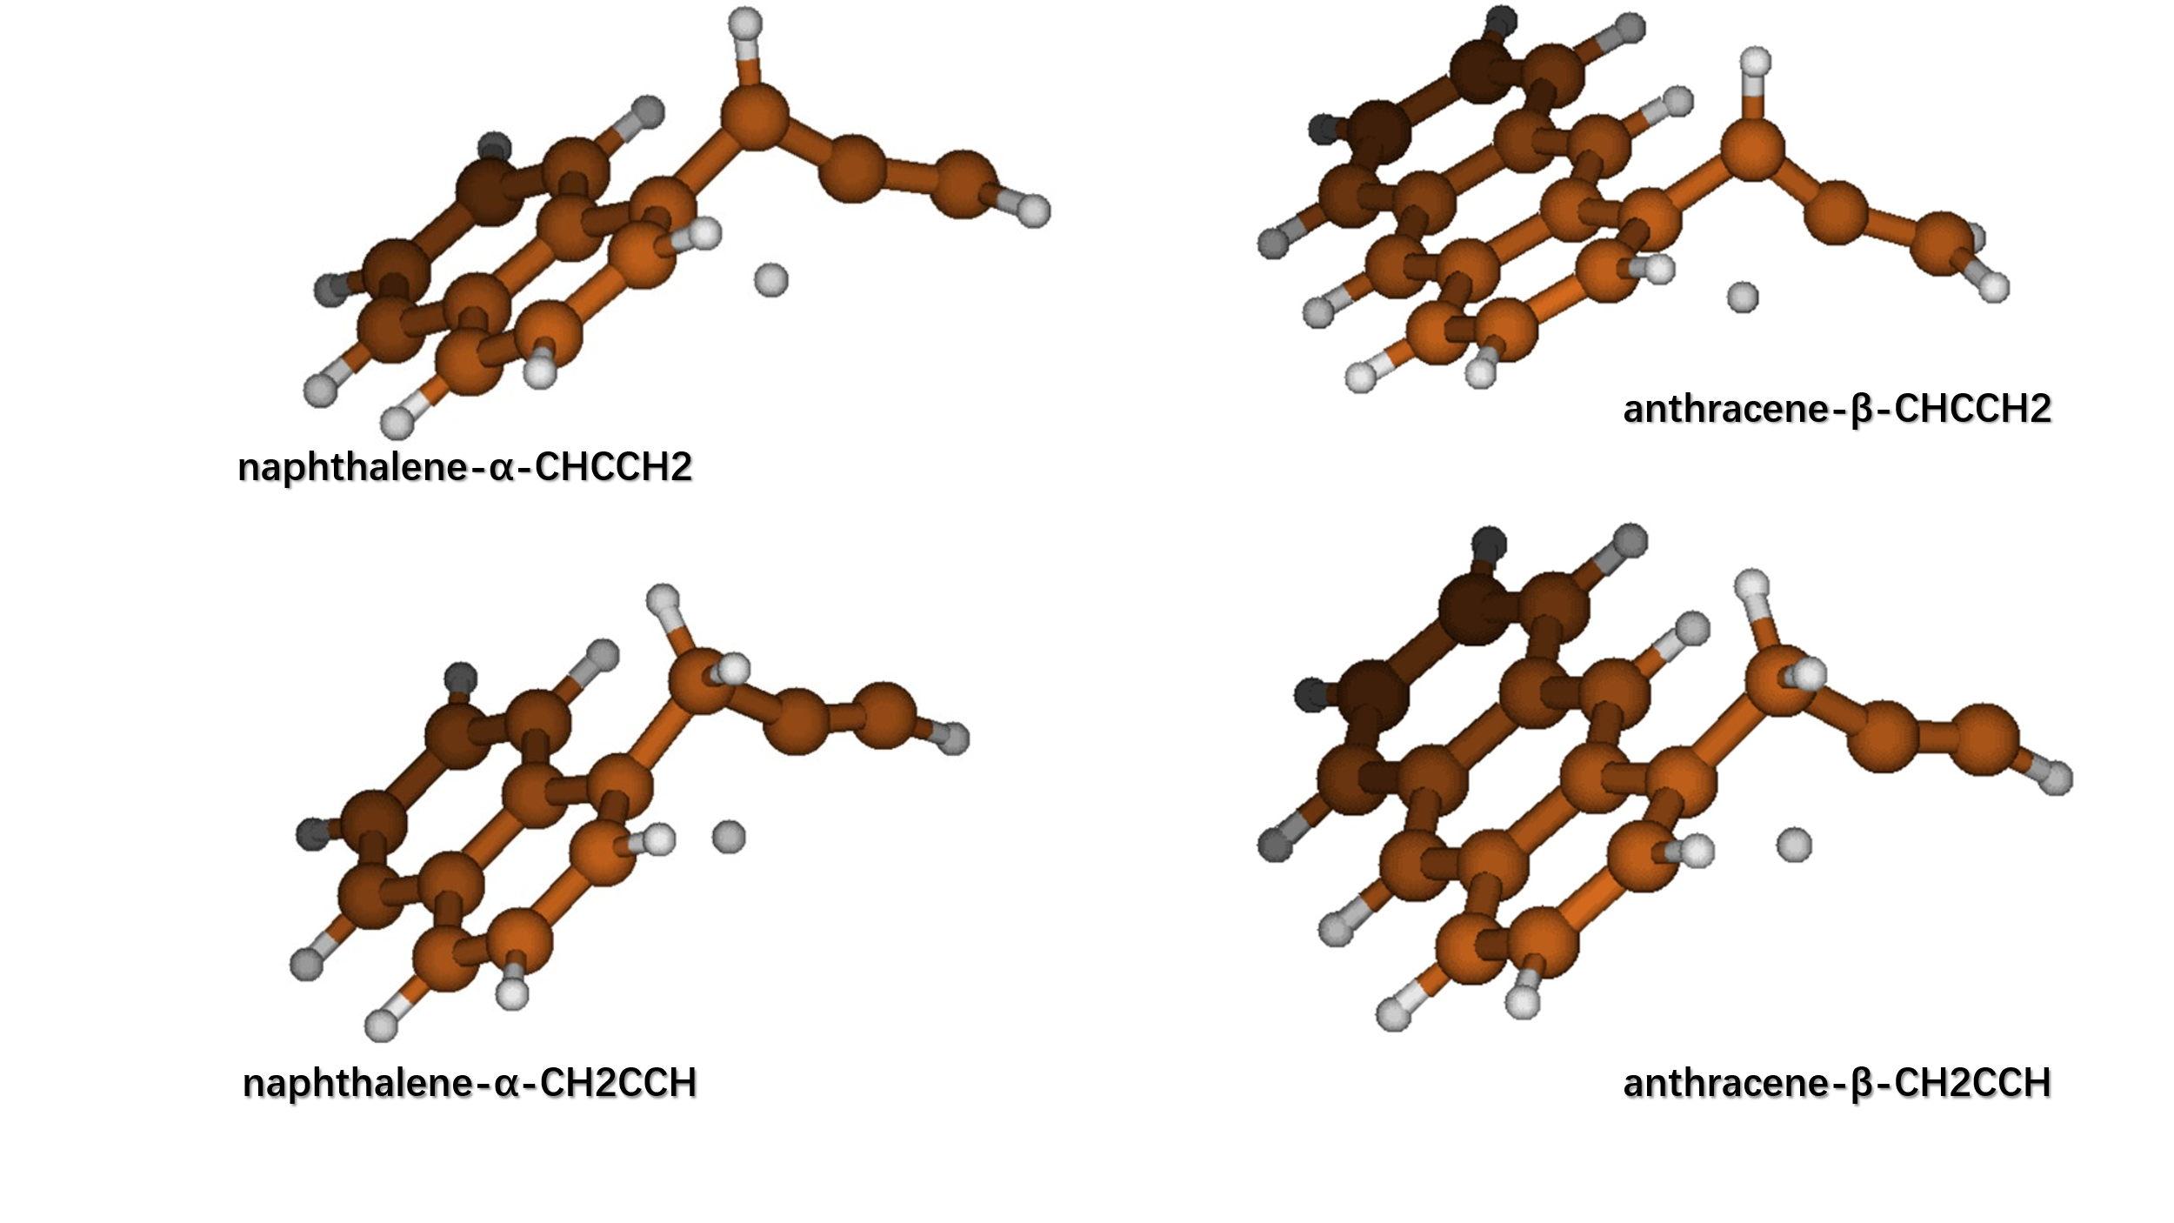
Figure 3.22: TS structure of H-transfer

Table 3.5: Basic data of H-transfer(isomerization)
ΔEa,iso |  |  | ΔH,iso | kcal/mol
Naphthyl-Propargyl |  |  | Naphthyl-Propargyl
 | -chcch2 | -ch2cch |  | -chcch2 | -ch2cch
α | 44.0 | 46.8 | α | -33.3 | -3.03
Anthracenyl+Propargyl |  |  | Anthracenyl+Propargyl
 | -chcch2 | -ch2cch |  | -chcch2 | -ch2cch
β | 46.5 | 49.0 | β | -30.1 | 0.594

Table 3.6 compares the reference energy of H-dissociation and H-transfer products with respective to biomolecules PAH + propargyl radical. Although the energy barrier of H-transfer is rather higher than that of H-dissociation, the H-transfer product is magnificently lower. With the PAH size increasing, the H-transfer barrier decreases slightly faster than H-dissociation.

Table 3.6: Examples of PES prior to ring closure
PES | Bi | TS,add | A | Ts,hd | D+H
 |  |  |  | Ts,iso | I
-CHCCH2
α-naphthalene | 0.00 | 12.2 | -9.41 | 23.4 | 17.0
 |  |  |  | 34.6 | -42.7
β-anthracene | 0.00 | 11.0 | -13.6 | 22.5 | 16.8
 |  |  |  | 32.9 | -43.7
-CH2CCH
α-naphthalene | 0.00 | 10.3 | -8.33 | 26.3 | 20.5
 |  |  |  | 38.4 | -11.4
β-anthracene | 0.00 | 8.95 | -12.5 | 25.5 | 20.2
 |  |  |  | 36.5 | -11.9
Note: Bi = Bimolecular starting point of aromatics + propargyl radical; TS,add = Transition state of propargyl addition; A = Adducts; TS,hd = Transition state of H-dissociation; D+H = bimolecular ending after H-dissociation; Ts,iso = Transition state of isomerization (H-transfer); I = H-transfer product

Figure 3.23 compares high pressure limits at T = 1000 – 2500 K of H-transfer at marginal zigzag sites. As PAH size increases, the rate constant in -CH2CCH channel decreases by about an order of magnitude, which is very similar to the situation in H-dissociation channel. However, the decreasing degree in -CHCCH2 is almost ignorable, indicating a weaker dependence on PAH size. Therefore, the competition between H transfer and H dissociation for the -CH2CCH wells seems to be kept constant with size, while that for the -CHCCH2 wells might favor H transfer for larger PAHs.
So far, a primary conclusion could be that, although H-transfer channel is less competitive than H-dissociation for smaller PAH species, the H-transfer channel of -CHCCH2 could become the more competitive for larger PAHs, promoting the kinetic selectivity to ring closure direction.
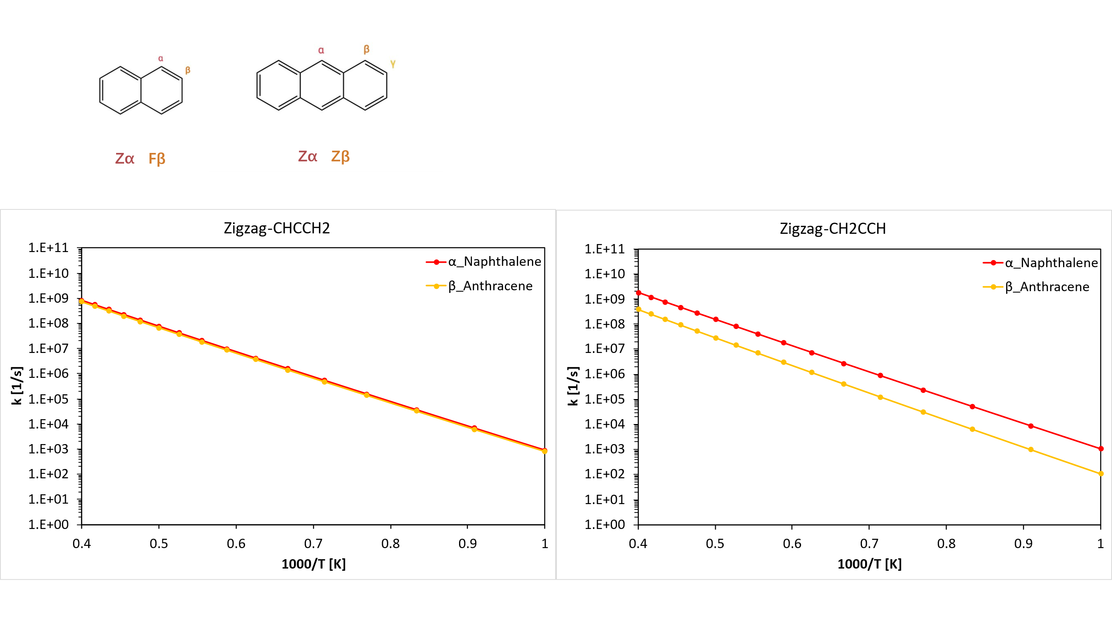
Figure 3.23: High pressure limits of H-transfer at marginal zigzag sites

PES example from Naphthalene-α-Propargyl
To demonstrate how the mechanism primarily proposed in this thesis works, the relevant reaction pathways on the PES for naphthalene addition to propargyl leading to ring closure up to phenalene were derived. The results are illustrated here, then discussed in detail with the help of ME analysis.
After channels discussed earlier, i.e. propargyl radical addition, H atom dissociation, and H atom transfer, there follow the ring closure (intramolecular β-scission) and phenalene formation (H atom dissociation) channels. Figure 3.24 and Figure 3.25 display the structure of bimolecular species, wells, and TS, respectively. The major DFT theory for structure and energy determination is M062X, while the special treatment on TS A1-I1 and A2-I2 has been explained in Chapter 3.3. Notably, O1 is introduced coincidentally just from that unreasonable TS structure found in optimization at level 1 with M062X in H-transfer channel A1-I1, which is proved as the TS structure of channel O1-I1 according to the visualization of the imaginary vibrational frequency and the results of IRC analysis. From another perspective, A1-O1-I1 could serve as a supplementary channel with lower energy barrier for the formation of the critical intermediate I1.

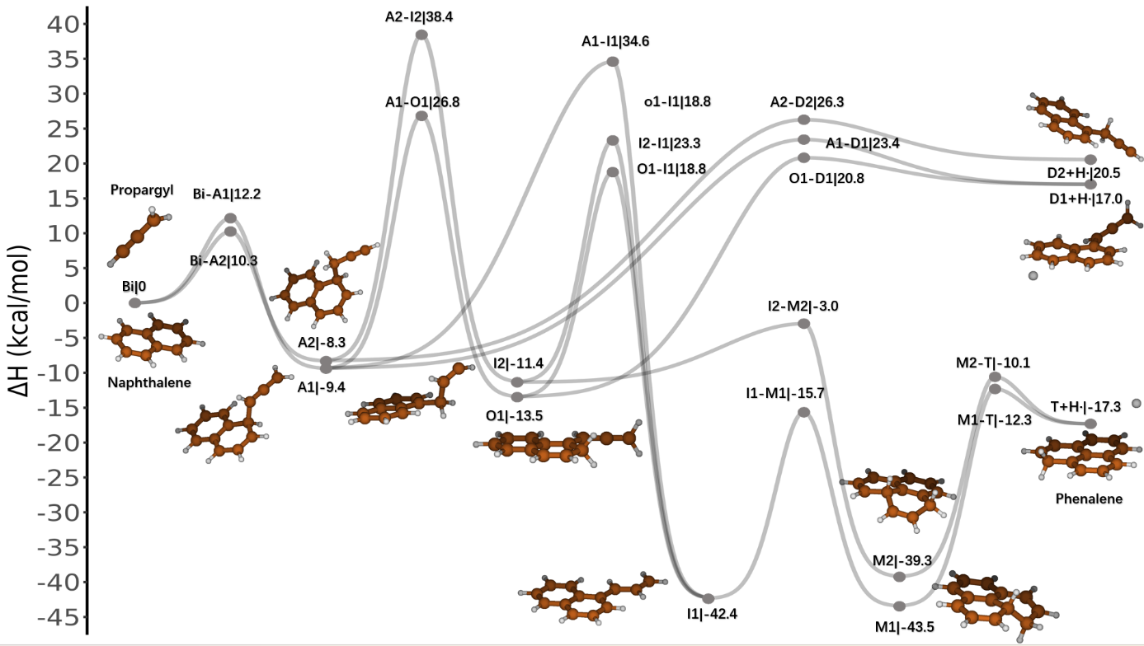
Figure 3.24: Potential energy surface of propargyl addition to naphthalene. Energies in kcal/mol are inclusive of zero-point energy (ZPE) contribution.

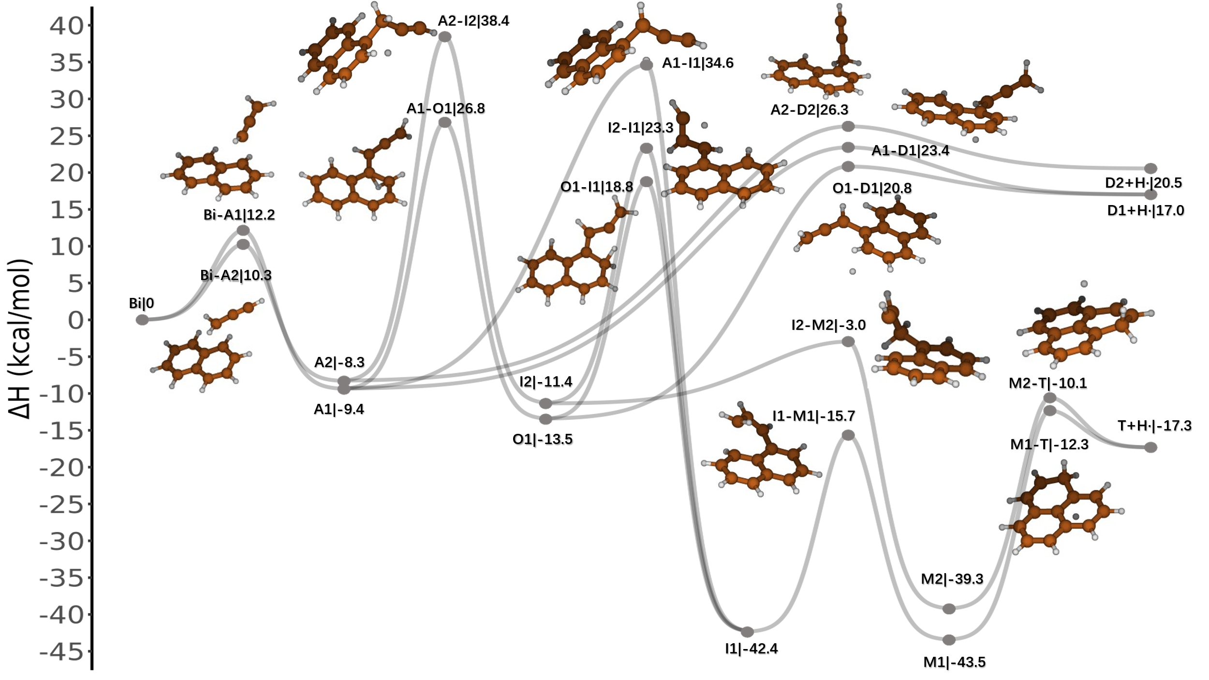
Figure 3.25: Transition state structures on the PES depicted in Fig. 3.24

I1 and I2 are the critical intermediates for ring closure phenalene formation in this mechanism, since all of the TS in the subsequent channels are submerged because of their negative potentials. Therefore, the competition between H-dissociation and H-transfer is especially important in this mechanism. However, on the contrary, Raj et al. [20] have also explored the possibility of ring closure initiated by H-addition reactions on D1 and D2. Additionally, through a pathway with low energy barriers, they have also discovered a vinyl acenaphthylene structure as one of the bimolecular ending points. However, there exists considerable disagreement on the energy of some species up to 8 kcal/mol, where the energy of wells A1, A2 and biomolecules D1/D2+H by B3LYP/6-311++G(d,p) are higher than those in thesis by M062X/6-311+g(d,p).
To figure out the relationships among those channels in the mechanism, ME analysis has been conducted. According to the results, propargyl radical addition is a limiting step since at even moderate pressure and temperature, once generated, adducts A1 and A2 could be immediately consumed by subsequent channels.
Figure 3.26 and Figure 3.27 plot the well-skipping rate constants from biomolecules Bi (naphthalene and propargyl radical) with dependence on pressure and temperature. With higher energy barriers for formation of the intermediates I1 and I2 (through H transfer channels A1-O1, A1-I1, A2-I2), the rate constants to phenalene (Bi-T+H), are lower than those to H-dissociation products D1 and D2. Furthermore, high pressures have considerable inhibition effects on well-skipping rate of Bi-T, while the rates to D1 and D2 are less vulnerable. The reason is rather explicit in Figure 3.25 and 3.26 that between Bi and T, there exist three much deeper wells, i.e. I1, M1, and M2. Overall, Bi-D1/D2 (H dissociation) is favored over the ring closure in the temperature and pressure range analyzed, with differences varying in orders of magnitude from almost 0 under 2500K and 1 atm, to 3 under 1000K and 100 atm.
With regard to the reactivity of M1 and M2, the competition between H dissociation channel M1/M2-T1 and ring-opening channel M1-I1/M2-I2 are relevant as well. In this case, the H-dissociation channel is favored evenly by about an order of magnitude within the temperature range, with minimum discrepancies of factor 3.

Figure 3.26: Well-skipping rate constants from Bi to T1

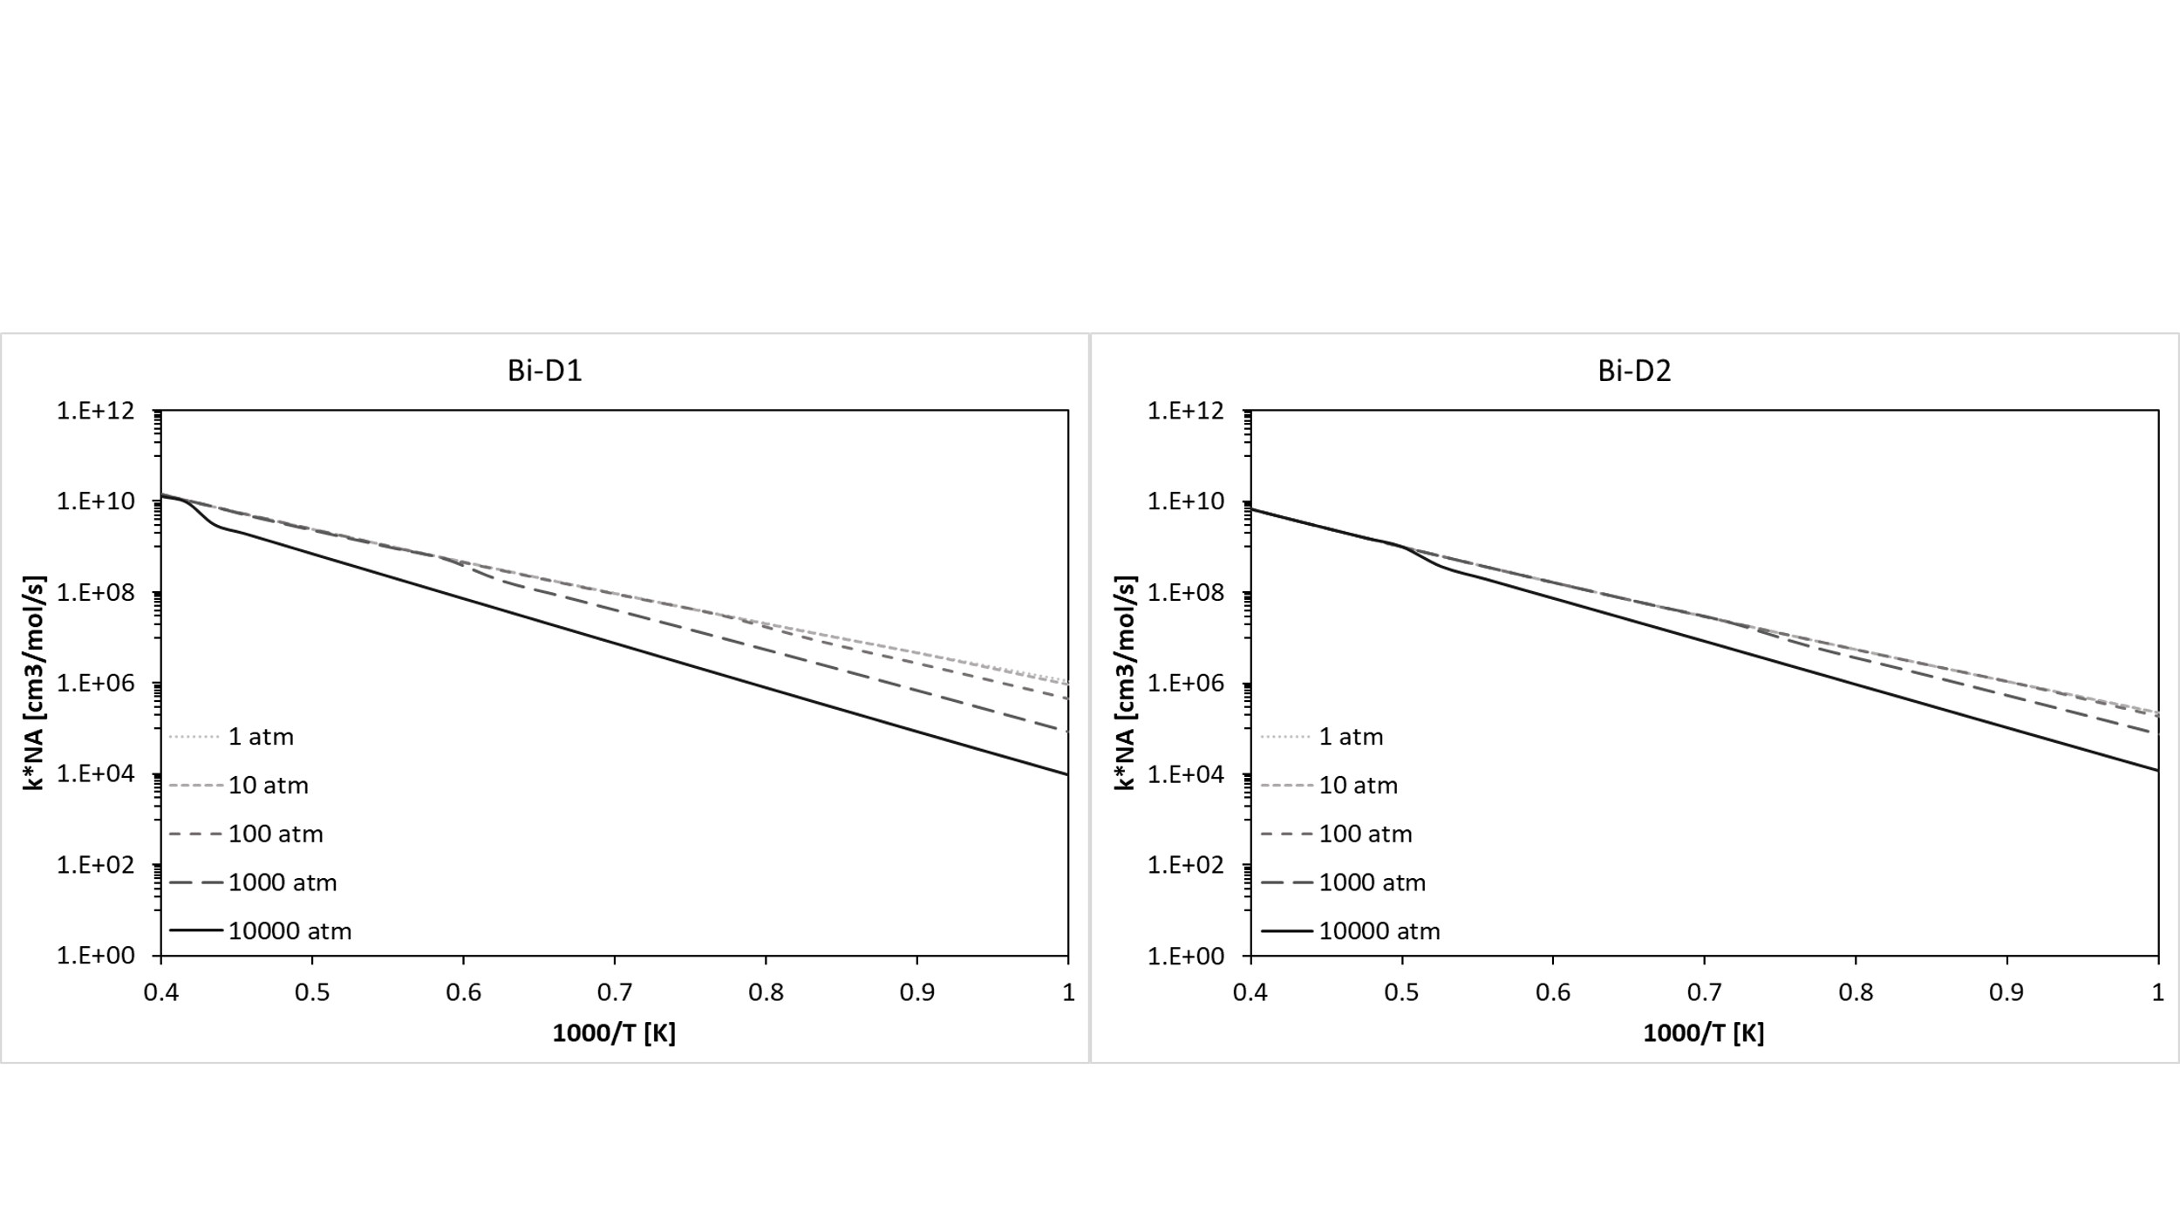
Figure 3.27: Well-skipping rate constants from Bi to D1/D2

The reaction behaviors of stable wells I1, M1, M2 are that:
- Among channels from M1, M1-T and M1-I1 are the evenly matched, major two channels, with others negligible in comparison.
- Similarly, channels M2-T and M2-I2 are the only two competitive evolution pathways for M2
- Under low pressures, I1-T could be assumed as the only possible reaction channel for I1. However, under up to 2500 K and 100 atm, the selectivity of I1 to T is just by around a magnitude higher than those of I1-Bi and I1-D2.
To sum up, propargyl radical addition is a critical step defining the upper formation rate limits of all the other species. The formation of phenalene is more competitive under higher temperature but lower pressure in kinetics, otherwise, the well skipping motion would get trapped into the deep well I1, M1 and M2 under high pressures.

Conclusion and future developments
This thesis has proposed a new mechanism for ring closure on PAHs initiated by propargyl radical, which includes propargyl radical addition, H atom dissociation, H atom transfer (isomerization reaction), and the eventual intramolecular addition to finalize a new 6-member ring. Not only has the PES from naphthalene to phenalene been finished as a convincing, representative example for the new mechanism, but also some distinguishable patterns have been figured out with rate rules established for several critical steps of the ring closure process, through investigating a series of species – benzene, naphthalene, anthracene, phenanthrene, tetracene and pyrene.
Addition of propargyl radical on PAHs replenishes another three carbon atoms to close a 6-member ring in a zigzag region. This reaction channel has several explicit patterns, which is summarized by comparations below:
- stability of adducts: of PAH species (linear acenes > planar PAHs, large PAHs > small PAHs), at sites on PAHs (central zigzag > marginal zigzag > free edge), by the attacking side of propargyl radical (alkenyl side > methylene side)
- Heights of energy barriers: linear acenes < planar PAHs, larger PAHs < small PAHs, central zigzag < marginal zigzag < free edge, methylene side
- Rate constants: linear acenes > planar PAHs, large PAHs > small PAHs, central zigzag > marginal zigzag > free edge, methylene side > alkenyl
- Sensitivity to low pressure: linear acenes < planar PAHs, large PAHs < small PAHs, central zigzag < marginal zigzag < free edge, alkenyl < methylene
Furthermore, the rate rules reveal that on the one hand, based on the correction of degeneracy factor, the correction of the energy barrier is enough to derive reaction constants from a small reference species in most cases included in this thesis. Or for higher accuracy, a scaling constant is already enough for predicting pre-exponential factors from reference, however, this factor varies between linear acenes and planar PAHs, among different addition sites on PAH, as well as between the two adduct types (aromatics-CHCCH₂/ -CH₂CCH), which fall into the region of 0.5 – 1.5. On the other hand, the energy barrier of propargyl radical addition to linear acenes presents a decrease with strong linearity as the size of acene increases. This linear approximation implies that for the acenes larger enough in size, the theoretical energy barrier could fall negative, which means the addition would behave like radical recombination. It is reasonable to infer that other addition reactions, where a simple radical attacks a close-shell PAH molecule, might share similar characteristics as what has been seen here.
After propargyl addition, there are competing channels to recover the aromaticity of the parent ring:
- H atom dissociation where the hydrogen atom, originally bonded to the addition site, leaves the system to form a new branched close-shell aromatic molecule
- H atom transfer where the hydrogen atom is transferred from the addition site to the propargyl branch so that the propargyl branch is bent and prepared to attack back to close the 6-member ting
Notably, H-dissociation shows entirely opposite patterns to those of propargyl radical addition while in the reverse direction, the patterns of H-addition are identical instead. Hence, these comparisons further prove the consistency of the hypothesis proposed earlier for the reaction patterns between close-shell aromatics and simple radicals.
The competition between these two channels is especially important for ring closure, since all of the subsequent reactions, along the evolution pathway to new PAH formation, has submerged energy barriers that are lower than the bimolecular starting point, i.e. the sum of the old PAH plus propargyl radical.
To quantitively figure out the relationships between those channels, ME analysis has conducted on the ring closure PES from naphthalene + propargyl radical to phenalene. Notably, propargyl radical addition is a limiting step since at even moderate pressure and temperature, once generated, adducts A1 and A2 could be immediately consumed by subsequent channels. Nevertheless, the results have revealed that H-dissociation is more abstractive than ring closure in the temperature and pressure range analyzed. Especially, well skipping rates from naphthalene + propargyl radical considerably decrease under higher pressure. This preference could be attributed to higher energy barrier of H-transfer channels, as well as to the presence of three much more stable well species along the evolution pathway to phenalene, which intensifies quenching effect of high pressure on the well-skipping motions
On the other hand, the study on H-transfer channels shows that with the PAH size increasing, the relative energy of H-transfer TS, with respect to the bimolecular starting point (reactant PAH + propargyl radical), decreases slightly faster than H-dissociation. Furthermore, although the reactivity of H-dissociation and H-transfer decreases with larger PAH size, the decreasing trend of H-transfer channel for PAH-CHCCH₂ is almost invisible on the plot. Therefore, a primary conclusion could be that, although H-transfer channel is less competitive than H-dissociation for smaller PAH species, the H-transfer channel of -CHCCH2 could become the more competitive for larger PAHs, promoting the kinetic selectivity to ring closure direction.
To sum up, this thesis serves as a supplementary work in two aspects for the large kinetic mechanisms of PAH growth and soot formation. On the one hand, it reveals several possible patterns for the addition reactions of simple radicals on close-shell PAH species. On the other hand, it proposes a clear mechanism as an example for ring closure that happens in a 2-ring case, which could be used either in the examination for the rate rules derived from single-ring species, or serve as a reference basis to establish new rate rules. Reaction pattern studies, together with ME analysis on the ring closure PES, indicates that for small PAH, propargyl radical addition is the critical step defining the upper formation rate limits of all the other species. Therefore, larger PAH size has a positive effect on all the other channels due to the higher reactivity. However, as the behavior of large PAH approaching diradical, this promotion could be less and less pronounced. Although H-dissociation is more competitive than ring closure in naphthalene case, the reactivity of H-dissociation seems decreasing faster, thus increasing the kinetic selectivity to ring closure Still, more studies are required to give an explicit conclusion by testing more H-transfer channels in different PAHs.

Bibliograph

[1] | M. Wiatros-Motyka, N. Fulghum and D. Jones, "Global Electricity Review 2024," 2024.
[2] | Energy Institute, "Statistical Review of World Energy," 2024.
[3] | "2025 Statistical Review of World Energy," Energy intitute, 2025. [Online]. Available: https://www.energyinst.org/statistical-review.
[4] | The International Energy Agency (IEA), 2024. [Online]. Available: https://www.iea.org/reports/renewables-2024/global-overview.
[5] | The International Energy Agency (IEA), 2024. [Online]. Available: https://www.iea.org/reports/renewables-2023/electricity.
[6] | "Black carbon," The Climate and Clean Air Coalition (CCAC), [Online]. Available: https://www.ccacoalition.org/short-lived-climate-pollutants/black-carbon.
[7] | J. Yang, M. J. Z. Sakhvidi, K. d. Hoogh, D. Vienneau, J. Siemiatyck, M. Zins, M. Goldberg, J. Chen, E. Lequy and B. Jacquemin, "Long-term exposure to black carbon and mortality: A 28-year follow-up of the GAZEL cohort," Environment International, 2021.
[8] | C. Russo, B. Apicella and A. Ciajolo, "Blue and green luminescent carbon nanodots from controllable fuel-rich flame reactors," Nature, vol. 9, 2019.
[9] | P. Namdari, B. Negahdari and A. Eatemadi, "Synthesis, properties and biomedical applications of carbon-based quantum dots: An updated review," Biomedicine & Pharmacotherapy, vol. 87, pp. 209-222, 2017.
[10] | J. W.Martin, M. Salamanca and M. Kraft, "Soot inception: Carbonaceous nanoparticle formation in flames," Progress in Energy and Combustion Science, vol. 88, 2022.

[11] | M. Frenklach, D. W. Clary, W. C. Gardiner and S. E. Stein, "Detailed kinetic modeling of soot formation in shock-tube pyrolysis of acetylene," Symposium (International) on Combustion, vol. 20, no. 1, pp. 887-901, 1982.
[12] | L. Pratali Maffei, M. Pelucchi, C. Cavallotti, A. Bertolino and T. Faravelli, "Master equation lumping for multi-well potential energy surfaces: A bridge between ab initio based rate constant calculations and large kinetic mechanisms," Chemical Engineering Journal, vol. 422, no. 15, 2021.
[13] | M. Pelucchi, C. Cavallotti, A. Cuoci, T. Faravelli, A. Frassoldati and E. Ranzi, "Detailed kinetics of substituted phenolic species in pyrolysis bio-oils," Reaction Chemistry & Engineering, vol. 4, pp. 490-506, 2019.
[14] | E. Ranzi, A. Frassoldati, A. Stagni, M. Pelucchi, A. Cuoci and T. Faravelli, "Reduced kinetic schemes of complex reaction systems: Fossil and biomass-derived transportation fuels," International Journal of Chemical Kinetics, vol. 46, no. 9, pp. 512-542, 2014.
[15] | E. Ranzi, M. Dente, S. Pierucci and G. Biardi, "Initial Product Distributions from Pyrolysis of Normal and Branched Paraffins," Industrial & Engineering Chemistry Fundamentals, vol. 22, pp. 132-139, 1983.
[16] | M. Dente, E. Ranzi and A. G. Goossens, "Detailed prediction of olefin yields from hydrocarbon pyrolysis through a fundamental simulation model (SPYRO)," Computers & Chemical Engineering, vol. 3, no. 1-4, pp. 61-75, 1979.
[17] | C. S. McEnally, L. D. Pfefferle, B. Atakan and K. Kohse-Höinghaus, "Studies of aromatic hydrocarbon formation mechanisms in flames: Progress towards closing the fuel gap," Progress in Energy and Combustion Science, vol. 32, no. 3, pp. 247-294, 2006.
[18] | M. Colket and D. Seery, "Reaction mechanisms for toluene pyrolysis," Symposium (International) on Combustion, vol. 25, no. 1, pp. 883-891, 1994.
[19] | J. Zhang, J. Gao and H. Wang, "American Chemical Society," Less-Dominant Resonance Configuration of Propargyl Radical Leads to a Growth Mechanism for Polycyclic Aromatic Hydrocarbons that Preserves the Cyclopenta Ring, vol. 147, no. 11, pp. 9283-9293, 2025.
[20] | A. Raj, M. J. Al Rashidi and S. H. Chung, "PAH Growth Initiated by Propargyl Addition: Mechanism Development and Computational Kinetics," American Chemical Society, vol. 118, no. 16, pp. 2865-2885, 2014.

[21] | A. Violi, . A. D’Anna and A. D’Alessio, "Modeling of particulate formation in combustion and pyrolysis," Chemical Engineering Science, vol. 54, no. 15-16, pp. 3433-3442, 1999.
[22] | A. D'Anna and A. Violi, "A kinetic model for the formation of aromatic hydrocarbons in premixed laminar flames," Symposium (International) on Combustion, vol. 27, no. 1, pp. 425-433, 1998.
[23] | J. F. Alarcon, A. N. Morozov, A. M. Mebel, A. Della Libera, L. Pratali Maffei and C. Cavallotti, "Mechanism and kinetics of the oxidation of propargyl radical by atomic oxygen,," Proceedings of the Combustion Institute,, vol. 40, no. 1-4, 2024.
[24] | A. M. Mebel, . Y. Georgievskii, . A. W. Jasper and . S. J. Klippenstein, "Pressure-dependent rate constants for PAH growth: formation of indene and its conversion to naphthalene," Faraday Discussions, vol. 195, 2016.
[25] | A. Nobili, L. Pratali Maffei, A. Baggioli, M. Pelucchi, A. Cuoci, C. Cavallotti and T. Faravelli, "On the radical behavior of large polycyclic aromatic hydrocarbons in soot formation and oxidation," Combustion and Flame, vol. 235, 2022.
[26] | A. G. Taube and R. J. Bartlett, "Frozen natural orbital coupled-cluster theory: Forces and application to decomposition of nitroethane.," J. Chem. Phys., vol. 128, no. 16, 2008.
[27] | A. L. East and L. Radom, "Ab initio statistical thermodynamical models for the," Journal of Chemical Physics, vol. 106, no. 16, pp. 6655-6674, 1997.
[28] | C. Eckart, "The penetration of a potential barrier by electrons," Physical Review, vol. 35, no. 11, pp. 1303-1309, 1930.
[29] | Y. Georgievskii, J. A. Miller, M. P. Burke and S. J. Klippenstein, "Reformulation and Solution of the Master Equation for Multiple-Well Chemical Reactions," Journal of Physical Chemistry, vol. 117, no. 46, pp. 12146-12154, 2013.
[30] | J. A. Miller and S. J. Klippenstein, "Master Equation Methods in Gas Phase Chemical," Journal of Physical Chemistry, vol. 110, pp. 10528-10544, 2006.
[31] | C. Cavallotti, M. Pelucchi, Y. Georgievskii and S. J. Klippenstein, "EStokTP: Electronic Structure to Temperature- and Pressure-Dependent Rate Constants—A Code for Automatically Predicting the Thermal Kinetics of Reactions," American Chemical Society, vol. 15, no. 2, pp. 1122-1145, 2019.

[32] | H.-H. Carstensen and A. M. Dean, "Rate Constant Rules for the Automated Generation of Gas-Phase Reaction Mechanisms," American Chemical Society, vol. 113, no. 2, pp. 367-380, 2009.
[33] | A. Nobili, W. Pejpichestakul, M. Pelucchi, A. Cuoci, C. Cavallotti and T. Faravelli, "Modeling soot particles as stable radicals: a chemical kinetic study on formation and oxidation. Part II. Soot oxidation in flow reactors and laminar flames," Combustion and Flame, vol. 243, 2022.

- Appendix: High pressure limit rate constants

Propargyl radical addition channels

H atom dissociation channels

H atom transfer channels
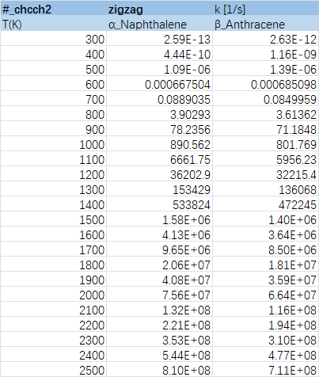

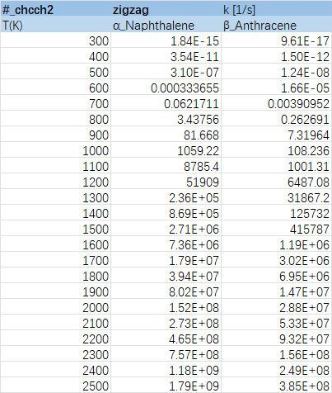

List of Figures
Figure 1.1 Resonance structure of propargyl radical 6
Figure 3.1: Notations of reaction sites 24
Figure 3.2: TS structure of aromatics-free edge-CHCCH2 25
Figure 3.3: TS structure of aromatics-free edge-CH2CCH 26
Figure 3.4: High pressure limits of propargyl radical addition to free edge sites 27
Figure 3.5: Threshold temperatures of propargyl radical addition to free edge at 1 atm 28
Figure 3.6: Scaling factors for rate constants of propargyl radical addition to free edge sites 29
Figure 3.7: Linear approximation for energy barriers of propargyl radical addition to free edge sites with regard to the size of acenes 30
Figure 3.8: TS structure of aromatics-marginal zigzag-CHCCH2 31
Figure 3.9: TS structure of aromatics-marginal zigzag-CHCCH2 32
Figure 3.10: High pressure limits of propargyl addition to marginal zigzag sites 33
Figure 3.11: Threshold temperatures of propargyl radical addition to marginal zigzag sites at 1 atm 34
Figure 3.12: Scaling factors for rate constants of propargyl addition on marginal zigzag sites 35
Figure 3.13: Linear approximation for energy barriers of propargyl radical addition to marginal zigzag sites with regard to the size of acenes 36
Figure 3.14: TS structure of aromatics-marginal zigzag-CHCCH2 37
Figure 3.15: High pressure limits of propargyl addition to central zigzag sites and selected marginal zigzag sites 39
Figure 3.16: Scaling factors for rate constants of propargyl addition on all central and selected marginal zigzag sites 40
Figure 3.17: TS structure of H-dissociation from aromatics-CHCCH2 42
Figure 3.18: TS structure of H-dissociation from aromatics-CH2CCH 42
Figure 3.19: Schematic diagram for PES of aromatic radical substitution reactions 44

Figure 3.20: High pressure limits of H-dissociation 45
Figure 3.21: Scaling factors for rate constants of H-dissociation 46
Figure 3.22: TS structure of H-transfer 47
Figure 3.23: High pressure limits of H-transfer at marginal zigzag sites 49
Figure 3.24: Exhibition of biomolecules and wells structure on PES 50
Figure 3.25: Exhibition of TS structure on PES 50
Figure 3.26: Well-skipping rate constants from Bi to T1 52
Figure 3.27: Well-skipping rate constants from Bi to D1/D2 52

List of Tables
Table 3.1: Basic data of propargyl radical addition to free edge 26
Table 3.2: Basic data of propargyl radical addition to marginal zigzag 32
Table 3.3: Basic data of propargyl radical addition to central zigzag and marginal zigzag sites 38
Table 3.4: Basic data of propargyl radical addition to central zigzag and marginal zigzag sites 43
Table 3.5: Basic data of H-transfer(isomerization) 47
Table 3.6: Examples of PES prior to ring closure 48

Acknowledgments
I would like to express my sincere gratitude to Prof. Luna Paratali Maffei, my supervisor, for her patient guidance, continuous support, and insightful advice throughout the entire duration of this thesis. Her expertise, encouragement, and attention to detail have been invaluable to both my research and my development as a scientist.
I am also deeply grateful to Prof. Carlo Alessandro Cavallotti. His course provided a rigorous and exceptionally useful foundation for the theoretical and computational methods employed in this work. The clarity and depth of his teaching have significantly shaped my understanding of reaction kinetics and computational chemistry and have proven essential to the successful completion of this thesis.
I would additionally like to thank all the professors and researchers at the Politecnico di Milano who have supported my academic journey, as well as my friends and family whose encouragement has accompanied me along the way.
Finally, I wish to express my heartfelt gratitude to my family. Their unwavering love, patience, and support have sustained me throughout my studies and during the most challenging moments of this work. Their belief in me has been a constant source of strength, and I am profoundly thankful for everything they have done to help me reach this stage.
.

